Using Simple Probability Rules

I. The rules:

If the probability of an event occurring is p, then the probability of it not occurring is 1-p.
If two independent events both must occur, then the probabilities for each must be multiplied.
If either of two independent event must occur, then the probabilities for each are added.

II. An imaginary example.

Suppose you are working with a self-fertilizing worm like C. elegans except that it has only a single pair of chromosomes and you want to determine how frequently a chromosome can be mutated to produce a Dumpy (Dpy) phenotype. (You know from previous experiments that the organism has many genes of this sort.) You mutagenize the animal and put individual F1 progeny on ten plates and get the following results when you look at their progeny (i.e., 3 plates of 10 have some Dpy; if R is the fraction of plates with animals with the phenotype, then R = 0.3

Although three plate have Dpy animals, we do not know whether these animals occurred because of a mutation on one chromosome or mutations on two chromosomes of the F1 (if two different genes – one on each chromosome – were mutated, then you would see animals homozygous for either chromosome that are Dpy and heterozygotes that are wild type in length). We are interested in determining the rate (p) at which the chromosomes are mutated. This value could be anything from 6/20 (both chromosomes for each F1 that start the three plates out of the total F1 chromosomes – 10 plates X 2 chromosomes) and 3/20 (single mutations in each of the three F1s). But saying the 0.15 ≤ p ≤ 0.3 is not a very satisfying way to determine p.
If we look instead at the plates that do not have mutant animals, we can derive a better estimate. The fraction of plates with no mutants is 1-R (0.7 in this case). Since these plates to have no mutants, neither chromosome is mutated. The probably of no mutants being produced is therefore (1-p)², i.e., the probably of one chromosome not being mutated times that of the other chromosome not being mutated. These two values 1-R and (1-p)² are the same; one calculates the fraction in terms of plates, the other in terms of chromosomes. The equation 1-R = (1-p)² yields p = 1-√(1-R) or 0.16.
III. A real experimental result: calculating the number of C. elegans [from Sydney Brenner (1974) The genetics of Caenorhabditis elegans. Genetics 77: 71-94.]

Sydney Brenner wanted to calculate the number of genes on the X chromosome of C. elegans that could be mutated to give a lethal phenotype. He started with a strain that was homozygous for two recessive mutations, one in an autosomal sma gene (the sma mutation makes the animals Sma or Small) and the other in an X-linked lon gene (the lon mutation makes the animals Lon or Long). The sma mutations are epistatic to the lon mutations. Epistasis is when only one of two contradictory phenotypes is seen; in this case the doubly mutant animals are Sma. He mutated sma; lon hermaphrodites and then mated the F1 animals with wild-type males.
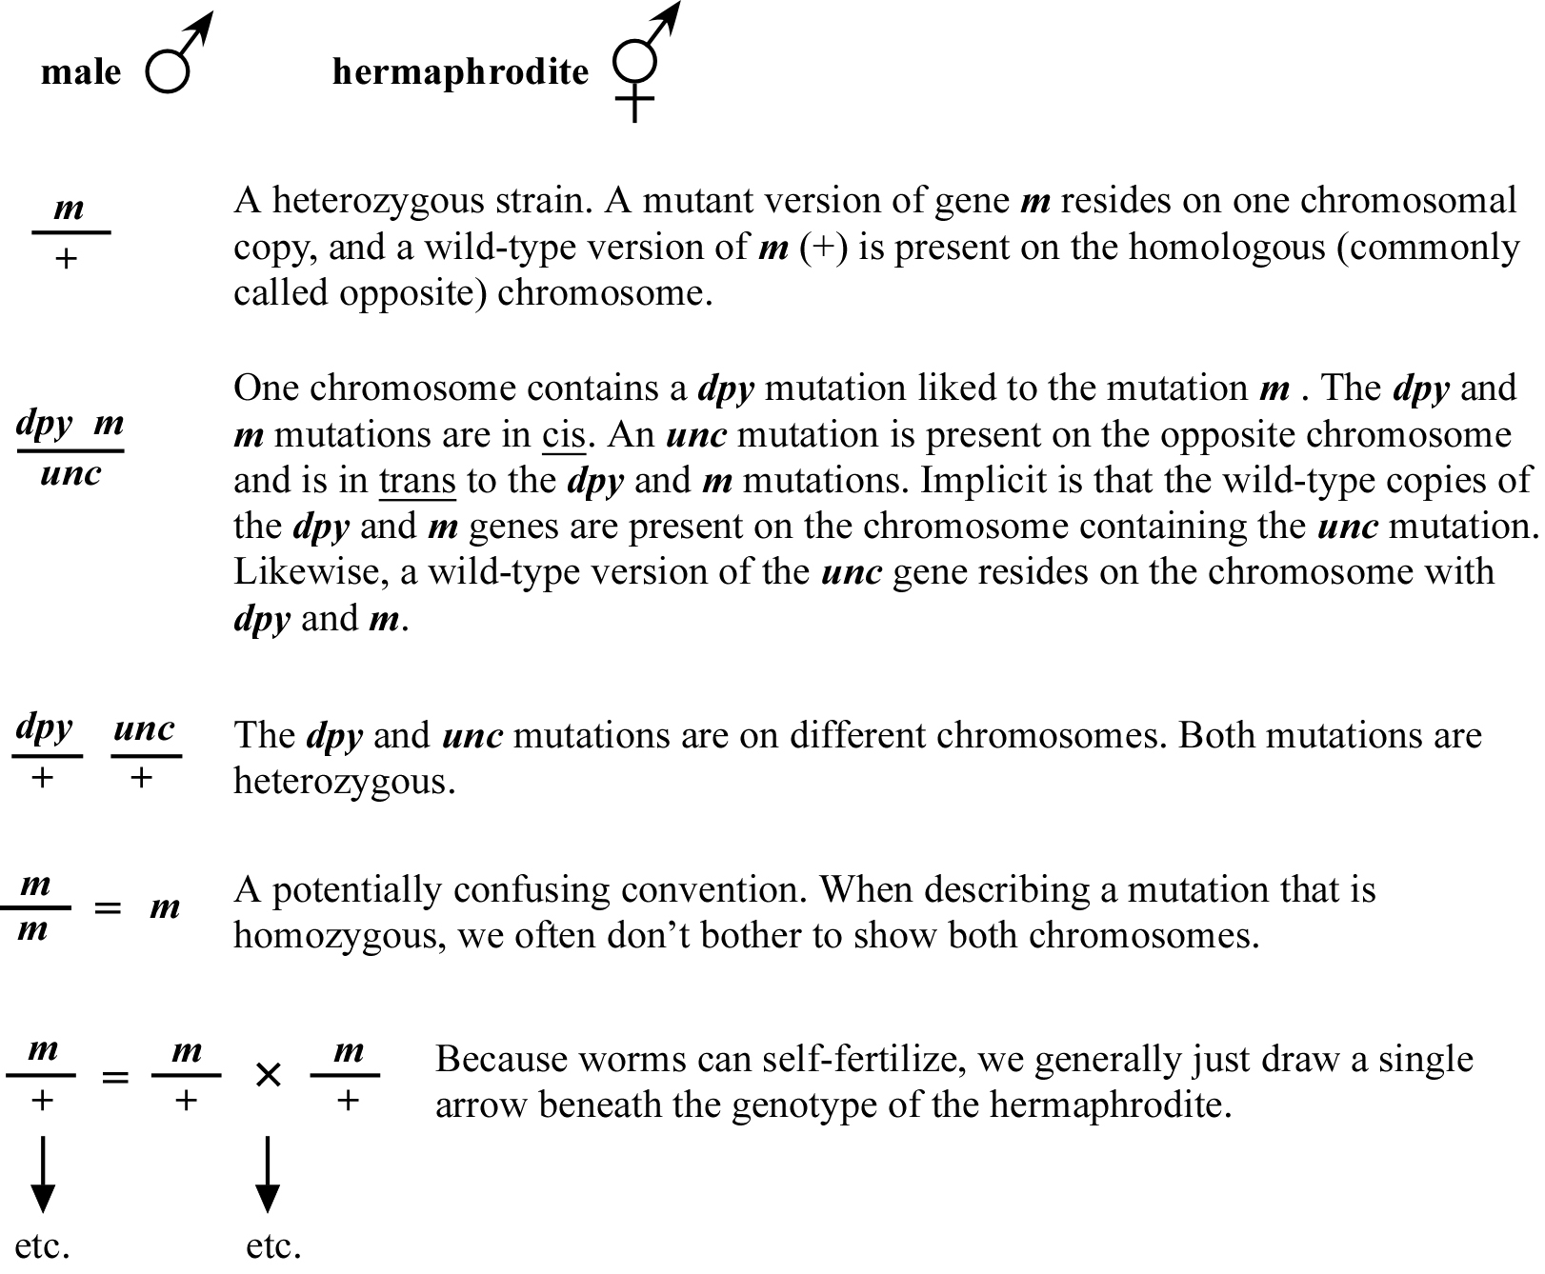
sma; lon
sma/+; lon
sma/+; lon/+
Lon
+;+
Wild type
Sma
X
Self Progeny:
Cross Progeny:
sma; lon
Sma
Wild type
He expected equal numbers of wild-type hermaphrodites and Lon males if neither X in the sma;lon hermaphrodite had a recessive lethal mutation on it (remember hermaphrodites have two X chromosomes; males have one). If either or both X chromosomes had a lethal mutation, then males with that single X would die and not be seen. Thus, an indication of an X-linked lethal mutation would be a ratio of Lon males to wild-type hermaphrodites that was less than one. He did 74 matings and found that 26 of them gave ratios less than one. This result gave him a fraction of matings with lethal mutations (R = 26/74), but not the fraction of affected chromosomes (p). The problem as in the example above was that one or both X chromosomes could have a lethal mutation. However, we could write an equation for the fraction of chromosomes that were not affected. As above this equation was: 1-R = (1-p)² or p = 1-√(1-R). For his experiment, the value of p was, thus, 0.15. In another experiment, he found that the average rate at which a gene was mutated was 1/2000, i.e., on average one of every 2000 copies of a gene available for mutation would be mutated. Dividing this rate (1/2000) into the rate per X chromosome (0.15) gave him an estimate that the X chromosome contained 300 genes. Since C. elegans has six chromosomes, he reasoned that the total number of lethal genes in the animals would be six times the number on the X chromosome or approximately 2000. At the time people that the overwhelming majority of genes in an animal would mutate to lethality, so this would be a very good estimate for the total number of genes in C. elegans. Later in the course we will discuss reasons why this estimate was wrong (the animal has ten times this number of genes).

