CLiMB

Computational Linguistics for Metadata Building


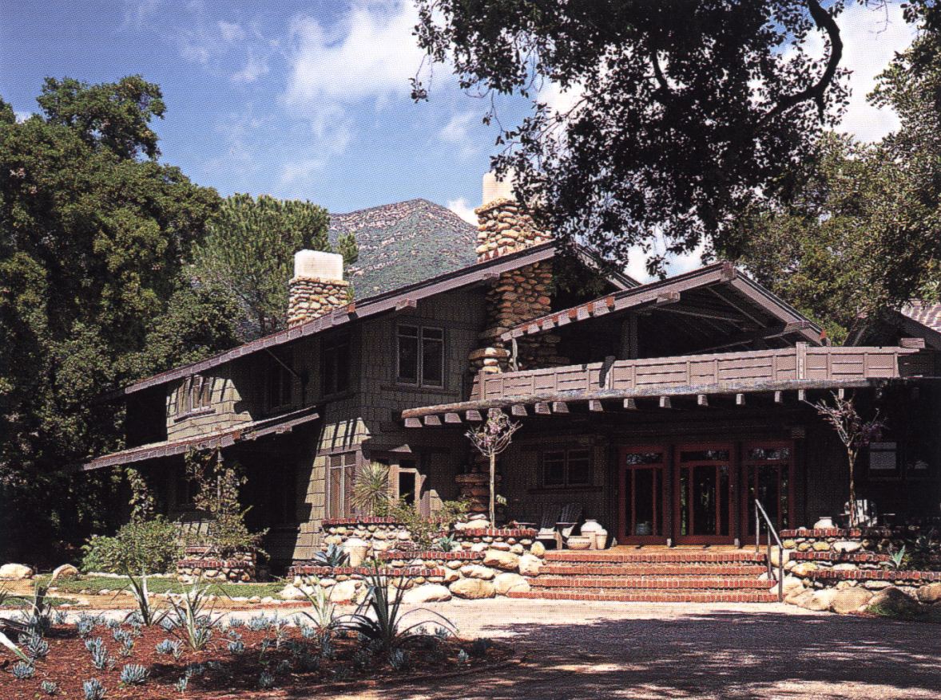
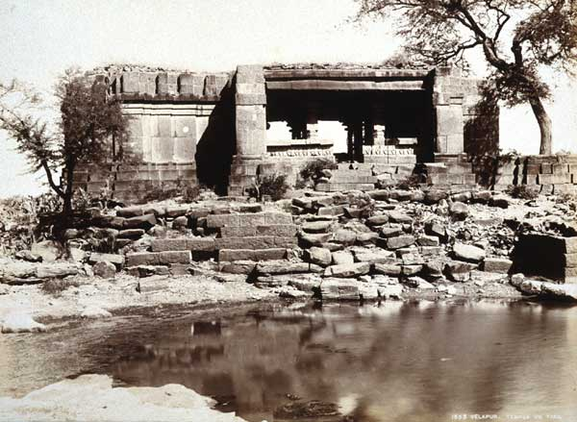

Center for Research on Information Access
Columbia University

Interim Report
April 2002 - September 2002

Highlights of Progress - April 2002 to September 2002

The CLiMB project at Columbia University aims to use automatic techniques to extract descriptive metadata from texts associated with image collections. In the first six months of the project, we have:
- Mapped a strategy for using computational linguistic tools and techniques in conjunction with external resources such as book indexes, authority files, and other controlled vocabularies
- Performed initial tests of natural language processing software over selected documents for identification of
  - Noun phrases
  - Other words and phrases
  - Segmentation
- Developed a set of working guidelines for choosing collections for the project
- Selected three diverse collections of images, and texts connected with them, as datasets upon which to test our tools
  - Greene & Greene architectural images
  - Chinese Paper Gods collection
  - South Asian Temples images
- Established detailed guidelines for defining relevance in terms of metadata extraction
- Explored initial evaluation methodologies for
  - Determining the accuracy of subject related terms derived from texts
  - Verifying the usefulness of this metadata for users
- Hired all staff

Goals of the CLiMB Project
The CLiMB project at Columbia University aims to use automatic techniques to extract descriptive metadata from texts associated with image collections. Ordinarily, descriptive metadata (in the form of catalog records and indexes) are compiled manually, a process which is slow, expensive, and often tailored to the purpose of a collection. Our goal is to explore the potential for employing computational linguistic techniques to help alleviate some of the cataloging bottleneck by enhancing descriptive metadata through the use of automatic procedures. The new software that is currently being developed as part of the CLiMB project identifies relevant search terms by extracting them from written material associated with images in digital collections. CLiMB takes as its major goal the creation of a set of tools that can ultimately be embedded in existing search platforms, in order not only to enable automatic indexing procedures, but also to enhance search, retrieval, and presentation techniques that will directly benefit end-users. CLiMB also includes an extensive evaluation component, which measures the effectiveness of the tools at extracting the information we desire and assesses the usefulness of this information once included in image search platforms. To our knowledge, CLiMB is engaged in a unique approach to issues of metadata extraction.

CLiMB Progress Summary
During the first months of the CLiMB project, the members of our internal groups were able to achieve several thematic and research-based goals, in effect determining the course of the project in terms of many important questions. The Technical Group tested the metadata extraction capabilities of an initial toolset of Natural Language Processing (NLP) software on scholarly text associated with the Greene & Greene architectural images. After assessing the findings of the initial trials, the Group began the process of improving upon the capabilities of these tools by composing variations on existing algorithms, which were then reapplied to the data. In conjunction with the continued refinement of these algorithms, the Group has also begun to augment the techniques that they are developing by employing additional NLP strategies to address the challenges that have arisen from the data. This technological work proceeded in part from earlier decisions reached by the Curatorial Group about what materials would best serve as the initial dataset for the CLiMB project. After applying decisions from their early meetings to the task of defining criteria that could be employed to guide the selection process, the Group settled upon the Greene & Greene Collection, a group of architectural drawings and papers held at Avery Library, Columbia University, as the initial dataset for testing. Architectural images from the Greene & Greene collection represent a model for the types of collections to which the results of the CLiMB project will eventually be applied, and they allow for the measurement of CLiMB results against the catalog records that already exist for these images. The text relating to the Greene & Greene images that was selected for the initial testing of metadata extraction capabilities was scanned in early June and now exists in three workable formats. Finally, staffing requirements for the CLiMB project were fulfilled. The creation of an External Advisory Board is currently underway; potential invitees will be officially contacted about participating in the project.

CLiMB Project Groups

Project Leader: Judith Klavans

CLiMB Coordinating Committee
- Judith Klavans, Director, Center for Research on Information Access (klavans@cs.columbia.edu)
- Patricia Renfro, Deputy University Librarian, Columbia University (pr339@columbia.edu)
- Stephen Davis, Acting Director, Libraries Digital Program Division (daviss@columbia.edu)
- Bob Wolven, Director of Bibliographic Control & Library Systems (wolven@columbia.edu)
- Angela Giral, Director, Avery Art and Architecture Library (giral@columbia.edu)

CLiMB Curatorial Group
- Judith Klavans
- Angela Giral
- Stephen Davis
- Bob Wolven
- Roberta Blitz, CLiMB Art Librarian (rlb179@columbia.edu)
- Bob Scott, Head, Electronic Text Service (scottr@columbia.edu)
- Amy Heinrich, Director, Starr East Asian Library (heinrich@columbia.edu)
- David Magier, Director, Area Studies and Digital South Asian Library (magier@columbia.edu)

CLiMB Technical Group
- Judith Klavans
- Stephen Davis
- Angela Giral
- Roberta Blitz
- Peter Davis, Graduate Research Assistant (ptd7@cs.columbia.edu)
- David Elson, Programmer (delson@cs.columbia.edu)

CLiMB Progress Report
April 1, 2002 to September 1, 2002
(1st and 2nd Quarters)

CLiMB's project groups have made significant progress on several themes, particularly in terms of creating a strong foundation for the project by addressing many of its fundamental questions. As a result of this groundwork, the project has been able to take substantial steps towards implementing its major goals. This report closes with an overview of the next steps the CLiMB project will take during the upcoming quarter and beyond.

Contents

Preface: Elaborating the Problem

- Choosing and Testing Pre-existing Tools
- Creating Original Algorithms and Refining the Toolset
- Using subject-oriented vocabulary
- Employing segmentation techniques
- Determining Image Selection Criteria
- Defining criteria for image collections and associated text
- Collecting data on how people will use CLiMB information
- Generating the Initial Dataset
- Fulfilling Staffing Needs
- Developing External Support

Current CLiMB Bibliography
- Collections and Related Material
- Information on CLiMB

Postscript: Taking Next Steps

Preface: Elaborating the Problem

The innovative contribution of the CLiMB project is its use of computational linguistic tools in order to extract metadata from the text accompanying images in large digital collections — hence Computational Linguistics for Metadata Building. Put in basic terms, the project applies techniques developed for research in computational linguistics to the problem of cataloging and describing the images in a given collection; it does this by putting to use the information that already exists in the form of written material that is related to those images. Although manual cataloging is an established field, what is novel about the CLiMB approach is the notion that some cataloging can be accomplished automatically.

In general, when a collection of images is cataloged, librarians specializing in subjects related to the collection provide intellectual access to the material by selecting relevant name and subject terms from existing authority lists and controlled vocabularies. If, for example, a collection contains images of artworks, an art librarian will employ his or her knowledge of the material to select the applicable terms from among such lists and vocabularies, which can then be entered into a catalog or index. These terms answer a fundamental set of questions that might be put to the collection by potential users when they are searching for images: What does this image depict? What is the object made out of? What other physical characteristics does it exhibit? Who created it? What is its historical and cultural significance? The benefit of using experts to perform this task is that they possess an extensive and invaluable understanding of the material; however, given the incredible size of the digital collections now being created, it is both too expensive and too time consuming to accomplish this manually.

Fortunately, people have already described many of these images in other contexts, such as scholarship. For example, if we have a book containing extensive visual and written material on particular art or architecture topics, the information necessary for cataloging images related to these topics already exists. The challenge is to identify the meaningful facts (or metadata) in the written material we already have and extract them from among the thousands of other words that make up the text and allow it to be read in its primary form. This is precisely the task that CLiMB is currently undertaking. The end result will be the CLiMB toolset: software that can be embedded in existing search platforms to extract metadata, which can then be put to use in cataloging, searching, and retrieving images from collections that might otherwise be unmanageably large.

- Choosing and Testing an Initial Toolset

The process of extracting metadata from texts by employing software tools designed for computational linguistics begins with the idea that most of the terms we hope to find in a given text will be nouns and more complex noun phrases. Because noun detection is not a new endeavor for computational linguistics, the CLiMB Technical Group began work by testing software tools that already exist: POS (Part of Speech) taggers and NP (Noun Phrase) chunkers. As their generic names indicate, POS taggers are software programs that determine the part of speech of each word in a written text or transcript, whereas NP chunkers combine nouns into complex noun phrases. Locating particular kinds of words, rather than searching for specific predetermined terms (which is actually a kind of manual process), was the first step in developing techniques for automatically extracting relevant metadata from text.

The CLiMB Technical Group thus began by testing three software tools: Alembic Workbench version 2.8, a POS tagger made by Mitre (www.mitre.org); LinkIT, an NP chunker created by Columbia University's NLP Group; and LTChunk, an NP chunker created by the University of Edinburgh Language Technology Group. The software was applied to Chapter 5 of Edward R. Bosley's book Greene & Greene, which documents the work of Pasadena architects Henry Mather Greene (1870-1954) and Charles Sumner Greene (1868-1957). (The process that led to the selection of Greene & Greene materials for the initial dataset is described in detail below in sections C and D.) The text of Chapter 5 spans 47 paragraphs and contains close to 11,500 words; the content of the chapter is primarily devoted to detailed descriptions of houses designed during the "most demanding phase" of the architects' careers.

For testing the software on this initial dataset, the group measured the performance of each of the three tools against provisional "gold standards," which were lists of terms directly related to the Greenes' projects and to architecture-specific terminology. The initial tests revealed that Alembic Workbench (AWB) performed better than either LinkIT or LTChunk at identifying relevant nouns and noun phrases (which are often designated by the technical phrase "named entities"). On the basis of these preliminary results, the Group decided that AWB would provide the best initial basis for CLiMB's metadata extraction.

B. Creating Original Algorithms and Refining the Toolset

After completing tests on pre-existing software, the next task the Technical Group undertook was the development of new techniques for addressing the expected shortcomings of the tools they initially assessed. This development took place in two main areas, which to this point have run parallel to one another, though the Group began to consider productive ways to combine the capabilities of the two towards the end of this report period (for a brief description of this process of integration, please refer to "Postscript: Taking Next Steps" at the end of this document). The first area the Group focused on was the automatic creation of subject-oriented (or "domain") vocabularies, which identify terms specific to a given field (in this case, architecture) to improve metadata extraction results. The second is segmentation, which is a computational technique for dividing written texts into discrete parts pertaining to specific themes.

Using subject-oriented vocabulary

Much of the success of Alembic Workbench (AWB) in extracting relevant terms from Chapter 5 of the Bosley text resulted from locating proper nouns. These kinds of terms are often extremely valuable as metadata, because they can describe something important about a given image. In the initial dataset, for example, the city Pasadena or the name Greene would qualify as "relevant." On the other hand, not all of the constructive metadata in a given text is limited to terms that are proper nouns. As a counter-example, the term "sleeping porches" refers to a specific architectural component (and occurs in Greene & Greene), but it is not comprised solely of nouns, let alone proper ones ("sleeping," for instance, is a present participle of the verb "to sleep" that here functions as an adjective). Terms such as these were not readily identified by the existing software; in order to address this problem, the Technical Group determined that the creation of a set of architecture-specific terms would greatly enhance the software’s ability to detect relevant pieces of data.

Because it would be impractical to manually create such a set of terms for every subject-specific vocabulary, the Group set about creating one automatically. To do this they composed and implemented a variant of the Term Frequency / Inverse Document Frequency (TF/IDF) algorithm, which is a tool for measuring the relative frequency of words appearing in different sets of data. The Technical Group's variant was designed to be able to measure the frequency of words in the Bosley Chapter against the frequency of those words in material capable of representing general English usage. For the latter information, the Group decided to employ the "Brown corpus," which was developed by W. N. Francis and H. Kucera at Brown University. It contains nearly one million words taken from news articles, literature, technical documents, and other sources; its aim is to present a reasonable model of common usage in English. When run on the Brown corpus and the Bosley chapter, the Group's algorithm assigned a score to words and phrases based upon their recurring incidence in both sets of data. Those items that appeared significantly more often in Bosley than in the Brown corpus were determined to be part of the "domain" vocabulary, or architecture-specific (subject-oriented) terms.

Once this "domain specific" vocabulary had been generated, it was gauged for its ability to represent a set of relevant terms for Chapter 5 of Greene & Greene. The algorithm's results were measured against the Group’s existing standards and compared with the results that had been obtained for AWB. Though the algorithm was indeed able to present more subject-oriented terms (those belonging to the domain vocabulary), it sacrificed the specificity to Greene & Greene projects that characterized the extraction capabilities of AWB (which located more proper nouns). When both procedures were combined, the performance of the toolset overall was better than that of either tool taken by itself, albeit with a certain amount of "noise" in the extracted metadata. The algorithm was thus refined, and in conjunction with a filtering process based upon semantic analysis of the metadata, much of the unwanted static was removed from the results.

Employing segmentation techniques

Parallel to their work on algorithm development, the Technical Group began testing segmentation software. Segmentation is a technique for automatically breaking up a text into smaller, more specialized parts relating to particular topics. When a person using a digital collection searches for relevant items, it is often the case that only certain parts of an accompanying text will be applicable to the needs of the search. Taking Chapter 5 of Bosley as an example, a user searching for information on the "Gamble House" will not find all of the 47 paragraphs equally pertinent. As opposed to a search method that would simply identify "Gamble" in the text of the chapter and highlight its location (which is akin to the process followed when employing a standard print index), segmentation identifies entire sections of relevant written material.

The Group began its work in this area by testing two segmenters: Texttiling, which was developed by Marti Hearst at the University of California, Berkeley, and an original segmenter based upon the Term Frequency / Inverse Document Frequency (TF/IDF) algorithm. The TF/IDF algorithm, as described above, measures the relative concentration of a particular word or phrase across given texts; the Technical Group employed it here in a unique way to segment a document based upon where TF/IDF scores rise and fall significantly, which could indicate changes in topic. Using the metadata extracted by Alembic Workbench, the Group created another gold standard (this time based upon successive appearances of significant terms) against which to measure the results of the two segmenters.

Texttiling fared poorly in these tests, breaking the text far too often to prove useful. The Group determined that this was likely due to the fact that the program was developed for use on different kinds of written materials than those presented by Bosley as a dataset. The Modified TF/IDF segmenter performed far better, identifying each of the breaks determined by the gold standard, with far fewer unwanted segments than were identified by Texttiling. The Group decided that it would likely be beneficial to attempt to refine the TF/IDF segmenter, in addition to testing other segmenters in the future.

- Determining Image Selection Criteria

The CLiMB Curatorial Group spent a great deal of time in their first meetings establishing a typology for the image and text collections that would be applicable to the project.

One crucial subtopic that emerged in these discussions was the need to categorize the types of relationships that exist between images and written material. For example, in certain collections, written material explicates (and thus in a sense is generated by) the images, whereas in others this is not the case (the relationship can be reversed, as when images illustrate written text, or there can be little or no relationship at all). In order for the project to move forward smoothly it was necessary to choose an initial dataset that did not present avoidable complications for the initial testing of NLP software tools; thus, the Group decided that it was essential to begin by selecting data in which the written material clearly served the purpose of describing the images (rather than the other way around). Group members also determined that it was important to consider the ratio of the number of texts to the number of images used in the project. Careful attention paid here would prevent too large a variety of data types from diffusing the initial results, which could potentially lead to a lack of depth in the early stages of the study. Primarily for these reasons, the group decided that the collections under consideration would be narrowed down to those that were art and architecture related. Image collections in these areas provide a good balance of images and written material; in addition, the relationship between text and image in these types of collections usually presupposes that the former (text) describes the latter (image).

Defining criteria for image collections and associated text

At subsequent meetings of the CLiMB Curatorial Group, members discussed the criteria that needed to be defined before beginning the process of compiling image collections. The following initial considerations were outlined:

- In determining principles for selection criteria, it was determined that one important standard for image selection should be image content type, which can be broadly categorized into the following three groups: primary items (for example, a building), secondary items (for example, blueprints of a building), and individual items (for example, a statue). What distinguishes "individual" items from "primary" items is their relative autonomy; whereas a "primary" item tends to presuppose or require a "secondary" one, an "individual" item is potentially (though not necessarily) a stand-alone object.
- Another criterion for image selection should be the properties of the text associated with those images. Questions that must be asked about associated text include that of whether certain text was generated specifically around (or for) the images in a given collection, and, just as importantly, that of whether the accompanying text is in some sense authoritative.
- A third consideration should be the determination of what pre-existing dependable lists are related to the text. For example, the selection process must take into account whether there are indexes or catalogs for the written or visual material in a given collection, and whether the images in a given collection have captions. Likewise, it is important to ask whether there is already existing database information for any potentially applicable collection.
- A final important issue in image selection is that of whether a "gold standard" can be easily built for a given collection. In other words, the Group must ask whether there is already enough catalog information for a collection such that CLiMB will be able to measure its progress in terms of replicating, enhancing, and perhaps even replacing the information that already exists. This issue to a large extent depends upon the results of point three above.

Collecting data on how people will use CLiMB information

During its initial meetings, before the Art Librarian was hired, the CLiMB Curatorial Group also discussed ways to determine what types of image collections would be most valuable for users. In order to arrive at an adequate conception of how a collection's metadata might be structured most effectively, it is important to understand what types of questions a typical user might ask the database. The Group decided that one important task of the Art Librarian, would be to decide which currently existing, searchable collections are relevant to the project with these issues in mind. The person filling this position would be able to compile a set questions that are being asked of image collection databases presently. One method that might be employed for gathering a workable list of questions that users are likely to ask would be to provide a number of librarians with a succinct description of the project, and then ask them to list recent questions that they have encountered from users about image collections.

The Group also recognized that it would be a valuable part of the information gathering process to consult with those who have created (as opposed to those whose primary responsibility is to maintain) existing image collection databases. It is a safe assumption that people in these positions have query logs that could provide a summary of how their collections have been approached by users.

Members of the group additionally considered whether consulting with teachers would prove a valuable method of collecting information about potential users. Given a database such as those the CLiMB project proposes to work with, teachers would be in a position to answer the question of how such a database might be put to use. However, information from teachers is also potentially limited because it does not make use of one of the major advantages of this project, which is that CLiMB metadata extraction will be able to employ words and word groups that are not normally thought of as search terms because they don’t appear in controlled vocabularies.

D. Generating an Initial Dataset

The consensus among the members of the CLiMB Curatorial Group was that multiple collections were desirable as a dataset for the long term goals of the project; however, the Group also agreed that it was important to begin with a single text before eventually adding others. The decision was thus made soon after the beginning of the project to use the Greene & Greene Collection as the initial dataset. This collection is comprised of architectural drawings and papers held at Columbia University's Avery Library, and it fulfills the requirements the Group established on several accounts. Foremost among these is that the collection is architecture based and exhibits the sort of relationship between text and image that is necessary for the project. Although Edward R. Bosley's Greene & Greene is not the only available text on these architects, Chapter 5 of that book was chosen because it presented a clearly workable dataset.

Upon having agreed to select Greene & Greene images and text as a starting dataset, the materials from Bosley's book were sent for scanning and returned in mid-June, at which point the Technical Group began to employ them in the testing process described in sections A and B above. These materials were converted to TEI Lite XML format, and currently exist in 3 working versions: plain XML, XML with a minimal stylesheet, and plain text.

Despite the benefits of selecting Bosley, the Group was able to anticipate a characteristic of the scanned material that could prove inherently problematic. This is that the written texts accompanying images in the collection do not describe those images, which are often drawings of buildings; the written texts describe the buildings themselves, but do not often comment upon the blueprint or photographic representations of them. Thus on occasion the data requires a mental leap of sorts, whereby the written material refers to the building project rather than to any individual image or plan of it.

Near the end of the second quarter, the Curatorial Group chose two additional collections to serve as the basis for the development of an enlarged dataset. The first of these is the Chinese Paper Gods collection housed at the Starr East Asian Library at Columbia University; the second is a group of images of South Asian Temples that are part of the University of Chicago's Digital South Asia Library. Though they (purposefully) represent different kinds of material than that found in the images and texts associated with Greene & Greene, both of these more recently selected collections fulfill the requirements for applicability to the CLiMB project that the Curatorial Group established in their early meetings. Additionally, the primary objects in the former collection (the Chinese paper gods themselves) are housed at Columbia, and the means to directly scan them are available. In contrast, the latter group of images (South Asian temples) is already digitized, and thus represents the kind of material to which the CLiMB toolset might eventually be applied.

E. Fulfilling Staffing Needs

With the recent hiring of Roberta Blitz as CLiMB's Art Librarian, staffing for the CLiMB project as a whole was finished. At this point, each of the three internal project Groups has a full complement of members. The first of these is the core CLiMB group, which serves as the Coordinating Committee. It includes Judith Klavans, Patricia Renfro, Stephen Davis, Bob Wolven and Angela Giral. The second is the CLiMB Curatorial Group, which includes Judith Klavans, Angela Giral, Stephen Davis, Bob Wolven, Bob Scott, Amy Heinrich, David Magier, and Roberta Blitz. The third is the Technical Group, which includes Judith Klavans, Stephen Davis, Angela Giral, Roberta Blitz, Peter Davis, and David Elson. (A list of the members of each of these three groups is also provided at the beginning of this report.) These three project groups meet officially every two to four weeks, and together comprise the CLiMB staff at Columbia University in its entirety. The fourth group is the External Advisory Board, which is described in detail below. This is the only group in the project that exists specifically in a consultative role, and it will be comprised exclusively of members who are not otherwise associated with CLiMB.

- Developing External Support

Progress is currently being made toward the formation of an External Advisory Board, which will consist of approximately twelve people from outside of the CLiMB project who possess backgrounds and interests that will enable them to contribute useful input and guidance as the project moves forward. The CLiMB Coordinating Committee has collected and discussed names of potential board members, and expects that initial contact with these individuals will be made in fall. They will be asked to attend a 'Launching Meeting', which will include a briefing as to what is involved in the CLiMB project, its goals, and its progress so far. Once formed, the board will meet annually to hear the reported results of the project; these meetings will also enable the CLiMB group to hear about related projects with which board members are involved.

Current CLiMB Bibliography

Collections and Related Material

Greene and Greene – Architecture, large image collection owned by Avery Library
- Bosley, E. Greene & Greene. London: Phaidon Press, 2000
- Current, W. Greene & Greene: Architects in the Residential Style. Fort Worth, Tex.: Amon Carter Museum of Western Art, 1974
- Smith & Vertikoff. Greene & Greene Masterworks. San Francisco: Chronicle Books, 1998
- Makinson, R. Greene & Greene: Architecture as a Fine Art. Salt Lake City: Peregrine Smith, 1977
- Makinson, R. Greene & Greene: The Passion and the Legacy. Salt Lake City: Gibbs Smith, 1998
- Strand, J. A Greene & Greene Guide. Pasadena, Calif.: 1974

Chinese Paper Gods – Fragile paper with descriptions, held at the Starr East Asian Library
- Goodrich, Anne. Peking Paper Gods: A Look at Home Worship. Nettetal: Steyler-Verlag, 1991

South Asian Temples – Images with descriptive text
- Archaeological Survey of India. Western Circle. Progress report. 1898. Calcutta.
- Digital South Asia Library. http://dsal.uchicago.edu/books/

Information on CLiMB

- CLiMB website: http://www.columbia.edu/cu/cria/climb/
- CRIA website: http://www.columbia.edu/cu/cria/
- Regularly updated PowerPoint presentation slides on the CLiMB project: http://www.cs.columbia.edu/~delson/mellon/CLiMB-6mo-report.ppt
- Press Release for the CLiMB project:
http://www.columbia.edu/cu/lweb/ news/files/2002-04-26.climb.html

Postscript: Taking Next Steps

In the upcoming months, CLiMB project groups will be building upon their prior efforts in order to take specific steps towards achieving the major goals outlined at the beginning of this report.
- The Technical Group will continue to develop and test software for its ability to define and extract valuable descriptive metadata from text related to the three collections of digital images with which CLiMB is now working. One essential aspect of this is the creation of an XML-based testing environment that will allow for the integration of diverse tools and techniques (such as segmentation, noun phrase chunking, and TF/IDF, which were tested separately during the initial stages of the project). Creating an architecture for such an environment also represents a significant step towards designing the overall structure of project deliverables.
- The Curatorial Group will be focusing on two main areas: the establishment of a more authoritative set of "gold standards" for software testing, and the continued development of datasets. The former task will greatly enhance CLiMB's evaluation procedures in terms of measuring the relevance of metadata extracted from text; by using already-existing resources such as indexes and subject related vocabularies, the software being developed can be measured against the work of experts in scholarly fields associated with particular image collections. The second goal for the Curatorial Group will involve the creation of new datasets and the enhancement of existing ones. Whereas initial software tests were performed exclusively on Greene & Greene materials, technical work now has a strong enough foundation to be able to branch out into more diverse sets of data. These will be developed from the Chinese Paper Gods collection and the South Asian Temples images.
- The Coordinating Committee will be completing the formation of the External Advisory Board during the next quarter, and will schedule a Launching Meeting for sometime in early 2003. The expertise of the Board will be invaluable for taking the extensive Technical and Curatorial work already underway one step closer to integrating CLiMB tools into a standard search platform, testing them with users, and packaging them for external use.

