Problem Solution or Legitimacy – What is the Purpose of the Concept of Knowledge based Social Work?

What I want to talk about has been inspired by the work on the ‘Imquiso’ paper (note of interest for the 6th framework program for Research and Development of the European Commission), a study I finished lately and an ongoing almost political discussion about the cutback of professional autonomy (White 2000; Dent, O'Neill & Bagley 1999; Duncan & Worrall 2000). There are three major key notions that I’ll treat in the following argumentation. Two of them derive directly from the research program of the European Union: “knowledge society” and “governance”. The third key notion is social work as a profession.
This contribution wants to use sociological knowledge to produce an understanding of the actual societal processes and to create by this a common ground for a discussion about what knowledge based social work could mean for the profession and others. With other words: I want to line out these mentioned key notions and embed them into a societal framework that should allow us to discuss what we understand when we are talking about knowledge based social work. To achieve this goal and to give at least a common ground for possible answers to these questions, I shall lead you into German and French sociology, then I’ll give you a short insight in some of our latest research results and finally I’ll make some remarks on a model of knowledge production that could eventually constitute an ‘utopian realist’ way to develop a knowledge based social work in the sense of strengthening and improving the professional social work. Apart the intellectual challenge there are two concrete motivations to develop this paper as a part of our workshop, that I would like to mention: 1) ‘Imquiso’ and the research we might develop in this framework could be in my opinion a privileged program to realize some parts of the model I’ll be arguing for. 2) I think that there is a paradigmatic choice we all have consciously to make, a choice between professional learning or development on the one hand and the external control of professional action on the other. There are two completely different underlying paradigms of learning and of creating performance: a managerial and a professional one.
To get through this vast program, I had to reduce the sociological theories to a minimum size (mostly one central aspect of a theory), hoping that you all know what kind of differentiated theories I refer to. In order to be as precise as possible, I have prepared a form of presentation that works with images. These images will be commented in a rather short but hopefully sharp way, so that the analyses of the societal conditions of knowledge production should be dense but understandable.
To give you a kind of orientation for the journey through my argumentation I’ll give you two guiding assumptions. They point to some basic issues that are concerned by the concept of knowledge or evidence based social work in my view and are related to the basic sense such a concept may have: To improve practice and problem solving.
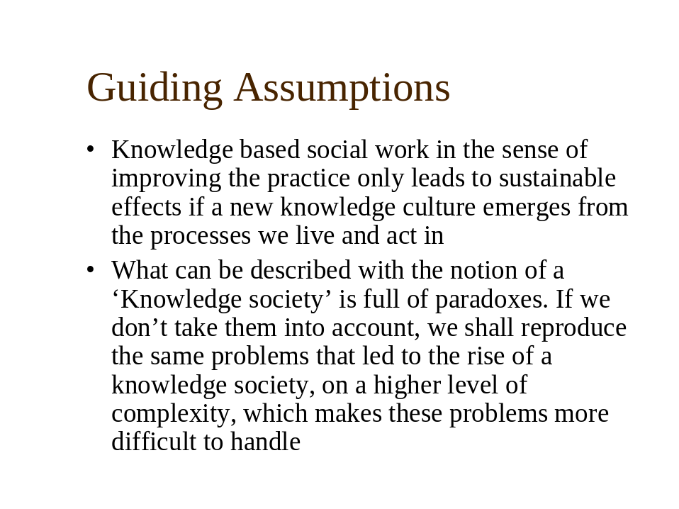
Figure 1: Guiding Assumptions

The societal development as a background for the understanding of the rise of the concept of knowledge/evidence based social work

Primary Modernisation, functional Differentiation, Risik Society, Reflexive Modernisation
Our societies are marked by a process, different authors (see Beck, Giddens & Lasch 1996) call “modernisation”. In the very essence modernisation means rationalisation of both production and reproduction (Schroeder 1998, Weber 1996). And this means that knowledge plays a prominent role in these modern societies. Knowledge (and knowledge production) even can be thought of as one of the central driving forces in modernisation. Another main characteristic of modern societies can be best described with Niklas Luhmann: the “functional differentiation” as the dominant mode of (self-)organising society (Luhmann 1977; Luhmann 1997). Functional differentiation means in short, that around the most relevant functions for the reproduction of society and the people as well, “functional systems” emerge. For example the systems of economics, politics, law or social work emerge. Emergence is an important notion because the functional systems in Luhmanns view are self-organising or as he calls it, they are “autopoietic systems”. Autopoietic systems are systems that build themselves out of themselves. This means that autopoietic systems are closed systems that work along their own regulations and their own rationality, along some basic operations. This last definition of functional systems as closed systems is very important for the later parts of my argumentation and has in so far to be kept in mind.
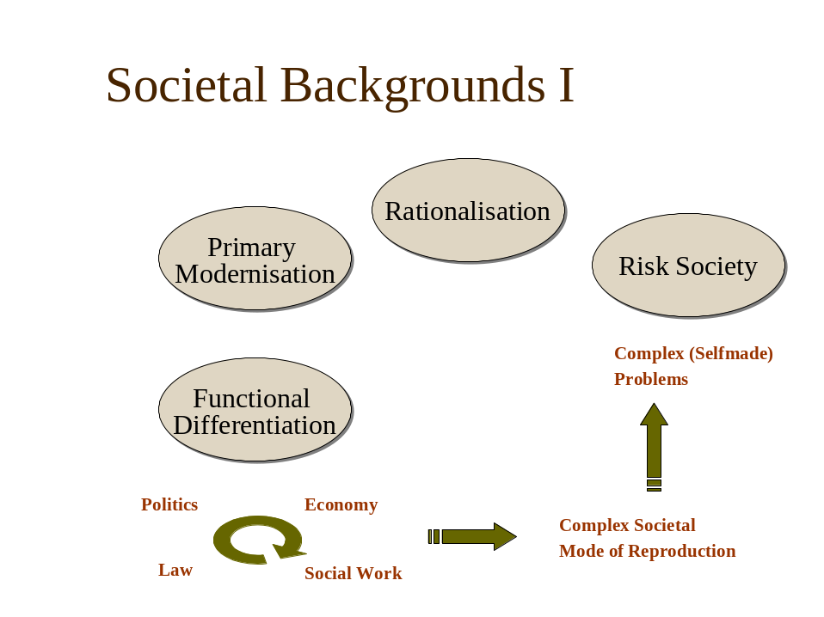
Figure 2: Societal Backgrounds I
It is very easy to observe that this kind of societal structure is a very dynamic but also a quite complex mode of organising society, because every functional system builds up a complex structure to be able to challenge environmental conditions. All the other systems constitute a part of the environment of every system. By the evolution of modern society, or by the ongoing process of modernisation, the complexity of the systems in themselves as well as elements of the environment of the other systems enter in a dynamic self generating circle of production of ever more complexity. If we return to Beck at this point, we could assume that the complex way of organising societal processes creates more complex problems that the society as a whole is confronted with. Or in Becks terminology: this form of society is characterised by risks. This is the reason why he calls the stage in which modernisation has driven society “risk society” (Beck 1986). The society produces risks for its own reproduction as well as for the individuals. For example: The climate is affected by emissions that come from the production of goods and the consummation of petrol. There are important risks linked to this development, for the societies and for all living humans and future generations. For example the rising probability of destructive storms or floods and even worse the risk that there will be very difficult living conditions on this planet, if the ozone completely disappears. And the possibilities of solving the problem are very small because of the complexity of the natural processes involved and because any intervention only has a chance to succeed only if it is globally coordinated and between different functional systems (i.e. politics and economics al least). Poverty is another example of this kind. Functional differentiated societies produce an enormous amount of inequalities. And because they destroy traditional forms of human reproduction (family, clan, traditional forms of exchange and stability), they cause systematically poverty with the tendency towards growth. This poverty is a risk for the reproduction of whole societies and even for the functional differentiation as the dominant form. Poverty is the destiny and the unchangeable reality for a big and growing part of the global population and it threatens most of the people as a risk, that is more or less probable (Argentina for one example, parts of the middle class in Europe and US). The problems linked to poverty are immense and various. There are a lot of interventions (for example: there are hundreds of pages describing the programs only the European Commission has launched, http://europa.eu.int/scadplus ). In the perspective of systems theory, the whole system of social work has emerged because of the relevance of poverty related problems for the society (with all the cultural differences between our nations). But a solution of the problem of poverty is almost unthinkable because of the complexity of the processes involved which are the societal processes as a whole.

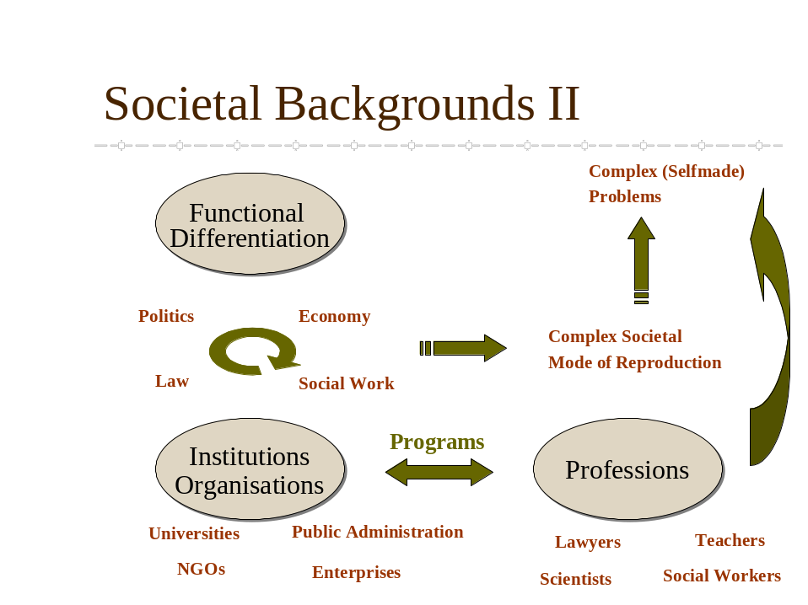
Figure 3: Societal Backgrounds II

So the mode of the modernisation of the society in itself and the functional differentiation related to it creates a risk society. There is a further point that has to be shortly mentioned: The functional systems reproduce themselves as communication, if we follow Luhmann. This communication takes place in most of the cases in organisations. We can observe historically the emergence of special and specialised organisations inside the functional systems. For example: universities, public administrations, NGOs or enterprises. And another speciality of modern societies has to be mentioned: the professions. Functional systems are systems that build themselves around the tasks and constructions that derive from the function, for example producing scientific knowledge inside the system of science. The concretisation takes place in organisations or at least organized forms of social acting (for example in a physicians cabinet). And the professions are a special social form of handling complex problems and tasks (Stichweh 2000) inside these organisations or as freelancers in relation to organisations. The structure of professional acting is, that it is always directed on a sort of crisis that can’t be resolved by some routinely exercised technologies nor can be standardised. And it is always directed on cases. And it is different from lay acting through the application of general and specialised knowledge and skills to these single cases (Oevermann 1996). For example the lawyer who interpretes the laws and preceding cases, makes a connection to his mandate and his special circumstances and takes this into a formalised procedure at court, where the crisis (of insecurity in terms of right) is solved in form of a decision (and may be sanctions). And by doing so, his communications (which include his acts in Luhmanns theory) are part of the system of rights, that operates on the difference between what is right and what is not right. Or the physician creates his case by means of diagnosis and anamnesis, which is a process of creating a relation between observations (of symptoms) and the physical, biochemical, physiological, psychological and even sociological knowledge, he has access to. The crisis (of illness) is solved by constructions about the causes of the symptoms and related therapeutical means and finally by intervention. And by doing so, his communications are part of the reproduction of the health system which operates on the difference between what contributes to healing or not.
In short: inside the functional systems emerge organisations. They develop specialised programs that are designed to resolve the tasks and problems or some of them that are connected to the functional system they belong to. And in some of these organisations there are professions acting in a special way, as described above. And now there is a peculiar effect out of this. By developing the professional knowledge and means, and this includes often more differentiated constructions about reality, i.e. better instruments for observation, the more problems get into the scope of observation and the more complexity of these problems comes into conscience. For example the problem of ozone in the atmosphere wouldn’t be a problem for us if we hadn’t the instruments to observe this problem and the knowledge to think about the consequences. With the growing knowledge we have systematically linked a paradoxical process that the problems get more complex just by the way of construction and amelioration of observation methods. And there are of course processes built into modernisation that create “real” problems with grater complexity, as the example of the ozone makes clear.
So not only modernisation creates more problems and more complex ones, but by the way of searching for solutions we create more complex knowledge that brings the complexity of the problems to our minds. This is a part of what is meant with “reflexive modernisation” (Beck op.cit.). The institutions of the modern society, which are the main driving forces of modernisation, get under pressure, their success becomes their problem, because the never ending process of problem solving and problem creating rises critique and questions. In sum these processes create a fast turning circle of social change and a lack or a problem of legitimacy of the modern institutions (Heinze, Schmid & Strünck 1999).
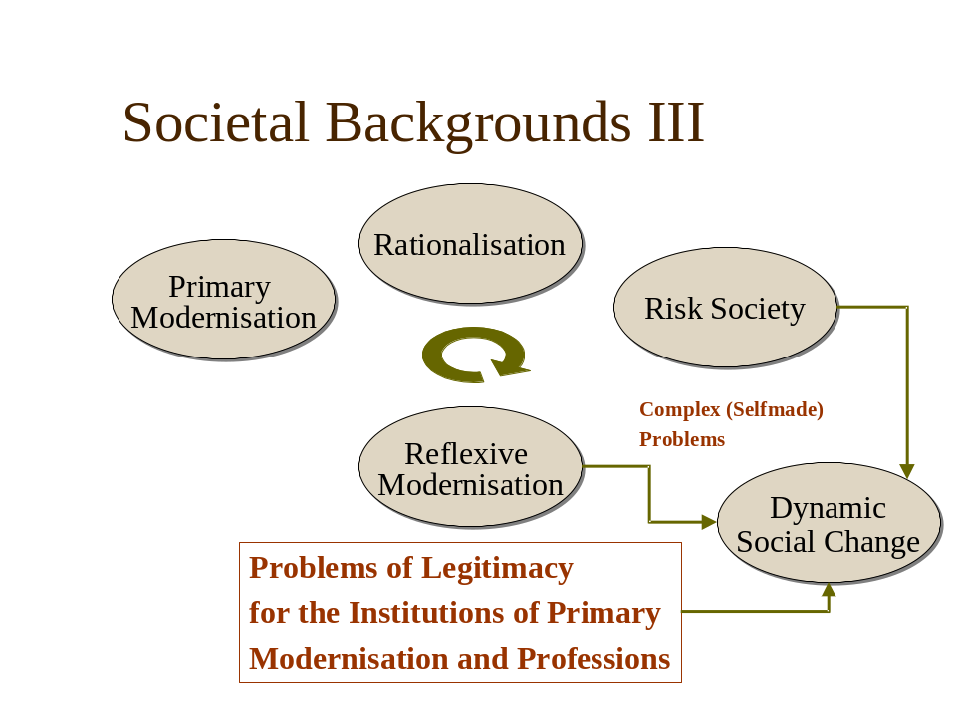
Figure 4: Socetial Backgrounds III
With the following arguments I want to put the focus on three parts of the social change related to the process of reflexive modernisation we live in: the rise of “knowledge society”, the changes of the political-administrative system and the consequences for the professions.

Knowledge Society: Societal valorisation of applied knowledge
The term „knowledge society“ marks a difference in regard of the role and the status of knowledge in the society. Knowledge has become, if we follow for example Stehr (Stehr 1994), the third major factor for the production of goods and problem solving in general, beside the traditional factors capital and labour. Knowledge makes the difference in modern production processes and creates profit on competitive markets. This is so because modern technologies are able to operate on a level of complexity unknown in former times. And this implies knowledge. Knowledge as one of the basic forces of modernisation has been even upgraded and highly valued by the processes of reflexive modernisation for the hope that the complex problems in general, that we have, might be solved by the means of knowledge production. The strategy, if a society can have strategies, is “more of the same”. And, once again, there is a transformation from a successful mode inside the technical and economic world (knowledge based production) to a generalised mode of problem solving (knowledge based social work etc). The upgrade of applied knowledge is, so my suggestion, directly linked to the complexity of the problems we face. Society needs solutions, and in so far problem solving knowledge is wanted. This leads to a change of the institutions that are traditionally concerned with knowledge production. Today it doesn’t matter where the problem solving knowledge is produced. The traditional universities and specially the basic sciences feel the pressure. And at the same time there a new forms of knowledge production (see Gibbons, Limoges, Nowotny, Schwartzman, Scott & Trow 1994), forms that are fluid, short term orientated, cooperative, local. These forms are based on the principle to bring together different people (specialists from different professions as well as stakeholders (politicians, citizens, clients and so on) to create directly applicable problem solving knowledge by recombination of the different knowledge horizons of the different actors.
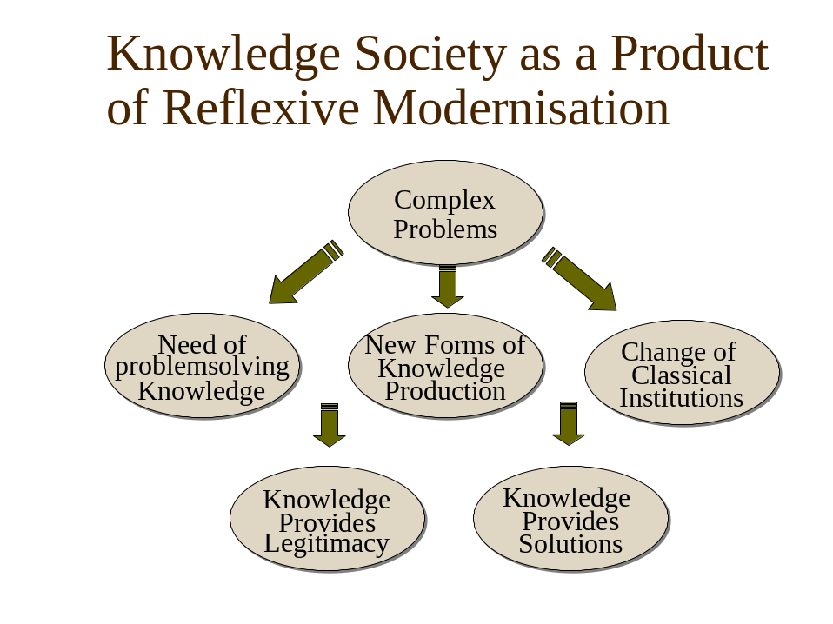
Figure 5: Knowledge Society as aProduct of Reflexive Modernisation
And there is another characteristic point about the knowledge society. The upgrade and the associated and attributed value of problem solving knowledge leads to the phenomenon that knowledge becomes a major source of legitimacy. To be modern in times of reflexive modernisation means to demonstrate ones capability to produce solutions or at least to apply knowledge in the intention to solve problems. It is not absolutely necessary to really solve the problems. If you can convince that you are heading for solutions by the means of knowledge and knowledge production, if you seem to have things under control, you can load legitimacy. It is somehow like a captain in a storm. Nothing would be worse than the feeling that the situation runs out of the scope of control, as far as the knowledge and the skills (the competence) of the captain are concerned. Therefore it is important to demonstrate competence and steering in heavy weather might just consist in making people run, even in the case that the captain knows, that there is nothing left to do.
What ever all the implications of knowledge society may be: For those who have a professional view of Social Work, the knowledge society and the added value to knowledge is a very big chance. Knowledge and evidence based social work (and professional structures which refer to knowledge) never had better chances to be implemented, because the societal environment of the system of Social Work demands evidence and the use of knowledge. And the applied sciences inside the social sciences get more attention and this leads to a growth of research capacities for the discipline of Social Work. The crucial question for the discipline is, what can we make out of this opportunity. The crucial question for the practice is whether it will be sufficient to make the appearance of competence or whether a real improvement of problem solving capacities will generate the legitimacy Social Work as a functional system needs as well as every single organisation and actor in it. The later is the goal of our network, I suppose. But this would need, referring to my first assumption, a change of the knowledge culture in social work practice. And this change depends primarily upon what happens inside the (closed) system of Social Work.
Anyway, the most significant environment for Social Work is the political-administrative system. The political system is also one of the prominent systems of modernisation and as the others is immediately related to the processes of reflexive modernisation.

Crisis of Legitimacy of the state as an example of reflexive Modernisation
A very direct consequence of reflexive modernization is, that legitimacy becomes a rare resource. Legitimacy no longer (as in the times of primary modernization) can be obtained by reference to “progress” or whatever political ideology or just by being an important institution of modernization like the university for example. Today every organization in every functional system has to seek for legitimacy (and knowledge or problem solving competence is one major way to be successful in this endeavor). As I said, all systems are concerned by the lack of and the search for legitimacy, but for the political system legitimacy is the major fuel for its reproduction. The political system runs by the basic operation to get power. And in democratic (functional differentiated) societies legitimacy is necessary to get and stay in power. The trustworthiness of the political leaders (see Sennett 1994) depend on legitimacy. And, trustworthiness as well as legitimacy of the political leaders today depend on whether they seem competent to get the problems solved or at least seem to steer (remind the captain). Tony Blair is a good example for this.
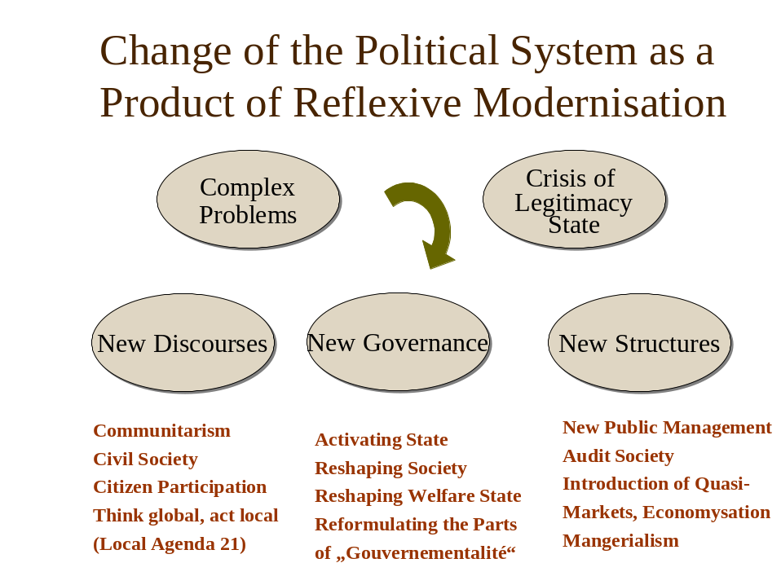
Figure 6: Change of the Political System as a Product of Reflexive Modernisation
The political system has to produce answers or solutions to the complex problems modern societies have created and face today. Problem solving would be the best way to get legitimacy. But most of the complex problems that have to be solved, like unemployment or the change of the climate or global poverty for example can’t be solved in the short periods of time the leaders today have before their legitimacy is measured at the poll. So new answers (as a way to demonstrate competence in heavy weather) will do, and the new answers Blair or Schröder for example pronounce, can be classified under one label: modernization. So knowledge society and the modernization, the political system promotes, is just more of the same. But it is not completely the same, because of the need to produce legitimacy and this means, once again, to make the appearance of being competent in steering in heavy weather. But how can you show your competence in steering, if the systems are closed and this means that they are completely autonomous. They are linked together (“strukturelle Kopplung” Luhmann 1984; Schimank 1998), but they can’t directly by controlled or steered by another system. They control and steer themselves, if steering is the right expression in terms of autopoietic systems, that means self-organizing systems.
Anyway, what we can observe and put into this framework, I just developed, I’d like to summarize under three main topics: “new discourses” (for example: Perlas 2000; Wendt 1996), “new governance” (for example: Löffler 2001; Grunwald 2001; Heinze, Schmid & Strünck 1999) and “new structures” (for example: Damkowski 1995; Muetzelfeld 2000). I have listed some examples of what I mean by this in the picture below. I will not say much about these examples. We all know about these concepts. The point I want to underline can be best understood with the help of Michel Foucault and his notion of “gouvernementalité” (Foucault 2000). Foucault’s concern was, again in very short terms, to understand how power leads to the possibility of getting control over social processes, over autonomous actors, which led him to his studies about disciplinization (see Faubion 2000). Foucault was occupied by the question of how “govern” can work, or how power can be realized. How can you make someone do what you want him to do. In his notion of “gouvernementalité” he reflects on the contradiction of government and souveranity, or of leadership and autonomy, how I would call it. Or once again: How can you govern autonomous entities or how can the political system steer closed functional systems? There is a very large apparatus needed, that I will not expose here. The point Foucault gets to, and that is interesting me in this context, is that you have to develop or to create a “mentality” inside the autonomous entities that makes them act finally in the way you want them to act. And by the way of creating such a “mentality” you create a form of communication or acting that can be controlled in a specific way. Foucault developed these thoughts in the 70ies and he then came to the description of a possible form how the political system could gain power in the sense of governing other systems and this way is “economisation”, which means to measure social processes that are not economic processes with economic measures. With the new discourses that strengthen in a way the status of a citizen by taking him into responsibility, Government can get paradoxically more power to direct the activities of the citizens. One of the main points of new governance is to create a new mentality in regard of the relation between government and citizens. And finally the new structures are nothing more than an “economisation” of the social processes inside the administration and in the relations between the administration and every other system that depends on public funding: science, education, health, social work.
Because there is the underlying process of seeking legitimacy, the political system can’t implement such a transformation without legitimacy. There are two main trails to get this. The first is the implementation of the market ideology into processes where are no markets. The market in our culture has the image to be the most efficient and the most effective mode of functioning, so this seems to be a good thing in regard of the complex problems to be solved. Once the quasi markets introduced into the systems of science, education, health and social work, the state gets a quasi monopole on the side of the buyer of services (because the students, patients and clients or in general the consumers don’t pay for all of the costs). This gives a lot of power back to the political-administrative system, but power of the state in terms of reflexive modernization is suspect. So the government and the administration not only have to demonstrate that they are steering well in heavy weather (or even better, to produce solutions) but they have to show that they don’t abuse the power they have. This is where the second trail comes into sight: Quality or better quality discourses. The administration in order to perform its power that derives from the introduction of quasi-markets into the functional systems has to show that all this is made in the intention of solving complex problems and steering means that the administration in respect of its financial and societal responsibilities buys only good services and therefore needs evidence. So knowledge or evidence production has the double and paradox function of producing legitimacy for the political system and knowledge based solutions at the same time. If the measures are done in an economic rationality (for example controlling), the effect of the generated evidence is disciplinisation because there is a pressure on the processes inside the systems and new ”mentality” or a new rationality of regulation, a new structuring of the social processes is implemented.

Consequences for the professions: from trust to accountability/
In the following two chapters I want to demonstrate that the change I described above, really has taken place.
Some of the functional systems were monopolised by professions. That means that the one function (for example “healing” in the system of health) has been dominantly realized by one profession. So these functional systems were professionalised systems (education, health, social work eventually, science) in primary modernisation (Stichweh op. cit.). The monopoly was built by specialised knowledge and this means specialised education and training and the mode of self control. The mode of communication between the professions inside the functional systems and the society in their environment was “trust”. Today we have a different setting. The professions are confronted with external observation and control. And this goes sometimes so far that other professionals (managers to be short) who represent another rationality (the economic rationality, sometimes the rationality of law) are placed inside the organisations. So the mode of communication between the professionals inside and the environment has changed to “accountability”, which is an economic concept and which creates the possibility for an external control. I don’t want to say more about this theme. It is a broad consensus in the sociology of professions (Aldridge 1996; Hanlon 1999; Evetts 2001) and can be followed there.
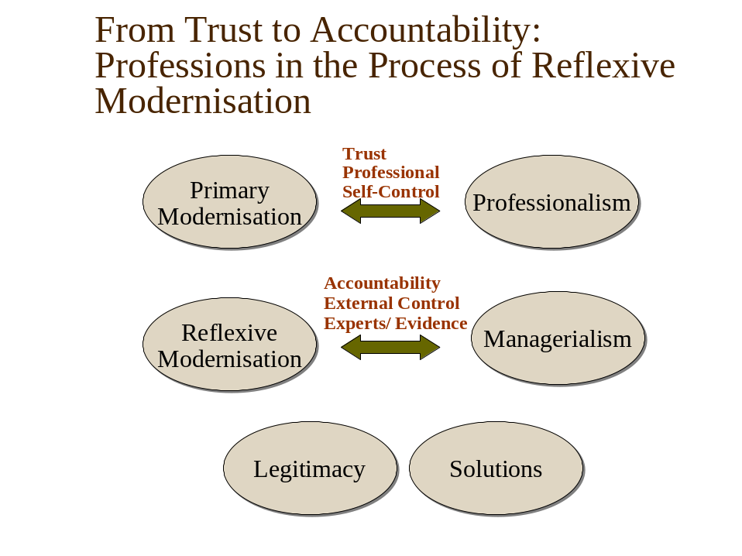
Figure 7: From Trust to Accountability: Professions in the process of Reflexive Modernisation
But I want to put some emphasis on the fact that here again the processes are building a self-generating dynamic that is basically structured by the “contradictory unit” (“widersprüchliche Einheit”, vgl. Oevermann op. cit.) of legitimacy and problem solving. The external control can on a long run maintain the legitimate power only if there are solutions. And this is why the economic rationality as well as measurements only in this rationality are not enough. This is why evaluation research, peer review and audits by peers in the meantime are broadly implemented. This is why a professional knowledge and evidence is systematically needed. But it is a contradictory or paradox structuring and this means we face another round of dynamic social change and the outcome of this process is necessarily open. And the outcome of this process or better of these thousands of processes under the same structuring can be observed among others in terms of what kind of knowledge is produced and for what purposes it is used.

Professionalism and Managerialism – results from a case study
When two different rationalities are structurally linked together, it is quite clear that cultural issues are to be dealt with. I want to show this and some of the consequences for our purposes, i.e. for the promotion of a knowledge based social work in a professional sense, I suppose, and not in disciplining or controlling way.
Once again I want to be short. The figures 8 and 9 show a typology we reconstructed in a research project we finished this summer. The research context: Our study (that I did together with Dieter Haller) was a part of a larger evaluation. Our task was to look at the organisational culture and the supposed cultural changes. This social work organisation that works in the field of non-stationary work on illegal drug abuse was one of the first in Switzerland to implement the philosophy and the tools of new public management. The data base were 19 Interviews with mangers and team members, all of them being qualified professionals of social work with one exception. We worked with the Grounded Theory Approach (Strauss 1994; Strauss & Corbin 1990) And to be methodologically straight, our findings are not completely saturized (“gesättigt”). This means the typology as we developed it is “grounded” but there is a possibility that there are more types than we could observe.
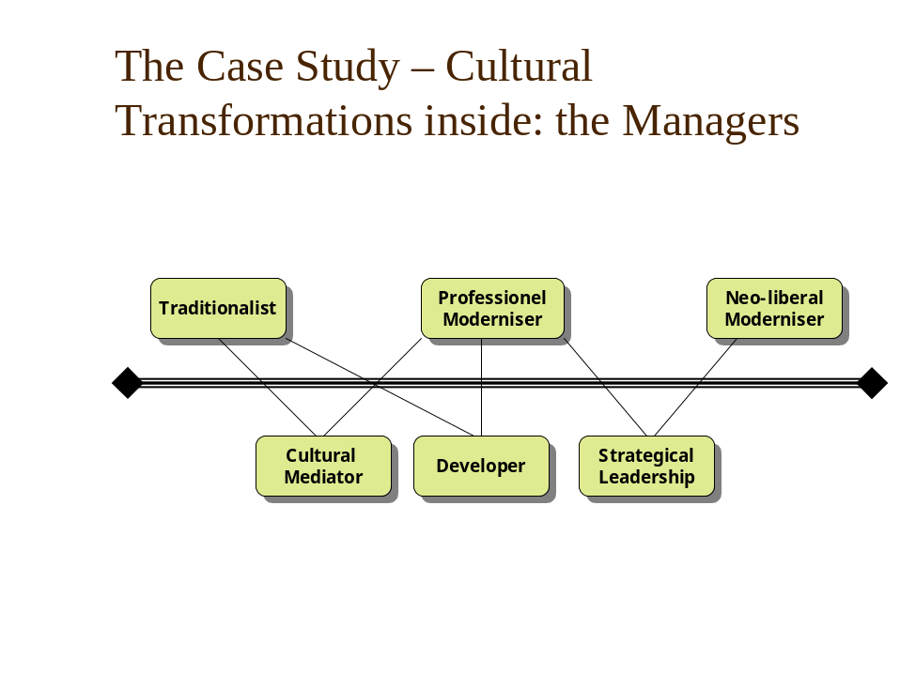
Figure 8: The Case Study – Cultural Transformations inside: the Managers
The labels of the types are almost self explaining. It is not necessary, I think, to explain all the details of the different types (see Sommerfeld & Haller 2003). In the concrete system, materialised in these types, we can observe the individual interpretations of the paradox structuring between the professional and the economic rationality or between Managerialism and Professionalism. But all of them, the “traditionalist” as well as the “neo-liberal moderniser” have both rationalities on their mind. They just have different constructions of what is needed to create good conditions for the professional acting. The main difference between the “traditionalist” and the “neo-liberal moderniser” is how they conceive the way to get good professional performance: The traditinalist ceonception relies on colleaguiality, the neo-liberal on control.
Apart that we have the very interesting type of the “professional moderniser”. This type together with its sub-types of “cultural mediator” and “developer” (of new projects) is strongly oriented towards strengthening the professional capacity in problem solving and to use the managerial tools and knowledge primarily in this sense, secondarily in the sense of getting legitimacy by the means of accountability and this means to get the necessary resources. And they are very successful at least in the last point. This type is sensible for scientific knowledge production as a necessary resource for developing the problem solving capacities of the organisation and the single professionals. But the problem is, that this type has difficulties in realizing his orientation. Why this is so, I’ll explain by roughly describing the social dynamics they are in. But before we can do this, I have to say some words on the complementary side, the side of the team members.
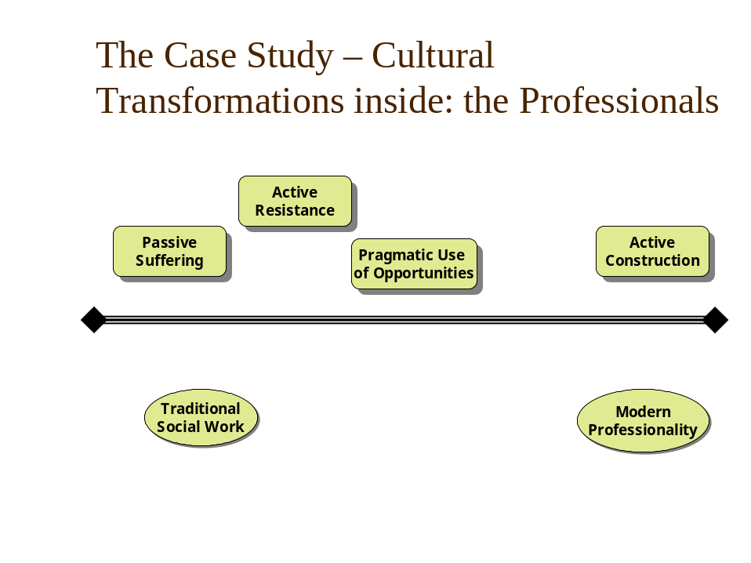
Figure 9: The Case Study – Cultural Transformations inside: the Professionals
On the level of the team members we have “suffering” of the processes of change, we have “active” and professional “resistance”, we have pragmatic adaptation and we have a minority of “active construction” of a new professional way. It is quite obvious that Professionalism here is a somehow defensive concept, a concept that has to be defended against the new developments and the cultural change coming on with these developments. Only “active resistance” and “active construction” are types that refer to a knowledge based professional conception. The others use the term “professional” as a metaphor of the old culture, that is useful in the sense that they still want to create legitimacy by the institutional concept of a profession and by the mode of communication by “trust” but without filling their conceptions and their acting with a professional (and this means among others open and reflexive) “habitus” (see Bourdieu 1989), which would include by the way a clear communication of what they are doing.
The interesting point is the social dynamic which is in sum the cultural dynamic inside this organisation. And to get straight to the point: The cultural dynamic is a direct transformation of makrostructural processes into microstructural processes. With other words: Foucaults theory about how to gain control over the processes in a closed and autonomous system can be observed in this reconstruction.
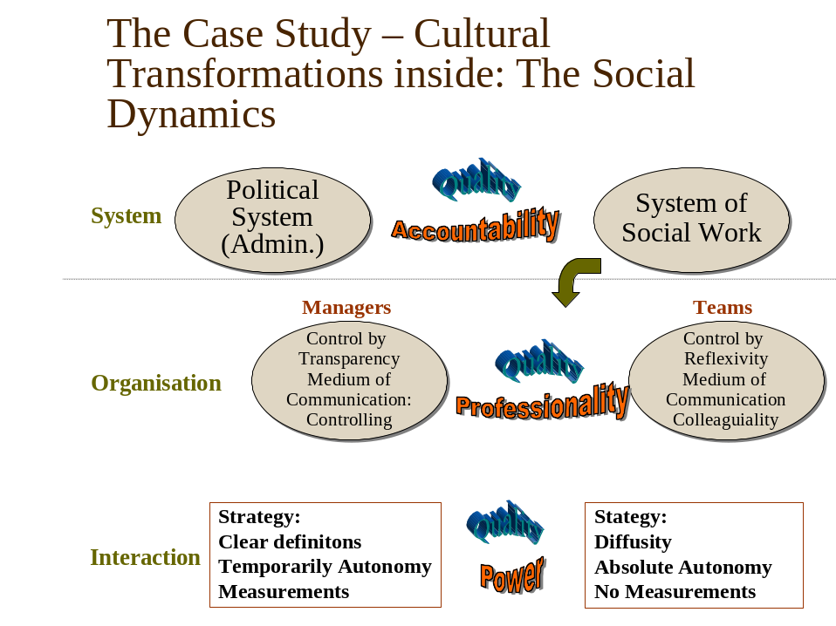
Figure 10: The Case Study – Cultural Transformations inside: The Social Dynamics
What is symbolised in figure 10 are the different system levels and the different media of communication between parts of these system levels. The political system in relation to the system of social work uses accountability to get control and turns this into a discourse of quality (see in an abstract description Bauer 1996). This is transformed into a struggle between the managers of the organisation and the members of the professional teams. The struggle is a struggle about the organisational culture and the mode of control. It is a struggle between Managerialism and Professionalism as a representation of an economic and a professional rationality. What is intriguing me, is that the managers or at least a part of them are oriented in a very distinctive professional way and even much more than the social workers at the front themselves. And once again quality serves as a metaphor both sides are reclaiming for themselves. Finally the reconstruction of the level of concrete interaction reveals that the power that is executed by the political-administrative system on the macro level reappears on the micro level. And the processes are finally not shaped to sustain quality. The managers make a use of the management tools to obtain transparency which is in a professional rationality a good thing, because it is necessary if you really want to exercise reflexive self control. But in the economic rationality the measurements are thought to be used as instruments of control. And the mangers by the way of following the economic rationality conceive themselves responsible for the quality of the professional service. On the other side (of the team members) we found the strategy to be as diffuse as possible, to fight against any kind of measurement and if measurement is not possible to avoid then the data is not necessarily related back to their praxis.
In short there is a struggle for power between the management and the team members in which transparency/intransparency is one major source of power. This is in its consequence deeply anti-professional even if the struggle is motivated to defend professionalism. This leads to a blockage of energy in many regards. The danger is great that the fight escalates. Then the managers would probably use more control measures and the team members would use new ways to neglect what they are doing. What we can observe here is a transformation of the processes between functional system to the very concrete level of interaction and an empirical demonstration of what Foucault meant by “gouvernementalité”.
On the other side there seems to be evidence that there could be a potential for a cultural change, in the sense of a new knowledge culture which is synonymous for me with a modern professionalism (that means trusted self control, but on a higher level of transparency, with reflexive means of control (to be developed), and by this better accountability) .Our study could give some indications about how this cultural change could be promoted. For example: we have to identify those persons who are “developers” and “cultural mediators” for example. We have to cooperate with people with an “active construction” attitude. But we have also to try to get a professional dialogue with those with an orientation towards “active resistance”, because they have a professional attitude and the new knowledge culture should be attractive for them.

Knowledge based social work in this context
What does this all mean for our idea of a knowledge based social work? First of all, I think, that we have the responsibility to think from time to time what is the use, made of our research activities. If we want that our findings are used in a professional way, we have to face the problems that are caused be the paradoxes due to the economisation of social work organisations. The case study shows that evidence might lead to a fight for transparency/intransparency. Learning by referring to knowledge, in respect of the amelioration of the problem solving capacities, which is the sense of producing knowledge in my view, can’t take place in such a social dynamics that is systematically produced by the logic of accountability and a culture of professionalism that has run out of time. Learning processes seem to need much more time and energy than the measurement of some outcome indicators. Really applied knowledge needs a different knowledge culture.
Now we have to get back to the societal framework I exposed above. What we saw on the level of one organisation is the paradox (“widersprüchliche Einheit”, contradictory unit) of legitimacy and problem solving. Out of this emerges another paradox, deriving from the reflexive modernisation process: The contradiction of internal and external control. Paradoxes of this kind can’t be resolved by taking the one or the other pole. And I think, this is what is reflected in the historical process we live in. Professionalism stands for the pole of problem solving. But the old form of professionalism, has proved weaknesses (stagnation, power to neglect inefficient modes of functioning etc.). Managerialism stands for the pole of economic rationality, strengthening efficiency (eventually) and (measurement of) outcome. This leads to more dynamics in the field, but there are difficulties not only in measurement, but may be in an inadequate dynamic of the necessary processes to produce the outcome in the sense of problem solution (this is at least what could be drawn from our little case study). There are other weaknesses of Managerialism. For example it is very probable that the efficiency has not been improved (Mäder 2001) and that the amount of work, necessary for satisfaction of managerial needs, only has led to more intensity of the individual performance, which in itself is another part of “gouvernementalité” and leads to greater “discipline”.
Anyway, may be it could be a good idea to lay back and think it all over: What was the initial idea to introduce professionalism as a mode of autonomous control. If we follow Ulrich Oevermann at this point, it is the structure of professional acting itself: There is a need for autonomous control because professions handle different sorts of crisis, and doing so, they have to apply general knowledge to a single case. And this single case is single, that means it is not possible to standardise the professional acting. The quality of the intervention is only observable by the process itself and relatively often the outcome is not directly related to the quality of the process of intervention, because of the complexity of involved parameters. For example, a perfect medical operation may not avoid the death of the patient, a perfect advocatory process may not lead to avoid a condemnation of the client even if he is not guilty, a perfect social work intervention may not lead to an improvement of the social living conditions of a client, even if this client is actively trying to work on a change.
If it is true, that the process of professional performance has a structure that is a single case structure, it will not be controllable by the rationality of economics – and our little case-study seems to point into this direction. Managerialism will not produce better outcome than the old way of professionalism because it reduces the complexity of a professional intervention and of the problems to be solved in a way that can’t produce adequate processes. Managerialism for the moment produces legitimacy, but on the long run it will fall under the procedures of reflexive modernisation as well. In my view knowledge production in a pure managerialist way just produces a lot of inadequate and finally useless data, that has only one sense and function: Producing legitimacy for the political system and the organisations of the professions in order to get the resources they need to reproduce themselves. If this is true, we would not have made any progress at all. We just would have exchanged the modes of producing legitimacy: from trust to accountability. But wasn’t the idea about quality? Wasn’t the idea to improve problem solving in order to make the world a better place?
The other thing we can take out of our little case study is, that seemingly it is possible to move between the poles of Professionalism and Managerialism. We reconstructed different types of leading that point into the direction of syntheses between the poles (professional monderniser). With other words they point into the direction of my final assumptions that I told you at the beginning. There has to emerge a new knowledge culture, that uses knowledge in the sense of professionalism and uses accountability in the sense of reflecting about the use of the means. In our case study it was the leaders who adopted such a perspective, and unfortunately not the professionals at the front. This is, as I showed, because of the transformation of the power related basics of the communication between the systems from the system level to the level of interaction. So even leaders with a professionalist view are in danger to get caught in the paradoxes that derive from what Foucault calls “gouvernementalité”.
So we are in some way also caught in the paradoxes of governance, above all if we go into a politically designed program as the EU framework program. This is why I exposed all this thinking: we have to be aware of the paradoxes we are in, or we will be caught. May be we are caught anyway, but I think we can choose at least the main orientation of our acting. And if it is true that Managerialism is not a sustainable development, it might be useful to have conceptions of what comes at the next level of modernisation.
David Jary (Jary 1998) sees a “third way” between the Professional self-control and the external “expert control” in a dialogic and research based syntheses. He calls this, using the notion of Giddens, an “utopian realist potential for dialogic reflexivity and empowerment”, with the potential to regain trust for the professions, but on a higher level of reflexivity and transparency: Knowledge or evidence based. I think indeed, that the only way to develop better solutions, is to concentrate on these dialogic and learning oriented forms of cooperation, cooperation between the professionals and the researchers in a friendly and trustful way. Control will lead to fight, not to learning. And if we make this choice, we have to be clear about the extension of the processes we have to go through. It is not done when we have done our research work. Then the development process starts and this is not possible without having the resources for this kind of work. We need more resources to do this kind of work. May be if we could make a use of the resources that are spent on all this control stuff that has been built up the last years, we could create some convincing and sustainable innovations in problem solving.
This syntheses of Managerialism and Professionalism Jary thinks about in terms of “utopian realist” way seems to need a change in the mode of knowledge production and transfer. Knowledge society has led to the emergence of new forms of knowledge productions (Gibbons et al. op. cit.). These new forms exist, they are not an utopia. I think we can learn from these new forms when we think about what is needed to advance in the production of knowledge production and problem solving: We need more complex ways of knowledge production. I applied some characteristics of these new forms of knowledge production to the mode of knowledge production in universities some years ago (Sommerfeld 2000; Sommerfeld 1996) I think that we have to move from a hierarchical model of knowledge production and transfer (with the construction that knowledge is produced in the basic sciences, a little bit transformed and transferred by the applied sciences and finally applied by the practice) to a heterarchical or cooperative model. The basic idea of this model that you can see in figure 11 is, that it is possible to create joint problem solving settings where the different knowledge horizons of science and practice merge in a cooperative way. As I said, there are a lot of similar endeavors in the technical sciences. Another basic epistemological idea of this model is, that the actors of the joint problem solving setting continue to refine the findings in their own system, the system of science for the ones, the system of practice for the others.
With this model there is a big but still utopian chance to get major innovations in terms of problem solving and a clearly shaped social work “technology”. This model could give us a common ground in the struggle for legitimacy, for the research in social work as well as for the practice of social work. This model, you may see this potential, can enable us to overcome the restrictions of traditional Professionalism and Managerialism by diminishing the gap between theory and practice. And by creating an evidence and knowledge based transparency, which is open to professional reflexivity, instead of a managerial transparency which is too much loaded with the power aspect.

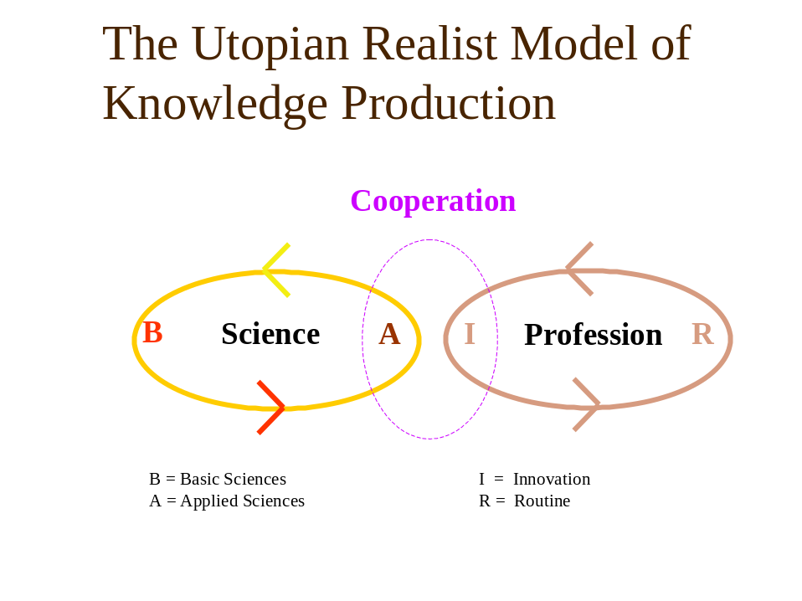
Figure 11: The Utopian Realist Model of Knowledge Production

What has this to do with the IMQUISO paper?
Imquiso could be a chance to work together over a longer period internationally. We would be free to work on the common ground of the model I suggested if we want to do so. We could experience and, if it is a successful way, promote this idea of cooperative research based development of social work practice. If we were successful we could demonstrate the possibilities related to a new knowledge culture and to improve the problem solving programs we have. Possibly we could reach some good new practice projects and create evidence, that this approach really creates quality and knowledge based social work on the long run. This is what I would like to do in the near future, and not just produce legitimacy for what purpose ever.

References

Aldridge, M. (1996): Dragged to Market: Being a Profession in the Postmodern World. In: British Journal of Social Work, 26, S. 177-194
Bauer, R. (1996): "Hier geht es um Menschen, dort um Gegenstände". Über Dienstleistungen, Qualität und Qualitätssicherung. Zur Begriffssystematik und zur politisch-ökonomischen Erklärung der gegenwärtigen Entwicklungslinien Sozialer Dienstleistungen in der Bundesrepublik. In: WIDERSPRÜCHE, Heft 61, S. 11-49
Beck, U. (1986): Risikogesellschaft. Auf dem Weg in eine andere Moderne. Frankfurt a.M.: Suhkamp
Beck, U., Giddens, A., Lasch, S. (1996): Reflexive Modernisierung: eine Kontroverse. Frankfurt a.M.: Suhrkamp
Bourdieu, P. (1989): Die feinen Unterschiede. Kritik der gesellschaftlichen Urteilskraft. Frankfurt a.M.: Suhrkamp
Damkowski, W. P., Claus (1995): Public Management: neuere Steuerungskonzepte für den öffentlichen Sektor. Stuttgart: Kohlhammer
Dent, M., O'Neill, M., Bagley, C. (Hg.) (1999): Professions, New Public Management and the European Welfare State. Stafford: Staffordshire University Press
Duncan, G., Worrall, J. (2000): Die Folgen neoliberaler Politik für die Soziale Arbeit in Neuseeland. In: Widersprüche, Heft 77, S. 29-44
Evetts, J. (2001): Professionalization and Professionalism: explaining professional performance initiatives. Konferenz "Professionelle Leistung", Zürich, 9.-10. Februar 2001
Faubion, J. D. (Hg.) (2000): Power/ Michel Foucault. New York: New Press
Foucault, M. (2000): Die Gouvernementalität. In: Bröckling, U., Krasmann, S., Lemke, T. (Hg.): Gouvernementalität der Gegenwart. Frankfurt a. M.: Suhrkamp. S. 41-67
Gibbons, M., Limoges, C., Nowotny, H., Schwartzman, S., Scott, P., Trow, M. (1994): The new production of knowledge. The dynamics of science and research in contemporary societies. London, Thousand Oaks, New Dehli: SAGE Publications
Grunwald, K. (2001): Neugestaltung der freien Wohlfahrtspflege. Management organisationalen Wandels und die Ziele der Sozialen Arbeit. Weinheim und München: Juventa
Hanlon, G. (1999): Lawyers, the State and the Market: Professionalism Revisited. Basingstoke: Macmillan
Heinze, R. G., Schmid, J., Strünck, C. (1999): Vom Wohlfahrtsstaat zum Wettbewerbsstaat: Arbeitsmarkt- und Sozialpolitik in den 90er Jahren. Opladen: Westdeutscher Verlag
Jary, D. (1998): The Implications of Audit society. In: Dent, M., O'Neill, M., Bagley, C. (Hg.): Professions, New Public Management and the European Welfare State. Staffordshire: University Press. S. 29-52
Löffler, E. (2001): Governance - die neue Generation von Staats- und Verwaltungsmodernisierung. In: Verwaltung und Management, 7. Jg., S. 212-215
Luhmann, N. (1977): Differentiation of Society. In: Canadian Journal of Sociology, 2, S. 29-53
Luhmann, N. (1984): Soziale Systeme. Frankfurt: Suhrkamp
Luhmann, N. (1997): Die Gesellschaft der Gesellschaft. Frankfurt a.M.: Suhrkamp
Mäder, C. (2001): Der moralische Kreuzzug des "New Public Management" in der Schweiz. In: sozialersinn, Heft 1/2001, S. 191-204
Muetzelfeld, M. (2000): Profession und Neues Management in den Sozialen Diensten. In: Widersprüche, Heft 77, S. 45-61
Oevermann, U. (1996): Theoretische Skizze einer revidierten Theorie professionalisierten Handelns. In: Combe, A., Helsper, W. (Hg.): Pädagogische Professionalität. Frankfurt a.M.: suhrkamp. S. 70-182
Perlas, N. (2000): Die Globalisierung gestalten: Zivilgesellschaft, Kulturkraft und Dreigliederung. Frankfurt a.M.: Info-3-Verlag
Schimank, U. (1998): Code - Leistungen - Funktion. In: Soziale Systeme, H. 1/98, S. 175-183
Schroeder, R. (Hg.) (1998): Max Weber, democracy and modernization. Basingstoke: Macmillan, New York: St. Martin's Press
Sennett, R. (1994): Verfall und Ende des öffentlichen Lebens. Die Tyrannei der Intimität. Frankfurt a.M.: Fischer Taschenbuch Verlag
Sommerfeld, P. (1996): Soziale Arbeit - Grundlagen und Perspektiven einer eigenständigen wissenschaftlichen Disziplin. In: Merten, R., Sommerfeld, P., Koditek, T. (Hg.): Sozialarbeitswissenschaft - Kontroversen und Perspektiven. Neuwied: Luchterhand. S. 21-54
Sommerfeld, P. (2000): Forschung und Entwicklung als Schnittstelle zwischen Disziplin und Profession. Neue Formen der Wissensproduktion und des Wissenstransfers. In: Homfeldt, H. G., Schulze-Krüdener, J. (Hg.): Wissen und Nichtwissen. Herausforderungen für Soziale Arbeit in der Wissensgesellschaft. Weinheim und München: Juventa. S. 221-236
Sommerfeld, P., Haller, D. (2003): Professionells Handeln und Organisation oder: Ist der Ritt auf dem Tiger möglich? In: erscheint in: Neue Praxis, S.
Stehr, N. (1994): Arbeit, Eigentum und Wissen: Zur Theorie von Wissensgesellschaften. Frankfurt a.M.: Suhrkamp
Stichweh, R. (2000): Professionen im System der modernen Gesellschaft. In: Merten, R. (Hg.): Systemtheorie Soziale Arbeit - Neue Ansätze und veränderte Perspektiven. Opladen: Leske + Budrich. S. S. 29 - 38
Strauss, A. L. (1994): Grundlagen qualitativer Sozialforschung. München: Fink
Strauss, A. L., Corbin, J. (1990): Basics of qualitative research: grounded theory procedures and techniques. Newbury Park: Sage
Weber, M. (1996): Die protestantische Ethik und der "Geist" des Kapitalismus. Bodenheim: Athenäum
Wendt, W. R. (1996): Zivilgesellschaft und soziales Handeln: bürgerschaftliches Engagement in eigenen und gemeinschaftlichen Belangen. Freiburg i.Br.: Lambertus
White, V. (2000): Profession und Management. Über Zwecke, Ziele und Mittel in der Sozialen Arbeit. In: Widersprüche, Heft 77, S. 9-27

