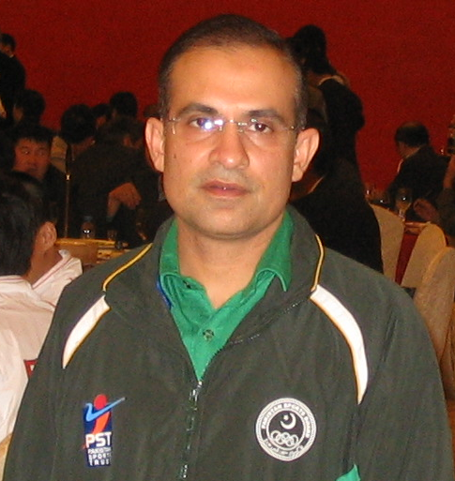
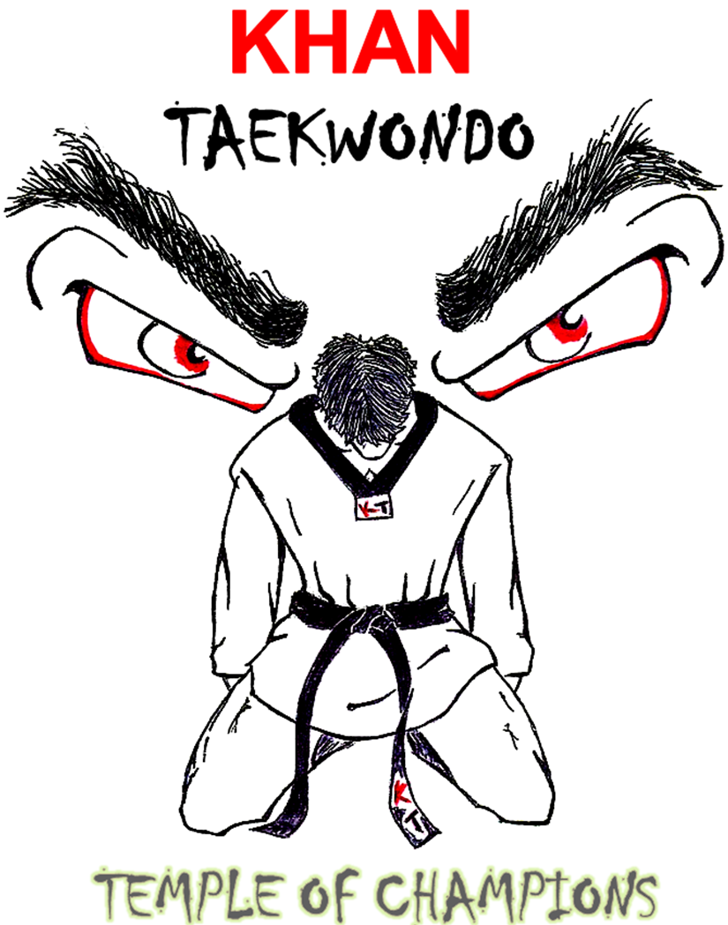
M. Sohail Ali Khan
International Gold Medalist
7 Dan Black Belt
khantaekwondo@yahoo.com
718-501-8695

I have been practicing Taekwondo for the last 23 years and received my Black Belt in 1988 by Master Koo Bong Kim, a 7th Degree Black Belt and ex-world champion. Over the years, I have competed in many countries, winning medals and the most rewarding title given to me in Iran was “The Golden Boy of Pakistan”. With the grace of GOD I won the first International medal and First International gold medal in Pakistan’s Taekwondo history. Recently accepted the position of First Official Head Coach in the history of Pakistan.

Coaching Experience:

2010 West Point University Taekwondo Championship, NY
University of Pennsylvania, PA
U.S. Open Taekwondo Championship, NV
NYS Taekwondo National Qualifier Championship, NY
Annual Friendship Taekwondo Championships, NJ

2009 Columbia University Taekwondo Championship, NY
Cornell University Taekwondo Championship, NY
Princeton University Championship, NY
Junior Olympics & U.S. National Championships
Director Technical Advisor for Pakistan Taekwondo Federation
Taekwondo Training Camp Karachi, Pakistan
Taekwondo Training Camp Islamabad, Pakistan
NYS Taekwondo Championship
Annual Friendship Taekwondo Championships, NJ
National and Junior Olympic Qualifier, NY

2008 17th Annual NY University Taekwondo Tournament, NY
11th Annual Friendship Taekwondo Championships, NJ
Grand Prix Taekwondo Championships, NJ
2008 Champions Open, NY
Taekwondo Training Camp Karachi, Pakistan
Taekwondo Training Camp Islamabad, Pakistan
USA Taekwondo National Qualifier, PA
The Taekwondo Association of Grater NY
Champion’s open, NY
Commission NY Sports Taekwondo
Junior Olympic, MI
NYS Taekwondo Championships

2007 Pakistan National Taekwondo Team Head Coach for Asian Olympic
Qualifying for 2008 Summer Olympics-Vietnam
18th Asian Taekwondo Championships-China
7th WTF World Junior Taekwondo Championships-Turkey
Member of Olympic Council of Asia
Member of U.S. Olympic Committee
Annual Friendship Taekwondo Championships, NJ
2007 New York State Taekwondo Championships, NY
2007 New Jersey State Taekwondo Championships, NJ
2007 Providence National Qualifier, RI
Grand Prix Taekwondo Championships, NJ

2006 New York Sate Taekwondo Championship, NY
New Jersey State Taekwondo Championship, NY

2005 New York State Taekwondo Championships, NY
Annual Friendship Taekwondo Championships, NY
2005 Master’s Cup, NY
1st EGUA Cup Taekwondo Invitational Tournament, NY
25th New Jersey State Taekwondo Championships, NY
NYSTC President Cup 2005, NY
11th Int’l. Battle of New York INCTL Collegiate Taekwondo Championships, NY
High Performance Summer Championship, NY
Gold Cup 2005, NY
Chung Ma’s Regional Taekwondo Championships, NY

2004 INCTL Collegiate Taekwondo Championships, NY
NJ States Taekwondo Championship, NJ
10th International Battle of New York Taekwondo Championship, NY
Gold Cup Taekwondo Championship, NY
Junior Olympics, FL

2003 1st Galaxy Taekwondo Warriors Championship, NY
Big Apple Taekwondo Championship, NY
INCTL Collegiate Taekwondo Championships, NY
Grand Prix Taekwondo Championship, NJ
National Qualifier, NY
New York State, NY

2002 U.S. Junior Olympics, TX
New Jersey State Taekwondo Championships, NJ
North-East Regional Taekwondo Championship, NY
J. W. Shus Taekwondo Championship, NY
Gold Cup Taekwondo Championship, NY
Governor Cup Taekwondo Championship, CT
Grand Prix Taekwondo Championship, NJ
Big Apple Taekwondo Championship, NY
INCTL Collegiate Taekwondo Championships, NY

2001 Int’l Battle of New York Taekwondo Championship, NY
INCTL Collegiate Taekwondo Championships, NY
Big Apple Taekwondo Championship, NY
Grand Prix Taekwondo Championship, NJ
Gold Cup Taekwondo Championship, NY

2000 U.S. Junior Olympics Texas, San Diego
Gold Cup Taekwondo Championships, NY
New Jersey State Taekwondo Championships, NJ
2nd Battle of In Wood, NY
Grand Prix Taekwondo Championship, NJ
Hwang’s 9th Invitational Taekwondo Championship, CT
INCTL Collegiate Taekwondo Championships, NY

1999 U.S. Junior Olympics Las Vegas, Nevada
New York State Taekwondo Championships, NY
INCTL Collegiate Taekwondo Championships,
Battle of Champions, CT
President’s Cup National Taekwondo Championships, CT
Governor’s Cup Taekwondo Championship, CT
Senior Nationals, Golden Seniors & Juniors Black Belts
Taekwondo Championships Daytona Beach, FL
US Taekwondo Instructional President Cup, CT

1998 22nd CT Taekwondo Championships & 17th Jr. TKD Championships, CT
13th Governor’s Cup, CT
Connecticut State Taekwondo Championships, Yale University, CT
Battle of Champions, CT
President’s Cup National Taekwondo Championships, CT

1997 US Cup Taekwondo Championships, CT
Battle of Champions, CT
Connecticut State Taekwondo Championships, CT
NJ State Championships, NJ
11th US Cup Taekwondo Championships, CT

1996 New York State Taekwondo Championships, NY
Second Annual Metropolitan Taekwondo Championship, NY

1995 President’s Cup National Taekwondo Championships, CT
U.S. Cup Taekwondo Championships, CT

1994 Future Olympians 2000 AD Jr. Taekwondo Championships, CT
Twentieth New York State Taekwondo Championships, Staten Island

1993 President’s Cup, National Taekwondo Championships, CT

If there are any questions or comments feel free to contact me either via e-mail: khantaekwondo@yahoo.com or cell phone (718)501-8695

