Oral Health
Evelyn Berger-Jenkins, MD

Learning Objectives:
- Recall normal pattern of primary and secondary tooth development
- Identify common non-tooth related pathology in the oral cavity
- Include screening for caries in well child care, and establish prevention strategies with parents
- Be aware of some of the evidence base around controversial oral health issues

Primary References:
- MAIN:
  - Website AAP Health Topics, Oral Health: www.aap.org/healthtopics/oralhealth.cfm
- OTHER:
  - Natal Teeth A Review: J Natl Med Assoc. 2006 Feb. 98(2):226-8
  - Delayed Tooth Eruption: Am J Orthod Dentofacial Orthop. 2004 Oct. 126(4):432-45
  - Fever & Teething: Archives of Disease in Childhood. 2007. 92:266
  - Ankyloglossia: J Paediatr Child Health 2005 May-Jun. 41(5-6):246-50
  - Fluoride content in various water sources: http://apps.nccd.cdc.gov/MWF/Index.asp

CASE ONE:
‘A’ is a 3-week old, ex-FT boy with no significant peri-natal complications. He comes today for his first well-child visit.

His mother had no complaints, but on exam you notice the following:

- What is this?
- A natal tooth

- What is the difference between natal and neonatal teeth?
- Natal if present at birth. Neonatal if develop shortly after birth. Natal teeth are more common than neonatal teeth by a ratio of 3:1
- Natal teeth:
- Incidence = 1/2000 births.
- Rarely associated with genetic syndrome:
  - Ellis van Creveld syndrome (or chondroectodermal dysplasia) is an autosomal recessive skeletal dysplasia characterized by short limbs, short ribs, postaxial polydactyly, dysplastic nails and teeth, and less often congenital heart malformation.
  - Hallermann-Streiff syndrome presents with bird-like facies with hypoplastic mandible and beaked nose, proportionate dwarfism, hypotrichosis, microphthalmia, and congenital cataract.
  - Jadassohn-Lewandowski syndrome is an autosomal disorder characterized natal teeth and epidermoid cysts.
- Majority (90%) of natal teeth are the normal primary teeth that have erupted early. If this is the case, and there is no risk of aspiration, there is nothing to do. If the tooth is supernumery (i.e. extra) it might affect growth of the normal primary teeth and should be removed. The only way to distinguish “normal” primary teeth from supernumery teeth is with an x-ray.
Sources:
- PEDIATRICS. 1963 Dec;32(6):1087-1093
- J Natl Med Assoc. 2006 Feb;98(2):226-8

CASE TWO:
‘B’ is A’s twin sister. She has no natal teeth, but mom is concerned about this other bump in her mouth:

- What do you tell mom about this bump?
- Epstein pearls are keratin-filled cystic lesions lined with stratified squamous epithelium, usually on the palate. They are completely benign.

- What are these other common bumps in the mouth?
- Mucocele – a painLESS, translucent or bluish lesion of traumatic origin, most often involving minor salivary glands of the lower lip. It may alternately enlarge and shrink. Treatment is surgical excision of the lesion and the salivary gland involved b/c otherwise it remains a chronic condition.

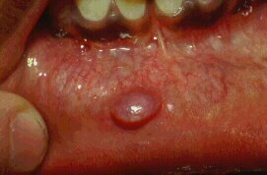

- Ranula – a retention cyst of the floor of the mouth that appears bluish and fluctuant. Simple I & D is not effective b/c it will recur. Therefore MARSUPIALIZATION by suturing the edges of the opened cyst wall to the mucous membrane is recommended.

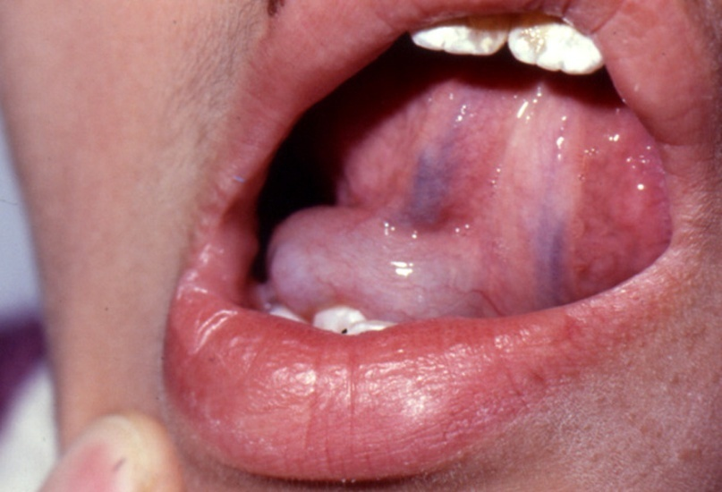

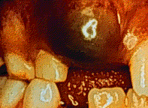
- Ranulae are not to be confused with eruption cysts or hematomas, which are fluid (or blood) filled swellings over the crown of an erupting tooth. These are usually non-tender. If they are tender they may be super-infected and if so should be incised and drained.

- Benign idiopathic apthous ulcers or canker sores present as painful open sores inside the mouth, caused by a break in the mucous membrane. They are more common in women, and often recur. The exact cause of aphthous ulcers is unknown, but they are not thought to be infectious. Factors that provoke them include stress, illness, injury from accidental biting, hormonal changes (menses) and food allergies. Treatment is supportive, though topical steroids have been shown to be effective if the ulcers do not resolve by 7 days and/or are extremely painful.
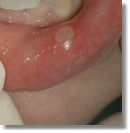

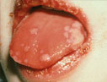
- Herpes gingivostomatitis is usually caused by a primary infection of the anterior third of the mouth with herpes simplex type 1. Herpes Labialis (Cold Sores) are caused by the reactivation or recurrence of the infection. Gingivostomatitis is painful and can be associated with avoidance of feeds and dehydration. Therefore, treatment involves pain management and oral rehydration until the ulcers resolve, usually by 7-10 days. Topical acyclovir is ineffective. Oral acyclovir may be given early on to decrease duration of illness, but is not necessary in immunocompetent hosts.

CASE THREE:

‘C’ is a 4 month-old girl who presents because her mother noticed “some white stuff on her tongue”.
1. What is your differential diagnosis?
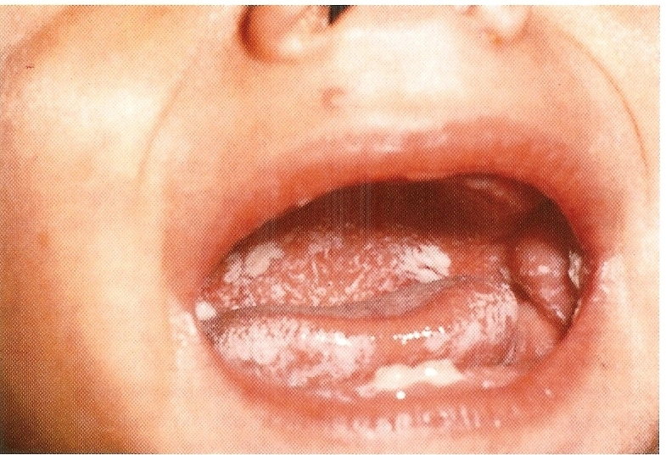
- Candidiasis (thrush) occurs when normal candidal flora overgrows due to diabetes, immunosuppression, antibiotics or simply due to a micro-biologically favorable environment for overgrowth. It presents with superficial curdy, gray-white membranes on the mucosa. It is differentiated from adherent milk/food by an “auspitz-like sign” or blood tinge when removed with a tongue blade.

- Geographic tongue aka benign migratory glossitis affects 1-2% of population. It tends to run in families and is more commonly found in atopic individuals. Some think that it may be linked to stress or diets high in sugar or processed foods. It presents as red flat areas that are due to denuding of the normal filliform papillae surrounded by white patches where the filliform papillae have remained. This process of denudation waxes and wanes hence the “migratory” appearance. Geographic tongue is usually asymptomatic. Individuals who experience persistent burning or pain may be referred to dermatology as treatments such as cyclosporine and zinc have proven effective.

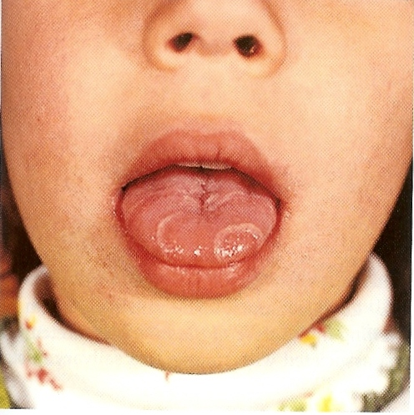

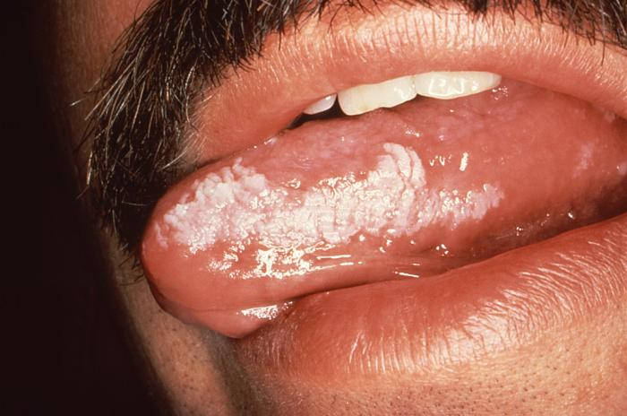
- Leukoplakia is the “general” term given to white inflammatory scale of the tongue. The cause in most cases is unknown, but many are related to tobacco use and chronic irritation, and a small proportion is associated with cancer of the mouth. Hairy leukoplakia (shown here on the lateral surface of the tongue) is associated with HIV infection and other diseases of severe immune deficiency.

CASE FOUR:
‘D’ is a 10 month-old healthy girl presenting for well-child care. Her father complains that she’s been taking less formula and wonders if it’s because she’s teething. She had eruption of her lower central incisors at 6 months. He asks you when she will get her two front teeth?

- What is the normal/expected progression of the primary teeth?
- 1st, lower central incisors
- 2nd, upper central incisors
- 3rd, lateral incisors (upper or lower)
- 4th, first pre-molars
- 5th, canines

- When do you consider tooth eruption to be delayed? And what are some causes of delayed tooth eruption?
- If there are no signs of primary tooth eruption by 6 months after the schedule above (essentially 18 months of age) the patient should be referred to a dentist for evaluation of delayed tooth eruption. Delayed or failed tooth eruption may be associated with;
- Local problems such as tumors (hemangiomas for example) impinging the tooth bud, ankylosis (abnormal attachment of the tooth to underlying skeleton), or head & neck irradiation
- Systemic problems:
    - Genetic syndromes like Down’s syndrome, ectodermal dysplasias
    - Endocrine disorders like hypothyroidism, hypoparathyroidism
    - Skeletal problems such as achondroplasia, osteopetrosis or rickets

Sources:
Am J Orthod Dentofacial Orthop. 2004 Oct;126(4):432-45

- Normal development of secondary (permanent) teeth starts with eruption of the first permanent molars at ~6 years of age and then progresses in an order similar to that of eruption of the primary teeth. The process continues for ~ 6 years.
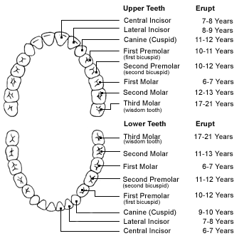
- 1st, lower central incisors
- 2nd, upper central incisors
- 3rd, lower lateral incisors
- 4th, upper lateral incisors
- 5th, lower canines (cuspids)
- 6th, First pre-molars (bicuspids)
- 7th, Second pre-molars

CASE FIVE:
E’ is an 18-month old boy with no significant past medical history. He presents with fever to 101.2 x 2 days. He had mild nasal congestion yesterday.

Mom asks if his fever could be due to teething?
1. Does teething cause fever?

- Slide 16 lists studies reviewed in a recent evidence-based medicine review in the Archives of Disease in Childhood (Tighe M et al. Archives of Disease in Childhood. 2007;92:266
- There were no controlled studies, three prospective studies and 1 retrospective study identified. Therefore, the majority of studies were of poor quality (i.e. retrospective, relied on subjective measurements of outcomes such as parent report, and lacked controls).
- The best methodologic study (prospective and with objective measurements of outcomes) by Wake et al revealed NO association between teething and fever.
- The two prospective studies that revealed an association between fever and teething relied heavily on parent report. However, they DID statistically confirm an association between increased temperature and the day of teething +/- 1 day compared to other days in the same children.
- Bottom line
- Infants with fever > 38.5, or with temperature 38-38.5 on days other than the day of tooth eruption +/- 1 day should be evaluated for other sources of fever.
- Those presenting with low-grade fever (< 38.5) during this window (day of tooth eruption +/- 1 day) may be monitored conservatively if well appearing.

CASE SIX:
‘F’ is a 2 year-old girl with mild speech delay. Her mother is concerned that her speech delay is due to her “tongue tie”.

What do you tell her?

- Ankyloglossia (from Greek “agkilos” for crooked, and “glossia” for tongue) or tongue-tie is restriction of tongue movement caused by a prominent lingual frenulum. The lingual frenulum normally recedes as a child grows and will continue to recede during the first 6 years of life. Therefore there is hesitation to attribute ultimate language delay to tongue-tie and subject children to what could be unnecessary and potentially risky procedures.
- Incidence ~ of tongue tie 3-5% with a male-to-female ratio of 3:1
- Complications?
- Breastfeeding difficulties:
  - In one prospective, controlled study (Arch Otolaryngol Head Neck Surg 2000 Jan;126(1):36-9) breastfeeding difficulties were self-reported by more mothers with tongue-tied infants (25%) compared to mothers without tongue tied infants (3%). BUT, the number who successfully breast-fed for at least two months was NOT significantly different between the two groups.
  - In one controlled trial (J Paediatr Child Health 2005 May-Jun;41(5-6):246-50) 57 infants with tongue-tie and feeding difficulties were randomized to frenuloplasty versus lactation consultation. 3% of those who received lactation consultation improved compared to 100% in the frenuloplasty group. However, “improvement” was by self-report, and there was obviously no blinding of the groups to the intervention.

- Speech/language problems:
- One cross sectional study of 200 children referred for tongue tie found that 27% had an articulation problem as measured by three separate speech pathologists. Measurements of frenulum length were done, and a dose relationship between frenulum length and articulation problems was found such that those with moderate to severely shortened frenula had articulation problems whereas those with mildly shortened frenula did not. (Oral diseases 2005;11:170-4)
- One prospective study of 30 children found that 82% of those with articulation problems improved (by speech pathologists report) after frenuloplasty. However this was not compared to a control group that did not undergo frenuloplasty. (Otolaryngology-Head and Neck Surgery 2002;127(5):539-45)
- REMEMBER that the lingual frenulum normally recedes as a child grows and will continue to recede during the first 6 years of life. There is no way to predict which children will have articulation problems early on. One prudent thing to do is measure the frenulum distance. If is it moderate or severe (shorter than 1.5 cm) they may have more articulation problems. Given the data however, there is good reason to observe conservatively, at least until the age of 6 years at which point a speech pathology evaluation may be prudent if parents are still concerned.

CASE SEVEN:
‘G’ is a healthy 3 year-old boy presenting for WCC. Mom has had trouble getting him to sleep throughout the night b/c he still wakes for his bottle.

On exam you are presented with the following: Slide 22

1. What are dental carries?
- Stages of dental carry formation:
- All of the images in Slide 22 present various stages of dental caries.
- The breakdown of enamel occurs slowly. The first signs are areas of demineralization that appear as white spots near the gum line (Upper left image), followed by yellow discoloration (Upper right image). Depending on many factors (including saliva, presence of fluoride, removal of plaque, and modification of the substrate (carbohydrate)), the lesion can become remineralized (Lower left image). Ideally, this is the time for a dentist to begin treatment. For small lesions, topical fluoride is sometimes used to encourage remineralization.
- If left untreated and early decay advances, a brown or black collar surrounds the tooth, progressing slowly toward the distal/chewing surface of the tooth. This will eventually lead to cavitation. (Lower right image)

- Epidemiology:
  - Dental caries is the most common chronic disease affecting children in the United States. It is 5 times more common than asthma and 7 times more common than hay fever.
  - The prevalence rate increases steadily with age. The frequency of caries in children is
• 18% in children aged 2 to 4 (It is especially common in < 3 year-olds due to the fact that primary teeth are thinner than permanent teeth, and teeth that erupt 1st are less protected by saliva)
• 52% in children aged 6 to 8
• 67% in children aged 12 to 17
- Prevalence rates vary by ethnicity as well as socioeconomic status. African American and Hispanic children have higher rates than Caucasians. American Indian/Alaska Native children have among the highest rates of caries. It is unclear whether genetics (predisposition to certain mouth flora) or SES (poorer access to hygienic practices or dentists) have more of an impact on caries.

- Pathogenesis: (Slide 24 Diagram)
  - In order to have dental caries one must have:
  - a susceptible tooth,
  - exposed to pathogenic flora. These pathogenic bacteria mostly consist of Strep mutans, which colonizes the mouth after eruption of teeth, not at birth. Colonization most commonly occurs after transmission from the mother’s mouth due to hand-to-mouth behaviors such as that depicted here.
  - in the presence of substrate (like fruit juices and candy as well as complex carbs). How often and how long a child is exposed to carbohydrate is important. Breastfeeding is not necessarily protective as it is a source of carbohydrate. Nighttime feeds tend to last longer and are factors in the pathogenesis of caries.
- Under the above conditions, the bacteria metabolizes substrate to form acid that decalcifies teeth.
- Plaque = carbohydrate substrate and bacteria stuck to the tooth before demineralization occurs

Source:
Website AAP Health Topics, Oral Health: www.aap.org/healthtopics/oralhealth.cfm

2. What is in the differential diagnosis of discolored teeth (besides carries)?
- The most common cause of extrinsic stains is poor oral hygiene. Other causes include;
  - Dyes in foods (coffees, teas, artificial coloring)
  - Tobacco and tar from cigarette smoke
  - Medications such as tetracyclines (become incorporated into the hydroxyapatite complex enamel), anticholinergics (decrease saliva which is protective of enamel).
  - Metals interact with dental plaque to produce surface stains. Iron can stain teeth black. Mercury and lead dust can cause a blue-green stain.
  - Trauma to developing teeth can disturb enamel formation (amelogenesis) and may result in enamel hypoplasia, which is visualized as a localized opacity on the erupted tooth. Such teeth commonly are referred to as Turner teeth
- Intrinsic stains are rare

3. What advice would you offer for the management of caries?
- Antibiotics are usually not used to eliminate bacteria unless infection is thought to have spread. Bacteria/infection is removed by removing the plaque and decayed teeth. If the infection has spread through the enamel to the dentin and pulp, a root canal may be necessary.
- PREVENTION includes reducing the dietary sugars and carbohydrates, which promote growth of cariogenic bacteria, maintaining good oral hygiene to limit bacteria and administering fluoride.
How?
- Brush twice per day. Children younger than 2 years swallow up to 60% of toothpaste that is used. Therefore toothpaste is usually not recommended until age 2.
- Children may begin flossing with the help of a parent by 2 years of age.
- Refer to a dentist: If an infant is assessed to have >/= 1 of the following risks, it is recommended that he or she be referred to a dentist as early as 6 months of age and no later than 6 months after the first tooth erupts or 12 months of age (which ever comes first).
  - Children with special health care needs
  - Children of mothers with a high caries rate
  - Children with demonstrable caries, plaque, demineralization, and/or staining
  - Children who sleep with a bottle or breastfeed throughout the night
  - Children in families of low socioeconomic status

4. Mom asks if this could have been prevented if she had given him a vitamin. Her friend is giving her child supplemental fluoride, but you never prescribed this for her. Why?

- Fluoride is anti-cariogenic b/c it decreases demineralization by combining into & strengthening enamel and decreasing production of acid from bacteria
- It is present in 2/3 of all US public water supplies (http://apps.nccd.cdc.gov/MWF/Index.asp) and most toothpastes. The optimal level of fluoride in drinking water is 0.7 to 1.2 ppm.
- Therefore, supplement only if there is low fluoride levels in water supply or the child doesn’t drink water. See map on website to determine levels in drinking water; http://apps.nccd.cdc.gov/MWF/Index.asp
- Fluorosis? In communities with drinking water containing 0.7-1.2 ppm fluoride, the prevalence of moderate fluorosis was 1.3% and zero for the severe form of fluorosis. Fluorosis is only a concern in less than 6 year-olds because mineralization of enamel is still ongoing and excess fluoride may be incorporated into the enamel causing white stains. The consequence of this is cosmetic. There are no other risks of fluorosis, i.e. it’s only effect is protection against caries formation.

CASE EIGHT:
You’re in the ED and are presented with ‘H’, a 5 year-old boy who comes in with his front tooth in a cup of salt water. It fell out when he was hit in the face during a baseball game.

1. Were these likely his primary or secondary teeth?
- Review normal tooth development (slides 12-13).
- These are likely primary teeth as the incisors don’t start to “exfoliate” until 6-7 years.

2. What should you do with the patient? The tooth?
- Don’t forget that the mouth is part of the head. Assess for head trauma.
- Call dental if;
- Pain in any teeth (may be due to pulpal exposure)
- Fractures of teeth
- Change in occlusion (may be due to displaced teeth)
- Injury to soft tissues (frenula, palate)

- Teeth may be “Concussed” = neither loose nor displaced but sensitive due to inflammation, “Subluxed” = loose but not displaced from the socket, “Displaced” = displaced from the socket, “Avulsed” = completely removed from the mouth, or “Fractured”. Preserving avulsed teeth?
- Avulsed primary teeth should NOT be reimplanted b/c of potential damage to the remaining tooth bud. The tooth itself SHOULD be examined to ensure that the entire crown and root are present.
- Avulsed permanent teeth have a 85-97% chance of viability if they are re-implanted at 5 minutes → 0% chance at 1 hour. Can instruct parent to reimplant the tooth ASAP and hold it in place until they get to the dentist. If it can’t be reimplanted immediately it should be placed in culture media (Hank) or cold milk if all else fails which has more favorable osmolality than saline or water.
*NOTE that fractured permanent teeth can be reattached after much longer than avulsed teeth b/c the periodontal ligament is not severed or at risk of ischemia/death.

- Follow up is important to assure viability of both the pulp (where the neurovascular bundle is) and the periodontal ligament which holds the tooth in place. Ischemia of the pulp will present with later onset discoloration of the traumatized tooth.

CASE NINE:
‘I’ is a 12 year-old girl with no significant past medical history. She sucks her thumb, and her mother is asking your opinion about obtaining braces for the following problem:

- What are the causes of this problem?
- Malocclusion can be due to:
- Hereditary
- Behaviors (bottles, pacifiers and thumb sucking esp. beyond 5 yrs.). Thumb sucking could be considered normative unless it persists beyond the age at which the dental arch is becoming permanent = age 5 years

- How do you explain the options for treatment?
- Malocclusion is mostly a cosmetic problem. Only very rarely, and in severe cases, does malocclusion affect feeding, speech or caries formation due to overcrowding and difficulty with hygiene. Therefore the decision to obtain braces is a personal one.
- If the decision is made to obtain braces, the patient should be seen by an orthodontist by age 7-8 when permanent teeth erupt. Early treatment can guide jaw growth and permanent teeth into better position, and avoid the need to extract teeth. Waiting until all the permanent teeth have come in or until facial growth is complete may make correction of some problems more difficult.

CASE TEN:
‘J’ is a 14 year-old girl who is preparing for her quinceañera. She asks you whether there is any “downside” to using teeth whiteners, and whether you could recommend a whitening method.

1. What do you tell her?
- A recent review of tooth whiteners (Lee SS et al. Pediatric Dentistry. 2005 Sep-Oct;27(5):362-8) found the following:
      - 30-50% of patients experience gingival irritation (which is increased in children)
      - Excessive peroxide exposure can cause pulpal/root damage esp. in < 18 year olds
      - Whitening during mixed dentition will result in uneven results
- The American Academy of Pediatric Dentistry also published a position statement in 2004 on this very topic. Recommended delaying tooth whiteners until after 18 years of age for the reasons discussed in this review.

