Dental Health 0-6 months

The bacteria that cause cavities begin to grow in your baby’s mouth even before your baby has teeth, so good oral hygiene should start within the first few months of life. Although baby teeth do fall out, cavities in those teeth are still a problem because they cause pain, and can cause problems with permanent (adult) teeth.
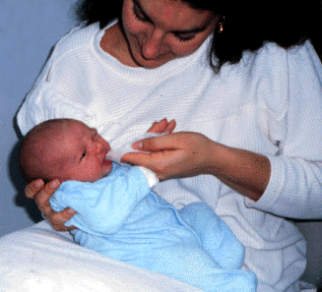
Oral Hygiene:
1. For Parents:
a) Keep your mouth clean so you
don’t give your baby the bacteria
from your mouth.
- Brush, floss and fluoride daily
(NYC water has enough fluoride in it --
no fluoride vitamins are needed.)
2. For the infants:
- The first teeth usually come in at around 6 months old, but they can come earlier or much later.
- It can be normal to have no teeth even a little after 1 year old.
- When the babies first teeth come in, clean teeth with a clean moist cloth by gently massaging the teeth and gums.

Feeding:
--Don’t put the baby to sleep with a bottle. The sugar in the milk sits on the teeth and can cause “milk bottle cavities.”

Going to the Dentist:
--Take your child to his/her first dental visit at 2 years of age, unless your Pediatrician suggests an earlier visit.
--Ask your pediatrician for a recommendation if you can’t find a dentist that sees children this young.

Dental Health 6-12 months

The bacteria that cause cavities begin to grow in your baby’s mouth even before your baby has teeth, so good oral hygiene should start within the first few months of life. Although baby teeth do fall out, cavities in those teeth are still a problem because they cause pain and can cause problems with permanent (adult) teeth.

Oral Hygiene:  - For Parents:  - Keep your mouth clean so you don’t give  your baby the bacteria your mouth:  - Brush, floss and fluoride daily (NYC water has enough fluoride in it --no fluoride vitamins are needed.)  - For the child:  - The first teeth usually come in at around 6 months old, but they can come earlier or much later.  - It can be normal to have no teeth even a little after 1 year old.  - When the babies first teeth come in, clean teeth with a clean moist cloth by gently massing the teeth and gums. | 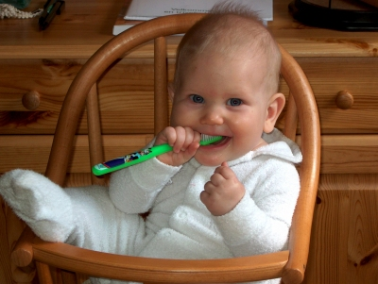

Feeding:
--Don’t put the baby to sleep with a bottle. The sugar in the milk sits on the teeth and can cause “milk bottle cavities.”

Going to the Dentist:
--Take your child to his/her first dental visit at 2 years of age, unless your Pediatrician suggests an earlier visit.
--Ask your pediatrician for a recommendation if you can’t find a dentist that sees children this young.
Dental Health: 1-3 years

Taking care of baby teeth is very important, even though they will eventually fall out, because the baby teeth hold spaces for the permanent teeth. Cavities in the baby teeth can cause the permanent teeth to develop improperly and can cause a lot of pain for the child.
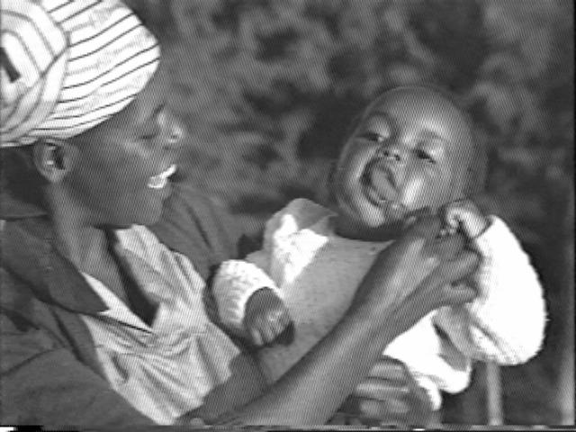
Diet:
--Limit candy or other sugary foods for rare occasions.
--Limit juice and avoid soda.
--Avoid constant snacking by having specific snack times.
--Change to a sippee cup after one year old and get rid of the bottle.
--Never put your child to bed with a bottle.
--Provide a balanced diet.
--Ask your doctor or dentist about Fluoride vitamins. In NY, the water from the sink has enough fluoride to help teeth become strong, but in some areas, vitamins are needed.

Going to the Dentist:
-- Take your child to his/her first dental visit at 2 years of age, unless your Pediatrician suggests an earlier visit.
--Then visit dentist every 6 months or year (depending on the recommendation of your dentist).
--Ask your pediatrician for the name of a dentist who takes care of children this age.

Brushing:
--Brush teeth with a small soft-bristled brush twice a day. (Let your child brush alone, but make sure you brush afterwards.)
--Don’t forget to also brush the tongue.
--Clean teeth after sticky foods like raisins or peanut butter.
--Around age 2 or 3, when your child is able to rinse his mouth and spit, begin to use a pea-sized amount of toothpaste with fluoride.
--Dental flossing should be started now once/day if you haven’t started already.
--Let your child to watch you brush and floss your teeth. Be a role model!
Dental Health: 3 - 6 years

Taking care of baby teeth is very important, even though they will eventually fall out, because the baby teeth hold spaces for the permanent teeth. Cavities in the baby teeth can cause the permanent teeth to develop improperly and can cause a lot of pain for the child. The first teeth usually fall out around 6 years old, new teeth will replace them.

Diet:  --Limit candy or other sugary foods for rare occasions.  --Limit juice and avoid soda.  --Avoid constant snacking by having specific snack times.  --Provide a balanced diet.  --Ask your doctor or dentist about Fluoride vitamins. In NY, the water from the sink has enough fluoride to help teeth become strong, but in some areas, vitamins are needed. | 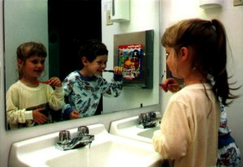

Going to the Dentist:
-- Take your child to his/her first dental visit at 2 years of age, unless your Pediatrician suggests an earlier visit.
--Then visit dentist every 6 months or year (depending on the recommendation of your dentist).
--Ask your pediatrician for the name of a dentist if you don’t have one.

Brushing:
--Brush teeth with a small soft-bristled brush twice a day. (Let the child brush themselves, but make sure you brush for them afterwards until they are around 8 years old.)
--Don’t forget to also brush the tongue.
--Clean teeth after sticky foods like raisins or peanut butter.
--Dental floss once a day.
--Let your child to watch you brush and floss your teeth. Be a role model!
Dental Health: 7 – 12 years

During these years, more and more baby teeth will fall out and new, permanent or “adult” teeth will grow in. It is very important to take care of these teeth as they will last the rest of your child’s life.

Diet:  --Limit candy or other sugary foods for rare occasions.  --Limit juice and avoid soda.  --Avoid constant snacking by having specific snack times.  --Provide a balanced diet. | 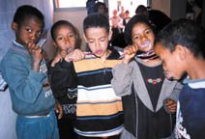

Going to the Dentist:
-- Take your child to his/her first dental visit at 2 years of age, unless your Pediatrician suggests an earlier visit.
--Then visit dentist every 6 months or year (depending on the recommendation of your dentist).
--Ask your pediatrician for the name of a dentist if you don’t have one.

Brushing:
--Brush teeth with a small soft-bristled brush twice a day
--Don’t forget to also brush the tongue.
--Clean teeth after sticky foods like raisins or peanut butter.
--Dental floss once a day.
--Be a role model! Make sure to take care of your teeth as well as your child’s!
Dental Health: 13 - 19 years

The teeth in a teenager’s mouth are now “adult” or permanent teeth. It is very important to take care of these teeth as they will last the rest of a teenager’s life. Also during this time, the back molars will be growing in.

Diet:  --Limit candy or other sugary foods.  --Limit juice and soda.  --Avoid constant snacking by having specific snack times.  --Provide a balanced diet. | 

Going to the Dentist:
-- Take your child to his/her first dental visit at 2 years of age, unless your Pediatrician suggests an earlier visit.
--Then visit dentist every 6 months or year (depending on the recommendation of your dentist).
--Ask your pediatrician for the name of a dentist if you don’t have one.

Brushing:
--Brush teeth with a soft-bristled brush twice a day.
--Don’t forget to also brush the tongue.
--Clean teeth after sticky foods like raisins or peanut butter.
--Dental floss once a day.

Piercing and Tobacco:
--Pierced jewelry in the tongue or the lips can cause erosions in the teeth
--Tobacco not only is bad for the lungs. It is bad for the teeth and mouth, too. Chewing tobacco can cause tongue or jaw cancer requiring removal of parts of the tongue or jaw. Smoking can cause throat cancer as well.
--Tobacco can also stain the teeth and cause bad breath

