Developmental Progression of the Grasp

Age 4-5 months: Crude Palmar Grasp

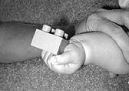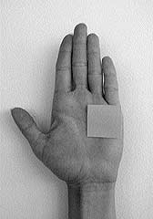

Observe the grasp of the object in the ulnar side of the palm and the lack of thumb involvement in this grasp. And the picture on the right shows where on the palm an object is placed while using a crude palmar grasp.

Age 5-6 months: Palmar Grasp

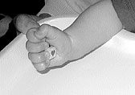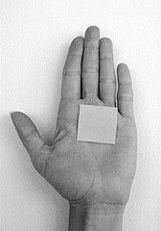

The object is secured in the center of the palm in the palmar grasp. Again, there is lack of thumb use. Although the object is quite small, this infant has grasped it with the whole hand because he or she does not yet have the ability to use more precise movements. Note that now the object is in the center of the palm.

Ages 6-7 Months: Radial Palmar Grasp

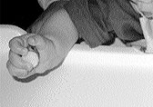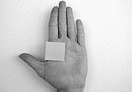

The object is secured in the radial side of the palm. Note the flexion of the ulnar fingers for stability and the thumb that is beginning to oppose and actively press the object into the palm.

Ages 7-8 months: Raking Grasp

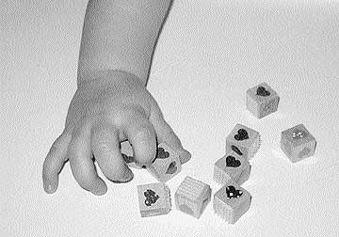

Note the flexion of the radial fingers to bring the objects into the palm while using the raking grasp.

Ages 8-9 months: Radial Digital Grasp

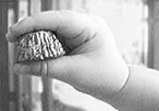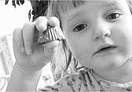

Observe the full opposition of the thumb to help secure the object, and the flexion of the ulnar fingers for stability while using the radial digital grasp.

Also Ages 8-9 months: Inferior Pincer Grasp

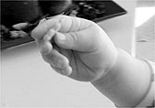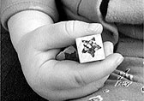

Note the adduction of the thumb to secure the object against the extended index finger while using the inferior pincer grasp.

Ages 10-12 months: Pincer Grasp

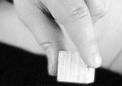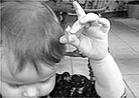

Note the full opposition of the pad of the thumb and the pad of the index finger to secure the object while using the pincer grasp. This is differentiated from the neat pincer grasp, in that the pad of the finger secures the object in the pincer grasp; whereas the tip of the finger secures the object in the neat pincer grasp.

