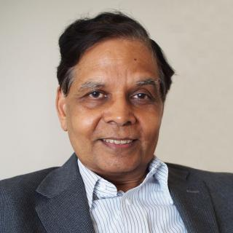Arvind Panagariya holds a PhD from Princeton University and is currently a Professor of Economics and the Jagdish Bhagwati Professor of Indian Political Economy in the School of International and Public Affairs at Columbia University. From January 2015 to August 2017, he served as the first Vice Chairman of the NITI Aayog, Government of India in the rank of a Cabinet Minister. During these years, he also served as India’s G20 Sherpa and led the Indian teams that negotiated the G20 Communiqués during presidencies of Turkey (2015), China (2016) and Germany (2017). He has been the Chief Economist of the Asian Development Bank. Professor Panagariya’s scientific papers have appeared in the top economics journals such as the American Economic Review and the Quarterly Journal of Economics while his policy papers have appeared in Foreign Affairs and Foreign Policy. He writes a monthly column in the Times of India and his guest columns have appeared in the Financial Times, Wall Street Journal and India Today. In March 2012, the Government of India honored Professor Panagariya with Padma Bhusan, the third highest civilian honors the country bestows in any field.
His latest book, “Free Trade and Prosperity” (Oxford University Press) offers the first full-scale defense of pro-free-trade policies with developing countries at its center.

