CROWDSOURCED CITY: USING YOUR COLUMBIA WEBSPACE

STEP 1: WEB POSTING SET-UP

Because google maps is a web-based program all assignments are essentially posted to the web. Below are instructions for setting up your Columbia web space, making a simple web page, and adding the google API to your webpage. All the web pages will be grouped together on the classes overall webpage so that we can see everyone’s google maps during class. So after you set up your web page you will need to give me your web address.

Step 1: Working with your Columbia WEB/UNIX Space:
When you get an email account you also get a Web Space, but that web space does not become readable to the world until you tell it to. So, the first steps below teach you how to look at your web space and make your web space readable to the world of the internet.

- Go to Start, Programs, open up WinSCP.

- Type in “cunix.cc.columbia.edu” under Host Name. Your User name is your UNI and your Password is your UNI password (whatever your password to your email account is.) Hit Login.

- When you’ve logged in to your session, you should see the following screen. This screen shows you all your files located on your web space. The public_html folder is the folder that we will make viewable for the web.

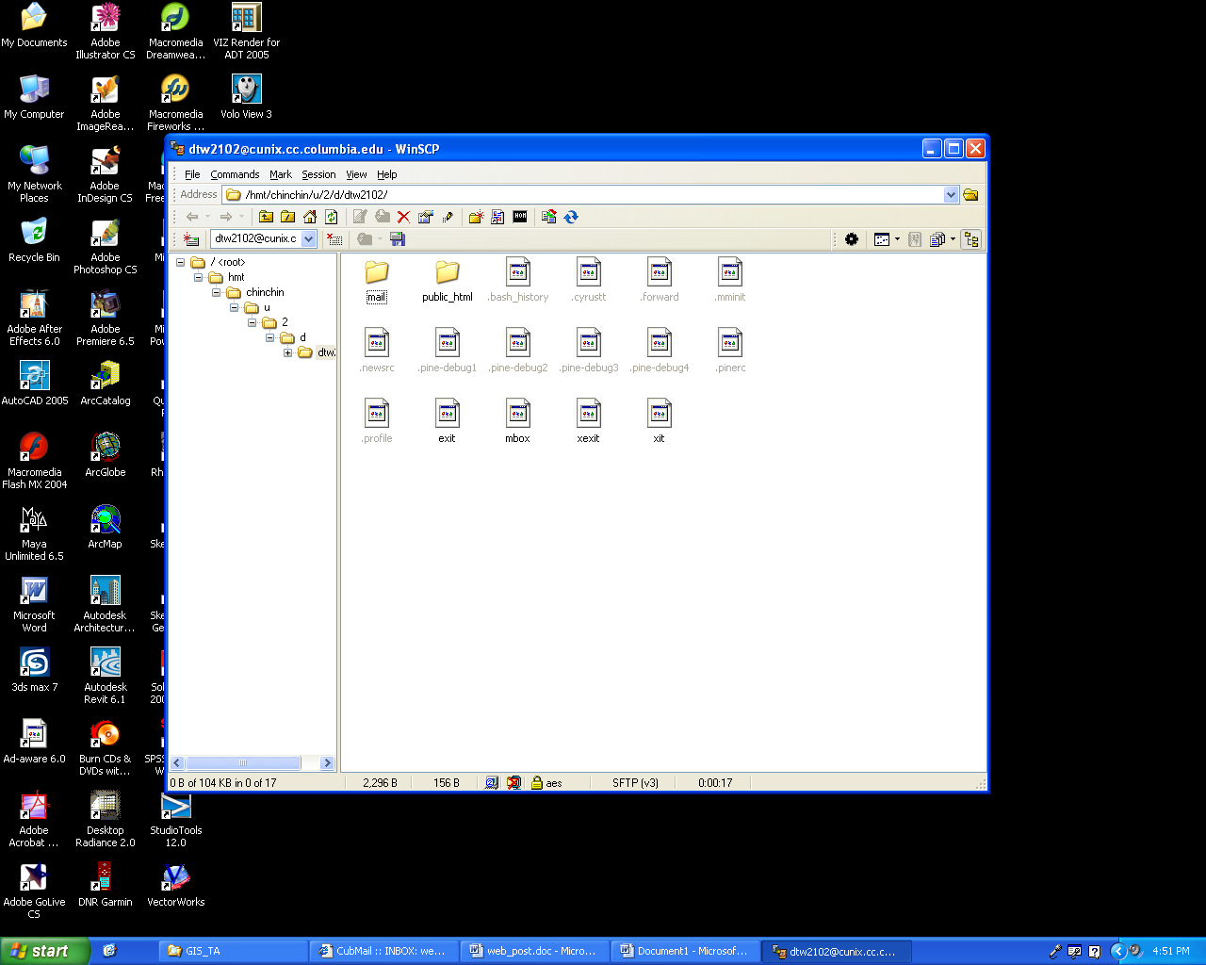

4. The WINSCP program has a better way to view your files than default display of your dialog. This view allows you to see the files on your local machine as well as the files located on your Columbia UNIX space where your public_html folder is located. To view the program in this way, follow these directions:

- In the Main Menu go to View>Preferences. In the dialog, under the Environment option, pick Interface. Select that you want the Norton Commander interface – as shown below. To set this interface you actually have to close out of WINSCP and open again. So click OK on the dialog below then close out of WINSCP. Yes it is weird that you have to close the program to make this preference happen, but that is how it works.

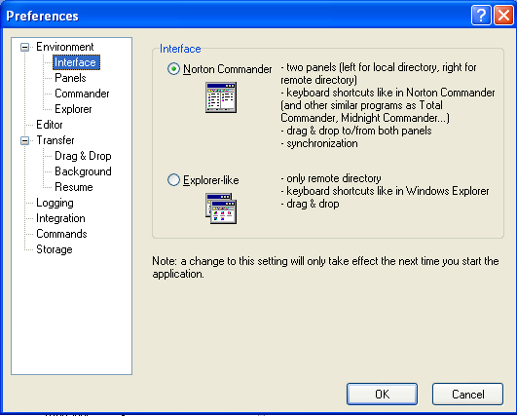

- Now Open WINSCP. You will need to specify Host Name, User Name, and Password again.

Host Name : cunix.cc.columbia.edu
Username : your UNI (for example mine is sw2279)
Password : Your UNI password

Once you log in the dialog below will appear. This dialog allows you to drag files from your hard drive into your UNIX space, thereby making it web readable. Ahh… but we haven’t made your folder web readable yet so that’s the next step.

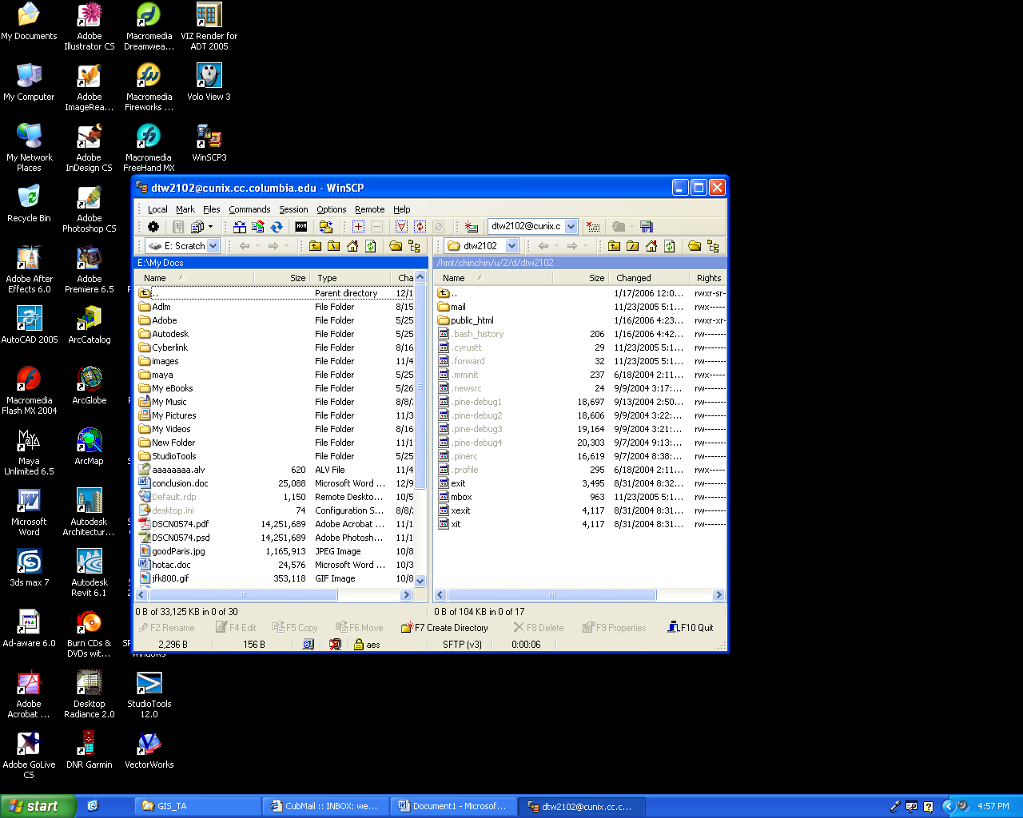

Step 2 : Making your Public_Html folder Readable on the World Wide Web.

- In the Main Menu of WINSCP go to Commands>Open Terminal. Click OK to the popup message. Your screen should look like the following:

- In the Enter command box, type the following commands:

chmod a+x ~

Click the Execute Button
chmod a+rx ~/public_html

Click the Execute Button
(Note these are UNIX commands that allow you to make a directory and allows the world to read your files, but not write files to your website directly.)

This is the only time you will need to do this. Once you have made your directories readable to the world, they will always be world-readable.

Adding Files to Your Web Space

- In your WinSCP window, you should see your local directories on the left and your public directories on the right. Double click the “public_html” folder to open. Anything added to this folder will now be read able to the world.

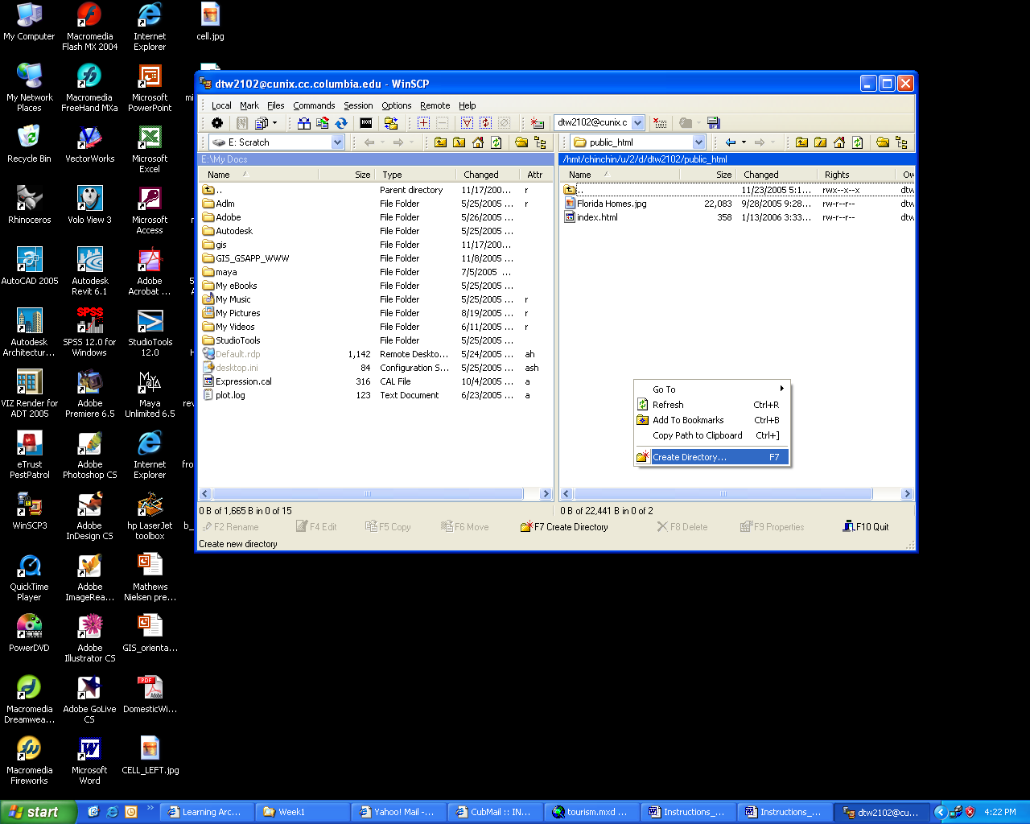

Test that you were able to make your web site readable to the world. Drag anything into the public_html folder. It can be an image or file - even these instructions would work. Than check you web space..

Your Web Site is www.columbia.edu/~youruni so my web site is www.columbia.edu/~sw2279 .

Try Going to Your Web Site to see your file

