Part III:
Continuous Distributions and Portfolio Analysis
An Average is but a solitary fact, whereas if a single other fact be added to it, an entire Normal Scheme, which nearly corresponds to the observed one, starts potentially into existence. Some people hate the very name of statistics, but I find them full of beauty and interest. — Francis Galton (1822-1911).
Up to now we have considered only what are called discrete random variables. These variables take on a countable number of values, usually whole numbers like 0, 1, 2, ... There are many cases where the range of possible values can be quite numerous and not necessarily nice whole numbers. It is sometimes easier to look at these random variables as if they were defined on a continuum of possible numbers. These are called continuous random variables. For example:
- The amount of impurity in one gram of a chemical (10.29 milligrams, 11.383 milligrams)
- The water level of a reservoir (44.33 inches, 23.140 inches).
- Any percentage (e.g. 23.2% market share, 11.51% return).
- An index (e.g. DJIA).
Example: Advertising on the Internet is a booming business. To monitor the length of time a user spends at a particular site, the operations of 10,000 users were recorded and timed. After 5 minutes at the site, a user is automatically sent to another site for help documentation. The question the advertiser was interested in is how long do people spend at the site before he/she is sent to the help site? Here is a histogram of the time spent at the site:
What would you estimate as the following probabilities? Let X be the length of a randomly chosen phone call:
- P(X ≤ 2.5) =
- P(2.5 ≤ X ≤ 4) =
- P(1 ≤ X ≤ 3) =
- P(X < 2.5) =
This is an example of a uniformly distributed random variable.
Uniform Random Variable: A random variable X is uniform on the interval [a, b] if there is an equal probability of being anywhere in the interval [a, b].
Notation: X ~ U[a, b]
Probability Density Function: The probability density function of a random variable X, denoted f_{X}(x), has the following properties:
- f_{X}(x) ≥ 0, for all values of x (that is, there is no such thing as negative density), and
- For any two values c and d, P(c  X  d) is equal to the area “under” the graph of f_{X}(x) between c and d. Stated another way,
$$P\left(c≤X≤d\right)$$ | $$=\frac{d−c}{b−a}$$
For a uniform random variable between a and b, the function f_{X}(x) is constant between a and b. Since the probability that the random variable falls between a and b must be 1, the function must be:
$$f_{X}\left(x\right)=\left\{\begin{matrix}0, \\ \frac{1}{b−a}, \\ 0,\end{matrix}\right.\begin{matrix}\text{if}\overset{}{}x<a \\ \overset{}{}\overset{}{}\text{if}\overset{}{}a≤x≤b \\ \text{if}\overset{}{}x>b\end{matrix}$$
A random variable X that is uniformly distributed between a and b has:
Expected Value: | $$\overline{X}$$ | $$=\frac{\left(a+b\right)}{2}$$
Variance: | $$σ_{X}^{2}$$ | $$=\frac{{\left(b−a\right)}^{2}}{\text{12}}$$
Standard Deviation: | $$σ_{X}$$ | $$=\frac{\left(b−a\right)}{\sqrt{\text{12}}}$$

Note: Inevitably, someone in the class wants to know why there is a 12 in the denominator of the formula for the standard deviation of a uniformly distributed random variable. For that person, the following derivation is provided. (This will not be on the exam.)
First, note that
$$μ_{X}$$ | $$=\int{\frac{x}{b−a}\text{dx}}$$
 | $$=\frac{b^{2}−a^{2}}{2\left(b−a\right)}$$
 | $$=\frac{b+a}{2}$$
and
$$E\left(X^{2}\right)$$ | $$=\int{\frac{x^{2}}{b−a}}\text{dx}$$
 | $$=\frac{b^{3}−a^{3}}{3\left(b−a\right)}$$
 | $$=\frac{b^{2}+\text{ab}+a^{2}}{3}$$
Now, from our previous definition of a variance:
$$σ_{X}^{2}$$ | $$=E\left(X^{2}\right)−μ_{X}^{2}$$
 | $$=\frac{b^{2}+\text{ab}+a^{2}}{3}−{\left(\frac{a+b}{2}\right)}^{2}$$
 | $$=\frac{4\left(b^{2}+\text{ab}+a^{2}\right)}{4\left(3\right)}−\frac{3\left(a^{2}+2\text{ab}+b^{2}\right)}{3\left(4\right)}$$
 | $$=\frac{4b^{2}+4\text{ab}+4a^{2}−3a^{2}−6\text{ab}−3b^{2}}{\text{12}}$$
 | $$=\frac{b^{2}−2\text{ab}+a^{2}}{\text{12}}$$
 | $$=\frac{{\left(b−a\right)}^{2}}{\text{12}}$$

Example: A manufacturer has observed that the time that elapses between the placement of an order with a just-in-time supplier and the delivery of parts is uniformly distributed between 100 and 180 minutes.
a) What proportion of orders takes between 2 and 2.5 hours to be delivered?

b) What proportion of orders takes between 2 and 3 hours to be delivered?

c) What is the expected delivery time?

d) What is the standard deviation of the delivery time?

e) The contract between the manufacturer and supplier stipulates that the cost of the order will be $4,000 minus ten dollars per minute that it takes between the order and the delivery. What is the expected cost of an order? What is the standard deviation of the order cost?

Question: What is the probability that a continuous random variable X takes on any particular value x?
The Normal Distribution

History
Abraham de Moivre (1667-1754) first described the normal distribution in 1733.
Adolphe Quetelet (1796-1874) used the normal distribution to describe the concept of l'homme moyen (the average man), thus popularizing the notion of the bell-shaped curve.
Carl Friedrich Gauss (1777-1855) used the normal distribution to describe measurement errors in geography and astronomy.
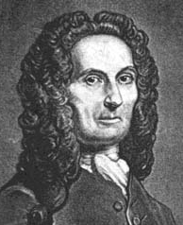 |  | 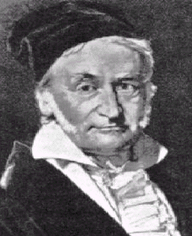 |  | 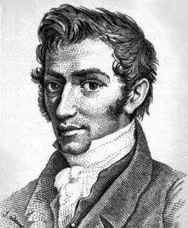
de Moivre |  | Gauss |  | Quetelet
The normal distribution has the following shape:
It has two parameters, μ and σ, and is denoted N(μ, σ). Here μ is its mean, σ² its variance, and σ is its standard deviation. The normal distribution is a continuous distribution with probability density function:
$f_{X}\left(x\right)=\frac{1}{σ\sqrt{2π}}e^{−\frac{1}{2}{\left(\frac{\left(x−μ\right)}{σ}\right)}^{2}}$, where π ≅ 3.1416 and e ≅ 2.7183
Here is a picture of the old German 10-mark note, which features Gauss:
 | 

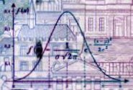 | The front of the note includes a picture of the normal probability density function.
 | The back of the note shows a map of Bavaria, where Gauss noticed a bell-shaped distribution of distances between towns, as measured by different surveyors.
If we know that X is normally distributed and we also know its mean and standard deviation, we can make exact probability statements about X.
Remember that for any continuous random variable X with probability density function f_{X}(x) we can calculate the probability of X lying between any two numbers a and b as follows:
P(a ≤ X ≤ b) = area under f_{X}(x) between a and b.
But for the normal distribution, calculating the area under f_{X}(x) is not easy!
Standardization: To make the area calculation easier, we standardize a normally distributed random variable in the following way: Consider a random variable X with mean μ and standard deviation σ. Now look at the random variable Z:
$$Z=\frac{X−m}{s}$$
Then
$$E\left(Z\right)=E\left(\frac{X−m}{s}\right)=E\left(\frac{X}{s}−\frac{m}{s}\right)=\frac{E\left(X\right)}{s}−\frac{m}{s}=\frac{m}{s}−\frac{m}{s}=0$$
and
$$\text{Var}\left(Z\right)=\text{Var}\left(\frac{X−μ}{σ}\right)=\text{Var}\left(\frac{X}{σ}−\frac{μ}{σ}\right)=\frac{\text{Var}\left(X\right)}{σ^{2}}=\frac{σ^{2}}{σ^{2}}=1$$
The resulting random variable Z is normally distributed with mean 0 and standard deviation 1.
This random variable Z is called a standard normal random variable. Any normally distributed random variable X (with mean μ and standard deviation σ) can be transformed into a standard normal random variable by simply subtracting the mean and dividing by the standard deviation. This value of Z tells us the number of standard deviations that X is away from its mean.
To determine probabilities with the standard normal distribution:
$$P\left(a≤X≤b\right)$$ | $$=P\left[\left(a−μ\right)≤\left(X−μ\right)≤\left(b−μ\right)\right]$$
 | $$=P\left[\left(\frac{a−μ}{σ}\right)≤\left(\frac{X−μ}{σ}\right)≤\left(\frac{b−μ}{σ}\right)\right]$$
 | $$=P\left[\left(\frac{a−μ}{σ}\right)≤Z≤\left(\frac{b−μ}{σ}\right)\right]$$
To calculate the probability of a X being between a and b we just need to
- standardize it (convert a and b into standard deviations) and then
- get the probability that Z = $\left(\frac{X−m}{s}\right)$, a standard normal random variable, is between $\left(\frac{a−m}{s}\right)$ and $\left(\frac{b−m}{s}\right)$.
Example: Monthly sales of CDs at the Corner Music Store are normally distributed with mean 5,000 discs with a standard deviation of 1,000. Let X denote the sales.
a) What is the probability that sales are more than 6,000 CDs?
$$P\left[X≥6,\text{000}\right]$$ | $$=P\left[\left(X−5,\text{000}\right)≥\left(6,\text{000}−5,\text{000}\right)\right]$$
 | $$=P\left[\left(\frac{X−5,\text{000}}{1,\text{000}}\right)≥\left(\frac{6,\text{000}−5,\text{000}}{1,\text{000}}\right)\right]$$
 | $$=P\left[Z≥1\right]$$
Now what? The probability that the standard normal random variable Z lies in some interval can be determined from a Standard Normal Table. The table only gives a particular kind of probability. For a positive value of z, the tables give P(0 ≤ Z ≤ z). So to calculate any probability we need to be a little careful. There are two things to remember:
- The total area under the curve is 1. That is, P(Z ≥ 1) = 1 - P(Z ≤ 1).
- The curve is symmetric. That is, P(Z ≥ 1) = P(Z ≤ -1), or P(Z ≤ 1) = P(Z ≥ -1).
Using these two rules and the Standard Normal Table (pg. E-4 in the textbook), the entire right half of the standard normal distribution (where Z is greater than 0) has an area of 0.5. From this we subtract the value in the table associated with Z = 1, namely 0.3413. Therefore, the probability of Z being greater than 1.0 is:
0.5 - 0.3413 = 0.1587
There is about a 16% chance that sales are more than 6,000 CDs.
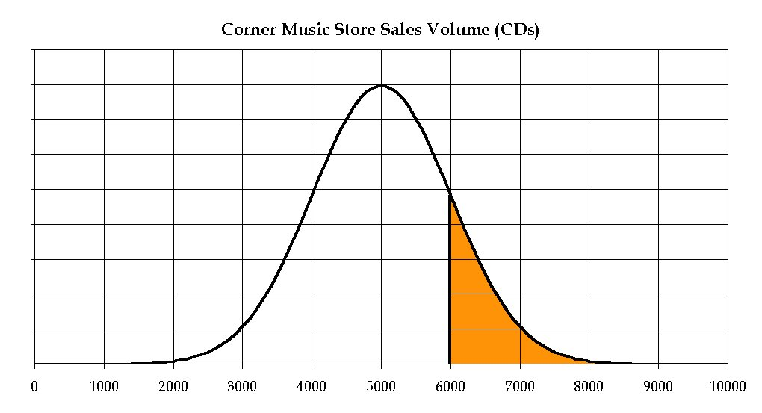
b) Sales need to be at least 3,500 CDs in order for the store to cover operating expenses. What is the probability that sales are more than 3,500? Once again we refer to the standard normal table in the textbook:
P(X ≥ 3,500) | $$=P\left(\frac{X−5,\text{000}}{1,\text{000}}≥\frac{3,\text{500}−5,\text{000}}{1,\text{000}}\right)$$
 | = P(Z ≥ -1.5)
 | = P(Z ≤ 1.5)
 | = 0.5 + 0.4332
 | = 0.9332
So, about a 93% chance of that.
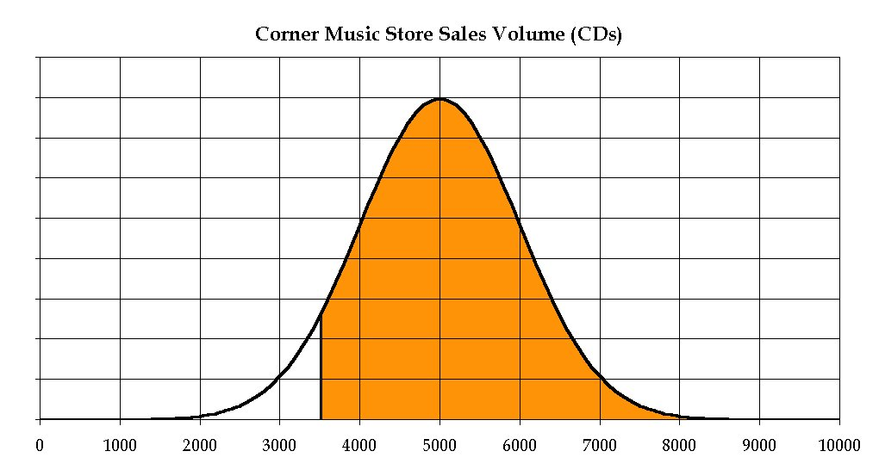
c) What is the likelihood that sales will be between 3,000 and 5,500?
P(3,000 ≤ X ≤ 5,500) | $$=P\left(\frac{3,\text{000}−5,\text{000}}{1,\text{000}}≤\frac{X−5,\text{000}}{1,\text{000}}≤\frac{5,\text{500}−5,\text{000}}{1,\text{000}}\right)$$
 | = P(-2.0 ≤ Z ≤ 0.5)
 | = P(-2.0 ≤ Z ≤ 0) + P(0 ≤ Z ≤ 0.5)
 | = 0.4772 + 0.1915
 | = 0.6687
 | = 66.87%
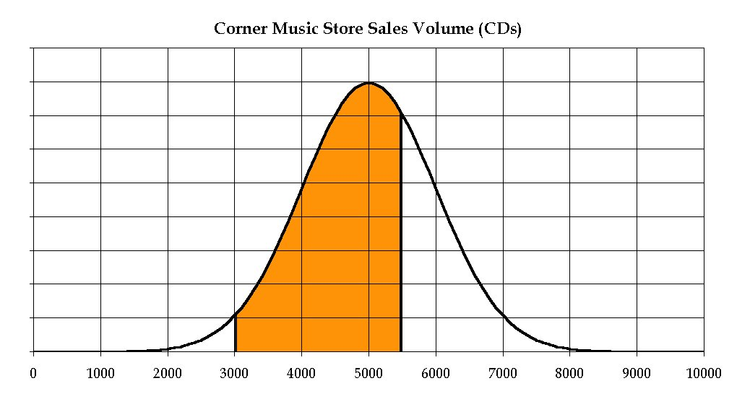

d) There is a 0.50 probability that the random variable “sales” will be between which two values? That is, what numbers x and y are such that P(x ≤ X ≤ y) = 0.5?
There are actually many possible values of x and y, but let's choose the ones that are symmetric around the mean of 5,000. So we need to find a number c such that
P[(5,000 - c) ≤ X ≤ (5,000 + c)] = 0.5.
How many standard deviations correspond to c? Look in the table to see what number d has
P(0 ≤ Z ≤ d) = 0.25.
It is 0.675. So c must be 0.675 standard deviations, or
c = (0.675)(1,000) = 675.
So, the interval we are looking for is from 5,000 - 675 = 4,325 to 5,000 + 675 = 5,675. There is a 50% chance that sales will be between 4,325 and 5,675 CDs.
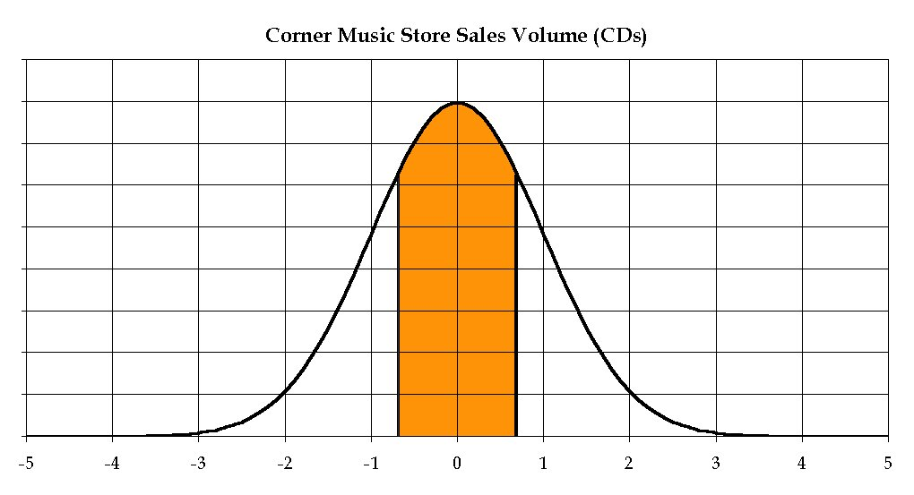
e) The probability is 23% that sales will be greater than what number?
Our tables are not set up to answer this question directly; they provide us with probabilities that sales will be less than some number. However, using our knowledge that the normal distribution is symmetrical, we can answer the question another way.
The number we want (call it a), above which 23% of sales will fall, also represents a point below which 77% of sales will fall, because 1 - .23 = .77. Therefore we need to find .77 in the body of the table and see what value of Z corresponds to a probability of .77.
The standard normal table provides us with a fairly close approximation: f(z) = 0.5 + 0.2704 = 0.7704 where z = .74. Therefore:
$$0\text{.}\text{74}=\frac{a−5,\text{000}}{1,\text{000}}$$
and a = 5,740. That is, there is a 23% chance that sales are more than 5,740 CDs.
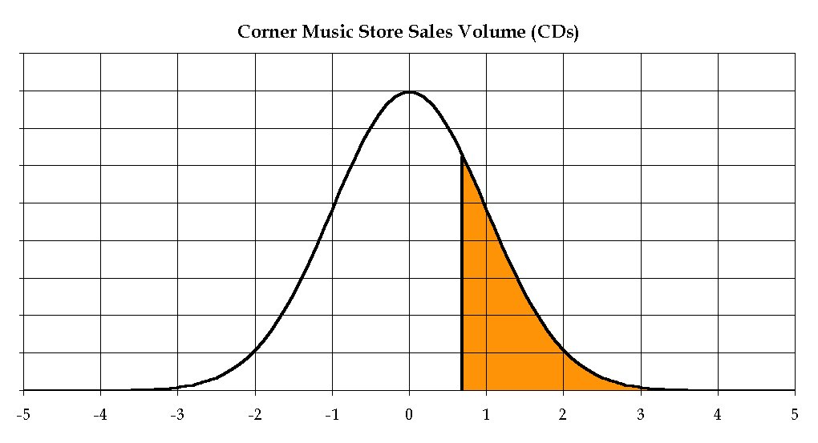
Example: Statistics midterm scores were normally distributed last year with a mean of 70. Only 7% of students scored above 85. What proportion of the students scored above 80?

Excel Functions for Normal Distributions
There are four Excel functions that are useful for calculating probabilities or z-values from the normal distribution. Here they are, using questions (b) above as an illustration.
Function Syntax | Result | Notes
=1-NORMDIST(3500,5000,1000,1) | 0.9332 | The function is set up to give the probability of being below the specified value; we want the probability of being above the value, so we subtract the whole function from 1. The last argument is a “logical” argument; it needs to be 1 or 0 (or True/False). Here we use 1.
=1-NORMSDIST(-1.5) | 0.9332 | We subtract from 1 as above.
=NORMINV(1-0.23,5000,1000) | 5,739 | The function is set up to give the value at the upper limit of the specified probability; we want the value at the lower limit, so we subtract the probability argument from 1.
=NORMSINV(1-0.23) | 0.7388 | We subtract from 1 as above. The units here are “standard deviations from the mean”, and need to be converted:  $$μ+0\text{.}\text{7388}∗σ=5,\text{739}$$

Other Continuous Distributions
Exponential
Parameters: | The exponential distribution has one parameter, λ (Greek letter lambda), which must be greater than zero.
Mean: | $$\frac{1}{λ}$$
Variance: | $$\frac{1}{λ^{2}}$$
Density Function: | $$f\left(x\right)={λe}^{−λx}$$
Applications: | The exponential distribution is used frequently in queueing theory to model the random time lapses between events, such as the arrivals of customers at a service facility. If the times between events follow an exponential distribution, then the number of events in a specific interval of time follows a so-called Poisson distribution.

Lognormal
Parameters: | μ and σ
Mean: | $$e^{μ+σ^{2}/2}$$
Variance: | $$e^{2μ+σ^{2}}\left(e^{σ^{2}}−1\right)$$
Density Function: | $$f\left(x\right)=\frac{1}{x\sqrt{2{\text{πσ}}^{2}}}\text{exp}\frac{−{\left(\text{ln}x−μ\right)}^{2}}{2σ^{2}}$$
Applications: | The lognormal distribution is often used to model the duration of some physical activity (which cannot be negative). It is used extensively in reliability analysis, such as in modeling the times between machine failures.

Gamma
Parameters: | α and β (Greek letters alpha and beta), both of which must be greater than zero.  α is sometimes called the “shape” parameter (usually a positive integer), and β the “scale” parameter.
Mean: | $$\text{αβ}$$
Variance: | $${\text{αβ}}^{2}$$
Density Function: | $$f\left(x\right)=\frac{β^{−α}x^{α−1}e^{−x/β}}{Γ\left(α\right)}$$
Applications: | Similar to lognormal.

Beta
Parameters: | α and β, both greater than zero.
Mean: | $$\frac{α}{α+β}$$
Variance: | $$\frac{\text{αβ}}{{\left(α+β\right)}^{2}\left(α+β+1\right)}$$
Density Function: | $$f\left(x\right)=\frac{Γ\left(α+β\right)}{Γ\left(α\right)Γ\left(β\right)}x^{α−1}{\left(1−x\right)}^{β−1}$$
Applications: | When constrained to the range from 0 to 1, this distribution is used to model random proportions. Also used in project management for random task times in PERT networks.

Chi-square
Parameters: | v, a number of degrees of freedom (a positive integer)
Mean: | v
Variance: | 2v
Density Function: | $$f\left(x\right)=\frac{x^{v/2−1}}{2^{v/2}Γ\left(\frac{v}{2}\right)}e^{−x/2}$$
Applications: | Since chi-square describes the distribution of sample variances, this is the basis for a number of useful hypothesis tests, such as goodness of fit tests.

Triangular
Parameters: | a, b, and c (minimum, maximum, and peak, respectively)
Mean: | $$\frac{a+b+c}{3}$$
Variance: | $$\frac{a^{2}+b^{2}+c^{2}−\text{ab}−\text{ac}−\text{bc}}{\text{18}}$$
Density Function: | $\frac{2\left(x−a\right)}{\left(b−a\right)\left(c−a\right)}$if $a≤x≤c$
 | $\frac{2\left(b−x\right)}{\left(b−a\right)\left(b−c\right)}$if $c<x≤b$
Applications: | This one is pretty crude, but is popular among simulation modelers in the absence of data.

F
Parameters: | Let A and B be independent chi-square random variables with parameters (degrees of freedom) v₁ and v₂, respectively. Then  $$F=\frac{\frac{A}{v_{1}}}{\frac{B}{v_{2}}}$$
Applications: | The F distribution is most commonly used as the basis for hypothesis tests in regression analysis, as we will see later in this course.

Portfolio Analysis I: Independent Returns
Consider portfolios made up of only 3 possible stocks. Let A, B and C (random variables) denote the random returns on the 3 stocks. Assume returns are independent for these three stocks. An analyst estimates that each of the stocks' returns is normally distributed. In addition, the analyst predicts:
 |  | Standard
 | Mean | Deviation
A | 8.0% | 0.5%
B | 11.0% | 6.0%
C | 17.0% | 20.0%
Consider the following two portfolios:
- “Safe” Portfolio: 0.5 of fortune in stock A, 0.25 in stock B, and 0.25 in stock C.
- “Risky” Portfolio: 0.333 of fortune in stock A, 0.333 in stock B, and 0.333 in C.
Which portfolio is “better”? Which has a higher probability of losing money?
Let S and R represent the investment returns for portfolios Safe and Risky respectively. To understand these random variables, we need the following facts:
If X is normally distributed with mean $μ_{X}$ and standard deviation $σ_{X}$ and Y is normally distributed with mean $μ_{Y}$ and standard deviation $σ_{Y}$ and they are independent, then the random variable aX + bY is normally distributed with
mean | $$={aμ}_{X}+{bμ}_{Y}$$

variance | $$=a^{2}σ_{X}^{2}+b^{2}σ_{Y}^{2}$$

standard deviation | $$=\sqrt{a^{2}σ_{X}^{2}+b^{2}σ_{Y}^{2}}$$
Therefore S and R are normally distributed, and we are left with trying to determine their means and standard deviations.
Note that
$$S=0\text{.}5A+0\text{.}\text{25}B+0\text{.}\text{25}C$$
and
$$R=0\text{.}\text{333}A+0\text{.}\text{333}B+0\text{.}\text{333}C$$
Note: To see these expressions for R and S are correct, say we have a fortune F available for investment. For the “Safe” investment, if the returns on the three stocks are A, B and C, then we would get back 0.5F(1 + A) from stock A, 0.25F(1 + B) from stock B and 0.25F(1 + C) from stock C. Therefore adding these up, we get back
0.5F(1 + A)+ 0.25F(1 + B)+ 0.25F(1 + C) = F + F(0.5A + 0.25B + 0.25C),
Our rate of return S is:
$\frac{F+F\left(0\text{.}5A+0\text{.}\text{25}B+0\text{.}\text{25}C\right)−F}{F}$ = 0.5A + 0.25B + 0.25C.
We can do a similar thing for the “Risky” investment.
Let $μ_{S}$, $μ_{R}$, σ_{S} and σ_{R} represent the means and standard deviations of the portfolio returns.
1) What are the expected returns?
$$μ_{S}$$ | = E(0.5A + 0.25B + 0.25C)
 | = 0.5$μ_{A}$ + 0.25$μ_{B}$ + 0.25$μ_{C}$
 | = (0.5)(0.08) + (0.25)(0.11) + (0.25)(0.17)
 | = 0.11
$$μ_{R}$$ | = E(0.333A + 0.333B + 0.333C)
 | = 0.333$μ_{A}$ + 0.333$μ_{B}$ + 0.333$μ_{C}$
 | = (0.333)(0.08) + (0.333)(0.11) + (0.333)(0.17)
 | = 0.12

2) The standard deviations give us some idea of the risk of each investment. We first must calculate the variances:
$$σ_{S}^{2}$$ | $$=σ_{\left(0\text{.}5A+0\text{.}\text{25}B+0\text{.}\text{25}C\right)}^{2}$$
 | $$={\left(0\text{.}5\right)}^{2}σ_{A}^{2}+{\left(0\text{.}\text{25}\right)}^{2}σ_{B}^{2}+{\left(0\text{.}\text{25}\right)}^{2}σ_{C}^{2}$$
 | $$=\left(0\text{.}\text{25}\right){\left(0\text{.}\text{005}\right)}^{2}+\left(0\text{.}\text{0625}\right){\left(0\text{.}\text{06}\right)}^{2}+\left(0\text{.}\text{0625}\right){\left(0\text{.}2\right)}^{2}$$
 | $$=\left(0\text{.}\text{25}\right)\left(0\text{.}\text{000025}\right)+\left(0\text{.}\text{0625}\right)\left(0\text{.}\text{0036}\right)+\left(0\text{.}\text{0625}\right)\left(0\text{.}\text{04}\right)$$
 | $$=0\text{.}\text{002731}$$

$$σ_{R}^{2}$$ | $$=σ_{\left(0\text{.}\text{333}A+0\text{.}\text{333}B+0\text{.}\text{333}C\right)}^{2}$$
 | $$={\left(0\text{.}\text{333}\right)}^{2}σ_{A}^{2}+{\left(0\text{.}\text{333}\right)}^{2}σ_{B}^{2}+{\left(0\text{.}\text{333}\right)}^{2}σ_{C}^{2}$$
 | $$=\left(0\text{.}\text{1111}\right){\left(0\text{.}\text{005}\right)}^{2}+\left(0\text{.}\text{1111}\right){\left(0\text{.}\text{06}\right)}^{2}+\left(0\text{.}\text{1111}\right){\left(0\text{.}2\right)}^{2}$$
 | $$=\left(0\text{.}\text{1111}\right)\left(0\text{.}\text{000025}\right)+\left(0\text{.}\text{1111}\right)\left(0\text{.}\text{0036}\right)+\left(0\text{.}\text{1111}\right)\left(0\text{.}\text{04}\right)$$
 | $$=0\text{.}\text{004847}$$
The standard deviations are: σ_{S} = 0.05226 and σ_{R} = 0.06962.
Now, which has higher probability of losing money?

Which portfolio is most likely to outperform a CD returning 8% (no risk)?

Relationships between Data
So far we have analyzed only one-dimensional data; what about two-dimensional data? Most will agree, for example, that advertising expenditures have some effect on sales figures. How can we quantify this? Suppose it is your job to predict sales of a particular item for the coming year. Here are some historical data:
Advertising | Total
Expenditures | Sales
in 1,000s | in 1,000s
3 | 50
5 | 250
7 | 700
6 | 450
6.5 | 600
8 | 1,000
3.5 | 75
4 | 150
4.5 | 200
6.5 | 550
7 | 750
7.5 | 800
7.5 | 900
8.5 | 1,100
7 | 600
How would you use these data to help you predict sales this year, given that you know advertising expenditures will be 7,200?
One way to examine the relationship between to variables is to make a scatter plot. Here we can see clear evidence that Sales is positively related to Advertising:
The scatter plot gives us a qualitative impression of the relationship, but provides no quantitative measure of association.

Coefficient of Correlation: Another way of studying the association between two sets of data is through the coefficient of correlation. The coefficient of correlation, denoted r, is given by a complicated formula that is best done on a computer. In this particular case: r = 0.978.
In this example, the coefficient of correlation is positive. That is, the association between advertising and sales is positive. An increase in advertising expenditure seems to lead to an increase in sales. Equivalently, a decrease in advertising seems to lead to a decrease in sales. These are statements about the average behavior and may not reflect every single occurrence. In other words, one might say that a below average advertising budget tends to lead to a below average sales figure. An above average advertising budget tends to cause an above average sales figure.
A few simple facts about the correlation coefficient:
- It is positive when the association between the variables is positive, and it is negative when the association between the variables is negative.
- It always takes on a value between -1 and +1.
- The extreme situations r = -1 and r = +1 indicate perfect straight-line association. Given information about one of the two variables, we can make exact predictions about the other.
- It measures how tightly the points on the scatter plot cluster about a straight line.
- Like the mean and standard deviation, the correlation coefficient is heavily influenced by outliers.
- The Greek letter rho () represents the population correlation coefficient; r represents the sample correlation coefficient.

Karl Pearson
1857-1936
Karl Pearson is credited with inventing the coefficient of correlation, and it is sometimes called Pearson’s r. He was a protégé of Francis Galton, and mentor to a number of significant statisticians, including W. S. Gosset, Jerzy Neyman, and his son Egon Pearson.

Example: Negative correlation:
Days of Rain | Sales of Swim Wear
(June) | (June) (in 100s)
$$x_{i}$$ | $$y_{i}$$
2 | 55
4 | 51
14 | 20
15 | 21
7 | 66
12 | 55
14 | 56
20 | 10
5 | 78
8 | 67
12 | 11
15 | 12
12 | 13
$$\overline{x}=\text{10}\text{.}\text{769}$$ | $$\overline{y}=\text{39}\text{.}\text{615}$$
s_{x} = 5.199 | s_{y} = 25.313
The coefficient of correlation here is r = -0.720, an example of negative correlation. This means that, speaking in average terms, a month of June with an above average number of rainy days is usually accompanied by a month of below average sales of swim wear. Similarly, a month of June with relatively nice weather, (with a below average number of rainy days) is usually accompanied by above average sales of swimwear. These variables have a negative association, or are negatively correlated.
Covariance: Another measure of association between two variables is covariance. It also measures the strength of the linear relationship between X and Y, but unfortunately in un-normalized terms. That is, the units of the covariance make it very difficult to infer anything from the particular value by itself. In the advertising vs. sales example Cov = 528.0, and in the rainy days vs. swim wear sales example Cov = -87.5.
Important facts about the covariance:
- Like the variance, the covariance is usually in odd units (for example dollar-days), so I suggest using the correlation coefficient instead.
- The covariance and the coefficient of correlation have the same sign.
- If the covariance is positive, this means the variables are positively correlated. Values of X above its mean tend to be associated with values of Y above its mean. Values of X below its mean tend to be associated with values of Y below its mean.
- If the covariance is negative, this means the variables are negatively correlated. Values of X above its mean tend to be associated with values of Y below its mean. Values of X below its mean tend to be associated with values of Y above its mean.
The covariance can be calculated using:
$${\text{Cov}}_{\left(\text{XY}\right)}=E\left[\left(X−\overline{X}\right)\left(Y−\overline{Y}\right)\right]$$
or equivalently
$${\text{Cov}}_{\left(\text{XY}\right)}=E\left(\text{XY}\right)−\left(\overline{X}\right)\left(\overline{Y}\right)$$
The units of the covariance are sometimes difficult to understand and therefore it may be more useful to consider the coefficient of correlation. That is,
$${\text{Corr}}_{\left(\text{XY}\right)}=\frac{{\text{Cov}}_{\left(\text{XY}\right)}}{σ_{X}σ_{Y}}$$
Sometimes the inverse relation is useful:
$${\text{Cov}}_{\left(\text{XY}\right)}=σ_{X}σ_{Y}{\text{Corr}}_{\left(\text{XY}\right)}$$
The correlation is always between -1 and +1. If two random variables X and Y are independent, then
Cov_{(XY)} = Corr_{(XY)} = 0.

It’s important not to confuse slope and correlation. They are related, but not the same. Here are four distributions with the same slope, but different correlations:

Example: Here are economic data, showing the percent change in GSP (gross state product) for the states of New York and Connecticut, as well as the analogous percent change in GNP (gross national product) for the United States.
 | USA | CT | NY
1998 | 4.5% | 4.2% | 4.1%
1999 | 4.4% | 5.4% | 1.6%
2000 | 3.7% | 5.5% | 4.7%
2001 | 0.9% | 2.2% | 0.5%
2002 | 1.5% | -0.3% | -1.6%
2003 | 2.4% | 2.1% | 0.5%
2004 | 3.5% | 2.7% | 4.0%
2005 | 3.0% | 3.8% | 3.2%
2006 | 3.1% | 5.2% | 3.4%
2007 | 2.0% | 4.4% | 2.8%

Is there any logical relationship among these three variables?

What would you expect these relationships to be?

How can these relationships be expressed graphically?

How can these relationships be expressed quantitatively?
Caution: Spurious Correlation
We will frequently make inferences from sample data and use them in business applications. In doing so, we need to watch out for erroneous inferences, such as concluding that some attribute observed in sample data exists in the overall population.
The point here is to try to formulate some logical theory as to why two variables are associated with each other before concluding that such a relationship actually exists. It is entirely possible for two samples from unrelated variables to have a fairly strong correlation coefficient.

Among the 50 United States, wine consumption has a 0.6324 correlation with the number of statisticians.
U.S. Dept. of Labor Statistics (statisticians) http://www.bls.gov/oes/
National Institutes of Health (wine consumption) http://pubs.niaaa.nih.gov/
Professional football fans have noted that when the Washington Redskins win their last home game before the U.S. presidential election, the incumbent party almost always wins the election:

 |  | 
Year | Last Home Game |  | Redskins’ Opponent |  | Score | Result | Election Winner |  | Incumbent Party?
1932 | Nov. 6 |  | Staten Island |  | 19-6 | Win | Roosevelt |  | No
1936 | Nov. 1 |  | Chicago Cardinals |  | 13-10 | Win | Roosevelt |  | Yes
1940 | Nov. 3 |  | Pittsburgh |  | 37-10 | Win | Roosevelt |  | Yes
1944 | Nov. 5 |  | Cleveland Rams |  | 14-10 | Win | Roosevelt |  | Yes
1948 | Oct. 31 |  | Boston Yanks |  | 59-21 | Win | Truman |  | Yes
1952 | Nov. 2 |  | Pittsburgh |  | 23-24 | Loss | Eisenhower |  | No
1956 | Oct. 21 |  | Cleveland |  | 20-9 | Win | Eisenhower |  | Yes
1960 | Oct. 30 |  | Cleveland |  | 10-31 | Loss | Kennedy |  | No
1964 | Oct. 25 |  | Chicago |  | 27-20 | Win | Johnson |  | Yes
1968 | Oct. 27 |  | New York Giants |  | 10-13 | Loss | Nixon |  | No
1972 | Oct. 22 |  | Dallas |  | 24-20 | Win | Nixon |  | Yes
1976 | Oct. 31 |  | Dallas |  | 7-20 | Loss | Carter |  | No
1980 | Nov. 2 |  | Minnesota |  | 14-39 | Loss | Reagan |  | No
1984 | Nov. 4 |  | Atlanta |  | 27-14 | Win | Reagan |  | Yes
1988 | Nov. 6 |  | New Orleans |  | 27-24 | Win | Bush |  | Yes
1992 | Nov. 1 |  | New York Giants |  | 7-24 | Loss | Clinton |  | No
1996 | Oct. 27 |  | Indianapolis |  | 31-16 | Win | Clinton |  | Yes
2000 | Oct. 30 |  | Tennessee |  | 21-27 | Loss | Bush |  | No
2004 | Nov. 1 |  | Green Bay |  | 14-28 | Loss | Bush |  | Yes
2008 | Nov. 1 |  | Pittsburgh |  | 6-23 | Loss | Obama |  | No
We can convert the Redskins’ results and the incumbent party’s results to zeros and ones, as shown here:
Year | Redskins’ Result | Incumbent Party Win?
1932 | 1 | 0
1936 | 1 | 1
1940 | 1 | 1
1944 | 1 | 1
1948 | 1 | 1
1952 | 0 | 0
1956 | 1 | 1
1960 | 0 | 0
1964 | 1 | 1
1968 | 0 | 0
1972 | 1 | 1
1976 | 0 | 0
1980 | 0 | 0
1984 | 1 | 1
1988 | 1 | 1
1992 | 0 | 0
1996 | 1 | 1
2000 | 0 | 0
2004 | 0 | 1
2008 | 0 | 0
The correlation coefficient between these two samples is 0.7980.
Portfolio Analysis II: Correlated Returns
We will now consider portfolios where the stock returns are correlated. Consider the previous investment situation, but now assume that the stocks’ returns are correlated in the following way:
Correlation | A | B | C
A |  | -0.95 | +0.12
B |  |  | -0.14
C
What is the mean and standard deviation of a “Diverse” portfolio, comprised of 92% stock A and 8% stock B?
Important Rule for Sums of Random Variables
Let X be a random variable with mean $μ_{X}$ and standard deviation $σ_{X}$. Let Y be a random variable with mean $μ_{Y}$ and standard deviation $σ_{Y}$. Then, for any numbers a and b:
Expected Value: | $$E\left(\text{aX}+\text{bY}\right)={aμ}_{X}+{bμ}_{Y}$$
Variance: | $$σ_{\left(\text{aX}+\text{bY}\right)}^{2}=a^{2}σ_{X}^{2}+b^{2}σ_{Y}^{2}+2{\text{abCov}}_{\left(\text{XY}\right)}$$
Standard Deviation: | $$σ_{\left(\text{aX}+\text{bY}\right)}=\sqrt{a^{2}σ_{X}^{2}+b^{2}σ_{Y}^{2}+2{\text{abCov}}_{\left(\text{XY}\right)}}$$
And, if X and Y are independent (meaning ${\text{Cov}}_{\left(\text{XY}\right)}=0$), we get our old rule:
$$σ_{\left(\text{aX}+\text{bY}\right)}=\sqrt{a^{2}σ_{X}^{2}+b^{2}σ_{Y}^{2}}$$
Back to our “Diverse” portfolio: Let D be the returns on the portfolio. Then
D = 0.92A + 0.08B and
$$μ_{D}$$ | $$=E\left(0\text{.}\text{92}A+0\text{.}\text{08}B\right)$$
 | $$=0\text{.}\text{92}μ_{A}+0\text{.}\text{08}μ_{B}$$
 | $$=0\text{.}\text{92}\left(0\text{.}\text{08}\right)+0\text{.}\text{08}\left(0\text{.}\text{11}\right)$$
 | $$=0\text{.}\text{08240}$$

The variance is:
$$σ_{D}^{2}$$ | $$=σ_{\left(0\text{.}\text{92}A+0\text{.}\text{08}B\right)}^{2}$$
 | $$={\left(0\text{.}\text{92}\right)}^{2}σ_{A}^{2}+{\left(0\text{.}\text{08}\right)}^{2}σ_{B}^{2}+2\left(0\text{.}\text{92}\right)\left(0\text{.}\text{08}\right){\text{Cov}}_{\left(\text{AB}\right)}$$
 | $$={\left(0\text{.}\text{92}\right)}^{2}{\left(0\text{.}\text{005}\right)}^{2}+{\left(0\text{.}\text{08}\right)}^{2}{\left(0\text{.}\text{06}\right)}^{2}+2\left(0\text{.}\text{92}\right)\left(0\text{.}\text{08}\right)σ_{A}σ_{B}{\text{Corr}}_{\left(\text{AB}\right)}$$
 | $$=\left(0\text{.}\text{8464}\right)\left(0\text{.}\text{00002500}\right)+\left(0\text{.}\text{006400}\right)\left(0\text{.}\text{003600}\right)+\left(2\right)\left(0\text{.}\text{92}\right)\left(0\text{.}\text{08}\right)\left(0\text{.}\text{005}\right)\left(0\text{.}\text{06}\right)\left(−0\text{.}\text{95}\right)$$
 | $$=0\text{.}\text{000002248}$$
Thus the standard deviation is $σ_{D}=\sqrt{0\text{.}\text{00000225}}=0\text{.}\text{001499}$. What do you notice about the “Diverse” portfolio?

Example: A dental care manufacturer sells two products, Dent-O-Matic electric toothbrushes and MintFresh toothpaste, to supermarkets and drugstores. The marketing division feels that sales of the Dent-O-Matic during the next year are normally distributed with mean 5,000 units and standard deviation 800. Sales of MintFresh toothpaste during the next year are expected to be normally distributed with mean 20,000 units and standard deviation 4,000. In addition, there is a positive correlation of 0.45 between sales of the two products. For each Dent-O-Matic sold, the company makes a profit of $20. For each unit of MintFresh toothpaste sold the profit is $2. What is the probability that profit will exceed $150,000 in the next year?
Covariance Example Using Discrete Variables:
(Excerpt from #19 in Part III Practice Problems)
Consider a Dow Jones Industrial Average index fund and a growth stock, with the following returns per $1000 invested:
Probability | Economic Scenario | DJIA Fund | Growth Stock
0.2 | Recession | -$100 | -$200
0.5 | Stable Economy | +$100 | +$50
0.3 | Expanding Economy | +$250 | +$350
- Calculate the expected value and standard deviation for the dollar return per $1000 invested for each of the two investments.
Dow Jones (X)
Expected Value
$$μ_{X}$$ | $$=\sum_{i=1}^{n}{P\left(X=x_{i}\right)}\left(x_{i}\right)$$
 | $$=\left(0\text{.}2\right)\left(−\text{100}\right)+\left(0\text{.}5\right)\left(\text{100}\right)+\left(0\text{.}3\right)\left(\text{250}\right)$$
 | $$=\$\text{105}$$
Standard Deviation
$$σ_{X}$$ | $$=\sqrt{\sum_{i=1}^{n}{\left[P\left(X=x_{i}\right){\left(x_{i}−μ_{X}\right)}^{2}\right]}}$$
 | $$=\sqrt{\left(0\text{.}2\right){\left(−\text{100}−\text{105}\right)}^{2}+\left(0\text{.}5\right){\left(\text{100}−\text{105}\right)}^{2}+\left(0\text{.}3\right){\left(\text{250}−\text{105}\right)}^{2}}$$
 | $$=\sqrt{\text{14},\text{725}}$$
 | $$=\$\text{121}\text{.}\text{35}$$
Growth Stock (Y)
Expected Value
$$μ_{Y}$$ | $$=\sum_{i=1}^{n}{P\left(Y=y_{i}\right)}\left(y_{i}\right)$$
 | $$=\left(0\text{.}2\right)\left(−\text{200}\right)+\left(0\text{.}5\right)\left(\text{50}\right)+\left(0\text{.}3\right)\left(\text{350}\right)$$
 | $$=\$\text{90}$$
Standard Deviation
$$σ_{Y}$$ | $$=\sqrt{\sum_{i=1}^{n}{\left[P\left(Y=y_{i}\right){\left(y_{i}−μ_{Y}\right)}^{2}\right]}}$$
 | $$=\sqrt{\left(0\text{.}2\right){\left(−\text{200}−\text{90}\right)}^{2}+\left(0\text{.}5\right){\left(\text{50}−\text{90}\right)}^{2}+\left(0\text{.}3\right){\left(\text{350}−\text{90}\right)}^{2}}$$
 | $$=\sqrt{\text{37},\text{900}}$$
 | $$=\$\text{194}\text{.}\text{68}$$

- Calculate the covariance and correlation coefficient between the two investments.
$${\text{COV}}_{\text{XY}}$$ | $$=E\left(\text{XY}\right)−μ_{X}μ_{Y}$$

$$ρ_{\text{XY}}$$ | $$=\frac{{\text{COV}}_{\text{XY}}}{σ_{X}σ_{Y}}$$

Financial Application: Beta
The correlation and covariance statistics, measures of association between random variables, are used in financial risk analysis. One commonly used measure is Beta ($β$):
$β_{\text{XY}}=\frac{σ_{Y}ρ_{\text{XY}}}{σ_{X}}$, or equivalently $β_{\text{XY}}=\frac{σ_{X}σ_{Y}ρ_{\text{XY}}}{σ_{X}^{2}}=\frac{{\text{COV}}_{\text{XY}}}{σ_{X}^{2}}$
where:
Standard Deviation of Returns on Stock Y | $$=σ_{Y}$$
Standard Deviation of Returns on Portfolio X | $$=σ_{X}$$
Correlation between Returns on X and Y | $$=ρ_{\text{XY}}$$
Covariance between Returns on X and Y | $$={\text{COV}}_{\text{XY}}$$
The beta of stock Y with respect to portfolio X is a measure of what effect an investment in stock Y will have on the risk of the investor who holds portfolio X. Beta can also be thought of as a theoretical slope, describing the incremental effect of changes in returns on portfolio X on expected returns of stock Y. In the linear model:
$\overline{Y}=β_{0}+β_{1}X$ (i)
the expected return on stock Y is estimated using an intercept ($β_{0}$) a slope ($β_{1}$, the same beta as calculated above) and the return on portfolio X. Beta is used as one of the elements in the Capital Asset Pricing Model (CAPM), which will be introduced in your Corporate Finance course. Later in this Managerial Statistics course, we will explore the basic method for estimating equations in the form of (i) above, called simple linear regression. We will usually let Excel estimate these for us, but there are closed-form equations for the slope and intercept.
$${\hat{β}}_{0}=\overline{y}−{\hat{β}}_{1}\overline{x}$$ |  | $${\hat{β}}_{1}=\frac{\sum{\left(y_{i}−\overline{y}\right)\left(x_{i}−\overline{x}\right)}}{\sum{{\left(x_{i}−\overline{x}\right)}^{2}}}$$
Here is an excerpt from Corporate Finance, by Ross, Westerfield, and Jaffe:
A rational, risk-averse investor views the variance (or standard deviation) of her portfolio’s return as the proper measure of the risk of her portfolio. If for some reason or another the investor can only hold one security, the variance of that security’s return becomes the variance of the portfolio’s return. Hence, the variance of the security’s return is the security’s proper measure of risk.
If an individual owns a diversified portfolio, she still views the variance (or standard deviation) of her portfolio’s return as the proper measure of risk of her portfolio. However, she is no longer interested in the variance of each individual security’s return. Rather, she is interested in the contribution of an individual security to the variance of her portfolio.
Example: Using the data from the covariance example on page 105, what is the beta of the growth stock with respect to the DJIA fund?

The Central Limit Theorem
The central limit theorem says that sums (and therefore sample means) of many independent and identically-distributed random variables will tend to be normally distributed.


Aleksandr Lyapunov
1857-1918
A number of mathematicians contributed to the development of the central limit theorem, including Abraham de Moivre, Pierre-Simon Laplace, Pafnuty Chebyshev and Andrey Markov. Aleksandr Lyapunov is credited with providing the first general and complete version of the theorem in 1901.

Example: Consider the following game: You pay $1 to play. With probability 60%, you win $2 (one new dollar and the dollar you paid to play). With probability 40% you win nothing (you lose the dollar you paid to play). Each play of the game is independent of the past.
a) If you play 100 times, how much money will you have?
b) If you play 100 times, what is the likelihood of having more than $10?
Consider one play of the game and let X be the net payoff. Then X is a random variable with P(X = 1) = 0.6 and P(X = -1) = 0.4. Thus, $\overline{X}=0\text{.}2$and to determine $σ_{X}$ we calculate:
$$σ_{X}^{2}$$ | $$=0\text{.}6{\left(1−0\text{.}2\right)}^{2}+0\text{.}4{\left(−1−0\text{.}2\right)}^{2}$$
 | $$=0\text{.}\text{96}$$

$$σ_{X}$$ | $$=\sqrt{0\text{.}\text{96}}$$
 | $$=\$0\text{.}\text{98}$$
Let X_{i} be the net payoff on the ith play of the game. Then $Y=\sum{X_{i}}$ is the amount of money won after 100 plays.
How much money do we expect to have after 100 plays? This is
$$μ_{Y}=E\left(\sum_{i=1}^{\text{100}}{X_{i}}\right)=\text{100}\overline{X}=\text{100}\left(0\text{.}2\right)=\$\text{20}\text{.}\text{00}$$
What is the standard deviation of the amount won after 100 plays? To determine this, we need to consider the variance of a sum of 100 plays. In general:
$$σ_{Y}^{2}$$ | $$=\text{Var}\left(\sum_{x=1}^{\text{100}}{X_{i}}\right)$$
 | $$=\sum_{x=1}^{\text{100}}{\text{Var}\left(X_{i}\right)}$$
 | $$=\text{100}σ_{X_{i}}^{2}$$

$$σ_{Y}$$ | $$=\sqrt{\text{100}}σ_{X_{i}}$$
 | $$=\text{10}\left(0\text{.}\text{98}\right)$$
 | $$=\$9\text{.}\text{80}$$
The only thing remaining is to ask: “What kind of distribution does Y have?”

The Central Limit Theorem: Assume the random variables X_{i} are independent and from the same distribution with mean μ_{X} and standard deviation σ_{X} (not necessarily normal). Then if n ≥ 30, $\sum{X_{i}}$ is approximately normally distributed!
This is surprising, in that the X_{i}'s can be from any type of distribution (as in the above game). From the CLT, we can get approximate probabilities (for large n) for sums of any random variables as long as they are independent and identically distributed.
To answer b), we simply need to calculate
P(Y ≥ 10) | $$=P\left(\frac{Y−\text{20}}{9\text{.}8}³\frac{\text{10}−\text{20}}{9\text{.}8}\right)$$
 | = P(Z ≥ -1.02)
 | = 0.5 + P( 0 ≤ Z ≤ 1.02)
 | = 0.5 + 0.3461 = 0.8461.

Example: Hotel Reservation Problem
To avoid losses from cancellations, most hotels overbook. The policy is to choose the number to overbook to minimize the probability of turning away customers while maximizing capacity. Say the capacity is 1500 rooms and there is a 12% cancellation rate. If the hotel takes 1650 reservations, what is the probability of having more reservations show up than rooms available?
Let Y denote the actual number of reservations who show up, so Y is Binomial with n = 1650 and p = 0.88. We simply want to calculate P(Y > 1500) or P(Y ≥ 1501). To calculate this we would do as follows: P(Y ≥ 1501) = P(Y = 1501) + P(Y = 1502) + ... +P(Y = 1650). As you can see, this is very time consuming. Is there a better way?
Consider the CLT again, and say the X_{i}'s are Bernoulli random variables. That is, X_{i} is Bernoulli with probability p, then E(X_{i}) = p and $σ_{X_{i}}^{2}=p\left(1−p\right)$.
Here X_{i} is 1 if person i shows up at the hotel, while it is 0 if the person does not show up. Let Y = $\sum{X_{i}}$. Then Y exactly counts the number of people who will show up at the hotel. We know from the nature of this problem that Y is a Binomial random variable with n trials and probability of success p.
But Y is also the sum of independent random variables with identical distributions and the CLT states that for large n (n ≥ 30), Y is very nearly normally distributed. This means that we can use the normal distribution to approximate the binomial distribution when n is large (n ≥ 30).
Clearly if we are going to use the normal distribution to approximate the binomial, we should choose the normal distribution that has the same mean and standard deviation, that is, Y is approximately normally distributed with mean np and standard deviation $\sqrt{\text{np}\left(1−p\right)}$ (these are the mean and standard deviation of the binomial).

Note: It is suggested that this approximation only be used if np > 5 and n(1 - p) > 5. If np ≤ 5 or n(1 - p) ≤ 5, the binomial distribution is non-symmetric, while the normal distribution is.
The normal approximation says that the binomially distributed random variable Y
with mean np = (1650)(0.88) = 1452
and standard deviation $\sqrt{\text{np}\left(1−p\right)}=\sqrt{\text{1650}\left(0\text{.}\text{88}\right)\left(0\text{.}\text{12}\right)}=\text{13}\text{.}2$
is approximately like the normally distributed random variable Y_{N}, where Y_{N} has mean  = 1452 and standard deviation  = 13.2.
P(Y ≥ 1501) | = P(Y_{N} ≥ 1501)
 | $$=P\left(\frac{Y_{N}−\text{1452}}{\text{13}\text{.}2}≥\frac{\text{1501}−\text{1452}}{\text{13}\text{.}2}\right)$$
 | = P(Z ≥ 3.71)
 | = 1 - P(Z ≤ 3.71)
 | = 1 - 0.9999
 | = 0.0001
This is very unlikely to occur.

Continuity Correction
Using the normal approximation to the binomial (as above in the hotel reservation example) can sometimes lead to inaccuracies. The inaccuracy is due to the inherent difference between calculating a probability in a discrete (binomial) distribution and in a continuous (normal) distribution. For example, what if we calculated the probability of having exactly 1500 people show up? Using the binomial distribution, this is
$$\left(\begin{matrix}\text{1650} \\ \text{1500}\end{matrix}\right){\left(0\text{.}\text{88}\right)}^{\text{1500}}{\left(0\text{.}\text{12}\right)}^{\text{150}}$$
But using the normal distribution, do we calculate this as:
P(1500 ≤ X ≤ 1500) = 0?
No, we approximate the probability with
P(1499.5≤ X ≤ 1500.5).

Example: Companies are interested in the demographics of those who listen to the radio programs they sponsor. A radio station has determined that 40% of listeners phoning into a morning talk program are male. During a particular show, this program receives 36 calls. We wish to determine the probability that between 15 and 20 callers (inclusive) were male.
a) Using the binomial distribution, what is this probability?
Number of Male Callers | Probability
15 | $$\frac{\text{36}!}{\text{15}!\text{21}!}{\left(0\text{.}4\right)}^{\text{15}}{\left(0\text{.}6\right)}^{\text{21}}=$$
16 | $$\frac{\text{36}!}{\text{16}!\text{20}!}{\left(0\text{.}4\right)}^{\text{16}}{\left(0\text{.}6\right)}^{\text{20}}=$$
17 | $$\frac{\text{36}!}{\text{17}!\text{19}!}{\left(0\text{.}4\right)}^{\text{17}}{\left(0\text{.}6\right)}^{\text{19}}=$$
18 | $$\frac{\text{36}!}{\text{18}!\text{18}!}{\left(0\text{.}4\right)}^{\text{18}}{\left(0\text{.}6\right)}^{\text{18}}=$$
19 | $$\frac{\text{36}!}{\text{19}!\text{17}!}{\left(0\text{.}4\right)}^{\text{19}}{\left(0\text{.}6\right)}^{\text{17}}=$$
20 | $$\frac{\text{36}!}{\text{20}!\text{16}!}{\left(0\text{.}4\right)}^{\text{20}}{\left(0\text{.}6\right)}^{\text{16}}=$$
 | Total =
b) Using the normal approximation to the binomial distribution without the continuity correction, what is this probability?

c) Using the normal approximation to the binomial distribution with the continuity correction, what is this probability?

