Solutions to Practice Problems for Part V
1. A random sample of 1,562 undergraduates enrolled in marketing courses was asked to respond on a scale from one (strongly disagree) to seven (strongly agree) to the proposition: "Advertising helps raise our standard of living." The sample mean response was 4.27 and the sample standard deviation was 1.32. Test at the 1% level, against a two-sided alternative, the null hypothesis that the population mean is 4.0.
Formulate Hypotheses:
H₀: μ | = 4
H_{A}: μ | ≠ 4
Create Decision Rule:
Reject H₀ if | -2.575 > z_{0.005}, or  2.575 < z_{0.005}
Calculate Test Statistic:
z | $$=\frac{4\text{.}\text{27}−4}{1\text{.}{\text{32}}/{\sqrt{\text{1562}}}}$$
 | $$=8\text{.}\text{08}$$
Decision:
Reject H₀ at the 1% level.

2. A random sample of 76 percentage changes in promised pension benefits of single employer plans after the establishment of the Pension Benefit Guarantee Corporation was observed. The sample mean percentage change was 0.078 and the sample standard deviation was 0.201. Find and interpret the p-value of a test of the null hypothesis that the population mean percentage change is 0, against a two-sided alternative.
Formulate Hypotheses:
H₀: μ | = 0
H_{A}: μ | ≠ 0
Calculate Test Statistic:
z | $$=\frac{0\text{.}\text{078}}{0\text{.}{\text{201}}/{\sqrt{\text{76}}}}$$
 | $$=3\text{.}\text{383}$$
p-value:
p-value | $$=2\left[P\left(z>3\text{.}\text{383}\right)\right]$$
 | $$=2\left(0\text{.}\text{000359}\right)$$
 | $$=0\text{.}\text{000717}$$
This null hypothesis can be rejected at any value of α (significance level) greater than 0.0717%.
Note: since the z value is too large to look up in the standard normal table, we need to use Excel to calculate this p-value. (Use the function:
=2*(1-NORMSDIST(3.38)))
On an exam, you could just say that the p-value is approximately equal to zero.
3. On the basis of a random sample, the null hypothesis
H₀: μ = μ₀
is tested against the alternative
H_{A}: μ > μ₀
and the null hypothesis is not rejected at the 5% significance level.
- Does this necessarily imply that μ₀ is contained in the 95% confidence interval for μ?
No. Since this is a one-tailed test, it is possible for $\overline{X}$ to be very low (way down in the lower tail) and still not reject the null hypothesis. Under this scenario, the hypothesized true mean μ₀ might not be contained in the confidence interval for μ.
If the hypothesis test were two-sided, the answer would have been yes.
- Does this necessarily imply that μ₀ is contained in the 95% confidence interval for μ, if the observed sample mean is bigger than μ₀?
Yes. The second sentence confines $\overline{X}$ to the upper tail, between μ₀ and μ₀ + 1.645 standard errors. The 95% confidence interval for μ goes 1.96 standard errors on either side of $\overline{X}$, and therefore must contain μ₀.

4. A beer distributor claims that a new display, featuring a life-size picture of a well-known athlete, will increase product sales in supermarkets by an average of 50 cases in a week. For a random sample of 20 supermarkets, the average sales increase was 41.3 cases and the sample standard deviation was 12.2 cases. Test at the 5% level the null hypothesis that the population mean sales increase is at least 50 cases, stating any assumption you make.
Formulate Hypotheses:
H₀: μ | = 50
H_{A}: μ | < 50
Create Decision Rule:
Note that t_{(19, 0.05)} = 1.729
Reject H₀ if | t₀ < -1.729,
Calculate Test Statistic:
t₀ | $$=\frac{\text{41}\text{.}3−\text{50}}{\text{12}\text{.}2/{\sqrt{\text{20}}}}$$
 | $$=−3\text{.}\text{189}$$
Decision:
Reject H₀ at the 5% level.
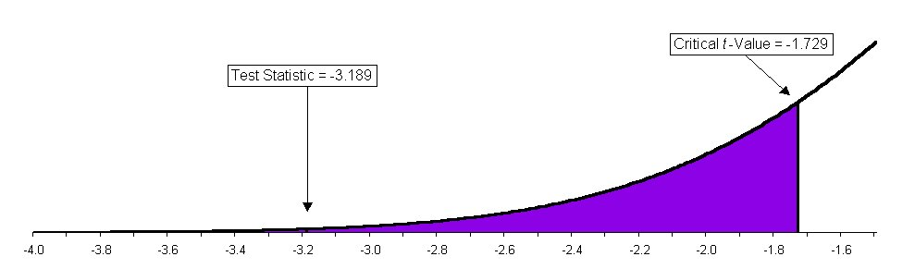
5. Of a sample of 361 owners of retail service and business firms that had gone into bankruptcy, 105 reported having no professional assistance prior to opening the business. Test the null hypothesis that at most 25% of all members of this population had no professional assistance before opening the business.
Formulate Hypotheses:
H₀: p | = 0.25
H_{A}: p | > 0.25
Calculate Test Statistic:
z | $$=\frac{0\text{.}\text{2909}−0\text{.}\text{25}}{\sqrt{\frac{\left(0\text{.}\text{25}\right)\left(0\text{.}\text{75}\right)}{\text{361}}}}$$
 | $$=1\text{.}\text{79}$$
p-value:
p-value | $$=P\left(z>1\text{.}\text{79}\right)$$
 | $$=0\text{.}\text{0367}$$
This null hypothesis can be rejected at any value of α (significance level) greater than 3.67%.
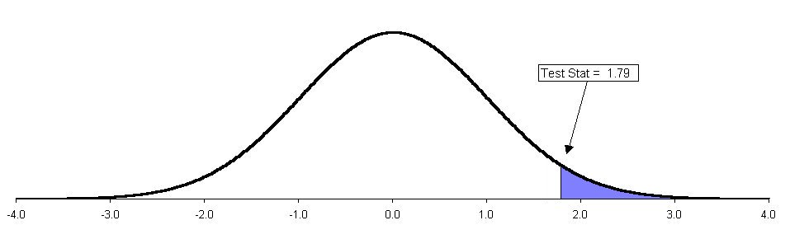

6. In a random sample of 160 business school graduates, seventy-two sample members indicated some measure of agreement with the statement: "A reputation for ethical conduct is less important for a manager's chances for promotion than a reputation for making money for the firm." Test the null hypothesis that one-half of all business school graduates would agree with this statement against a two-sided alternative. Find and interpret the p-value of the test.
Note that $\hat{p}=\frac{\text{72}}{\text{160}}=0\text{.}\text{45}$
Formulate Hypotheses:
H₀: p | = 0.5
H_{A}: p | ≠ 0.5
Calculate Test Statistic:
z | $$=\frac{0\text{.}\text{45}−0\text{.}5}{\sqrt{\frac{\left(0\text{.}5\right)\left(0\text{.}5\right)}{\text{160}}}}$$
 | $$=−1\text{.}\text{26}$$
p-value:
p-value | $$=2\left[P\left(z>1\text{.}\text{26}\right)\right]$$
 | $$=2\left(0\text{.}\text{1038}\right)$$
 | $$=0\text{.}\text{2076}$$
This null hypothesis can be rejected at any value of α (significance level) greater than 20.76%.
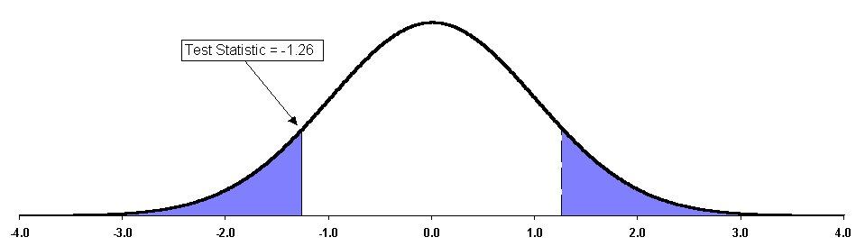
7. The MATWES procedure was designed to measure attitudes toward women as managers. High scores indicate negative attitudes and low scores indicate positive attitudes. Independent random samples were taken of 151 male MBA students and 108 female MBA students. For the former group, the sample mean and standard deviation MATWES scores were 85.8 and 19.3, while the corresponding figures for the latter group were 71.5 and 12.2. Test the null hypothesis that the two population means are equal against the alternative that the true mean MATWES score is higher for male than for female MBA students.
Formulate Hypotheses:
H₀: $μ_{X}−μ_{Y}$ | = 0
H_{A}: $μ_{X}−μ_{Y}$ | > 0
Calculate Test Statistic:
z | $$=\frac{\left(\text{85}\text{.}8−\text{71}\text{.}5\right)−0}{\sqrt{\frac{\text{19}\text{.}3^{2}}{\text{151}}+\frac{\text{12}\text{.}2^{2}}{\text{108}}}}$$
 | $$=7\text{.}\text{29}$$
p-value:
Seven standard deviations away from the hypothesized mean! We can reject this null hypothesis at any reasonable level.

8. In 1980, a random sample of 1,556 people was asked to respond to the statement: "Capitalism must be altered before any significant improvements in human welfare can be realized." Of these sample members, 38.4% agreed with the statement. When the same statement was presented to a random sample of 1,108 people in 1989, 52.0% agreed. Test the null hypothesis that the population proportions agreeing with this statement were the same in the two years, against the alternative that a higher proportion agreed in 1989.
Note that $p_{0}=0\text{.}\text{384}\left(\frac{\text{1556}}{\text{1556}+\text{1108}}\right)+0\text{.}\text{52}\left(\frac{\text{1108}}{\text{1556}+\text{1108}}\right)$
Formulate Hypotheses:
H₀: $p_{X}−p_{Y}$ | = 0
H_{A}: $p_{X}−p_{Y}$ | < 0
Calculate Test Statistic:
z | $$=\frac{\left(0\text{.}\text{384}−0\text{.}\text{52}\right)−0}{\sqrt{\left(0\text{.}\text{44}\right)\left(0\text{.}\text{56}\right)\frac{\text{1556}+\text{1108}}{\left(\text{1556}\right)\left(\text{1108}\right)}}}$$
 | $$=−6\text{.}\text{97}$$
p-value:
Once again, this z-value is so far away from the hypothesized mean that we can reject this null hypothesis at any reasonable level.

9. Of a random sample of 381 investment-grade corporate bonds, 191 had sinking funds. Of an independent random sample of 166 speculative-grade corporate bonds, 145 had sinking funds. Test against a two-sided alternative the null hypothesis that the two population proportions are equal.
Note that $p_{0}=\frac{\text{191}+\text{145}}{\text{381}+\text{166}}=0\text{.}\text{614}$
Formulate Hypotheses:
H₀: $p_{X}−p_{Y}$ | = 0
H_{A}: $p_{X}−p_{Y}$ | ≠ 0
Calculate Test Statistic:
z | $$=\frac{\left(0\text{.}\text{501}−0\text{.}\text{873}\right)−0}{\sqrt{0\text{.}\text{614}\left(0\text{.}\text{386}\right)\frac{\text{381}+\text{166}}{\left(\text{381}\right)\left(\text{166}\right)}}}$$
 | $$=−8\text{.}\text{216}$$
p-value:
We can reject this null hypothesis at any reasonable level.
10. A wine producer claims that the proportion of its customers who cannot distinguish its product from frozen grape juice is at most 0.10. The producer decides to test this null hypothesis against the alternative that the true proportion is greater than 0.10. The decision rule adopted is to reject the null hypothesis if the sample proportion that cannot distinguish between these two flavors exceeds 0.14.
- If a random sample of 100 customers is chosen, what is the probability of a Type I error, using this decision rule?
$$α$$ | $$=P\left(z>\frac{0\text{.}\text{14}−0\text{.}\text{10}}{\sqrt{\frac{\left(0\text{.}\text{10}\right)\left(0\text{.}\text{90}\right)}{\text{100}}}}\right)$$
 | $$=P\left(z>1\text{.}\text{33}\right)$$
 | $$=0\text{.}\text{0918}$$
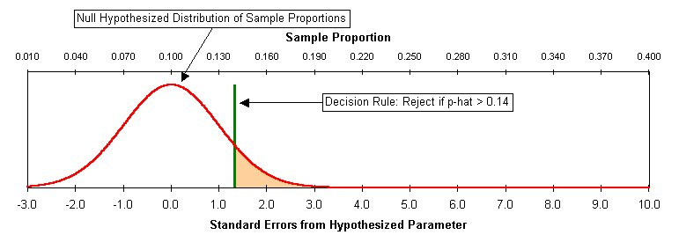
- If a random sample of 400 customers is selected, what is the probability of a Type I error, using this decision rule? Explain, in words and graphically, why your answer differs from that in part (a).
$$α$$ | $$=P\left(z>\frac{0\text{.}\text{14}−0\text{.}\text{10}}{\sqrt{\frac{\left(0\text{.}\text{10}\right)\left(0\text{.}\text{90}\right)}{\text{400}}}}\right)$$
 | $$=P\left(z>2\text{.}\text{67}\right)$$
 | $$=0\text{.}\text{0038}$$
With more data, our standard error is smaller. There is much less chance that a sample of 400, taken from the hypothesized distribution, would have a sample proportion greater than 0.14.
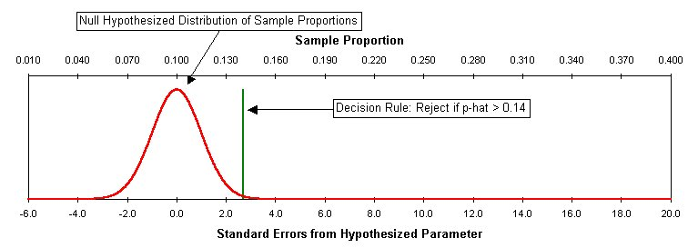
- Suppose that the true proportion of customers who cannot distinguish between these flavors is 0.20. If a random sample of 100 customers is selected, what is the probability of a Type II error?
$$β$$ | $$=P\left(z<\frac{0\text{.}\text{14}−0\text{.}\text{20}}{\sqrt{\frac{\left(0\text{.}\text{20}\right)\left(0\text{.}\text{80}\right)}{\text{100}}}}\right)$$
 | $$=P\left(z<−1\text{.}5\right)$$
 | $$=0\text{.}\text{0668}$$
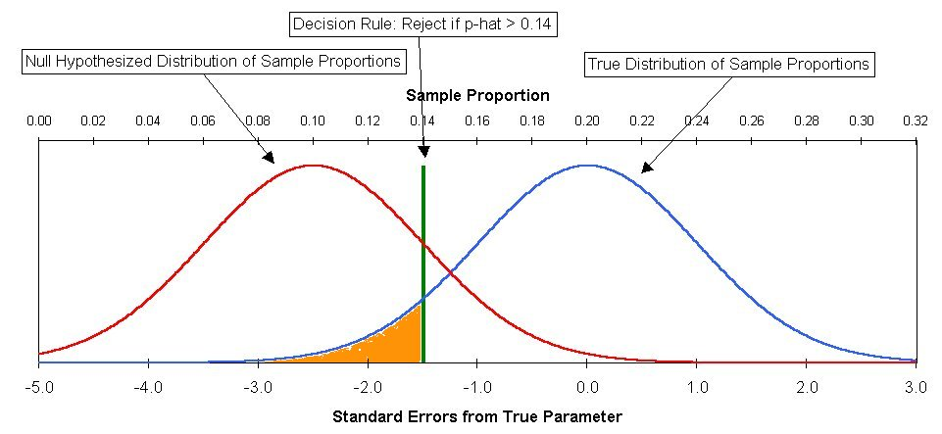
- Suppose that instead of the given decision rule, it is decided to reject the null hypothesis if the sample proportion of customers who cannot distinguish between the two flavors exceeds 0.16. A random sample of 100 customers is selected.
- Without doing the calculations, state whether the probability of a Type I error will be higher than, lower than, or the same as that in part (a).
Lower. We are, in effect, moving the critical value farther to the right (0.16 is farther than 0.14 from the hypothesized proportion of 0.10). The tail of the normal distribution beyond this new cut-off point will be smaller, and so will the probability of a Type I error.
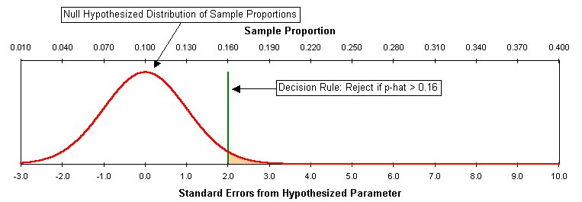
- If the true proportion is 0.20, will the probability of a Type II error be higher than, lower than, or the same as that in part (c)?
Higher. This new cut-off point (0.16) is closer to the true proportion (0.20) than the previous cut-off point (0.14). As the cut-off point gets closer to the true proportion, it becomes more difficult to show that the hypothesized proportion (0.10) is false. Our probability of accepting a false null hypothesis increases as our cut-off point approaches the true mean.
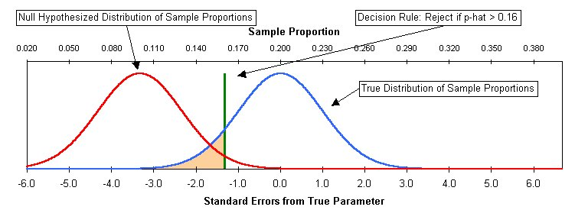
11. State whether each of the following is true or false.
- The significance level of a test is the probability that the null hypothesis is false.
False. The significance (α) is the probability of a sample falling into the rejection region, given that the null hypothesis is true.
- A Type I error occurs when a true null hypothesis is rejected.
True.
- A null hypothesis is rejected at the 0.025 level, but is accepted at the 0.01 level. This means that the p-value of the test is between 0.01 and 0.025.
True.
- The power of a test is the probability of accepting a null hypothesis that is true.
False. The power (1 - β) is the probability of correctly rejecting a false null hypothesis.
- If a null hypothesis is rejected against an alternative at the 5% level, then using the same data, it must be rejected against that alternative at the 1% level.
False. Recall that we reject the null hypothesis when the p-value is smaller than alpha. Now, if we reject at the 5% alpha level, the p-value is known to be less than 5%. That does not necessarily mean that it is less than 1%.
- If a null hypothesis is rejected against an alternative at the 1% level, then using the same data it must be rejected against that alternative at the 5% level.
True.
- The p-value of a test is the probability that the null hypothesis is true.
False. The p-value is based on the assumption that the null hypothesis is true. Given that assumption, the p-value is the probability of finding a sample as far (or farther) away from the null hypothesized value as the sample being analyzed.
12. Supporters claim that a new windmill can generate an average of at least 800 kilowatts of power per day. Daily power generation for the windmill is assumed to be normally distributed with a standard deviation of 120 kilowatts. A random sample of 100 days is taken to test this claim against the alternative hypothesis that the true mean is less than 800 kilowatts. The claim will be accepted if the sample mean is 776 kilowatts or more and rejected otherwise.
- What is the probability  of a Type I error using the decision rule if the population mean is in fact 800 kilowatts per day?
$$α$$ | $$=P\left(z<\frac{\text{776}−\text{800}}{\text{120}\sqrt{\text{100}}}\right)$$
 | $$=P\left(z<−2\right)$$
 | $$=0\text{.}\text{0228}$$
- What is the probability  of a Type II error using this decision rule if the population mean is in fact 740 kilowatts per day?
$$β$$ | $$=P\left(z>\frac{\text{776}−\text{740}}{\text{120}\sqrt{\text{100}}}\right)$$
 | $$=P\left(z>3\right)$$
 | $$=0\text{.}\text{0013}$$
- Suppose that the same decision rule is used, but with a sample of 200 days rather than 100 days.
- Would the value of α be larger than, smaller than, or the same as that found in (a)?
Smaller.
- Would the value of β be larger than, smaller than, or the same as that found in (b)?
Smaller.

- Suppose that a sample of 100 observations was taken but that the decision rule was changed so that the claim would be accepted if the sample mean was at least 765 kilowatts.
- Would the value of α be larger than, smaller than, or the same as that found in (a)?
Smaller.
- Would the value of β be larger than, smaller than, or the same as that found in (b)?
Larger.
13. If a 0.05 level of significance is used in a two-tailed hypothesis test, what will you decide if the computed value of the test statistic is +2.21?
Our decision rule will be to reject the null hypothesis if the absolute value of the test statistic is greater than 1.96. We are told that the computed value of the test statistic z₀ is +2.21, so we decide to reject the null hypothesis.
The 0.05 level of significance means we are prepared to take a 5% risk of a Type I error. Since this is a two-tailed test, this corresponds to a 2.5% probability in each of the two tails. Therefore, each of our two cut-off values ought to be far enough from the null-hypothesized parameter that they correspond to 50% - 2.5% = 47.5% probability.
Look in the middle of the z-table for a value near 0.475, and we find that it corresponds to approximately 1.96 standard deviations from the mean. So our decision rule will be to reject the null hypothesis if the test statistic is less than -1.96, or if it is greater than +1.96.
An alternative method for getting the critical value 1.96 is to use the Excel function
=NORMSINV(0.975).
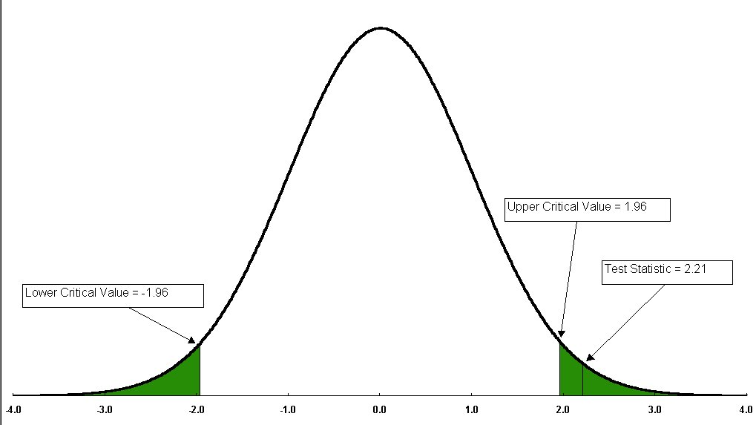
14. If a 0.10 level of significance is used in a two-tailed hypothesis test, what will be your decision rule in terms of z for rejecting a null hypothesis that the population mean is 500?
In this case, each tail must contain 5%, so we look in the middle of the z-table for a value near 0.45, and we find that it corresponds to approximately 1.645 standard deviations from the mean. You can also get the 1.645 critical value using the Excel function =NORMSINV(0.95).
Our test statistic will be:
$$z_{0}$$ | $$=\frac{\overline{X}−\text{500}}{s/\sqrt{n}}$$
Our decision rule will be to reject H₀ if the test statistic is less than -1.645, or if it is greater than +1.645.

15. If a 0.01 level of significance were used in a two-tailed hypothesis test, what would be your decision rule in terms of z for rejecting H₀: $μ=\text{12}\text{.}5$?
In this case, each tail must contain 0.005 so we look in the middle of the z-table for a value near 0.495, and we find that it corresponds to approximately 2.575 standard deviations from the mean. You can also get the 2.575 critical value using the Excel function =NORMSINV(0.995).
Our test statistic will be:
$$z_{0}$$ | $$=\frac{\overline{X}−\text{12}\text{.}5}{s/\sqrt{n}}$$
Our decision rule will be to reject the H₀ if the test statistic is less than -2.575, or if it is greater than +2.575.

16. What would be your decision in #15 above if the computed value of the test statistic z were -2.61?
-2.61 is less than -2.575, so we decide to reject H₀.

17. Suppose the director of manufacturing at a clothing factory needs to determine whether a new machine is producing a particular type of cloth according to the manufacturer's specifications, which indicate that the cloth should have a mean breaking strength of 70 pounds and a standard deviation of 3.5 pounds. A sample of 49 pieces reveals a sample mean of 69.1 pounds.
- State the null and alternative hypotheses.
H₀: | $$μ=\text{70}$$
H_{A}: | $$μ≠\text{70}$$
- Is there evidence that cloth from this machine has an average breaking strength that is different from the manufacturer's specifications? (Use a .05 level of significance.)
Test Statistic: $z_{0}=\frac{X−μ_{0}}{s/\sqrt{n}}$.
Decision Rule: Reject H₀ if the test statistic is greater than 1.96 or less than -1.96.
$$z_{0}$$ | $$=\frac{\overline{X}−μ_{0}}{s/\sqrt{n}}$$
 | $$=\frac{\text{69}\text{.}1−\text{70}}{3\text{.}5/\sqrt{\text{49}}}$$
 | $$=−1\text{.}8$$
We do not reject. There is insufficient evidence against H₀ to reject it at the 0.05 level.
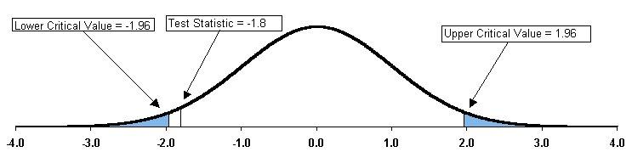
Notice in the chart above how the test statistic z₀ lies in the non-rejection region.
- What will your answer be in (b) if the standard deviation is specified as 1.75 pounds?
$$z_{0}$$ | $$=\frac{\text{69}\text{.}1−\text{70}}{1\text{.}\text{75}/\sqrt{\text{49}}}$$
 | $$=−3\text{.}6$$
Now we reject H₀.
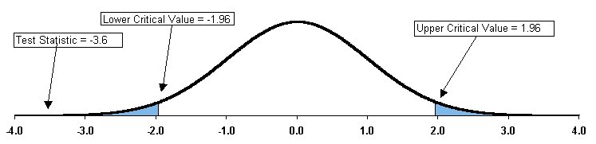
- What will your answer be in (b) if the sample mean is 69 pounds?
$$z_{0}$$ | $$=\frac{\text{69}−\text{70}}{3\text{.}5/\sqrt{\text{49}}}$$
 | $$=−2\text{.}0$$
Reject.
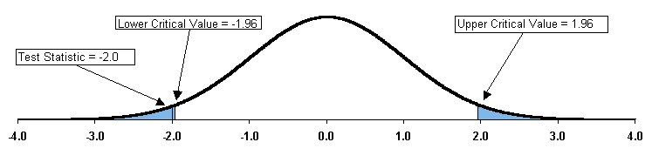
18. A potential entrepreneur is considering the purchase of a coin-operated laundry. The present owner claims that over the past 5 years the average daily revenue has been $675. The buyer would like to find out if the true average daily revenue is different from $675. A sample of 30 selected days reveals a daily average revenue of $625, with a standard deviation of $75.
- State the null and alternative hypotheses.
H₀: | $$μ=\text{675}$$
H_{A}: | $$μ≠\text{675}$$
- Is there evidence that the claim of the present owner is not valid? (Use a .01 level of significance.)
Test Statistic: $z_{0}=\frac{X−μ_{0}}{s/\sqrt{n}}$.
Decision Rule: Reject H₀ if the test statistic is greater than 2.575 or less than -2.575.
$$z_{0}$$ | $$=\frac{\overline{X}−μ_{0}}{s/\sqrt{n}}$$
 | $$=\frac{\text{625}−\text{675}}{\text{75}/\sqrt{\text{30}}}$$
 | $$=−3\text{.}\text{65}$$
We reject H₀. There is sufficiently strong evidence against H₀ to reject it at the 0.01 level. We conclude that the true mean is different from $675.
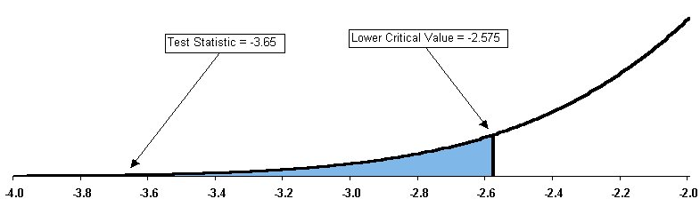
- What will your answer be in (b) if the standard deviation is now $100?
$$z_{0}$$ | $$=\frac{\text{625}−\text{675}}{\text{100}/\sqrt{\text{30}}}$$
 | $$=−2\text{.}\text{74}$$
We still reject H₀.
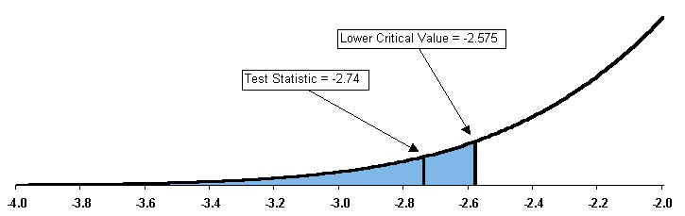
- What will your answer be in (b) if the sample mean is $650?
$$z_{0}$$ | $$=\frac{\text{650}−\text{675}}{\text{75}/\sqrt{\text{30}}}$$
 | $$=−1\text{.}\text{83}$$
Now we do not reject H₀.
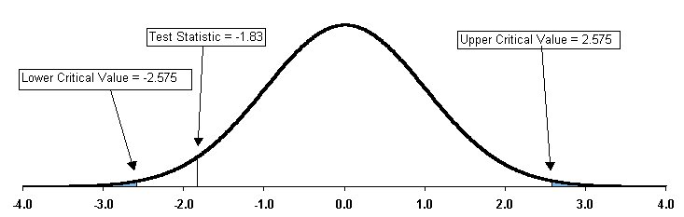

19. ATMs must be stocked with enough cash to satisfy customers making withdrawals over an entire weekend. On the other hand, if too much cash is unnecessarily kept in the ATMs, the bank is forgoing the opportunity of investing the money and earning interest. Suppose that at a particular branch the expected (i.e., population) average amount of money withdrawn from ATM machines per customer transaction over the weekend is $160 with an expected (i.e., population) standard deviation of $30.
- State the null and alternative hypotheses.
H₀: | $$μ=\text{160}$$
H_{A}: | $$μ≠\text{160}$$
[This is a two-tailed test because the language of the question suggests that we are interested to know whether the true mean is different from (either greater than or less than) the null-hypothesized mean of $160.]
- If a random sample of 36 customer transactions is examined and it is observed that the sample mean withdrawal is $172, is there evidence to believe that the true average withdrawal is no longer $160? (Use a 0.05 level of significance.)
Test Statistic: $z_{0}=\frac{X−μ_{0}}{s/\sqrt{n}}$.
Decision Rule: Reject H₀ if the test statistic is greater than 1.96 or less than -1.96.
$$z_{0}$$ | $$=\frac{\overline{X}−μ_{0}}{s/\sqrt{n}}$$
 | $$=\frac{\text{172}−\text{160}}{\text{30}/\sqrt{\text{36}}}$$
 | $$=2\text{.}4$$
We reject H₀. There is sufficient evidence against H₀ to reject it at the 0.05 level.
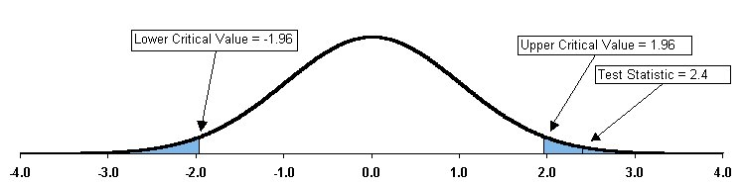
- What will your answer be in (b) if the standard deviation is really $24?
$$z_{0}$$ | $$=\frac{\text{172}−\text{160}}{\text{24}/\sqrt{\text{36}}}$$
 | $$=3\text{.}0$$
We still reject H₀.
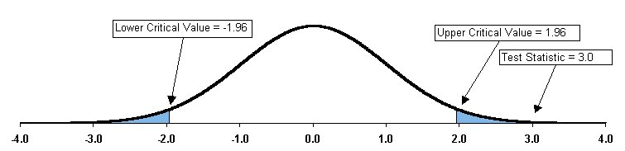
- What will your answer be in (b) if you use a 0.01 level of significance?
Now the critical values are -2.575 and +2.575. The test statistic's value of 2.4 is in this interval, so we do not reject H₀.
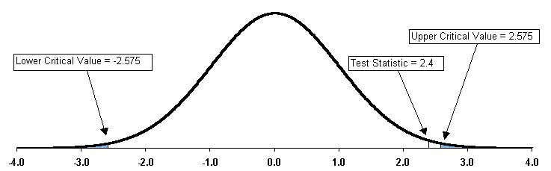
20. Suppose that in a two-tailed hypothesis test you compute the value of the test statistic as +2.00. What is the p-value?
We look up 2.00 in the standard normal table and see that it corresponds to a probability of 0.4772. Therefore, the area under the normal curve outside of 2 standard deviations from the mean is 0.5 - 0.4772 = 0.0228 in each tail.
Since this is a two-tailed test, we need to include both tails of the distribution in our p-value: 2 * 0.0228 = 0.0456. Alternatively, we could use the Excel function:
=2*(1-NORMSDIST(2))

21. Suppose that in a two-tailed hypothesis test you compute the value of the test statistic as -1.38. What is the p-value?
We look up 1.38 in the standard normal table and see that it corresponds to a probability of 0.4162. Therefore, the area under the normal curve more than 1.38 standard deviations from the mean is 0.5 - 0.4162 = 0.0838 in each tail.
Since this is a two-tailed test, our p-value is 2 * 0.0838 = 0.1676. Alternatively, we could use one of these Excel functions:
=2*(1-NORMSDIST(1.38))
=2*(NORMSDIST(-1.38))

22. In #21 above, what is your statistical decision if you test the null hypothesis at the 0.01 level of significance?
We can answer by examining the relationship between alpha (0.01 in this instance) and the p-value (0.1676 in this instance).
Relationship between α and p-value | Decision
p-value < α | Reject H₀
p-value > α | Do Not Reject H₀
In this problem the p-value > α, so we do not reject H₀.
23. Use the same information from Problem 17.
- Compute the p-value and interpret its meaning.
Our test statistic is:
$$z_{0}$$ | $$=\frac{\overline{X}−μ_{0}}{s/\sqrt{n}}$$
 | $$=\frac{\text{69}\text{.}1−\text{70}}{3\text{.}5/\sqrt{\text{49}}}$$
 | $$=−1\text{.}8$$
Looking at the standard normal table, we see that this z value corresponds to a probability of 0.4641. This implies a two-tailed p-value of 2*(0.5 – 0.4641) = 0.0718. (Note that there is no implied direction to our test; we do not have a one-sided alternative hypothesis.) We could also use:
=2*(1-NORMSDIST(1.8))
- What is your statistical decision if you test the null hypothesis at the 0.05 level of significance?
The decision rule is to reject H₀ if the p-value is less than 0.05. Our p-value is greater than 0.05, so we do not reject the null hypothesis.
- Is there evidence that the machine is not meeting the manufacturer's specifications for average breaking strength?
No, not at the 0.05 level of significance.
- Compare your conclusions here with those of (b) in #17 above.
Our conclusion is identical to the one in #19. However, instead of using the four-step classical hypothesis testing procedure, we have gone directly to the p-value.

24. Use the same information from #19 above.
- Compute the p-value and interpret its meaning.
$$z_{0}$$ | $$=\frac{\overline{X}−μ_{0}}{s/\sqrt{n}}$$
 | $$=\frac{\text{172}−\text{160}}{\text{30}/\sqrt{\text{36}}}$$
 | $$=2\text{.}4$$
2.4 standard deviations corresponds to a probability of 0.4918, so our two-tailed p-value is 2*(0.5 – 0.4918) = 0.0164. We could also use:
=2*(1-NORMSDIST(2.4))
- What is your statistical decision if you test the null hypothesis at the 0.05 level of significance?
Our p-value is smaller than 0.05, so we reject the null hypothesis.
- Is there evidence to believe that the true average withdrawal is no longer $160?
Yes. The observed sample mean of $172 would be extremely unlikely if the true population mean were really $160. We take this to be strong evidence that the true population mean is not $160.
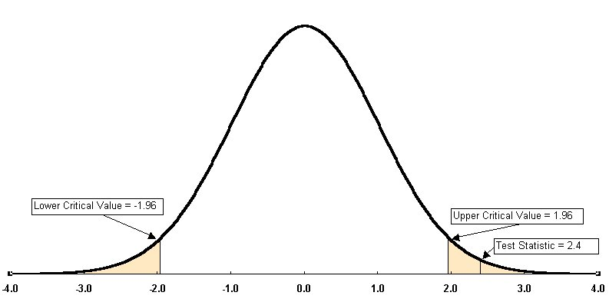
- Compare your conclusions here with those of (b) in #19 above.
Our conclusion is identical to the one in #19 (b). However, instead of using the four-step classical hypothesis testing procedure, we have gone directly to the p-value.
25. The Glen Valley Steel Company manufactures steel bars. If the production process is working properly, it turns out steel bars with an average length of at least 2.8 feet with a standard deviation of 0.20 foot (as determined from engineering specifications on the production equipment involved). Longer steel bars can be used or altered, but shorter bars must be scrapped. A sample of 25 bars is selected from the production line. The sample indicates an average length of 2.73 feet. The company wishes to determine whether the production equipment needs an immediate adjustment.
- State the null and alternative hypotheses.
From the question, we can infer that we are not concerned with bars that are too long, because they can be shortened and still be usable. This implies a one-tailed test, with the rejection region in the lower tail. (We will overlook the obvious wastefulness of having to re-cut all of the bars that come out too long.)
H₀: | $$μ=2\text{.}8$$
H_{A}: | $$μ<2\text{.}8$$

- If the company wishes to test the hypothesis at the 0.05 level of significance, what decision would it make using the classical approach to hypothesis testing? Express your decision rule in terms of the average bar length in feet.
The critical t-value corresponding to a lower tail probability of 0.05 (with 24 degrees of freedom) is –1.711. We want to find a critical value for the sample mean, in terms of bar length, below which we will reject the null hypothesis. 1.711 standard errors below the hypothesized mean can be translated:
$$−1\text{.}\text{711}$$ | $$=\frac{X^{}−μ_{0}}{s\sqrt{n}}$$
$$−1\text{.}\text{711}$$ | $$=\frac{X^{}−2\text{.}8}{0\text{.}\text{20}\sqrt{\text{25}}}$$
$$−1\text{.}\text{711}\left(0\text{.}\text{04}\right)$$ | $$=\frac{X^{}−2\text{.}8}{0\text{.}\text{04}}\left(0\text{.}\text{04}\right)$$
$$−0\text{.}\text{06844}$$ | $$=X^{}−2\text{.}8$$
$$2\text{.}8−0\text{.}\text{06844}$$ | $$=X^{}$$
$$2\text{.}\text{7316}$$ | $$=X^{}$$
The critical value is 2.7316. If the observed sample mean is less than 2.7316, then our decision rule will be to reject the null hypothesis. This decision rule is equivalent to saying that if the observed test statistic t₀ is less than –1.711, then our decision rule will be to reject the null hypothesis
The sample average is 2.73 feet, so we reject the null hypothesis and conclude that the true mean is less than 2.8 feet.
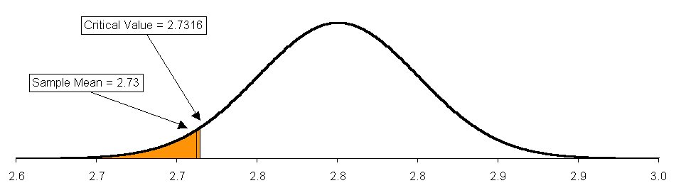
- If the company wishes to test the hypothesis at the 0.05 level of significance, what decision would it make using the p-value approach to hypothesis testing?
In a procedure similar to that used in Problem #22, we can answer by examining the relationship between alpha (0.05 in this instance) and the p-value.
Relationship between α and p-value | Decision
p-value < α | Reject H₀
p-value > α | Do Not Reject H₀

$$t_{0}$$ | $$=\frac{\overline{X}−μ_{0}}{s/\sqrt{n}}$$
 | $$=\frac{2\text{.}\text{73}−2\text{.}8}{0\text{.}\text{20}/\sqrt{\text{25}}}$$
 | $$=−1\text{.}\text{75}$$
In the z-table, 1.75 standard deviations corresponds to a probability of 0.4599, so our one-tailed p-value is approximately 0.5 – 0.4599 = 0.0401. Since this value is smaller than 0.05, we reject the null hypothesis, and conclude that the true population mean is less than 2.8 feet.
Note that this is merely an estimate of the true p-value, using z as an approximation of t. A more precise p-value calculation can be done with the Excel function:
TDIST(Test Stat, n-1, Tails) = TDIST(ABS(-1.75),25-1,1) = 0.04645
- Interpret the meaning of the p-value in this problem.
If the null hypothesis were true and the true population mean were really 2.8 feet, the probability of observing a sample mean of 2.73 feet or smaller would be only 4.64%. For hypothesis testing purposes, we take this to be strong evidence against the null hypothesis.
- Compare your conclusions in (b) and (c).
The conclusions are identical. In both cases we conclude that the true population mean is less than 2.8 feet.
26. The director of manufacturing at a clothing factory needs to determine whether a new machine is producing a particular type of cloth according to the manufacturer's specifications, which indicate that the cloth should have a mean breaking strength of 70 pounds and a standard deviation of 3.5 pounds. The director is concerned that if the mean breaking strength is actually less than 70 pounds, the company will face too many lawsuits. A sample of 49 pieces reveals a sample mean of 69.1 pounds. Is there evidence that cloth from this machine has an average breaking strength that is less than the manufacturer's specifications?
- State the null and alternative hypotheses.
In contrast to Problems #17 and #23 above, the language here suggests that we are interested specifically in whether the population mean is less than (and not merely different from) the hypothesized value of 70 pounds.
H₀: | $$μ=\text{70}$$
H_{A}: | $$μ<\text{70}$$
- At the 0.05 level of significance, is there evidence that the mean breaking strength is less than 70 pounds? Express your decision rule in terms of average breaking strength in pounds.
Our critical value will be the z-value corresponding to a lower tail probability of 0.05, namely –1.645.
$$−1\text{.}\text{645}$$ | $$=\frac{X^{}−μ_{0}}{s\sqrt{n}}$$
$$−1\text{.}\text{645}$$ | $$=\frac{X^{}−\text{70}}{3\text{.}5\sqrt{\text{49}}}$$
$$−1\text{.}\text{645}\left(0\text{.}5\right)$$ | $$=\frac{X^{}−\text{70}}{0\text{.}5}\left(0\text{.}5\right)$$
$$−0\text{.}\text{8225}$$ | $$=X^{}−\text{70}$$
$$\text{70}−0\text{.}\text{8225}$$ | $$=X^{}$$
$$\text{69}\text{.}\text{1775}$$ | $$=X^{}$$
The critical value is 69.1775 pounds. If the observed sample mean is less than 69.1775, then we will reject the null hypothesis. In this case, the sample mean of 69.1 pounds is less than the critical value. Therefore we reject the null hypothesis and conclude that the true mean strength is less than 70 pounds.
- At the 0.05 level of significance, using the p-value approach to hypothesis testing, is there evidence that the mean breaking strength is less than 70 pounds?
$$z_{0}$$ | $$=\frac{\overline{X}−μ_{0}}{s/\sqrt{n}}$$
 | $$=\frac{\text{69}\text{.}1−\text{70}}{3\text{.}5/\sqrt{\text{49}}}$$
 | $$=−1\text{.}8$$
Looking at the standard normal table, we see that this z value corresponds to a probability of 0.4641. This implies a one-tailed p-value of 0.5 – 0.4641 = 0.0359.
Note that the p-value of 0.0359 is less than our acceptable level of Type I error risk of 0.05. Therefore we reject the null hypothesis and conclude that the true mean breaking strength is less than 70 pounds.
- Interpret the meaning of the p-value in this problem.
If the null hypothesis were true and the true population mean were really 70 pounds, the probability of observing a sample mean of 69.1 pounds feet or less would be only 3.59%. For hypothesis testing purposes, we take this to be strong evidence against the null hypothesis.
- Compare your conclusions in (b) and (c).
The conclusions are identical.
27. A manufacturer of salad dressings uses machines to dispense liquid ingredients into bottles that move along a filling line. The machine that dispenses dressings is working properly when 8 ounces are dispensed. The standard deviation of the process is 0.15 ounce. A sample of 50 bottles is selected periodically, and the filling line is stopped if there is evidence that the average amount dispensed is actually less than 8 ounces. Sup-pose that the average amount dispensed in a particular sample of 50 bottles is 7.983 ounces.
- State the null and alternative hypotheses.
H₀: | $$μ=8$$
H_{A}: | $$μ<8$$
- At the 0.05 level of significance, is there evidence that the average amount dispensed is less than 8 ounces? Express your decision rule in terms of the average amount of liquid dispensed.
The critical z-value corresponding to a lower tail probability of 0.05 is –1.645.
$$−1\text{.}\text{645}$$ | $$=\frac{X^{}−μ_{0}}{s\sqrt{n}}$$
$$−1\text{.}\text{645}$$ | $$=\frac{X^{}−8}{0\text{.}\text{15}\sqrt{\text{50}}}$$
$$−1\text{.}\text{645}\left(0\text{.}\text{02121}\right)$$ | $$=\frac{X^{}−8}{0\text{.}\text{02121}}\left(0\text{.}\text{02121}\right)$$
$$−0\text{.}\text{03490}$$ | $$=X^{}−8$$
$$8−0\text{.}\text{03490}$$ | $$=X^{}$$
$$7\text{.}\text{9651}$$ | $$=X^{}$$
The critical value is 7.9651. If the observed sample mean is less than 7.9651, then we will reject the null hypothesis. As it happens, the sample mean is 7.983 ounces, so we do not reject the null hypothesis. The true mean is not significantly less than 8 ounces.
- At the 0.05 level of significance, using the p-value approach to hypothesis testing, is there evidence that the average amount dispensed is less than 8 ounces?
Our test statistic is:
$$z_{0}$$ | $$=\frac{\overline{X}−μ_{0}}{s/\sqrt{n}}$$
 | $$=\frac{7\text{.}\text{983}−8}{0\text{.}\text{15}/\sqrt{\text{50}}}$$
 | $$=−0\text{.}\text{80}$$
Looking at the standard normal table, we see that this z value corresponds to a probability of 0.2881. This implies a one-tailed p-value of 0.5 – 0.2881 = 0.2119.
- Interpret the meaning of the p-value in this problem.
If the null hypothesis were true and the true population mean were really 8 ounces, the probability of observing a sample mean of 7.983 ounces or smaller would be 21.19%. For hypothesis testing purposes, we take this to be weak evidence against the null hypothesis. This sample mean would not really be very unusual if the null hypothesis were true.
- Compare your conclusions in (b) and (c).
The conclusions are identical.
28. The policy of a particular bank branch is that its ATMs must be stocked with enough cash to satisfy customers making withdrawals over an entire weekend. Customer goodwill depends on such services meeting customer needs. At this branch the expected (i.e., population) average amount of money withdrawn from ATM machines per customer over the weekend is $160 with an expected (i.e., population) standard deviation of $30. Suppose that a random sample of 36 customer transactions is examined and it is observed that the sample mean withdrawal is $172.
- State the null and alternative hypotheses.
This question is similar to #19 and #24 above, but there is a subtle difference in the language that suggests an upper tail test instead of a two-tailed test. Note that management seems to be concerned only with the possibility that the true mean is greater than the null-hypothesized value of $160; in the previous problems there was some concern about the mean being either greater than or less than $160. We’ll use an upper tail test in this case.
H₀: | $$μ=\text{160}$$
H_{A}: | $$μ>\text{160}$$

- At the 0.05 level of significance, is there evidence to believe that the true average withdrawal is greater than $160? Express your decision rule in terms of average dollar value per withdrawal.
The critical z-value corresponding to an upper tail probability of 0.05 is 1.645.
$$1\text{.}\text{645}$$ | $$=\frac{X^{}−μ_{0}}{s\sqrt{n}}$$
$$1\text{.}\text{645}$$ | $$=\frac{X^{}−\text{160}}{\text{30}\sqrt{\text{36}}}$$
$$1\text{.}\text{645}\left(5\right)$$ | $$=\frac{X^{}−\text{160}}{5}\left(5\right)$$
$$8\text{.}\text{225}$$ | $$=X^{}−\text{160}$$
$$\text{160}+8\text{.}\text{225}$$ | $$=X^{}$$
$$\text{168}\text{.}\text{225}$$ | $$=X^{}$$
The critical value is 168.225. If the observed sample mean is greater than 168.225, then we will reject the null hypothesis. In this case, our sample mean of 172 is greater then the critical value, so we reject the null hypothesis and conclude that the true mean is greater than $160.
- At the 0.05 level of significance, using the p-value approach to hypothesis testing, is there evidence to believe that the true average withdrawal is greater than $160?
Our test statistic is:
$$z_{0}$$ | $$=\frac{\overline{X}−μ_{0}}{s/\sqrt{n}}$$
 | $$=\frac{\text{172}−\text{160}}{\text{30}/\sqrt{\text{36}}}$$
 | $$=2\text{.}4$$
Looking at the standard normal table, we see that this z value corresponds to a probability of 0.4918. This implies a one-tailed p-value of 0.5 – 0.4918 = 0.0082.
- Interpret the meaning of the p-value in this problem.
If the null hypothesis were true and the true population mean were really $160, the probability of observing a sample mean of $172 or greater would be only 0.82%. For hypothesis testing purposes, we take this to be strong evidence against the null hypothesis.
- Compare your conclusions in (b) and (c).
The conclusions are the same.
29. If, in a sample of size $n=\text{16}$ selected from an underlying normal population, the sample mean is $\overline{X}=\text{56}$ and the sample standard deviation is $s=\text{12}$, what is the value of the t-test statistic if we are testing the null hypothesis H₀ that $μ=\text{50}$?
Our test statistic is:
$$t_{0}$$ | $$=\frac{\overline{X}−μ_{0}}{s/\sqrt{n}}$$
 | $$=\frac{\text{56}−\text{50}}{\text{12}/\sqrt{\text{16}}}$$
 | $$=2\text{.}0$$

30. In #29 above, how many degrees of freedom would there be in the one-sample t-test?
The number of degrees of freedom is n – 1 = 16 – 1 = 15

31. In #29 and #30 above, what are the critical values from the t-table if the level of significance α is chosen to be 0.05 and the alternative hypothesis H_{A} is as follows:
- $μ≠\text{50}$?
The critical t-value corresponding to a two-tailed probability of 0.05 (0.025 in each tail) is ±2.131. If the absolute value of the observed test statistic is greater than 2.131, then we will reject the null hypothesis. (Compare this value to the more familiar z-value of 1.96 associated with the same probability.)
We could also get the critical value of 2.131 using the Excel function:
=TINV(0.05,15)
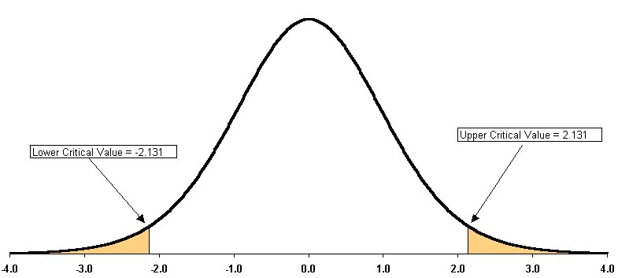
- $μ>\text{50}$?
The critical t-value corresponding to an upper tail probability of 0.05 is ±1.753. If the absolute value of the observed test statistic is greater than 1.753, then we will reject the null hypothesis. (Compare this value to the more familiar z-value of 1.645 associated with the same probability.)
We could also get the critical value of 1.753 using the Excel function:
=TINV(2*(0.05),15)
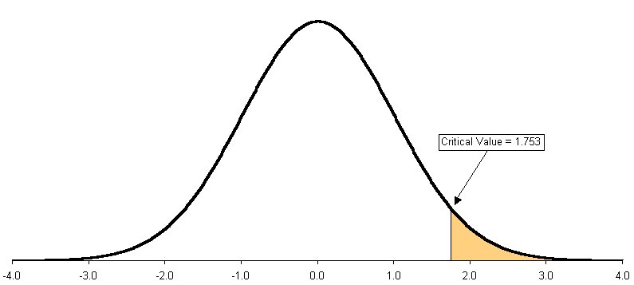
32. In #29, #30, and #31 above, what is your statistical decision if your alternative hypothesis H_{A} is as follows:
- $μ≠\text{50}$?
Recall that the critical t-value for this two-tailed test is ±2.131 (in other words, if the absolute value of the observed test statistic is greater than 2.131, then we will reject the null hypothesis). Here, our test statistic is 2.0, so we do not reject the null hypothesis. We conclude that the true mean is not significantly different from 50.
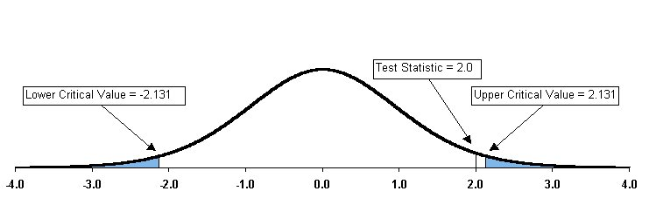
- $μ>\text{50}$?
Now we have an upper tail test, in which the entire 5% rejection region is in the upper tail. The critical value is now 1.753 (from 31b above). Since our test statistic is greater than the critical value (i.e. 2.0 > 1.753) we reject the null hypothesis and conclude that the true mean is significantly greater than 50.
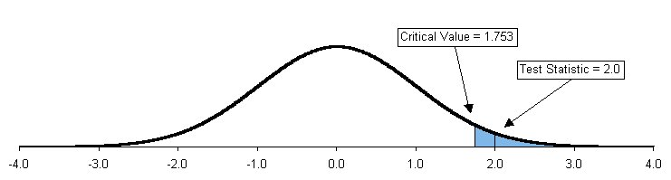
33. The manager of the credit department for an oil company would like to determine whether the average monthly balance of credit card holders is equal to $75. An auditor selects a random sample of 100 accounts and finds that the average owed is $83.40 with a sample standard deviation of $23.65.
- Using the 0.05 level of significance, should the auditor conclude that there is evidence the average balance is different from $75?
H₀: | $$μ=\text{75}$$
H_{A}: | $$μ≠\text{75}$$
Our decision rule is to reject the null hypothesis if the absolute value of the test statistic is greater than 1.96.
Our test statistic is:
$$z_{0}$$ | $$=\frac{\overline{X}−μ_{0}}{s/\sqrt{n}}$$
 | $$=\frac{\text{83}\text{.}4−\text{75}}{\text{23}\text{.}\text{65}/\sqrt{\text{100}}}$$
 | $$=3\text{.}\text{55}$$
Since 3.55 is greater than 1.96, we reject the null hypothesis and conclude that the true population mean is significantly different from $75.
Looking at the standard normal table, we see that this z value is off the chart. We conclude that the p-value is approximately zero.
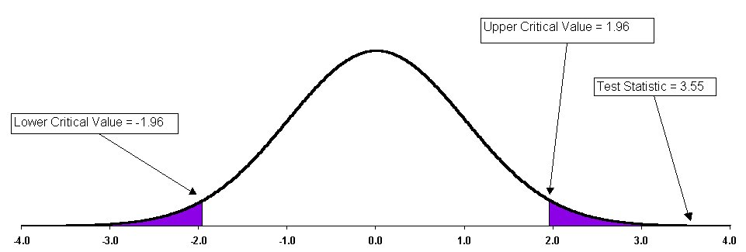
- What is your answer in (a) if the standard deviation is $37.26?
Our test statistic is:
$$z_{0}$$ | $$=\frac{\overline{X}−μ_{0}}{s/\sqrt{n}}$$
 | $$=\frac{\text{83}\text{.}4−\text{75}}{\text{37}\text{.}\text{26}/\sqrt{\text{100}}}$$
 | $$=2\text{.}\text{25}$$
This test statistic is still in the rejection region; we conclude again that the true mean is different from $75. Looking at the standard normal table, we see that this z value corresponds to a probability of 0.4878. This implies a two-tailed p-value of:
2*(0.5 – 0.4878) = 0.0244.
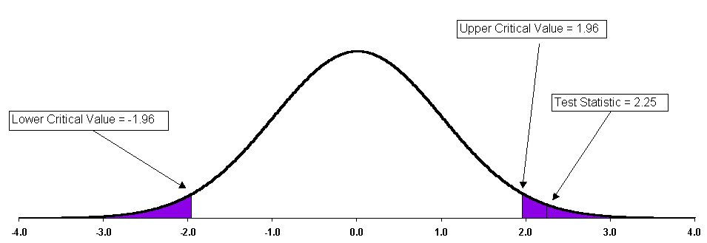
- What is your answer in (a) if the sample mean is $78.81?
Our test statistic is:
$$z_{0}$$ | $$=\frac{\overline{X}−μ_{0}}{s/\sqrt{n}}$$
 | $$=\frac{\text{78}\text{.}\text{81}−\text{75}}{\text{23}\text{.}\text{65}/\sqrt{\text{100}}}$$
 | $$=1\text{.}\text{61}$$
This test statistic is no longer in the rejection region. We conclude this time that the true mean is not significantly different from $75. Looking at the standard normal table, we see that this z value corresponds to a probability of 0.4463. This implies a two-tailed p-value of 2*(0.5 – 0.4463) = 0.1074.
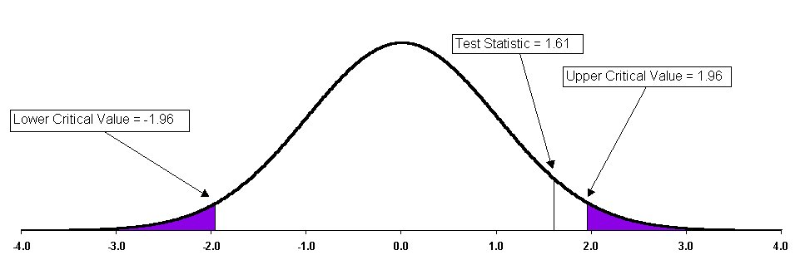
34. A manufacturer of detergent claims that the mean weight of a particular box of detergent is 3.25 pounds. A random sample of 64 boxes reveals a sample average of 3.238 pounds and a sample standard deviation of 0.117 pound.
- Using the 0.01 level of significance, is there evidence that the average weight of the boxes is different from 3.25 pounds?
H₀: | $$μ=3\text{.}\text{25}$$
H_{A}: | $$μ≠3\text{.}\text{25}$$
Our test statistic is:
$$z_{0}$$ | $$=\frac{\overline{X}−μ_{0}}{s/\sqrt{n}}$$
 | $$=\frac{3\text{.}\text{238}−3\text{.}\text{25}}{0\text{.}\text{117}/\sqrt{\text{64}}}$$
 | $$=−0\text{.}\text{82}$$
This test statistic is within the non-reject region. We conclude that the true population average is not significantly different from 3.25.
Looking at the standard normal table, we see that this z value corresponds to a probability of 0.2939. This implies a two-tailed p-value of 2*(0.5 – 0.2939) = 0.4122.
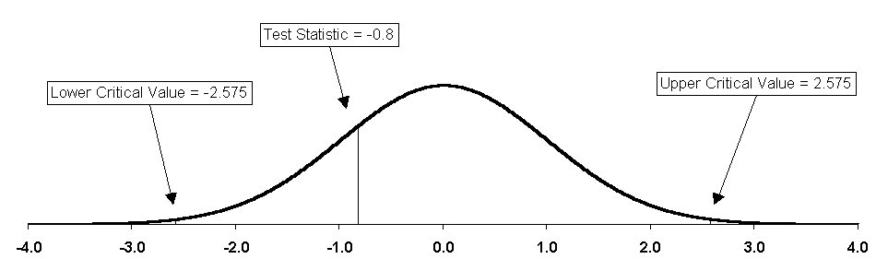
- What is your answer in (a) if the standard deviation is 0.05 pound?
Our test statistic is:
$$z_{0}$$ | $$=\frac{\overline{X}−μ_{0}}{s/\sqrt{n}}$$
 | $$=\frac{3\text{.}\text{238}−3\text{.}\text{25}}{0\text{.}\text{05}/\sqrt{\text{64}}}$$
 | $$=−1\text{.}\text{92}$$
The absolute value of this statistic is less than the critical value, so we do not reject the null hypothesis. The true mean is not significantly different from 3.25.
Looking at the standard normal table, we see that this z value corresponds to a probability of 0.4726. This implies a two-tailed p-value of 2*(0.5 – 0.4726) = 0.0548.
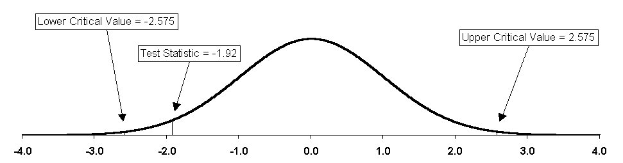
- What is your answer in (a) if the sample mean is 3.211 pounds?
Our test statistic is:
$$z_{0}$$ | $$=\frac{\overline{X}−μ_{0}}{s/\sqrt{n}}$$
 | $$=\frac{3\text{.}\text{211}−3\text{.}\text{25}}{0\text{.}\text{117}/\sqrt{\text{64}}}$$
 | $$=−2\text{.}\text{67}$$
The absolute value of this statistic is greater than our critical value, so we reject the null hypothesis and conclude that the true population mean is different from 3.25.
Looking at the standard normal table, we see that this z value corresponds to a probability of 0.4962. This implies a two-tailed p-value of 0.5 – 0.4962 = 0.0076.
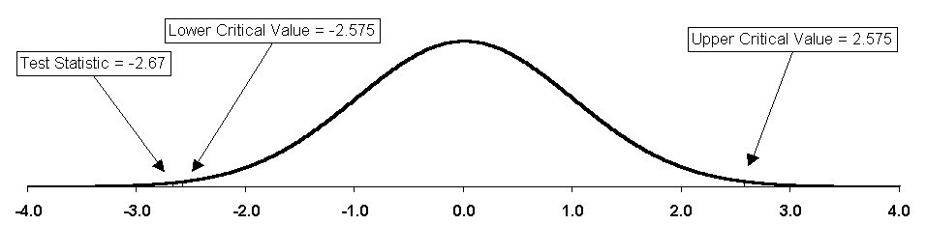
35. A manufacturer of plastics wants to evaluate the durability of rectangularly molded plastic blocks that are to be used in furniture. A random sample of 50 such blocks is examined, and the hardness measurements (in Brinell units) are recorded as follows:
283.6 | 273.3 | 278.8 | 238.7 | 334.9 | 302.6 | 239.9 | 254.6 | 281.9 | 270.4
269.1 | 250.1 | 301.6 | 289.2 | 240.8 | 267.5 | 279.3 | 228.4 | 265.2 | 285.9
279.3 | 252.3 | 271.7 | 235.0 | 313.2 | 277.8 | 243.8 | 295.5 | 249.3 | 228.7
255.3 | 267.2 | 255.3 | 281.0 | 302.1 | 256.3 | 233.0 | 194.4 | 291.9 | 263.7
273.6 | 267.7 | 283.1 | 260.9 | 274.8 | 277.4 | 276.9 | 259.5 | 262.0 | 263.5
(a) Using the 0.05 level of significance, is there evidence that the average hardness of the plastic blocks exceeds 260 (in Brinell units)?
H₀: | $$μ=\text{260}$$
H_{A}: | $$μ>\text{260}$$
We have an upper tail test with alpha = 0.05, so our critical value of z is 1.645.
Our test statistic is:
$$z_{0}$$ | $$=\frac{\overline{X}−μ_{0}}{s/\sqrt{n}}$$
 | $$=\frac{\text{267}\text{.}6−\text{260}}{\text{24}\text{.}\text{20}/\sqrt{\text{50}}}$$
 | $$=2\text{.}\text{23}$$
This test statistic is in the reject region. We conclude that the true population average is significantly greater than 260.
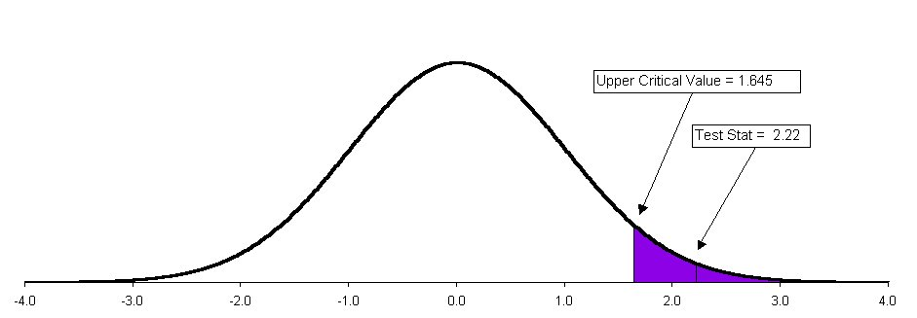
Here is the entire problem 35a in Excel:
- What assumptions are made to perform this test?
We assume that these 50 data form a representative sample of the population, such that $\overline{X}$ is a good estimate of μ and that s is a good estimate of σ. We also assume, based on the Central Limit Theorem, that the distribution of sample means is normal.
- Find the p-value and interpret its meaning.
Looking at the standard normal table, we see that this z value corresponds to a probability of 0.4871. This implies a one-tailed p-value of 0.5 – 0.4871 = 0.0129.
If the null hypothesis were true and the true population mean were really 260 Brinell units, the probability of observing a sample mean of 267.6 units or greater would be only 1.28% (note that we get a slightly more precise estimate of the p-value from Excel than from the z-table). For hypothesis testing purposes, we take this to be strong evidence against the null hypothesis.
- What will be your answer in (a) if the first data value is 233.6 instead of 283.6?
We change cell B8 in the spreadsheet to 233.6, and the sample mean and sample standard deviation update themselves. . Our test statistic is now:
$$z_{0}$$ | $$=\frac{\overline{X}−μ_{0}}{s/\sqrt{n}}$$
 | $$=\frac{\text{266}\text{.}6−\text{260}}{\text{24}\text{.}5/\sqrt{\text{50}}}$$
 | $$=1\text{.}\text{91}$$
We still reject the null hypothesis. Looking at the standard normal table, we see that this z value corresponds to a probability of 0.4719. This implies a one-tailed p-value of
0.5 – 0.4719 = 0.0281.
36. If in a random sample of 400 items, 88 are found to be defective, what is the sample proportion of defective items?
$$\hat{p}$$ | $$=\frac{n_{\text{defective}}}{n_{\text{total}}}$$
 | $$=\frac{\text{88}}{\text{400}}$$
 | $$=0\text{.}\text{22}$$

37. In # 36 above, if it is hypothesized that 20% of the items in the population are defective, what is the value of the z-test statistic?
Our test statistic is:
$$z_{0}$$ | $$=\frac{\hat{p}−p_{0}}{\sqrt{\frac{p_{0}\left(1−p_{0}\right)}{n}}}$$
 | $$=\frac{0\text{.}\text{22}−0\text{.}\text{20}}{\sqrt{\frac{0\text{.}\text{20}\left(1−0\text{.}\text{20}\right)}{\text{400}}}}$$
 | $$=1\text{.}\text{00}$$
38. In #36 and #37 above, suppose you are testing the null hypothesis H₀: $p=0\text{.}\text{20}$ against the two-tailed alternative hypothesis H_{A}: $p≠0\text{.}\text{20}$ and you choose the level of significance α to be 0.05. What is your statistical decision?
The decision rule will be to reject the null hypothesis if the absolute value of the test statistic is greater than 1.96. Our test statistic is 1.00, so we do not reject the null hypothesis. We conclude that the true proportion is not significantly different from 20%.
Looking at the standard normal table, we see that this z value corresponds to a probability of 0.3413. This implies a two-tailed p-value of 2*(0.5 – 0.3413) = 0.3174.
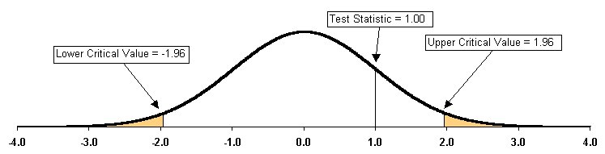
39. A television manufacturer claims in its warranty that in the past not more than 10% of its television sets needed any repair during their first 2 years of operation. To test the validity of this claim, a government testing agency selects a sample of 100 sets and finds that 14 sets required some repair within their first 2 years of operation. Using the 0.01 level of significance,
- is the manufacturer's claim valid or is there evidence that the claim is not valid?
H₀: | $$p=0\text{.}\text{10}$$
H_{A}: | $$p>0\text{.}\text{10}$$
We will reject the null hypothesis if our test statistic is greater than 2.33.
Our test statistic is:
$$z_{0}$$ | $$=\frac{\hat{p}−p_{0}}{\sqrt{\frac{p_{0}\left(1−p_{0}\right)}{n}}}$$
 | $$=\frac{0\text{.}\text{14}−0\text{.}\text{10}}{\sqrt{\frac{0\text{.}\text{10}\left(1−0\text{.}\text{10}\right)}{\text{100}}}}$$
 | $$=1\text{.}\text{33}$$
We conclude that there is insufficient evidence against the manufacturer’s claim; we cannot reject the null hypothesis at the 1% significance level.
- compute the p-value and interpret its meaning.
Looking at the standard normal table, we see that this z value corresponds to a probability of 0.4082. This implies a one-tailed p-value of 0.5 – 0.4082 = 0.0918.
If the null hypothesis were true and the true population proportion were really 10%, the probability of observing a sample proportion of 14% or greater would be 9.18%. For hypothesis testing purposes, we take this to be weak evidence against the null hypothesis. In other words, the evidence is insufficient for us to reject the null hypothesis.
- What is your answer in (a) if 18 sets required some repair?
Now our test statistic is:
$$z_{0}$$ | $$=\frac{\hat{p}−p_{0}}{\sqrt{\frac{p_{0}\left(1−p_{0}\right)}{n}}}$$
 | $$=\frac{0\text{.}\text{18}−0\text{.}\text{10}}{\sqrt{\frac{0\text{.}\text{10}\left(1−0\text{.}\text{10}\right)}{\text{100}}}}$$
 | $$=2\text{.}\text{67}$$
Now, we reject the null hypothesis and conclude that the true proportion is greater than 10%. Looking at the standard normal table, we see that this z value corresponds to a probability of 0.4962. This implies a one-tailed p-value of 0.5 – 0.4962 = 0.0038.
Here’s a close-up view of the extreme upper tail of the distribution of sample proportions, based on the assumption that the null hypothesis is true. The shaded area represents our alpha — a 1% probability. The area to the right of the test statistic is only 0.38%.
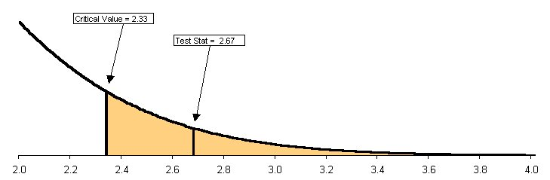
40. The personnel director of a large insurance company is interested in reducing the turnover rate of data processing clerks in the first years of employment. Past records indicate that 25% of all new hires in this area are no longer employed at the end of 1 year. Extensive new training approaches are implemented for a sample of 150 new data processing clerks. At the end of a 1-year period, 29 of these 150 individuals are no longer employed.
- At the 0.01 level of significance, is there evidence that the proportion of data processing clerks who have gone through the new training and are no longer employed is less than 0.25?
H₀: | $$p=0\text{.}\text{25}$$
H_{A}: | $$p<0\text{.}\text{25}$$
We will reject the null hypothesis if our test statistic is less than -2.33.
Our sample proportion is 29/150 = 0.1933.
The test statistic:
$$z_{0}$$ | $$=\frac{\hat{p}−p_{0}}{\sqrt{\frac{p_{0}\left(1−p_{0}\right)}{n}}}$$
 | $$=\frac{0\text{.}\text{1933}−0\text{.}\text{25}}{\sqrt{\frac{0\text{.}\text{25}\left(1−0\text{.}\text{25}\right)}{\text{150}}}}$$
 | $$=−1\text{.}\text{60}$$
This z-value is in the non-reject region. Therefore we do not reject the null hypothesis; the true population turnover rate is not significantly less than 25%.
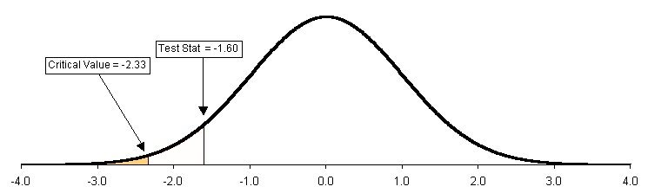
- Compute the p-value and interpret its meaning.
From the standard normal table, we see that our z value corresponds to a probability of 0.4452. This implies a one-tailed p-value of 0.5 – 0.4452 = 0.0548.
If the null hypothesis were true and the true population proportion were really 25%, the probability of observing a sample proportion of 19.33% or smaller would be 5.48%. This is a larger chance of Type I Error than we are prepared to accept. (We want the chance of a Type I Error to be no more than 1%.)
- What is your answer to (a) if 22 of the individuals are no longer employed?
Now the statistics change, as follows:
 | Before | After
Number No Longer Employed | 29 | 22
Sample Proportion | 0.1933 | 0.1467
Test Statistic | -1.60 | -2.92
Conclusion | Do Not Reject | Reject
p-Value | 0.0548 | 0.0018
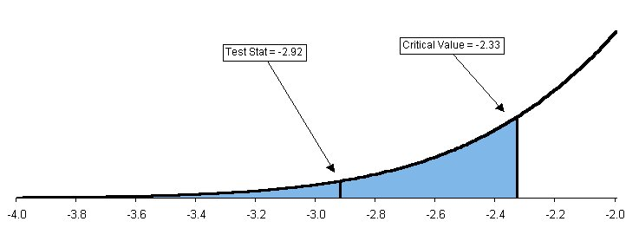
41. The marketing branch of the Mexican Tourist Bureau would like to increase the proportion of tourists who purchase silver jewelry while vacationing in Mexico from its present estimated value of 0.40. Toward this end, promotional literature describing both the beauty and value of the jewelry is prepared and distributed to all passengers on airplanes arriving at a certain seaside resort during a 1-week period. A sample of 500 passengers returning at the end of the 1-week period is randomly selected, and 227 of these passengers indicate that they purchased silver jewelry.
- At the 0.05 level of significance, is there evidence that the proportion has increased above the previous value of 0.40?
H₀: | $$p=0\text{.}\text{40}$$
H_{A}: | $$p>0\text{.}\text{40}$$
We will reject the null hypothesis if the test statistic is greater than 1.645.
$$z_{0}$$ | $$=\frac{\hat{p}−p_{0}}{\sqrt{\frac{p_{0}\left(1−p_{0}\right)}{n}}}$$
 | $$=\frac{0\text{.}\text{454}−0\text{.}\text{40}}{\sqrt{\frac{0\text{.}\text{40}\left(1−0\text{.}\text{40}\right)}{\text{500}}}}$$
 | $$=2\text{.}\text{46}$$
This z-value is in the rejection region. Therefore we reject the null hypothesis; the population proportion of tourists who purchase silver jewelry has increased.
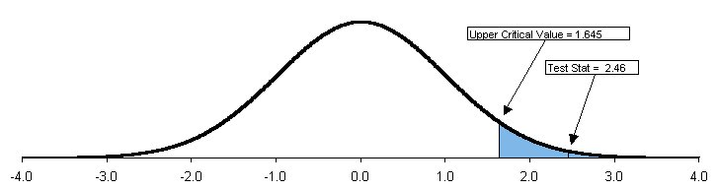
- Compute the p-value and interpret its meaning.
Our test statistic corresponds to a probability of 0.4931, which implies a one-tailed p-value of 0.0069. If the null hypothesis were true and the true population proportion were really 0.40, the probability of observing a sample proportion of 0.454 or greater would be only 0.69%. For hypothesis testing purposes, we take this to be strong evidence against the null hypothesis.
- What is your answer to (a) if 213 passengers indicate that they purchased silver jewelry?
Now the sample proportion is 0.426, the test statistic is 1.19, and the p-value is 0.1170. This time, we do not reject the null hypothesis.
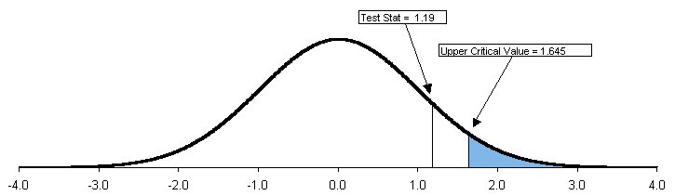

42. The operations manager at a light bulb factory wants to determine if there is any difference in the average life expectancy of bulbs manufactured on two different types of machines. The process standard deviation of Machine I is 110 hours and of Machine II is 125 hours. A random sample of 25 light bulbs obtained from Machine I indicates a sample mean of 375 hours, and a similar sample of 25 from Machine II indicates a sample mean of 362 hours.
- Using the 0.05 level of significance, is there any evidence of a difference in the average life of bulbs produced by the two types of machines?
H₀: | $$μ_{X}−μ_{Y}=0$$
H_{A}: | $$μ_{X}−μ_{Y}≠0$$
We’ll reject the null hypothesis if the absolute value of our test statistic is greater than t_{(24, 0.025)} = 2.064.
Our test statistic is:
$$t_{0}$$ | $$=\frac{\left(\overline{X}−\overline{Y}\right)−0}{\sqrt{\frac{s_{X}^{2}}{n_{X}}+\frac{s_{Y}^{2}}{n_{Y}}}}$$
 | $$=\frac{\left(\text{375}−\text{362}\right)−0}{\sqrt{\frac{{\text{110}}^{2}}{\text{25}}+\frac{{\text{125}}^{2}}{\text{25}}}}$$
 | $$=0\text{.}\text{3904}$$
This test statistic is in the non-reject range. We conclude that there is no significant difference between the average life expectancies of bulbs from the two machines.
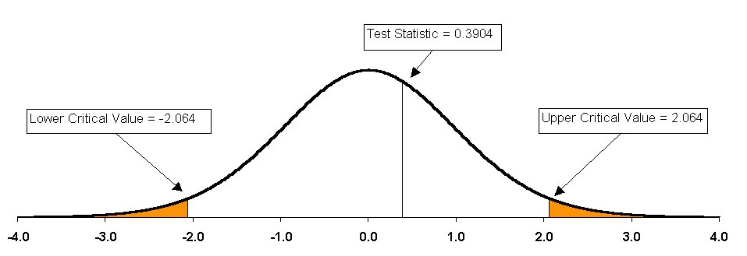
- Compute the p-value in (a) and interpret its meaning.
Looking at the standard normal table, we see that this t value corresponds to a probability of about 0.1517 (using z as an approximation of t). This implies a two-tailed p-value of 2*(0.5 – 0.1517) = 0.6963.
If the null hypothesis were true and there were no difference between the two population means, the probability of observing two samples with a difference of at least (375 – 362) = 13 hours would be 69.63%. We take this to be weak evidence against the null hypothesis. (In fact, it is mildly surprising that these two sample means are so close to each other!)
(Note that there is a more complicated version of this test, called the pooled-variance t-test, which is more statistically valid but beyond the scope of this course. It is demonstrated in Problem 49 below. In this case, the other method would not yield a different conclusion.)
43. The purchasing director for an industrial parts factory is investigating the possibility of purchasing a new type of milling machine. She determines that the new machine will be bought if there is evidence that the parts produced have a higher average breaking strength than those from the old machine. A sample of 100 parts taken from the old machine indicated a sample mean of 65 kilograms and a sample standard deviation of 10 kilograms, whereas a similar sample of 100 from the new machine indicated a sample mean of 72 kilograms and a sample standard deviation of 9 kilograms.
- Using the 0.01 level of significance, is there evidence that the purchasing director should buy the new machine?
H₀: | $$μ_{X}−μ_{Y}=0$$
H_{A}: | $$μ_{X}−μ_{Y}<0$$
This is a lower tailed test, because we want to see if there is evidence that the parts produced on the new machine have a higher average breaking strength than those from the old machine. We let the random variable X represent the breaking strength of parts produced on the old machine and Y represent the corresponding measurements from the new machine. If the difference $μ_{X}−μ_{Y}$ turns out to be significantly less than zero, then it suggests that the parts from the new machine are in fact stronger.
Our critical z-value will be –2.33. If the test statistic is lower than that, then we will reject the null hypothesis.
Our test statistic is:
$$z_{0}$$ | $$=\frac{\left(\overline{X}−\overline{Y}\right)−0}{\sqrt{\frac{s_{X}^{2}}{n_{X}}+\frac{s_{Y}^{2}}{n_{Y}}}}$$
 | $$=\frac{\left(\text{65}−\text{72}\right)−0}{\sqrt{\frac{{\text{10}}^{2}}{\text{100}}+\frac{9^{2}}{\text{100}}}}$$
 | $$=−5\text{.}\text{2031}$$
We reject the null hypothesis and conclude that the parts from the new machine have a higher average breaking strength. (In other words, we will recommend buying the new machine.)
- Compute the p-value in (a) and interpret its meaning.
Looking at the standard normal table, we see that this z value is off the chart.. This implies a one-tailed p-value of approximately zero. Using this Excel function, we can calculate it to be approximately 0.0000001:
=1-NORMSDIST(ABS(-5.2031))
If the null hypothesis were true and the true difference between the population means were really zero, the event of observing two samples with means this far apart would be nearly impossible. For hypothesis testing purposes, we take this to be strong evidence against the null hypothesis.
44. In intaglio printing, a design or figure is carved beneath the surface of hard metal or stone. Suppose that an experiment is designed to compare differences in average surface hardness of steel plates used in intaglio printing (measured in indentation numbers) based on two different surface conditions — untreated versus treated by light polishing with emery paper. In the experiment 40 steel plates are randomly assigned, 20 that are untreated and 20 that are lightly polished. Use a 0.05 level of significance to determine whether there is evidence of a significant treatment effect (i.e., a significant difference in average surface hardness between the untreated and the polished steel plates) if the sample mean for the untreated plates is 163.4 and the sample mean for the polished plates is 156.9. The sample standard deviation in surface hardness (in indentation numbers) was 10.2 for the untreated surfaces and 6.4 for the lightly polished surfaces.
H₀: | $$μ_{X}−μ_{Y}=0$$
H_{A}: | $$μ_{X}−μ_{Y}≠0$$
This is a two-tailed test, because there is no theorized direction to the difference between the two means. Using the most conservative test (19 degrees of freedom), our critical t-value will be ± 2.093; if the absolute value of our test statistic is greater than 2.093, then we will reject the null hypothesis.
Our test statistic is:
$$t_{0}$$ | $$=\frac{\left(\overline{X}−\overline{Y}\right)−0}{\sqrt{\frac{s_{X}^{2}}{n_{X}}+\frac{s_{Y}^{2}}{n_{Y}}}}$$
 | $$=\frac{\left(\text{163}\text{.}4−\text{156}\text{.}9\right)−0}{\sqrt{\frac{\text{10}\text{.}2^{2}}{\text{20}}+\frac{6\text{.}4^{2}}{\text{20}}}}$$
 | $$=2\text{.}\text{41}$$
This is greater than the critical value, so we reject the null hypothesis and conclude that there is a significant difference in average surface hardness between plates that are untreated and those that have been treated with emery paper.
We can approximate the p-value for this test using z instead of t. Looking at the standard normal table, we see that this z value corresponds to a probability of 0.4920. This implies a two-tailed p-value of 2*(0.5 – 0.4920) = 0.0160.
45. A real estate agency wants to compare the appraised values of single-family homes in two Nassau County, New York, communities. A sample of 60 listings in Farmingdale and 99 listings in Levittown yields the following results (in thousands of dollars):
 | Farmingdale | Levittown
$$\overline{X}$$ | 191.33 | 172.34
S | 32.60 | 16.92
n | 60 | 99
(a) At the 0.05 level of significance, is there evidence of a difference in the average appraised values for single-family homes in the two Nassau County communities?
H₀: | $$μ_{X}−μ_{Y}=0$$
H_{A}: | $$μ_{X}−μ_{Y}≠0$$
This is a two-tailed test, because there is no theorized direction to the difference between the two means.
Our critical z-value will be  1.96; if the absolute value of our test statistic is greater than 1.96, then we will reject the null hypothesis. Our test statistic is:
$$z_{0}$$ | $$=\frac{\left(\overline{X}−\overline{Y}\right)−0}{\sqrt{\frac{s_{X}^{2}}{n_{X}}+\frac{s_{Y}^{2}}{n_{Y}}}}$$
 | $$=\frac{\left(\text{191}\text{.}\text{33}−\text{172}\text{.}\text{34}\right)−0}{\sqrt{\frac{\text{32}\text{.}{\text{60}}^{2}}{\text{60}}+\frac{\text{16}\text{.}{\text{92}}^{2}}{\text{99}}}}$$
 | $$=4\text{.}\text{18}$$
This is greater than the critical value, so we reject the null hypothesis and conclude that there is a significant difference in average appraised real estate values between these two communities.
The p-value is approximately zero.
(b) Do you think any of the assumptions needed in (a) have been violated? Explain.
For this type of test, we assume that the two population variances are equal (in fact, the null hypothesis assumes that there is really only one population). Here there is some evidence that the two towns’ appraisals have significantly different standard deviations.
46. The manager of a nationally known real estate agency has just completed a training session on appraisals for two newly hired agents. To evaluate the effectiveness of his training, the manager wishes to determine whether there is any difference in the appraised values placed on houses by these two different individuals. A sample of 12 houses is selected by the manager, and each agent is assigned the task of placing an appraised value (in thousands of dollars) on the 12 houses. The results are as follows:
HOUSE | AGENT 1 | AGENT 2
1 | 181.0 | 182.0
2 | 179.9 | 180.0
3 | 163.0 | 161.5
4 | 218.0 | 215.0
5 | 213.0 | 216.5
6 | 175.0 | 175.0
7 | 217.9 | 219.5
8 | 151.0 | 150.0
9 | 164.9 | 165.5
10 | 192.5 | 195.0
11 | 225.0 | 222.7
12 | 177.5 | 178.0
- At the 0.05 level of significance, is there evidence of a difference in the average appraised values given by the two agents?
This is a two-tailed test, because there is no theorized direction to the difference between the two means. As it happens, we have a good situation for using the matched pairs method, because each house was appraised by each agent.
Let the true population difference between these two means be represented by
$$μ_{D}=μ_{X}−μ_{Y}$$
H₀: | $$μ_{D}=0$$
H_{A}: | $$μ_{D}≠0$$
We have a small-sample test, so we’ll get our critical value from the t-table. We have two tails, alpha = 0.05 (0.025 in each tail), and 11 degrees of freedom, so the critical t-value will be 2.201. If the absolute value of our test statistic is greater than 2.201, then we will reject the null hypothesis.
Our test statistic is:
$$t_{0}$$ | $$=\frac{\overline{D}−0}{s_{D}/\sqrt{n}}$$
 | $$=\frac{−0\text{.}\text{1667}−0}{1\text{.}\text{9042}/\sqrt{\text{12}}}$$
 | $$=−0\text{.}\text{30}$$
We do not reject the null hypothesis. There is no significant difference between the average appraisals made by these two agents.
- What assumption is necessary to perform this test?
We have assumed that the underlying distributions of appraisals from each agent are normal, and that they have equal variances. We also assume that these twelve houses are representative of the population of interest.
- Find the p-value in (a) and interpret its meaning.
There are three approaches to getting a p-value for this problem. First, we can use the z-table as an approximation, knowing that it will always under-estimate the p-value for a t-test. In the z-table we get a value of 0.1179, which implies a two-tailed p-value of
2*(0.5 – 0.1179) = 0.7642
Another way to go is to use a special t-table, such as
http://www.columbia.edu/dj114/t-table2.doc
Using that table, we get 2*(0.3849) = 0.7698.
Finally, we could use the Excel function =TDIST(0.3,11,2). That also yields 0.7698. (This is not surprising, because that is exactly how the special t-table was created.) Actually, our test statistic is more like -0.303195, and a more precise estimate of the p-value is 0.7674.
In any case, all three of these various p-values are fairly close together, and they all carry the same implication. If the null hypothesis were true and there really were no difference between the population means, then the event of having two sample means this far apart or farther would be 76.74%. This is very weak evidence against the null hypothesis. In fact, it is mildly surprising to see the difference so close to zero.
Here is the whole problem #46 in Excel:
Notes: (1) In cell B4 we have made it easy to change from a one-tail to a two-tail test, simply by changing the value in cell B2 from a one to a two. (2) In cell E3 we need to use the absolute value function to deal with the negative test statistic.

47. A few engineering students decide to see whether cars that supposedly do not need high-octane gasoline get more miles per gallon using regular or high-octane gas. They test several cars (under similar road surface, weather, and other driving conditions), using both types of gas in each car at different times. The mileage for each gas type for each car is as follows:
 | CAR
GAS TYPE | 1 | 2 | 3 | 4 | 5 | 6 | 7 | 8 | 9 | 10
Regular | 15 | 23 | 21 | 35 | 42 | 28 | 19 | 32 | 31 | 24
High-octane | 18 | 21 | 25 | 34 | 47 | 30 | 19 | 27 | 34 | 20
- Is there any evidence of a difference in the average gasoline mileage between regular and high-octane gas? (Use α = 0.05.)
This is a two-tailed test, because there is no theorized direction to the difference between the two means. Once again, we have a good situation for using the matched pairs method, because each car was tested with each type of fuel.
Let the true population difference between these two means be represented by
$$μ_{D}=μ_{X}−μ_{Y}$$
H₀: | $$μ_{D}=0$$
H_{A}: | $$μ_{D}≠0$$
We have two tails, alpha = 0.05 (0.025 in each tail), and 9 degrees of freedom, so the critical t-value will be 2.262. If the absolute value of our test statistic is greater than 2.262, then we will reject the null hypothesis.
Our test statistic is:
$$t_{0}$$ | $$=\frac{\overline{D}−0}{s_{D}/\sqrt{n}}$$
 | $$=\frac{−0\text{.}5−0}{3\text{.}\text{44}/\sqrt{\text{10}}}$$
 | $$=−0\text{.}\text{4596}$$
We do not reject the null hypothesis. There is no significant difference between the average gas mileage achieved using the two types of fuel.
- What assumption is necessary to perform this test?
We have assumed that the underlying distributions of gas mileage results from each type of fuel are normal, and that they have equal variances. We also assume that these ten cars are representative of the population of interest. In particular, the assumption of normality might be unreasonable here, especially in the case of the high-octane sample:
- Find the p-value in (a) and interpret its meaning.
Using the Excel function =TDIST(0.4596,9,2), we get a p-value of 0.6567. If the null hypothesis were true and there really were no difference between the population means, then the event of having two sample means this far apart or farther would be 65.67%. This is very weak evidence against the null hypothesis.

48. In order to measure the effect of a storewide sales campaign on nonsale items, the research director of a national supermarket chain took a random sample of 13 pairs of stores that were matched according to average weekly sales volume. One store of each pair (the experimental group) was exposed to the sales campaign, and the other member of the pair (the control group) was not. The following data indicate the results over a weekly period:
STORE | WITH SALES CAMPAIGN | WITHOUT SALES CAMPAIGN
1 | 67.2 | 65.3
2 | 59.4 | 54.7
3 | 80.1 | 81.3
4 | 47.6 | 39.8
5 | 97.8 | 92.5
6 | 38.4 | 37.9
7 | 57.3 | 52.4
8 | 75.2 | 69.9
9 | 94.7 | 89.0
10 | 64.3 | 58.4
11 | 31.7 | 33.0
12 | 49.3 | 41.7
13 | 54.0 | 53.6
- At the 0.05 level of significance, can the research director conclude that there is evidence the sales campaign has increased the average sales of nonsale items?
This is a one-tailed test, because it is proposed that perhaps the sales campaign has some positive effect on sales. There is some question here as to what is the proper statistical test. One possibility would be to use the independent samples method, on the assumption that there is no logical one-to-one relationship between the members of the two groups. (i.e. Store 1 in the campaign group has no more in common with Store 1 in the control group than it has with any other store in the control group). Alternatively, we could use the matched pairs method, arguing that the 13 pairs of stores were matched according to average weekly sales volume, and therefore do represent a one-to-one relationship. We’ll do both methods here, to illustrate any differences in conclusions that might result from our choice of methods.
First, the independent samples method:
Let the true population mean sales with the campaign be represented by _{X}, and the population mean sales without the campaign be represented by _{Y}.
H₀: | $$μ_{X}−μ_{Y}=0$$
H_{A}: | $$μ_{X}−μ_{Y}>0$$
We have a small-sample test, so we’ll get our critical value from the t-table. We have one tail, alpha = 0.05, and 12 degrees of freedom, so the critical t-value will be 1.782. If the value of our test statistic is greater than 1.782, then we will reject the null hypothesis.
Our test statistic is:
$$t_{0}$$ | $$=\frac{\left(\overline{X}−\overline{Y}\right)−0}{\sqrt{\frac{s_{X}^{2}}{n_{X}}+\frac{s_{Y}^{2}}{n_{Y}}}}$$
 | $$=\frac{\left(\text{62}\text{.}\text{85}−\text{59}\text{.}\text{19}\right)−0}{\sqrt{\frac{\text{20}\text{.}{\text{03}}^{2}}{\text{13}}+\frac{\text{19}\text{.}{\text{49}}^{2}}{\text{13}}}}$$
 | $$=0\text{.}\text{4714}$$
We do not reject the null hypothesis. The campaign made no significant difference in sales.
- What assumption is necessary to perform this test?
We have assumed that the underlying distributions of sales in each population are normal, and that they have equal variances. We also assume that these sets of thirteen stores are representative of the population of interest. Here’s a histogram of the more skewed of the two distributions, the “No Campaign” sample:
It’s hard to be confident that this sample came from a normal distribution, although it isn’t as obviously non-normal as the previous example in Problem 47.
- Find the p-value in (a) and interpret its meaning.
Looking at the standard normal table, we see that this t-value is corresponds to a probability of 0.1808 in the standard normal table. This implies a one-tailed p-value of at least 0.5 – 0.1808 = 0.3192.
Another approach to estimating the p-value would be to use a special t-table, such as http://www.columbia.edu/~dj114/t-table2.doc, which yields a p-value of somewhere between 0.3131 and 0.3481.
A third, more precise method is to use the Excel function =TDIST(0.4714,12,1), which gives us 0.3229.
If the null hypothesis were true and the difference between the true population means were really 0, the probability of observing two sample means with a difference this large or larger would be 32.29%. This is weak evidence against the null hypothesis.
Now, the matched pairs method:
Let the true difference between the population means be represented by _{D}.
H₀: | $$μ_{D}=0$$
H_{A}: | $$μ_{D}>0$$
The critical t-value will still be 1.782. If the value of our test statistic is greater than 1.782, then we will reject the null hypothesis.
Our test statistic is:
$$t_{0}$$ | $$=\frac{\overline{D}−0}{\frac{s_{D}}{\sqrt{n}}}$$
 | $$=\frac{3\text{.}\text{6538}−0}{\frac{3\text{.}\text{1855}}{\sqrt{\text{13}}}}$$
 | $$=4\text{.}\text{14}$$
This time we do reject the null hypothesis, and conclude that the campaign actually did have a significant positive effect on sales.
- What assumption is necessary to perform this test?
We have assumed that the underlying distribution of sample mean differences ($\overline{D}$) is normal, and that the pairs of stores are representative of the population of interest. The assumption of normality is not well supported by the histogram (see below).
The most critical assumption here is that the pairs really are pairs, in the sense that any difference between the two stores’ sales in each pair can be attributed to the difference between the campaign and no campaign.
- Find the p-value and interpret its meaning.
Looking at the standard normal table (or the special t-table for that matter), we see that this t-value of 4.14 is so large that it is off the table. We conclude that the p-value is very close to zero.
The Excel function =TDIST(4.14,12,1) gives us a one-tailed p-value of 0.0007.
If the null hypothesis were true and the difference between the true population means were really 0, the probability of observing sample differences with an average this large or larger would only be 0.07%. This is very strong evidence against the null hypothesis.
In comparing the results from the two methods, notice how the superior statistical power of the matched pairs technique allows us to make inferences that were not possible when we used the independent samples method.
49. The R & M department store has two charge plans available for its credit-account customers. The management of the store wishes to collect information about each plan and to study the differences between the two plans. It is interested in the average monthly balance. Random samples of 25 accounts of Plan A and 50 accounts of Plan B are selected with the following results:
PLAN A | PLAN B
$$n_{A}=\text{25}$$ | $$n_{B}=\text{50}$$
$$\overline{A}=\$\text{75}$$ | $$\overline{B}=\$\text{110}$$
$$s_{A}=\$\text{15}$$ | $$s_{B}=\$\text{14}\text{.}\text{14}$$
Use statistical inference (confidence intervals or tests of hypotheses) to draw conclusions about each of the following:
Note: Use a level of significance of 0.01 (or use 99% confidence) throughout.
- Average monthly balance of all Plan B accounts.
Confidence Interval | $$=\overline{B}±z_{α}\frac{s_{B}}{\sqrt{n_{B}}}$$
 | $$=\text{110}±2\text{.}\text{575}\frac{\text{14}\text{.}\text{14}}{\sqrt{\text{50}}}$$
 | $$=\text{110}±5\text{.}\text{15}$$
Or | $$\left(\text{104}\text{.}\text{85}, \text{115}\text{.}\text{15}\right)$$
- Is there evidence that the average monthly balance of Plan A accounts is different from $105?
H₀: | $$μ_{A}=\text{105}$$
H_{A}: | $$μ_{A}≠\text{105}$$
Decision rule: Based on the two-tailed critical values in the t-table, we’ll reject the null hypothesis if the absolute value of the test statistic t₀ is greater than 2.797. Our test statistic is:
$$t_{0}$$ | $$=\frac{\overline{A}−μ_{0}}{s_{A}/\sqrt{n_{A}}}$$
 | $$=\frac{\text{75}−\text{105}}{\text{15}/\sqrt{\text{25}}}$$
 | $$=−\text{10}$$
We definitely reject this null hypothesis. There is almost no chance that we would see a sample mean this far away from $105 if the true mean were really $105. We conclude that the true average monthly balance of Plan A accounts is significantly different from $105.
- Is there evidence of a difference in the average monthly balances between Plan A and Plan B?
Let the true population mean monthly balance for Plan A be represented by _{A}, and the population mean monthly balance for Plan B be represented by _{B}.
H₀: | $$μ_{A}−μ_{B}=0$$
H_{A}: | $$μ_{A}−μ_{B}≠0$$
This is an ambiguous situation, because we are used to having large samples when we perform the independent samples test for the difference between two means. Here we have on sample that is not quite large enough by statistical convention (Plan A’s sample has only 25 observations). We’ll use this problem to illustrate two possible testing methods: the familiar independent samples test, and the more correct pooled-variance t-test.
First, the independent samples test. It isn’t clear here whether the critical value ought to come from the t-table or the z-table, because one sample has a “large” size and the other is “small”. We will go with the more conservative approach here and get our critical value from the t-table. We have two tails, alpha = 0.01, and at least 24 degrees of freedom, so the most conservative critical t-value will be 2.797. If the absolute value of our test statistic is greater than 2.797, then we will reject the null hypothesis.
Our test statistic is:
$$t_{0}$$ | $$=\frac{\left(\overline{A}−\overline{B}\right)−0}{\sqrt{\frac{s_{A}^{2}}{n_{A}}+\frac{s_{B}^{2}}{n_{B}}}}$$
 | $$=\frac{\left(\text{75}−\text{110}\right)−0}{\sqrt{\frac{{\text{15}}^{2}}{\text{25}}+\frac{\text{14}\text{.}{\text{14}}^{2}}{\text{50}}}}$$
 | $$=−9\text{.}\text{71}$$
We reject the null hypothesis. There is a significant difference between the two population means.
- Determine the p-values in (b) and (c) and interpret their meaning.
In both cases the p-value is approximately zero. If the null hypotheses were true, there would be virtually no chance of seeing samples whose means were this far apart.
- On the basis of the results of (a), (b), (c), and (d), what will you tell the management about the two plans?
There is very compelling evidence to indicate that there is a significant difference between the average monthly balances for the two plans. I would tell them that Plan B customers carry significantly higher monthly balances than Plan A customers. (Note that technically we never actually tested whether Plan B balances were greater than Plan A balances — we only asked whether they were different from each other — but that is an obvious conclusion from our analysis.)
Now, for the pooled variance t-test.
H₀: | $$μ_{A}−μ_{B}=0$$
H_{A}: | $$μ_{A}−μ_{B}≠0$$
We will get our critical value from the t-table. We have two tails, α = 0.01, and n_{X} + n_{Y} - 2 = 73 degrees of freedom, so the appropriate critical t-value will be $t_{\left(α/2,n_{A}+n_{B}−2\right)}$, which we can get using Excel:
TINV(0.01,(25+50)-2) = 2.645
If the absolute value of our test statistic is greater than 2.645, then we will reject the null hypothesis. (You could make a reasonable argument for using the analogous z-value of 2.575 here, but we’ll stick with t.)
Our test statistic is:
$$t_{0}$$ | $$=\frac{\left(\overline{A}−\overline{B}\right)−0}{\sqrt{S_{p}^{2}\left(\frac{1}{n_{A}}+\frac{1}{n_{B}}\right)}}$$
 | $$=\frac{\left(\overline{A}−\overline{B}\right)−0}{\sqrt{\left(\frac{\left(n_{A}−1\right)s_{A}^{2}+\left(n_{B}−1\right)s_{B}^{2}}{\left(n_{A}−1\right)+\left(n_{B}−1\right)}\right)\left(\frac{1}{n_{A}}+\frac{1}{n_{B}}\right)}}$$
 | $$=\frac{\left(\text{75}−\text{110}\right)−0}{\sqrt{\left(\frac{\left(\text{25}−1\right){\text{15}}^{2}+\left(\text{50}−1\right)\text{14}\text{.}{\text{14}}^{2}}{\left(\text{25}−1\right)+\left(\text{50}−1\right)}\right)\left(\frac{1}{\text{25}}+\frac{1}{\text{50}}\right)}}$$
 | $$=\frac{−\text{35}}{3\text{.}\text{534}}$$
 | $$=−9\text{.}\text{90}$$
Our conclusion here is pretty much identical to that using the other method. Note, however, that we have a more powerful test, statistically speaking. The difference here is minimal, because (a) the difference between these sample means was in fact quite large, and (b) the samples were both fairly large, even if one of them was less than 30. If these two conditions were not true, then the pooled variance test might actually allow for rejecting H₀ when the standard test might not.
50. The manager of computer operations of a large company wishes to study computer usage of two departments within the company, the accounting department and the research department. A random sample of five jobs from the accounting department in the last week and six jobs from the research department in the last week are selected, and the processing time (in seconds) for each job is recorded.
Department | Processing Time (In Seconds)
Accounting | 9 | 3 | 8 | 7 | 12
Research | 4 | 13 | 10 | 9 | 9 | 6
Choosing a level of significance of 0.05 (or 95% confidence), use statistical inference (confidence intervals or tests of hypotheses) to draw conclusions about each of the following:
- Average processing time for all jobs in the accounting department.
Confidence Interval | $$=\overline{X}±t_{\left(n−1,α/2\right)}\frac{s}{\sqrt{n}}$$
 | $$=7\text{.}8±2\text{.}\text{776}\frac{3\text{.}\text{271}}{\sqrt{5}}$$
 | $$=7\text{.}8±4\text{.}\text{06}$$
Or | (3.74, 11.860)
- Is there evidence that the average processing time in the research department is greater than 6 seconds?
H₀: | $$μ=6$$
H_{A}: | $$μ>6$$
We’ll have an upper-tail test, with a critical value of t_{(n-1, α)} = t_{(5, 0.05)} = 2.015. Our decision rule will be to reject the null hypothesis if the test statistic is greater than 2.015.
Our test statistic is:
$$t_{0}$$ | $$=\frac{\overline{Y}−μ_{0}}{s/\sqrt{n}}$$
 | $$=\frac{8\text{.}5−6}{3\text{.}\text{146}/\sqrt{6}}$$
 | $$=1\text{.}\text{95}$$
We cannot reject the null hypothesis; there is insufficient evidence to conclude that the mean is greater than 6 seconds.
- Is there evidence of a difference in the mean processing time between the accounting department and the research department?
H₀: | $$μ_{X}−μ_{Y}=0$$
H_{A}: | $$μ_{X}−μ_{Y}≠0$$
This situation requires the pooled variance t-test, because we have such small samples and there is no basis for a matched-pairs test.
We will get our critical value from the t-table. We have two tails, alpha = 0.05, and n_{X} + n_{Y} - 2 = 9 degrees of freedom, so the appropriate critical t-value will be 2.262. If the absolute value of our test statistic is greater than 2.262, then we will reject the null hypothesis.
Our test statistic is:
$$t_{0}$$ | $$=\frac{\left(\overline{X}−\overline{Y}\right)−0}{\sqrt{S_{p}^{2}\left(\frac{1}{n_{X}}+\frac{1}{n_{Y}}\right)}}$$
 | $$=\frac{\left(\overline{X}−\overline{Y}\right)−0}{\sqrt{\left(\frac{\left(n_{x}−1\right)s_{X}^{2}+\left(n_{Y}−1\right)s_{Y}^{2}}{\left(n_{x}−1\right)+\left(n_{Y}−1\right)}\right)\left(\frac{1}{n_{X}}+\frac{1}{n_{Y}}\right)}}$$
 | $$=\frac{\left(7\text{.}8−8\text{.}5\right)−0}{\sqrt{\left(\frac{\left(5−1\right)3\text{.}{\text{271}}^{2}+\left(6−1\right)3\text{.}{\text{146}}^{2}}{\left(5−1\right)+\left(6−1\right)}\right)\left(\frac{1}{5}+\frac{1}{6}\right)}}$$
 | $$=\frac{−0\text{.}7}{1\text{.}\text{939}}$$
 | $$=−0\text{.}\text{361}$$
We cannot reject the null hypothesis. There is no significant difference between the two population means.
- What must you assume to do in (c)?
We have assumed that the two populations not only have the same mean (on the basis of the null hypothesis), but that they also have the same variance. In this case, the common variance assumption might be reasonable, considering that the two sample standard deviations are similar.
- Determine the p-values in (b) and (c), and interpret their meanings.
For (b), using the Excel function =TDIST(1.95, 5, 1), we see that the 1-tailed p-value is approximately 0.055.
If the null hypothesis were true and the true population mean were really 6 seconds, the probability of observing a sample mean of 8.5 seconds or greater would be 5.5%. For hypothesis testing purposes, we take this to be weak evidence against the null hypothesis; it is slightly more risk of a Type I error than we are prepared to accept.
For (c), using the Excel function =TDIST(ABS(-0.361),((5+6)-2),2), we see that the 2-tailed p-value is approximately 0.7264.
If this null hypothesis were true and the difference between the true population means were really zero, the probability of observing two sample means whose difference was 0.361 seconds or greater would be 72.64%. For hypothesis testing purposes, we take this to be very weak evidence against the null hypothesis; it is not at all surprising to see that the two sample means are this far apart, even if they come from the same underlying distribution.

There is a version of the F-test that can be used to test the null hypothesis that two populations have the same variance, but that test is beyond the scope of this course. The test is built into Excel (Tools – Data Analysis – F-Test Two Sample for Variances), but it requires all of the raw data, not just summary statistics as we have here.
There are more sophisticated statistical hypothesis tests to see whether data have come from a normal distribution (or any other distribution, for that matter). One such test is the chi-square test, which is beyond the scope of this class. For our purposes, we can use a histogram to perform an “eyeball” test to see if it is reasonable to assume that these data came from a normal distribution.

