[Editor’s note: In October 2004, Ronda Hauben and Jay Hauben met Professor Werner Zorn in Berlin Germany. They had heard that Zorn and Karlsruhe University in Germany were involved with the first email connectivity between the People's Republic of China and a foreign country. Zorn was happy to tell about the historic events in which he took part. He had for them articles and papers documenting the early history of computer networking in China and between China and especially Germany. His story was very informative for anyone piecing together the international origin and history of the Internet. What follows is some of the story Zorn shared and that is told in the documents.]

“Across the Great Wall”
The China-Germany Email Connection 1987-1994
by Jay Hauben
jrh@ais.org

In 1987 an email connection was established between the People’s Republic of China and the Federal Republic of Germany. Many factors contributed to make that connection possible. The World Bank extends credit and investments to developing countries. In the early 1980s, it supported the import of computers for use in universities in China. At that time, export of computers from the US to China was forbidden by the US government. The German government also subscribed to the COCOM export rules but computers made by the German company Siemens met the criteria to be allowed export to China. In 1982, the World Bank Chinese University Development Project I* was allotted $200 million. It used some of that money for the import into China of 19 Siemens BS2000 mainframe computers manufactured in Germany.

Werner Zorn who would play a crucial role in the first China-Germany email connection had experience with Siemens computers. He gained that experience in his work as Head of the Computing Center IRA (Informatik Rechnerabteilung) and Professor of Computer Science at Karlsruhe University, a major institute for education and research in western Germany. Zorn’s specialty was computer networks and performance analysis. Zorn was leader of the project which worked in 1983 and 1984 to make the first German email connection with the US Computer Science Network (CSNET). Also, in 1983, he began a friendly and collaborative relation with Professor Wang Yuen Fung (Yufeng Wang), Senior Advisor of the Chinese Institute of Computer Applications (ICA) in Beijing. That was when they organized the first Chinese Siemens Computer User Conference (CASCO – Symposium ‘83) which took place in September of that year. The ICA which was under the Chinese Ministry of Machinery and Electronics Industry was to play the crucial role on the Chinese side in establishing and maintaining the China-Germany email connectivity from 1987-1994.

At the first CASCO symposium in Beijing, Zorn gave a keynote speech on the German Research Network (DFN) project. He also led a seminar on the same topic. One of the Chinese interpreters challenged Zorn, remarking that lecturing was not enough. Would Zorn also do something more for China? That comment planted a seed that grew as the warmth and friendship developed between the German visitors and their Chinese hosts. They should try to do something together. Professor Wang encouraged a Chinese-German computer network collaboration.

The preparatory work for a China-Germany email connection began a few months after the Germany-US CSNET connectivity had been established. The Siemens BS2000 was to be the computer at ICA available for use for the email connection. It was hoped that the China-Germany email connection would be a step toward connecting China with the growing CSNET, a network begun in the US in 1980 to provide email connections among university computer science departments. To connect to CSNET, a computer would need particular communication functionality as part of its operating system. The specifications or protocols describing that functionality for CSNET were the CSNET/PMDF transport protocols. This PMDF had not yet been implemented in the Siemens BS2000 operating system. In late 1984, Zorn decided to undertake this task together with his students but only as a background job. Including the lower levels, it took at least two years to complete. The work was financially supported after November 1985 by the government of the West German state of Baden-Wuerttemberg, under Prime Minister Lothar Spaeth.

CSNET email traffic to and from Germany was routed using the X.25 lower level protocols. The X.25 protocols were the result of an effort to create a universal and global packet-switched network on what was then the bit-error prone analog telephone system. Much of the X.25 system is a description of the rigorous error correction needed to achieve this. In 1985, there was no physical path to carry X.25 email traffic between China and Germany. To have such a path, telephone lines with switches that could route X.25 email traffic were needed. China had begun to develop a network of such switches for internal X.25. So had Germany. X.25 email traffic could be transported within China and within Germany. But there was no X.25 link between them. With the help of the PKTELCOM data network administered by the Beijing Telecommunications Administration, the Karlsruhe team made contact with the Italian carrier Italcable which had some leased lines between China and Italy. Italcable agreed to open its switches to route the anticipated X.25 email traffic between China and Germany. Italcable was able to open its switches on Aug. 26 1986. From that day on, reliable remote computer-to-computer dialogue was available between Karlsruhe University and ICA through PKTELCOM. This channel would make possible the communication necessary one year later during the implementation phase of the China-Germany email connection. Also, as soon as the computer scientists at ICA and Karlsruhe could implement X.25, PMDF, and other protocols on the Siemens BS2000 computer at ICA in Beijing, the China-Germany connection would have an X.25 route through Italy.

In late summer 1987, Zorn was in Beijing for the third CASCO conference where he gave the keynote address on “Computer Networks”. But also he was there to work with the staff of the ICA to set up the first email connectivity between China and Germany. His team at Karlsruhe University had succeeded in getting the PMDF protocols to work on their Siemens BS2000 computer. In a little over two weeks, September 4 to 20, 1987, assisted by the staff of ICA, Zorn with his team implemented within the operating system of the ICA Siemens 7760/BS2000 computer the necessary protocols and installed the necessary communications equipment to make possible email connectivity with Karlsruhe. For the lower three OSI layers, X.25 with PAD access over telephone lines were used. For the higher layers, the Karlsruhe BS2000/PMDF implementation of the CSNET protocols was used. On September 14, 1987, Professor Zorn and the ICA staff achieved the breakthrough they needed, host-to-host connectivity with Karlsruhe University. Zorn was able then to leave half of his team in Beijing to work with their Chinese colleagues to finish the job.

Before Zorn left, the joint German and Chinese team composed an email message with the subject line, "First Electronic Mail from China to Germany". The message began in German and English, “Ueber die Grosse Mauer erreichen wie alle Ecken der Welt” "Across the Great Wall we can reach every corner in the world." The message, with cc:s to Lawrence Landweber, David Farber, Dennis Jennings, and to themselves was signed by Professor Werner Zorn for the University of Karlsruhe Computer Science Department (Informatik Rechnerabteilung) and Professor Wang Yuen Feng for the ICA. Eleven coworkers are also listed as signatories, Michael Finken, Stefan Paulisch, Michael Rotert, Gerhard Wacker and Hans Lackner on the Karlsruhe side and Dr. Li Cheng Chiung, Qiu Lei Nan, Ruan Ren Cheng, Wei Bao Xian, Zhu Jiang and Zhao Li Hua on the ICA side, suggesting the complexity of the task. Zorn mentioned Dr. Li Cheng Chiung, in particular, as playing an important role as the Director of the ICA Computing Center. Successful connectivity was achieved in a few more days. On September 20, 1987, the first email message, the one composed on September 14, could actually be sent to the VAX 11/750 computer at Karlsruhe.

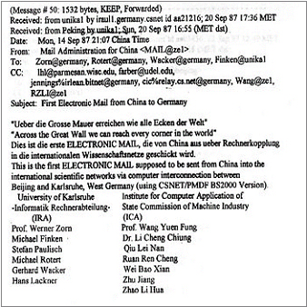
The transmission of this first email message went over an X.25 connection. At ICA, the sender dialed using a 300 baud modem to one of the ports of the PKTELCOM Beijing X.25 PAD, located at the Beijing PTT. PKTELCOM Beijing was connected over a satellite link to ITAPAC, which was the X.25 packet network of Italy. From there the message was sent via a gateway to the German X.25 network, DATEX-P, to be delivered to the Karlsruhe Siemens host. The Siemens host in Karlsruhe was connected via the Karlsruhe local area network with a VAX 11/750. That computer “irau11.germany.csnet” acted as the central CSNET node for Germany. It polled the CSNET relay in Boston several times a day. Thus the CSNET
The First Email Message for CSNET to eave China (http://www.internetdigital.org/image/firstemail.jpg)
node in Beijing was, with that first email
message, fully integrated into CSNET and via CSNET to the rest of the email world. The official status was however only experimental. At that time the node-name was "beijing", so the simplest address from Karlsruhe to Beijing was li@beijing. From then on, the Beijing node normally tried to connect with Karlsruhe once a day. Sometimes there was a delay due to power off and other failures in between. Also, there was often some noise on the line.

With this email connection, the first step was taken for the people of China to begin online communication with people around the world.

Email connectivity between China and Germany was only the necessary technical precondition for an email service. Worldwide reachability was already achieved and operational on Sept. 20, 1987. What was missing was the official approval of the US authorities that funded CSNET. The US National Science Foundation (NSF) was the umbrella institution for all CSNET networking within the US and also abroad at that time. Immediately after the technical connectivity was achieved, Zorn worked with Wang to win acceptance from the NSF for worldwide email traffic to and from China. With the help of Lawrence Landweber, the Chairman of the CSNET project, and support from Dave Farber and Ira Fuchs, acceptance by the NSF was achieved less than two months later. On November 8, 1987, in a letter to the executive committees of CSNET and BITNET, Stephen Wolff, Director of the NSF Division of Networking and Communications Research and Infrastructure welcomed the CSNET email connectivity with China. This letter was the official political approval, of what technically was already implemented.
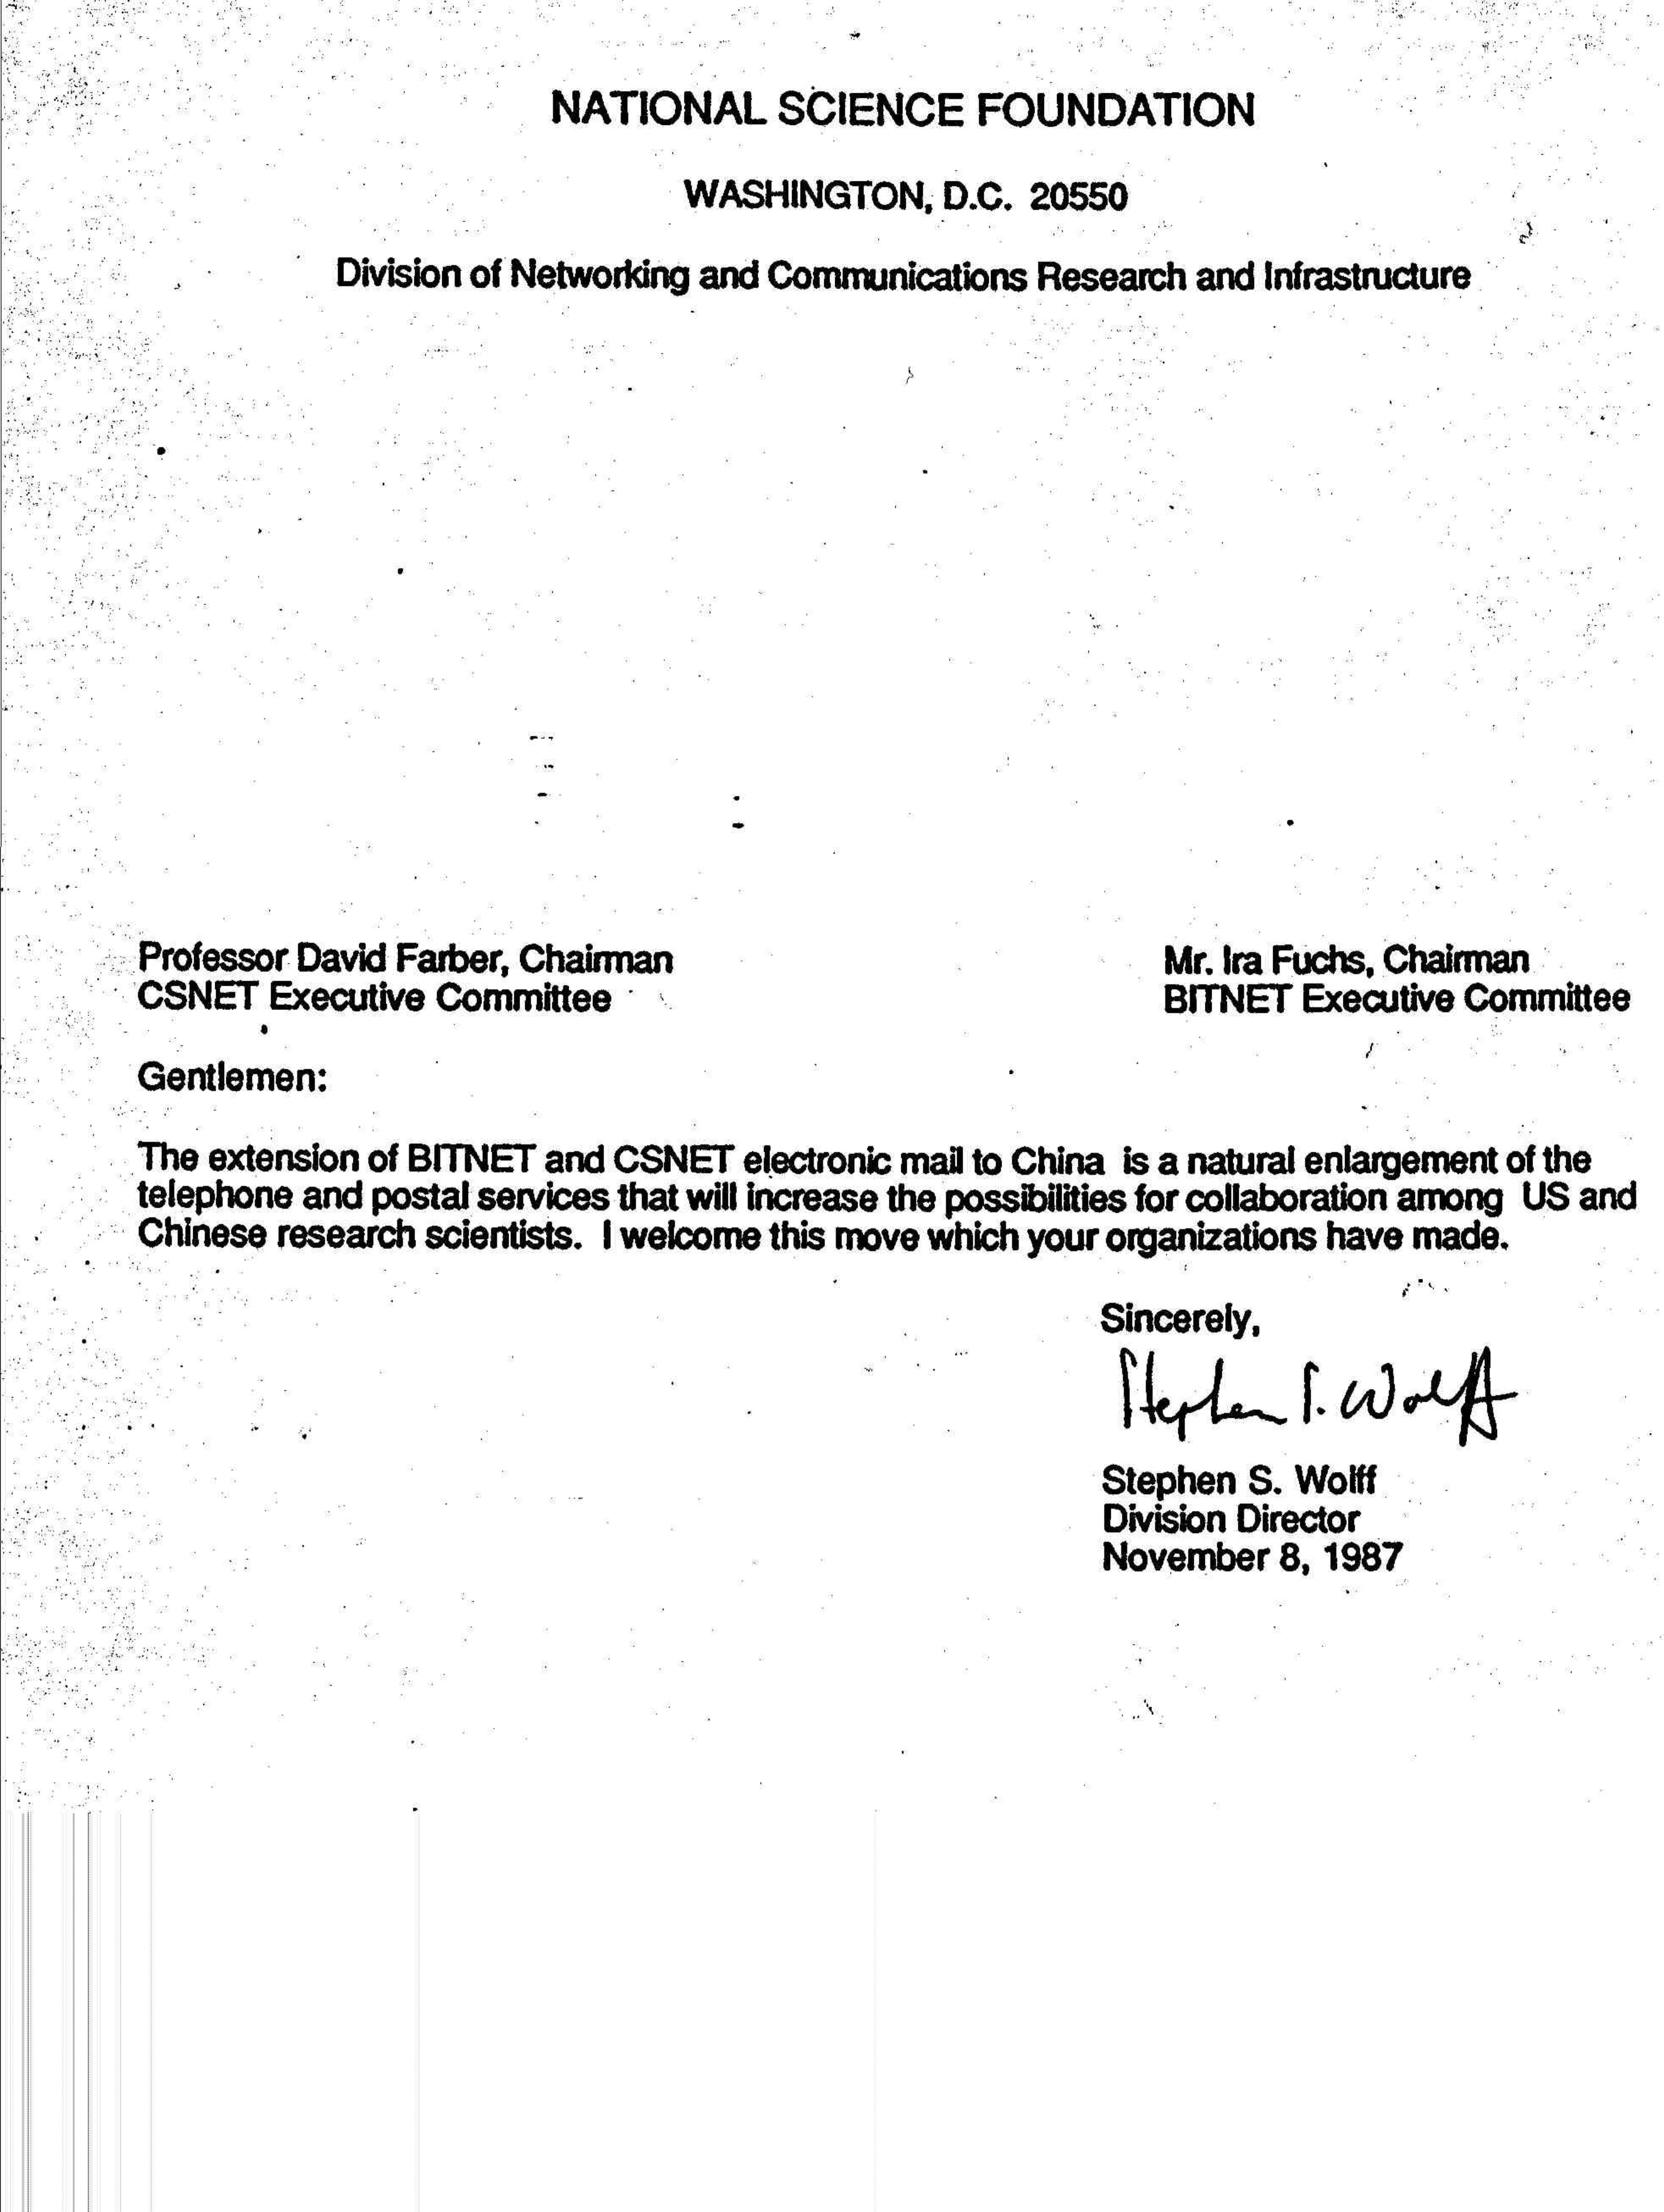
Letter from Stephen Wolff, November 8, 1987

Without Wolff's letter, the China-Germany email connection would have been vulnerable to a cutoff if the NSF decided to deny forwarding of email messages to and from ICA in Beijing. Zorn considers November 8, 1987 as the time China became officially connected with the rest of the world via the CSNET email system. Email received from China at Karlsruhe would be relayed from there to whichever host worldwide it was addressed. And the reverse, any host worldwide could send mail to ICA in Beijing and it would be relayed from there to users of the China Academic Net (CANET) throughout China as well as to remote dialogue users in other Chinese institutions outside CANET. The international computer science community and Chinese students abroad who learned of this connectivity answered with their warm congratulations.

Still these were small steps. Even with the support of the Chinese State Science and Technology Commission (SSTC), hardly any Chinese institution and no individual scientist could afford to send or receive email messages to or from abroad. That was because X.25 for international traffic increased in cost as the volume of email traffic increased. The cost on the Chinese side included charges for every message received as well as sent. Zorn estimated that longer email messages could cost a professor the equivalent of a whole month's salary. The charges, typically $2000 to $5,000 per month paid by each side were more of a burden for the Chinese side than the German side. Email usage was thus severely restricted.

But for the five years during which expensive email connectivity was the only network connectivity that could reach the rest of the world, China prepared itself to truly join the Internet.

In November 1990, the ICA registered the .CN country code domain name for China, again with crucial help from Zorn and Karlsruhe University. Qian Tianbai, an ICA Engineer was appointed as the Administrative Contact for .CN on the Chinese side. During the following four years, the university network center in Karlsruhe ran the primary domain name server for .CN on their iraun1.ira.uka.de VAX 3500. The domain name service was fully operational in January 1991. From then on email service was available in and to and from China with China's own domain name.

With encouragement from the Chinese government, knowledge and understanding of international computer networking was spreading in China, especially in the scientific and computer communities. The Institute for High Energy Physics (IHEP) belonging to the Chinese Academy of Science opened an email connection in 1989 with its partner in the US, the Stanford Linear Accelerator Center (SLAC) in California. Message Handling Systems (MHS) were set up in 1990 between the German Research Network (DFN) and the Chinese Research Network (CRN) and between the Beijing Tsinghua University Network (TUNET) and its partner in Canada at the University of British Columbia (UBC). Also, CHINAPAC an X.25 public telephone infrastructure was developed and used for email exchanged within China.

The email-only phase of connectivity between China and the rest of the world through Karlsruhe in Germany came to an end in 1994. That is when IHEP worked together with SLAC to take the next big step in connectivity between the people of China and the people of the world. On May 17, 1994, IHEP and SLAC established a full TCP/IP connection between China and the US. The use of the TCP/IP protocols allows data packets to take independent paths which meant the cost for email could come down and file transfer (FTP) and remote logon (Telnet) would now be available. That connectivity opened the Internet to China and China to the Internet.

Some of the story of the Internet in China after 1994 is told online at a number of web sites. 2004 was the Tenth Anniversary of TCP/IP connectivity. In early 2005, it was estimated that there were at least 100 million Internet users in China and Internet use was growing at perhaps 30% a year. There was a dynamic netizens movement developing. All this connectivity began with the first email message to leave China. It can only make computer network pioneers like Wang Yuen Fung, Werner Zorn, and Li Cheng Chiung proud of the early email connection they opened and celebrated by any of us who respect the progress the Internet represents for human society.
-----
* In an earlier version of this article, the project was mistakenly called Chinese University Development Project II.

The author wants to thank Werner Zorn in Germany, without whom many of the details and this story would have remained unknown to him. In many ways he is a coauthor. I thank him and Dr. Li Cheng Chiung in China for encouragement to tell this story. They are keeping the pioneer spirit alive.

COCOM, the Coordinating Committee for Multilateral Export Controls, was established during the Cold War to put an embargo on Western exports to East Bloc countries. It established multilateral export controls for strategic and military goods/materiel and technologies to proscribed destinations.
For over 30 years, Werner Zorn was affiliated with Karlsruhe University in Karlsruhe, Germany. Today he is a professor of Communications Systems at the Hasso-Plattner Institute (www.hpi.uni-potsdam.de) at the University of Potsdam near Berlin. The papers he gave the author include, “Wie China mit den internationalen Rechnernetzen verbunden wurde” In: PIK – Praxis der Informationsverarbeitung und Kommunikation 11 (1988), No. 1 pages 22-29, and “Die Entwicklun des Internet in China” written with Qian Tianbai, June, 1998. See also, http://www.cnnic.net.cn/html/Dir/2004/06/21/2349.html
When Karlsruhe University joined CSNET in July 1984, Werner Zorn was appointed the Administrative Liaison. At that time, Karlsruhe University was one of two gateways between CSNET and European research networks. (see CSNET NEWS Summer 1984, No 5, pages 5 and 6). His email address on CSNET was zorn@germany.
The Institute of Computer Applications was located at the Beijing Institute of Technology (BIT). It was created to provide data processing and computer services to small and medium organizations that could not afford their own computer installations. The ICA became a foremost computer networking center. From 1987 to 1994 it was the hub for CSNET email exchange between China and the rest of the world.
CASCO- Chinesische Anwender von Siemens Computern.
CSNET was the result of a proposal in 1979 submitted by Lawrence Landweber at the University of Wisconsin-Madison in the US to make computer network connections among US and other university computer science departments. It started as a simple telephone-based email relay network which became known as PhoneNet. In February, 1984, Israel became the first international node on the CSNET, soon followed by Korea, Australia, Canada, France, Germany, and Japan.
? http://en.wikipedia.org/wiki/X.25
A PAD is a device that receives data from one or more terminals, assembles the data into packets and sends the data packets out to the hosts it serves. It can do the reverse, receiving data packets from network hosts, it can translate them into character streams that can be displayed at terminals.
When Zorn read the above article he wrote to me about Lawrence Landweber, "Without his everlasting support from 1984 and after, the whole work would not have been possible." Zorn also wrote that the email connection project was strongly supported by many leading network people worldwide. He named, besides Landweber, Dave Farber, Ira Fuchs, Richard Mandelbaum and Stephen Wolff in the US, Wang in China and for example Dennis Jennings in the US and Daniel Karrenberg in the Netherlands who attended the first CANET conference in Beijing in March 1988 and Kilnam Chon in Korea who was active in networking in the Asia/Pacific Rim region. (email messages April 28 and May 18, 2005).
For computer networking activity, ICA was financially better off than were the Chinese universities because ICA was funded by the Ministry of Machinery Industry while the universities were funded by the Ministry of Education which could not distribute as much money as ICA received to each university.
Qian Tianbai is sometime given credit for the first email message from China to Germany. (See for example http://202.84.17.11/english/china_abc/internet.htm.) This does not appear to be correct. Dr. Li Cheng Chiung who was the director of the ICA from 1980 to 1990 writes that Qian Tianbai was an Engineer at the ICA from 1980 to 1998 but that he was in the US studying at the CST Company for the whole of the year in 1987 including when the first email message was sent. He includes that Mr. Qian was a good engineer who joined the CANET project in 1990 and was made a Senior Engineer in 1993 (email messages to the author May 10, May 11, and May 17, 2005). Online references indicate that Qian Tianbai was a Vice-Chief Engineer at ICA in 1992. Werner Zorn writes that his email contact with Qian Tianbai started not before 1990 (email message to the author May 3, 2005). It can be noted that in the first email message from China to Germany (see above), Qian Tianbai does not appear among the 13 signatories. Sadly, Qian Tianbai died of a sudden heart attack on May 8, 1998.
? http://www.nsrc.org/db/lookup/operation=lookup-report/ID=890202373777:497422478/fromPage=CN
? See for example, http://www.internetdigital.org/p222shinianqingdian.htm http://www.pcworld.idg.com.au/index.php/id;854351844;fp;2;fpid;1 http://lass.calumet.purdue.edu/cca/gmj/SubmittedDocuments/archivedpapers/Fall2003/pdf_files/Internet%20and%20democracy(xiguang).pdf

