A Brief History of the Internet in Korea
2005.8.29
Kilnam Chon¹, Hyunje Park², Kyungran Kang³, and Youngeum Lee⁴

¹ Department of Computer Science, KAIST, Daejeon 305-701, South Korea
² ZooinNet Co., Seoul 137-867, South Korea
³ College of Information Technology, Ajou University, Suwon 443-749, South Korea
⁴ Department of Media Art & Science, KNOU, Seoul 110-791, South Korea

Abstract
The TCP/IP network in South Korea started in May 1982, one of the earliest Internet deployments in the world. The initial TCP/IP network, called SDN, consisted of two nodes with 1200 bps bandwidth.
SDN served the research and education community with primary focus on network research, and had international links with UUCP initially. The international links cover several countries in Asia, which is called AsiaNet, as well as Europe and North America.
In parallel to TCP/IP development, the communications on personal computers using bulletin boards and others also proliferated. These two network developments along availability of WWW made explosive Internet growth in 1990s. These developments resulted in the leading broadband country with various applications.
The Internet is becoming the social infrastructure in Korea lately with many aspects of daily life are done through the Internet including social and political activities. Convergence of the Internet with telecommunications and broadcasting is taking place now.

1. The Pre-Internet Period
Basic Internet Technologies and Concepts Proposed
The 1960s was the period that saw the birth of technologies and concepts that were to become the foundation of the Internet. In 1965, the concept of "packet switching, which was to become the fundamental technology of the Internet, was proposed.
Domestic Network Developments
During the period between the late 1960s and 1970s, efforts to construct domestic computer networks were launched in countries such as France, UK, and USA. The most notable one is ARPANET(Advanced Research Project Agency Network) in USA in 1969.
2. Birth of the Korean Internet, SDN
SDN Begins Operation
Korea's first Internet system, SDN(System Development Network) began its operations on 15 May 1982. A computer at the Department of Computer Science at Seoul National University was connected to another computer at Korea Institute of Electronics Technology(KIET) in Gumi (Presently ETRI, Electronics and Telecommunications Research Institute) via a 1200 bps leased line, and in January 1983, a third computer at KAIST(Korea Advanced Institute of Science and Technology) was connected to the SDN, which resulted in a system that could be described as a network of computers. Since TCP/IP is one of the communications protocol used among the computers connected to the SDN, this can be noted as Korea's first Internet.
UUCP and USENET
SDN was connected to the mcvax in the Netherlands in August, 1983 by using UUCP(Unix-to-Unix-Copy), and in October of the same year, it was connected to the hplabs in the United States. Since UUCP was a protocol that was already installed in UNIX computers, there was the advantage of not having to install additional protocols, and thus could be expanded not only to overseas computers but also to domestic computer nodes with relative ease.
In the U. S., CSNET(Computer Science Network), a network that connected universities and research institutions that had not participated in ARPANET, had been constructed. SDN was connected to CSNET in December 1984, and this connection was utilized as a forum for exchange of technology until SDN was formally connected to the U.S. Internet in 1990. However, services such as the FTP could not be used because of the U.S. government's restrictions on connections to the ARPANET. Thus, only e-mail and news(USENET) services were available with USA. Moreover, because of the extreme high cost of international phone lines, a large portion of the USENET data had to be received in magnetic tape format by regular postal mail rather than via online connections.
Hangeul e-mail
In 1983, a Masters thesis on the development of a mail system using the Korean character set was reported in KAIST, and experiments on e-mail using the Korean character set was initiated. In 1985 a Korean e-mail program and a Korean editor program, called hvi was developed, enabling people to send and receive e-mail using Korean characters through SDN. In addition, in May 1984, Dacom began its commercial e-mail service through DACOM-net.
AsiaNet
From 1983, SDN was connected to various sites in Asia in addition to North America(hplabs and seismo in USA, CDNNET in Canada), and Europe(mcvax in the Netherlands). The network linking Asian countries was called AsiaNet, and included Australia, Indonesia, Japan, Korea, and Singapore.
3. Global Internet Connection, early 1980s
Use of the .kr Domain and IP Address
In the mid-80s, the progression of a series of critical events enabled the Internet in Korea to meaningfully participate in the global Internet. In July 1986, the first IP address(128.134.0.0) for Korea was assigned. In 1986, rules for second and third level domains under the .kr domain were established and the country code top level domain to represent Korea, .kr, was formally in operation. Also, computers in KAIST and others were registered as the domain name server for the .kr domain(for example, sorak.kaist.ac.kr) establishing the infrastructure for allowing not only domestic but also international open access to the computers using .kr as its domain name.
Establishment of Internet Policy Centers
As the use of the Internet expanded to domestic and then to the international networks, there was a need to establish a mechanism to systematically and efficiently manage Korea's domestic Internet use. Thus the ANC(Academic Network Committee) was formed in 1988 as the association that would perform this function. The ANC was composed of the ANC Steering Committee, consisting of representatives of ANC and other necessary committee members, and its technical sub-committee, the SG-INET, consisting of members involved in the everyday operations of networks. The ANC assumed the role of representing the Korean Internet society, and was involved in managing the use and assignment of domestic domain names and IP addresses as well as connections with overseas networks, and represented Korea in international network associations. The ANC changed its name to KNC (Korea Network Committee) in 1994 and then to NNC(Number and Name Committee)in 1998, and continued to operate as a civil organization establishing and recommending domestic Internet policies.
PC Communications
In addition to efforts to provide network services centered on the Internet, another type of network service was developed in the 1980s. This was the PC Communications, which began in 1984 as Dacom's Hangeul Mail, and then was consolidated in 1986 as Chollian. The KETEL(Korea Economic Daily Telepress) service that began in 1988 was reorganized as Hitel and became the most prominent PC communications service. This type of online communication using the PC communications operated as a separate service independent from the Internet until 1995 when regular PC network users were able to connect to the Internet using commercial networks. The most notable significance of the PC communications is that it contributed to the development of the concept of online communities.

The PACCOM Project
In 1989, the University of Hawaii was the focal point of the plan for PACCOM(Pacific Communications Networking Project), connecting Australia, Hawaii, Japan, Korea, and New Zealand. In Korea, many member institutions of SDN agreed to jointly fund the 56 Kbps leased line to Hawaii, and established an organization named HANA for this purpose. In March 1990, a computer at KAIST was connected to the University of Hawaii via satellite at 56 Kbps, and the HANAnet was constructed. Until then, charges for international connections to UUCP, and CSNET were based on the amount of data packets. Thus, international Internet connections were highly limited. But after the establishment of connections with PACCOM people could use it with relatively little limitations. Data traffic figures for Internet applications during this time show the highest usage in FTP, followed by Mail, Telnet, Archie, and DNS. In August 1992, The main gateway equipment and the operation of the HANAnet and SDN were transferred from KAIST to KT(Korea Telecom). Thenceforth, HANAnet of the KT research center gave birth to KORNET, KTs commercial Internet services. Since the construction of HANAnet, SDN was used to designate domestic networks and HANAnet was used to designate networks connected to the global Internet, and the name SDN slowly lost recognition, resulting in the decision by ANC in 1993 to no longer use the SDN name.
PCCS(Pacific Computer Communications Symposium 1985)
In 1985, a conference focusing on computer networks, PCCS(Pacific Computer Communications Symposium), which was one of the world's first conferences on the Internet, was held in Seoul, with approximately 300 Internet experts participating from Asia, Europe and North America.
Considering that the next global conference on the Internet was held in the early 1990s, this conference was a highly advanced conference. This also displays the active and leading role played by Korea in the global Internet field. In addition, the PCCS provided the impetus for the annual meeting of JWCC(Joint Workshop on Computer Communications), a meeting of Asian computer network experts was held annually with the meeting venue alternating between Japan and Korea initially. The participants of the JWCC expanded gradually, resulting in its development into ICOIN (International Conference on Information Network).
4. Prolification of the Internet among Research & Education Community, early 1990s
National Infrastructure Project
In July 1983, the plan for Five National Information Network Project which included National Administrative Information Network, and Education and Research Network Infrastructure among others was established, and the legal basis for pursuing the plan was put in place by legislation of Legislature #3848, "Law on Expansion of Network Infrastructure and Use" on 12 May 1986. Based on this law, the government of Korea established a Committee on Management of Networks to evaluate and manage policies related to the construction of the national information networks and began a government-led construction of the national information network. In June 1988, it was decided that
construction of the Research and Education Network, one of the national information networks would be divided into Research Network and Education Network. The Research Network was operated by the System Engineering Center(presently KISTI) which belongs to the Ministry of Science and Technology, and the Education Network was operated by Seoul National University which belongs to the Ministry of Education, and the construction of each network was launched. Both networks, the Research Network, KREONet(Korea Research Environment Open Network) and the Educational Network, KREN(Korea Research and Education Network), are still currently being used to connect many research centers and universities, respectively.
Voluntary Research on Network Technology by Experts
SG-INET was established in 1991 to perform the role of developing, implementing, and operating technologies by establishing subcommittees of working groups on naming, routing, Hangeul, and security. The activities of these working groups resulted in many achievements such as; the naming working group providing the fundamental infrastructure for the establishment of KRNIC, the Hangeul working group developing the IETF standard for Hangeul mail, and the security working group establishing CERT Korea. Many experts in network operation organizations such as KREN, KREONET, KAIST, ETRI, SNU, NCA, Dacom, KT, Samsung and Goldstar participated in SG-INET.
KRNIC
In 1992, Korea Network Information Center was established in order to provide a network information management function for all Internet services that had been under the supervision of ANC. Up to that point, the registration of domain names on the Internet and administration of network information had been performed on an individual network basis. However, because the magnitude of domestic Internet was growing and because there was a global trend for establishing network information centers within continents as well as individual nations, the Korea Network Information Center was founded. KAIST had been consigned to run the Korea Network Information Center since January 1993, In September 1994, its central functions were transferred to the National Computerization Agency, and in June 1999, an independent corporation named KRNIC was created to take complete charge of domestic network information administration functions. In 2004, based on the Internet Address Resources Law. the National Internet Development Agency of Korea was founded in order to perform the administrative function of Korea's domestic Internet address resources.
Standardization of Hangeul Encoding
Existing e-mail programs were able to deliver mail without error only when Roman characters and numbers were used, and mail sent in Korean characters were damaged, making it impossible for the receiver to read mail sent in Korean characters. In December 1991, a Korean mail program, Hangeul elm, was developed according to the Hangeul Encoding Standards(ISO2022-KR) which designated principles for encoding Korean Hangeul characters into Roman characters and numbers without corrupting the content. The encoding method used for this program was then further developed and recorded as an RFC document of the IETF(The Internet Engineering Task Force) in 1993 under the title, Korean Character Encoding for Internet Messages, which was the first RFC document by a Korean submitted to IETF.
World Wide Web Begins
In the 1990s the global Internet experienced a revolutionary transformation in the Internet technology called the World Wide Web, and in Korea the first web site, cair.kaist.ac.kr, was set up and operated at the Center for Artificial Intelligence Research(CAIR) at KAIST in 1993.
KRNET
The 1990s was a period when Internet technology made a dramatic development globally as well as domestically. One reflection of this could be found in the first KRNET(Korea Network Workshop) was held in Seoul in 1993. This workshop continues to be held annually, providing a forum for introducing new trends in Internet related technology, facilitating exchange of technology, and promoting cooperation among technical experts.
5. Commercial Internet
Commercial Internet Service Begins
In the mid 1990s the Internet, which had only been restricted for use in universities and research institutions up to that point, became available to businesses and individuals. Several commercial Internet services were initiated in 1994, beginning with KORNET by Korea Telecom in June, 'DACOM InterNet' by Dacom in October, and nuri.net by Inet Technologies in conjunction with Nowcom in November. Commercial Internet services in Korea has since developed into a major industry in Korea, with approximately 30 Internet service providers in operation in 2004.
KIX - Commercial Internet eXchange
In order to have the commercial Internet service providers operate with other Internet service providers, the National Computerization Agency established an exchange, called KIX (Korea Internet eXchange). The first step was to connect the Educational Network and the Research Network in February 1995, and after March, eleven commercial Internet Service Providers(ISPs) such as Inet and Nowcom were connected. In November that year, an agreement was made for an IX(Internet Exchanger) system that would have the National Computerization Agency(NCA), Korea Telecom, and Dacom be the hub(i.e., IX) for connecting and managing domestic Internet, and commercial ISPs were transferred to the commercial IXs(Korea Telecom, Dacom) by December 1996. Also, in June 1999, the Korea Internet eXchange Association, composed of many ISPs, set up a neutral Internet exchange named KINX(Korea Internet Neutral eXchange).
Internet and the Mass Media
In March 1995, the Joongang Daily News began its first Internet news service and in October that year the Chosun Daily News launched its Digital Chosun Daily News. Moreover, webzines(short for web magazines), news sites that exist independently, not in conjunction with printed newspapers, were introduced in September 1996 with the launching of im@ge by Inet and rapidly began to proliferate. In addition, in 1996, the era of e-commerce, where things could be searched and purchased from the web sites instead of at the stores, began with the opening of Interpark and Internet Lotte Department Store.
Internet Expo
The 1990s was a period when the Internet was rapidly becoming popularized. In 1996, an international Internet Expo was held on the Internet, an global event held with the purpose of encouraging the expansion of Internet use and to utilize the Internet that had been constructed. This event provided a range of opportunities for experimenting with the rapidly developing WWW technology and other Internet technologies by using a web site on the Internet as the gallery in place of a physical one. In Korea, this was an opportunity for the venture businesses to introduce their technologies domestically as well as internationally and further develop them, as well as an occasion for encouraging the news media to be involved in online operations. In addition, this provided the momentum for encouraging public organizations in Korea to establish web sites.
Internet Ventures
Many ventures on the Internet started their operations in 1990s as the commercial Internet service were deployed. Some of them led the Internet industry, and they include Ahn Chul Soo Laboratory on virus protection, Daum on portal site with email service, NCsoft and Nexon on online game, and Naver/NHN on search engine.
6. Broadband Internet
Widespread Availability of Broadband Internet
Until the late 1990s, individual home users of the Internet had a maximum connection speed of only 64 Kbps with dialup service. However, this changed when Thrunet began to provide broadband Internet services in July 1998 with approximately 1Mbps connection speed using cable TV networks, and Hanaro Telecom and KT joined in the broadband Internet provider race through the use of ADSL(Asymmetric Digital Subscriber Line) technology. In 2004 the number of home users with broadband Internet access exceeded 11 million, which covers over 70% of the households in Korea. The widespread availability of broadband Internet services provided the impetus for Korea to become the leading Internet stronghold nation of the world. Such a leap in the development of broadband Internet stimulated the expansion of various multimedia services and provided the foundation for an evolution into a ubiquitous networking made possible by a convergence of broadcasting and telecommunication and wireless Internet services provided by mobile phones as well as broadband Internet.
Factors in the Expansion of Broadband Internet
In the late 1990s when demand for services provided by the Internet was increasing but Internet access from individual homes was not common, Internet cafe, or 'PC bang' that provide the general public with Internet access began to appear. The first domestic Internet cafe is NET that began operating in Seoul on 15 September 1995. The number of Internet cafes gradually increased, reaching 15,150 by the end of 1999. In addition, the number of online gamers increased, and PC bangs was at the core of such a phenomenon. In 1998, an online war simulation game called Starcraft was widely played by general public, and PC bangs were the center for such games. Youth in their 10s and 20s provided the impetus for the increase in demand for online games, and it could be said that such a demand contributed greatly to the distribution of Internet access to individual homes.
Using online stock trading based on the Internet enabled easy stock trading without having to physically visit the stock brokerage. And Internet banking services enabled withdrawal or transfer of funds without visiting the bank. Because it was so convenient, approximately 11,310,000 users, which are about 30% of the total population of November 2001, were found to be registered users of Internet banking

7. Social Impact of the Internet
Negative Impact of the Internet
Although the Internet is making our lives more convenient, it also has negative impacts on our society. There is an increase in the number of people who are addicted to specific services on the Internet, most notably online games and indecent information, and are unable to lead normal everyday lives. There are web sites that plan suicides and actually carry them out. Criminal acts of obtaining and using other peoples personal information by means such as hacking have occurred. In addition, there are other negative incidents on the Internet such as the bombardment of unrestricted spam mail that unnecessarily consumes people's time and the spreading computer viruses through e-mails, obstructing business operations.
Governmental Efforts
In 1995, the Ministry of Information and Communication(MIC) established the Information Communication Ethics Committee in order to prevent and evaluate the negative effects of network communication. In addition, institutions such as the Internet Crime Investigation Center, Center for Internet Addiction, and Korea Spam Response Center were established by cooperative efforts between the government and civil societies and are involved in activities aimed at circumventing the negative effects.
Balance between Individual Freedom and Regulation of Negative Impacts
Efforts to address the negative impact of the Internet have the danger of infringing individual's freedom, and additional efforts to thwart such dangers have been concurrently pursued. In 2000, the Ministry of Information and Communication(MIC) had attempted to legislate the Internet Content Rating System when it was revising The Act on Promotion of Information & Communication Network Utilization and Information Protection. But this effort was annulled due to civilian opposition. Article 53 of the aforementioned act that allowed an order of the Minister of Information and Communication to place certain restrictions on electronic and telecommunication businesses in dealing with certain types of information was ruled partially unconstitutional in 2002.
8. Netizens
It was in the early 1990s that individuals of the general public were able to express their political and social opinions through the Internet. As part of its support program for developing countries, 'Sustainable Development Network Program (SDNP),' the UN established SDNPs in many countries including the one in Korea, which was hosted by YMCA. The anonymity and easy access afforded by the Internet prompted various people to set up and operate web sites and express more diverse views. In August 1997, the supporter club for the national soccer team selected the Red Devils as its official name, and in November 2000, the Red Devils opened its home page and provided the major impetus for the massive cheering crowds in the 2002 FIFA World Cup Games in Korea-Japan. When two middle school girls were killed by a U.S. armored tank in June 2002, on-the-street candle light vigil by netizens and online memorials spread throughout the country. In addition, during the December 2002 presidential election, there were many active online and offline campaigns organized and played out by many netizen groups such as a support club for Mr. No Moo Hyun, People Who Love No Moo Hyun(Nosamo). These netizen groups did not spring up suddenly with the introduction of the Internet. Rather, they are extensions of online communities that were formed through the PC communications in the early 1990s, using the Internet as their newer communication medium.

Bibliography
[1] Paul Baran, "The Beginnings of Packet Switching: Some Underlying Concepts," IEEE Communications Magazine, July 2002, pp42-48.
[2] Barry M. Leiner, et al., "A Brief History of the Internet," Internet Society, 2003. http://www.isoc.org/
[3] K. Chon, H. Park, and H. Cho, " SDN: A Computer Network for Korean Research Community," Proceeding of PCCS (Pacific Computer Communications Symposium), Seoul, Korea, 1985.10, pp.567-570.
[4] K. Chon, “National and Regional Computer Networks for Academic and Research Communities in the Pacific Region”, Proceeding of PCCS, Seoul, Korea, 1985.10, pp.560-566.
[5] GC Son, A study on the development of Hangul mail system, MS Thesis, KAIST, 1984.
[6] K. Chon, AsiaNet Map, Proceeding of PCCS(Pacific Computer Communications Symposium), Seoul, Korea, 1985.10.
[7] HJ Park, Korean Internet in the world; Korean Internet History, 1995.5. (in Korean)
[8] Ministry of Information and Communication, 20th Century Information Communication Cyber History Museum.(in Korean) http://20citfind.or.kr/
[9] U. Choi, K. Chon and H. Park, "Korean Character Encoding for Internet Messages," RFC1557, December 1993.
[10] Korea Internet Association, Internet History, 2005. http://www.internethistory.or.kr/
[11] Wired Magazine, 10 Years that changed the world, August 2005.
[12] MK Kang, MS Baek, et al, Study on Korea Internet History Museum, IAK, August 2005.

Abbreviation
DSL Asymmestric Digital Subscriber Line
ANC Academic Network Commitee
CAIR Center for Artificail Intelligence Research
DNS Domain Name Service
ETRI Electronics and Telecommunication Research Institute
FTP File Transfer Protocol
ICOIN International Conference on Information Network
IETF Internet Engineering Task Force
IX Internet Exchange
ISP Internet Service Provider
JWCC Joint Workshop on Computer Communications
KAIST Korea Advanced Institute of Science and Technology
KINX Korea Internet Neutral eXchange
KIX Korea Internet eXchange
KNC Korea Network Committee
KRNIC Korea Network Information Center
KREONET Korea Research Environment Open Network
KREN Korea Research and Education Network
KRNET Korea Network Workshop
NNC Number and Name Committee
PACCOM Pacific Communications Networking Project
PCCS Pacific Computer Communictions Symposium
RFC Request For Comment
SDN System Development Network
SDNP Sustainable Development Network Program
UUCP Unix-to-Unix Copy
WWW World Wide Web

Appendix

Appendix 1: SDN Network Configuration(as of May 1985)
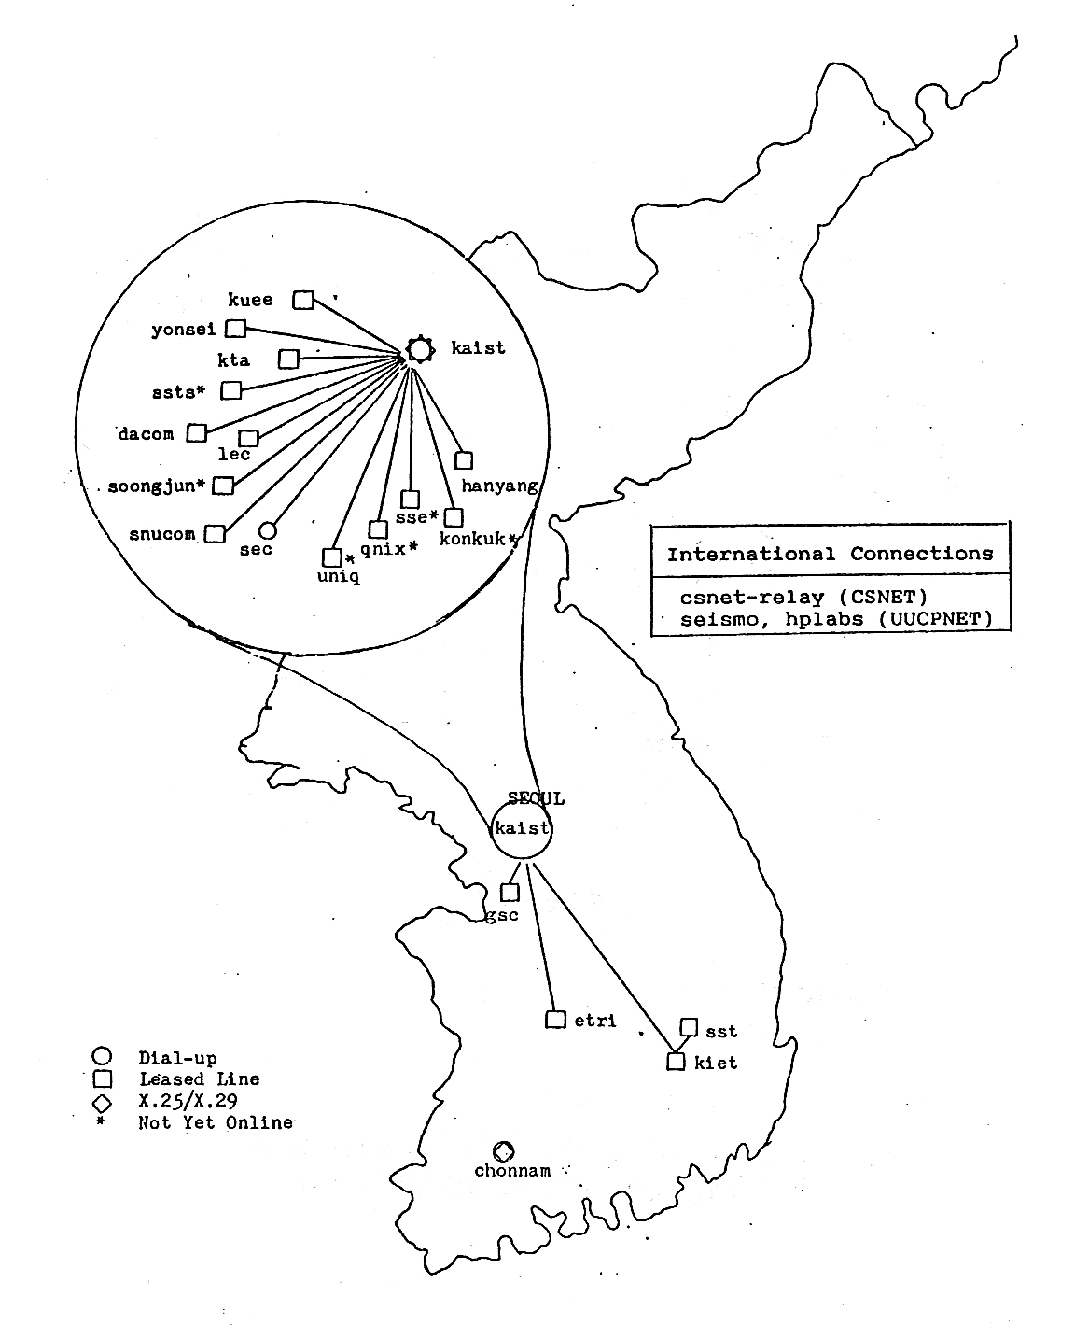

Appendix 2: AsiaNet Map
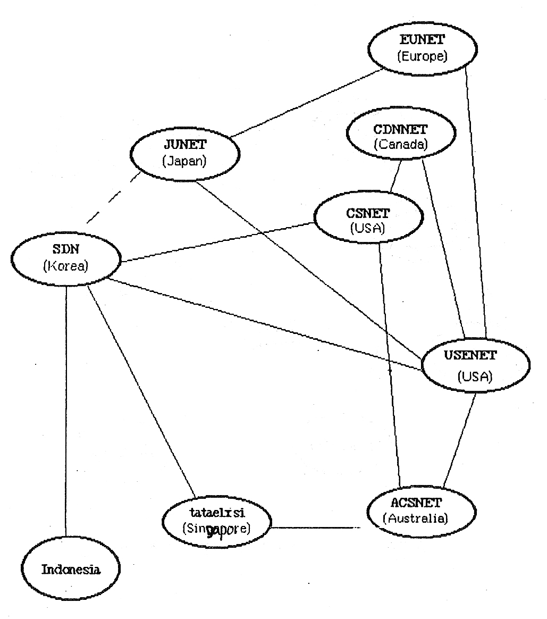
Appendix 3: Internet History Yearly Table (1969~2004)

Year | Infra/Business | Media/Community | Society/Law/Organization
1982 | SDN(TCP/IP)
1983 | UUCP/USENET  Hangeul E-mail
1984 | CSNET(X.25)
1985 | Commercial Hangeul E-mail
1986 | .kr domain | PC Communications | Law on Information Network  Promotion
1987 |  |  | NCA
1988 |  | Brain Virus | ANC(KNC)
1989
1990 | Global IP Connection
1991
1992 |  |  | KRNIC
1993 | First RFC | First Website | KRNET
1994 | Commercial ISP | First Online Game | Websites for Public Organization
1995 | Internet Exchange (KIX) | Internet Mass Media | ICEC
1996 | Electronic Commerce |  | Internet Expo 96
1997 | Online Stock Trade | hanmail | Internet Association of Korea
1998 |  | Starcraft
1999 | Internet Cafe (~10,000) | Daum Cafe
2000 |  |  | Internet Suicide Websites
2001 | Internet Banking  (~ 11million users) |  | Internet Crime Investigation Center
2002 | Broadband Internet  (~ 11million users) | Netizens | Center for Internet Addiction
2003 | 1.25 Internet Slammer Worm Virus |  | Korea Spam Response Center

Appendix 4: Genealogy of the Internet Organizations in Asia

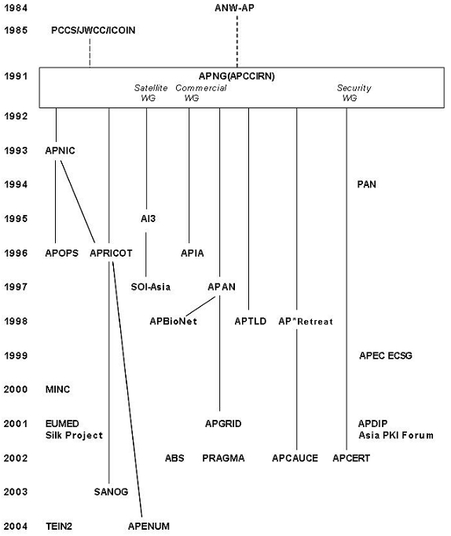

Appendix 5: A Brief History of the Internet in Asia
1. The Pre-Internet Period
The 1960s was the period that saw the birth of technologies and concepts that were to become the foundation of the Internet. In 1960s, the concepts of packet switching, which was to become the fundamental technology of the Internet, were proposed.
During the period between the late 1960s and early 1970s, efforts to construct domestic computer networks were launched in countries such as France, UK, and USA. The most notable one is ARPANET(Advanced Research Project Agency Network) in USA in 1969.
In Asia, similar efforts to develop computer networks were launched in 1970s and 1980s. They include CSIRONET and N-1 Network in Australia, and Japan, respectively.
2. Initial Regional Coordination
ANW-AP(Academic Networkshop - Asia Pacific)
(International) Academic Networkshop was one of the early coordination meetings on the internet globally, and had the first meeting in 1992. Asia started participation to the meeting from 1983. The first Asian coordination meeting, ANW-AP was held during the 1984 ANW, and Australia, Japan and Korea participated the meeting.
AsiaNet
In 1980s, there was much development of UUCP-based computer networks in Asia as well as in other
continents. These domestic UUCP networks in Asia were linked internationally including Australia, Indonesia, Japan, Korea and Singapore in 1983, and the international UUCP-based network in Asia was called AsiaNet. They were used for email and news. AsiaNet was also linked to North America(seismo, and hplabs) and Europe(mcvax).
PCCS(Pacific Computer Communications Symposium 1985)
In 1985, a conference focusing on computer networks, PCCS(Pacific Computer Communications Symposium), which was one of the world's first conference to address on the Internet, was held in Seoul, with approximately 300 Internet experts participating from Asia, Europe and North America. Joint Network Meeting was held during the Symposium with presentations of research and education networks in Australia, Japan, and Korea as well as European networks. Other countries and economies such as China, Indonesia, Singapore, and Taiwan participated the meeting, too.
In addition, the PCCS provided the impetus for the annual meeting of JWCC(Joint Workshop on Computer Communications), a meeting of Asian computer network experts was held annually with the meeting venue alternating between Japan and Korea initially. The participants of the JWCC expanded gradually, resulting in its development into ICOIN(International Conference on Information Network).
3. Prolification of the Internet for Research and Education Community
The first Internet in Asia
Korea's first Internet with IPv4, SDN(System Development Network), began its operation in 1982 with two nodes. The international link to USA was done with UUCP since the direct international link with IP was not permitted in USA. Other countries followed the development of IPv4-based computer networks in 1980s and beyond.
Campus Network
With prolification of Unix machines(minicomputers, workstations, PCs) and local area networks, the Internet became common among universities in mid to late 1980s. The BSD(Berkeley Software Distribution) version of UNIX, which includes TCP/IP protocols played a major role on the prolification of the IP-based campus network then. Networking between universities were normally handled by UUCP protocol, which was also readily available by mid-80s.
PACCOM(Pacific Communications Networking Project)
The direct international link with IP to USA was permitted later in the decade. With PACCOM (Pacific Communications Networking) Project in 1989, several countries connected to USA through Hawaii. They include Australia, Japan, Korea, and New Zealand. Many other countries connected to the US Internet in 1990s with their domestic Internet development.
Bitnet Asia
Bitnet Asia, another computer network for research and education community was developed in 1980s with the IBM network protocol to connect IBM mainframe computers of central computer centers among Asian universities. The network eventually changed its protocol to the Internet protocol in 1990s to fully connect to the Internet.
UUCP Network
UUCP-based networks were extensively deployed in Asia starting from AsiaNet in early 1980s.
These networks also changed their protocols to the Internet protocol in 1980s and 1990s as their traffic increased.
4. APNG, The First Regional Internet Group
CCIRN(Coordinating Committee for Inter-Continental Research Networking)
CCIRN(Coordinating Committee for Inter-Continental Research Networking) was spawned from (International) Academic Networkshop to coordinate international links between Europe and North America, and had its first meeting in 1987. Later, Asia was invited to participate, and APCCIRN was created to coordinate CCIRN participation, and had its first meeting in 1991.
APCCIRN/APNG
Since APCCIRN is the only coordinating body in Asia on the Internet then, it ended up to coordinate various matters on the Internet. The first matter was the creation of the regional IP registry, APNIC, which was formally started in 1993. Later, APCCIRN was renamed to APNG (Asia Pacific Networking Group), which span off many organizations in 1980s and 1990s. See Appendix A: Genealogy of Internet Organizations in Asia Pacific for detail. It is currently operating APNG Camp among others.
INET
(International) Academic Networkshop had its last annual meeting in Australia in 1989. Its successor, INET had its first annual meeting in Copenhagen in 1991, followed by Kobe in 1992, Many Asian participated INET Conferences, and various coordination efforts took place during INET Conferences.
5. APNIC, Regional IP Address Registry
Asia Pacific Network Information Center(APNIC) was created in 1983 to handle regional coordination body in Asia, was created in 1983 to handle IP registry IP registry for Asia. APNIC and its counterparts, RIPE NCC in Europe, ARIN in North America, LACNIC in Latin America, and AfriNIC in Africa coordinate the world-wide IP registry.
6. APRICOT, Regional Internet Conference on Operational Technologies
Asia Pacific Regional Internet Conference on Operational Technologies(APRICOT) was created by volunteers of APNIC, APNG, and others to provide a forum for those key Internet builders in the region to learn from their peers and others leaders in the Internet community from around the world, and had its first annual conference in 1996 in Singapore. APRICOT is managed by APIA, another spinoff from APNG as APNG Commercial WG.
7. Regional Research and Education Networks
There were two new major initiatives in mid-1990s to develop regional research and education networks; APAN(Asia Pacific Network Consortium), and AI3(Asia Internet Interconnection Initiative Project).
AI3
AI3 was kicked off in 1995 by WIDE Project and JSAT in Japan. It has been operating a satellite based testbed network in South East Asia and producing a series of research activities using the testbed. With its companion project called SOI-Asia(School of Internet-Asia), which is also based on the satellite, over 10 countries in South and Southeast Asia are linked to provide precious communication resources for research and education communities.
APAN
APEC Symposium was held in 1996 to discuss on gigabit networking among others. The subsequent meeting on the gigabit networking at APII Testbed Forum in 1997 resulted in the formation of APAN. APAN Consortium addresses a high-performance network for research and development on advanced next generation applications and services.
8. APTLD, Regional Domain Name Coordination
International Forum on the White Paper(IFWP) was held around the world in 1997-1998 to discuss on the creation of the international governance body on the Internet domain names, IP registry, and the root servers among others, and ICANN(Internet Corporation for Assigned Names and Numbers) was created. During these meetings, the consensus was developed to form a regional body to address country-code top level domain names(ccTLD). APTLD was established in 1998 to work as the forum of information exchange regarding technological and operational issues of domain names registries in Asia Pacific region.
9. AP* Retreat, Common for Information Exchange and Discussion
By late 1990s, there are many Internet-related organizations in Asia Pacific, and a common to exchange information among these organizations and discuss the relevant issues became necessary. The fist meeting was held in 1998. Since then, AP* Retreat was held during APRICOT in winter and APAN in summer every year.
10. Internationalized Domain Names
The internationalization of the Internet became very important as the Internet became common in the world. In order to progress the Internet internationalization, the Internationalized domain name(IDN) project was started in Asia, and IETF decided to standardize on IDN in late 1990s. Subsequently a set of the standards on IDN were completed in early 2000s. During the period of IDN development, several organizations were created to address IDN issues including MINC(Multilingual Internet Name Consortium), CDNC(Chinese Domain Name Consortium), and JET(Joint Engineering Team) in addition to INFITT, which addresses on Tamil Language and Arabic language group.
11. Governmental Initiatives
APEC(Asia Pacific Economic Cooperation)
With creation of APEC(Asia Pacific Economic Cooperation), various activities related to the Internet were started. The most noteworthy activities include APEC Tel WG on telecommunications and EC SG on e-commerce. These groups were created in 1990 and 1999 respectively.
UNDP(United Nations Development Programme)
The Asia-Pacific Development Information Programme(APDIP) is an initiative of the United Nations Development Programme(UNDP) that aims to promote the development and application of new information and communication technologies for poverty alleviation and sustainable human development in the Asia-Pacific region.
IDRC(International Development Research Centre)
PAN(Pan Asia Networking) is an IDRC program to seeks to understand the positive and negative impacts of information communication technologies(ICTs) on people, culture, the economy, and society, so as to strengthen ICT uses that promote sustainable development on the Asian continent. IDRC renamed the above program as PAN(Pan Asia Networking) in 2000.
12. Central, South and West Asia
The Internet came late to Central, South, and West(Middle East) Asia, but many interesting activities were reported lately.
SANOG(South Asia Network Operators Group)
SANOG was started in 2003 to bring together operators for educational as well as cooperation. SANOG provides a regional forum to discuss operational issues and technologies of interest to data operators in the South Asian Region, and meets twice a year. SANOG is the first regional Internet organization in South Asia with participatants from Afganistan, Bangladesh, Bhutan, India, Maldive, Nepal, Pakistan, and Sri Lanka. SANOG has very close cooperation with the rest of Asian Internet organizations including APNIC and APRICOT.
Silk Project
NATO's Silk Project is designed to develop national and regional research and education networks in Central Asia and the Caucasus, and it is officially called the Virtual Silk Highway. It also has the satellite links to Europe. The project originated as a NATO funded project in 2001, and includes the following countries in Central Asia; Afghanistan, Kazakhstan, Kyrgyzstan, Tajikstan,Turkmenistan, and Uzbekistan." It also includes three countries of the Southern Caucasus: Armenia, Azerbaijan,and Georgia. http://www.silkproject.org/.
EUMEDconnect
The EUMEDconnect project is an initiative to establish and operate IP-based network in the Mediterranean region, and the proejct started in 2001. The EUMEDconnect network serves the research and education communities of the Mediterranean region, and is linked to the pan-European GEANT network. Countries in West Asia(Middle East) which participate in EUMEDconnect Project include Egypt, Israel, Jordan, Lebanon, the Palestinian Authority, Syria, and Turkey.
13. Security
APNG started Security WG in early 1990s to coordinate on security in the region as well as with other continents. Later, APNG Security WG supported creation of several security-related groups including Asia PKI Forum in 2001, and APCERT in 2002.
14. Internet Prolification
Internet Users
The Internet became very popular in Asia lately, and the Internet user population in Asia surpassed those of North America and Europe in 2000s. There are many other Internet areas where Asia is leading the world including broadband penetration, online game, and mobile Internet.
Broadband
Broadband prolification started in late 1990s in Korea, first, followed by other East Asia countries and economies including Hong Kong, Taiwan, Japan and metropolitan areas of China. They are leading the Broadband penetration globally with many innovative applications. The broadband is rapidly becoming social infrastructure in the region.
Online Game
Online game over the Internet is one of the applications where East Asian countries and economies are leading globally. This is partially due to the broadband prolification. Many leading companies on the online game reside in the region.
Mobile Internet
The mobile Internet based on cellular telephone became very popular in Asia, starting from i-mode in Japan in 1999, followed by countries and economies in East Asia including Hong Kong, Korea, and Taiwan. The mobile Internet is used for email, web access, e-commerce and many other applications.
Many innovative applications have been developed in Asia.
15. Concluding Remark
It has been 23 years since the first Internet was deployed in Asia, and 20 years since the first Internet-related conference with the coordination meeting was held in Asia. This short paper on the brief Internet history in Asia focused on the Internet-related organizations, mostly technical and business organizations. We need another paper on social, cultural, and political aspects of the Internet history, and hope some group to take on this challenge. I appreciate AP* Retreat community, APNG community and others to contribute to review on this paper.
16. Bibliography
AP* Retreat, Yearly Milestones on the Internet in Asia, 2005. www.apstar.org
Kilnam Chon, "National and Regional Computer Networks for Academic and Research Communities in the Pacific Region," Proceedings of PCCS, North-Holland, 1985.
IAK, A Brief History of the Internet in Korea, 2005. www.iak.ne.kr
Bob Leiner, et al, A Brief History of the Internet, ISOC, www.isoc.org
Dan Lynch and Marshall Rose, Internet System Handbook, Addison-Wesley, 1993.
Carl Malamud, Exploring the Internet, Prentice-Hall, 1992.

