The International Origins of the Internet
and the Impact of this Framework on its Future.
Ronda Hauben
ronda@panix.com

[Editor’s note: The following is a talk given at Columbia University on Nov. 4, 2004.]

The research I have been doing for the past 12 years is about the origin, development and social impact of the Internet. I want to propose that knowing something of the nature of the Internet, of its international origins and early vision and development can provide a useful perspective for looking at a process that is currently ongoing at the initiative of the United Nations.

I want to share some of my research about the original vision and the international origins of the Internet and the implications of this heritage on the Internet's future. Just now, over the past two or more years, and continuing through November, 2005, there is a United Nations initiative going on in which the world's governments are participating, along with NGO's and corporate entities. Yet this high level activity, as Wired reports, "has been largely ignored by those not participating in it." (Wendy Grossman, “Nations Plan for Net's Future”, October 11, 2004)

This process is known as the World Summit on the Information Society (WSIS). After preparatory activities for almost two years, the first of two planned summits was held in Geneva, Switzerland in December 2003. Since that summit, a continuing series of meetings are scheduled to set the foundation for the second Summit which is planned to take place in Tunisia in November of 2005.


Heads of state of many nations, particularly developing nations came to the Geneva summit and spoke about the importance of the Internet to the people in their countries and to their present and future economic and social development and well being. The participants recognized that the Internet is an international network of networks, and that it has been built by a great deal of public and scientific effort and funding. The disagreement arises over the nature of the present and future management structure and processes for the governance of the Internet.

In 1998 the US government, which had previously overseen the Internet's infrastructure managed as a non commercial, scientific and educational medium, made a decision to begin to transition it to a private sector entity which is called the Internet Corporation for Assigned Names and Numbers (ICANN).

In the WSIS process there has been a lot of contention over the form and processes of ICANN. The concern is that ICANN was constructed as a business and technical creation and that this process marginalized governments.

Another way of describing this disagreement is that there a contest about whether the development and management of the Internet and its infrastructure should be left to the market to determine or set by the policies of governments.

Concern is being raised about what are the issues pertaining to Internet governance. Stimulating the spread of the Internet and who has access is one such issue. Others include safeguarding the Internet's integrity, oversight of the distribution of Internet addresses and domain names, determining the nature of the public interest and how to protect that interest, etc.

At the core of this dispute is the question of what kinds of policy decisions need to be made about the Internet and determining the process by which they will be made.

The WSIS meetings include those who it is claimed have an interest in questions of Internet governance. These are called the "Stakeholders" and thus far include representatives from:

governments
civil society (NGO's)
private sector

Others are sometimes mentioned, such as the scientific community, or the academic community.

In looking back at the origins of the Internet, I feel it is helpful to start with the vision of JCR Licklider, a psychologist, who was invited to begin a research office within the US Department of Defense in Oct 1962. Licklider called the office the Information Processing Techniques Office (IPTO).

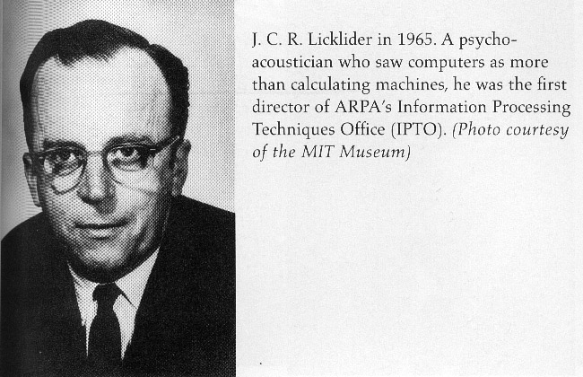

Licklider was an experimental psychologist who had studied the brain. For his PhD thesis he did pioneering work mapping where sound is perceived in the brain of the cat. Licklider was also excited about the development of the computer and of its potential to further scientific research.

He was particularly interested in the potential of the computer as a communication device. He saw it as a means of helping to create a community of researchers and of making it possible to strengthen the education available to the whole society through access to the ever expanding world of information. He envisioned that increased social contact would become available via the computer and computer networks.

Licklider created a community of researchers that he called the Intergalactic Network. He had in mind a network of networks. Though it was too early to create such a network when he began at IPTO in 1962, he set a foundation that inspired the researchers that followed him. He returned briefly to head the IPTO from 1974-75 just at the time that the research on the Internet was being developed.

In a paper Licklider wrote with another researcher Robert Taylor in 1968, Licklider outlined a vision for a network of networks. Licklider's vision was of the creation and development of a human-computer information utility. For this to develop and be beneficial, everyone would have to have access. The network of networks would be global. It wouldn't be just a collection of computers and of information that people could passively utilize. Rather his vision was of the creation of an online community of people, where users would be active participants and contributors to the evolving network and to its development. To Licklider, it was critical that the evolving network be built interactively.

Also Licklider believed that there would be a need for the public to be involved in the considerations and decisions regarding network development. He recognized that there would be problems with pressure being put on government from other sectors of society and that active citizen participation would be needed to counter these pressures. Licklider, writes:

. . . many public spirited individuals must study, model, discuss,
analyze, argue, write, criticize, and work out each issue and each
problem until they reach consensus or determine that none can be
reached -- at which point there may be occasion for voting.

Licklider believed that those interested in the development of the global network he was proposing, would have to be active in considering and determining its future. He also advocated that the future of politics would require that people have access to computers to be involved in the process of government. Licklider writes:

Computer power to the people is essential to the realization of a future
in which most citizens are informed about, and interested and involved in
the process of government.

Licklider and other computer pioneers of the 1950s and 1960s were concerned with the public interest and how the computer and networking developments of the future would be maintained in the public interest. Licklider writes that it is important to not only seek to consider the public interest, but also to make it possible for the public to be involved in the decision making process:

[Decisions] in the ‘public interest’ but also in the interest of giving the public
itself the means to enter into the decision-making process that will shape
their future.

Through the 1960s and into the early 1970s the IPTO pioneered new and important computer technology like the time sharing of computers and then the creation of packet switching and the ARPANET computer network. The research was written up in professional publications and widely distributed.

By the late 1960's and early 1970s it was recognized that there was widespread interest in developing computer networking in countries around the world. A conference was held in 1972 at the Hilton Hotel, in Washington DC from October 24-26. More than a thousand researchers from countries around the world attended and participated in the demonstration by US researchers that packet switching technology was functional. The demonstration excited many of the researchers. Also, however, international participation was recognized as critical to the development of networking technology. "International participation is no mere adornment to the Conference," the organizers wrote. "It is a primary means towards achieving a diversity of interest and viewpoint."

At the conference, a group was formed of those working on networking developments in different countries. It was called the International Network Working Group (INWG).

The great interest worldwide in computer networking was stimulating, but also it presented a problem. To understand the nature of this problem, it is helpful to consider the fact that there were packet switching networks being developed in different countries. These included Cyclades in France, NPL in Great Britain, and ARPANET in the US. These networks were different technically and were under the ownership and control of different political and administrative entities. Yet networking researchers realized the importance of making it possible for these networks to be able to interconnect, to be able to communicate with each other. This can be articulated as the Multiple Network Problem.

There was the recognition that no one of these different networks could become an international network. There would need to be some means found to make communication possible across the boundaries of different networks.

Collaboration among the researchers continued, with a number of meetings and exchanges about how it would be possible to design and create a means to support communication across the boundaries of these diverse networks.

At a meeting in Sept 1973 at the University of Sussex, in Brighton, England, two US researchers, Bob Kahn and Vint Cerf presented a draft of a paper proposing a philosophy and design to make it possible to interconnect different networks. The basic principle was that the changes to make communication possible would not be required of the different networks, but of the packets of information that were traveling through the networks.

To have an idea of the concept they proposed it is helpful to look at a diagram to show what the design would make possible,

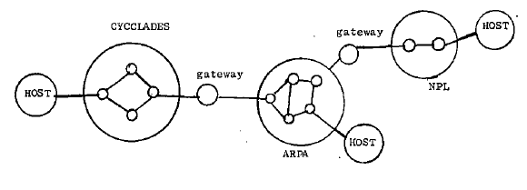
(This diagram is from a memo by Vint Cerf, but it is not an actual plan for the Internet)

In the gateways, changes to the packets would be made to make it possible for them to go through the networks. Also the gateways would be used to route the packets.

The philosophy and design for an Internet was officially published in a paper over 30 years ago, in May 1974. The paper is titled "A Protocol for Packet Network Intercommunication" by Vinton Cerf and Robert Kahn with thanks to others including several from the international network research community for their contributions and discussion.

Describing the process of creating the TCP/IP protocol, Cerf explains that the effort at developing the Internet protocols was international from its very beginnings. Peter Kirstein, a British researcher at the University College London (UCL) presented a paper in Sept 1975 at a workshop in Laxenberg, Austria, describing the international research process. This workshop was attended by an international group of researchers, including researchers from Eastern Europe. Kirstein reports on research to create the TCP/IP protocol being done by US researchers, working with British researchers and Norwegian researchers. Here is the diagram that Kirstein presents showing the participation of US researchers via the ARPANET, along with British researchers working at the University College London (UCL) and Norwegian researchers working at NORSAR.
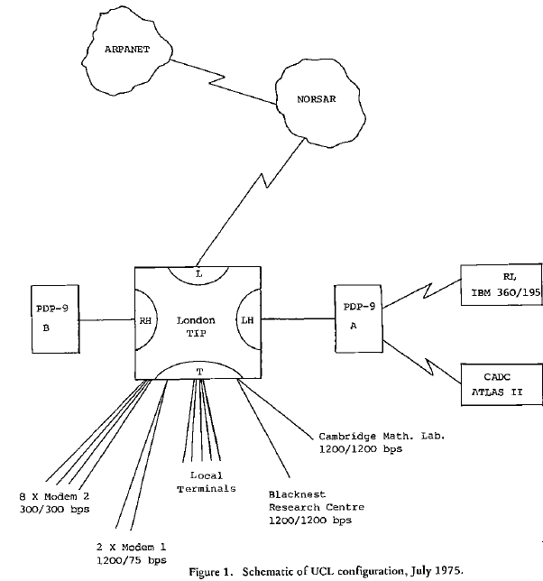

Collaboration between the Norwegian, British and US researchers continued, demonstrated by the research to create a satellite network, called SATNET.

Later researchers from Italy and Germany became part of this work.

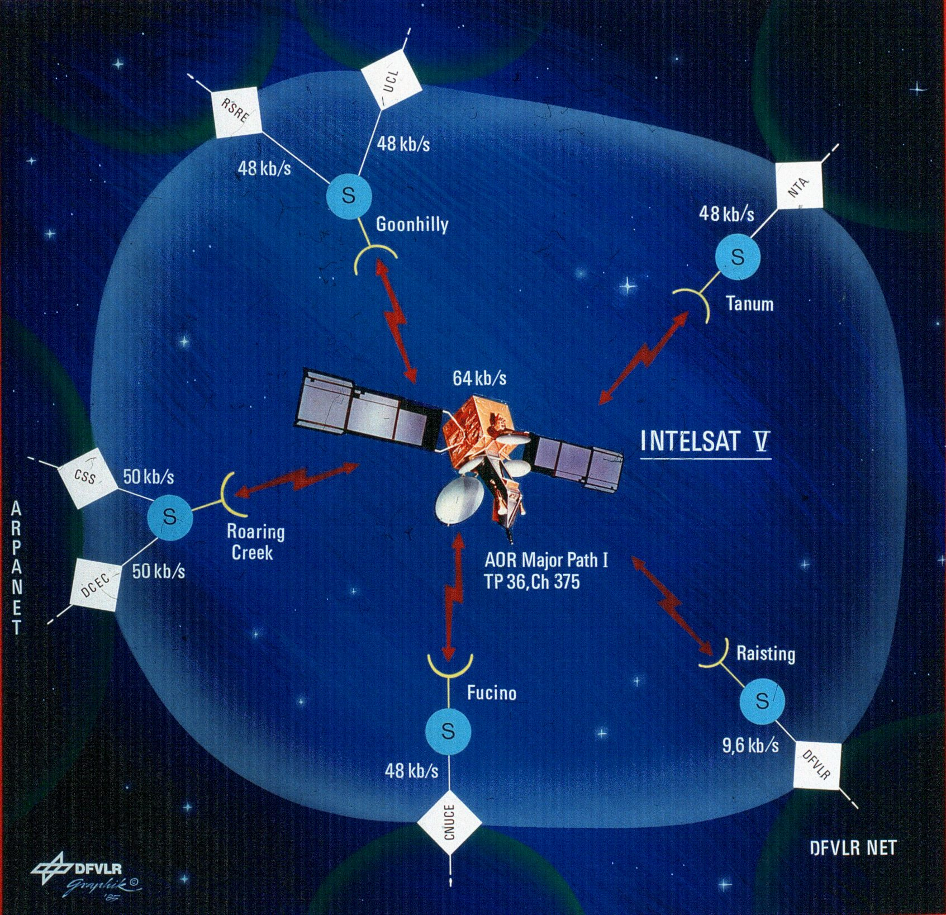

Describing this international collaboration, Bob Kahn writes:

SATNET...was a broadcast satellite system. This is if you like
an ETHERNET IN THE SKY with drops in Norway (actually
routed via Sweden) and then the UK, and later Germany and Italy.

Networking continued to develop in the 1980s. Among the networking efforts were those known as Usenet (uucp), CSnet, NSFnet, FIDONET, BITNET, Internet (TCP/IP), and others.

By the early 1990s TCP/IP became the protocol adopted by networks around the world.
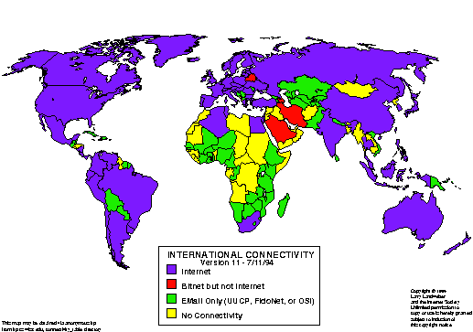

In this map you can see the areas of the world where TCP/IP networking was possible, the areas where there was access to BITnet but not the Internet and the areas there was only email access via different networking possibilities like uucp, FIDONET or OSI (X.25), etc.

It is also in the early 1990s that my co-author of the book Netizens, Michael Hauben, did some pioneering online research as part of class projects in his studies at Columbia University. He explored where the networks could reach and what those who were online felt was the potential and the problems of the developing Internet.

In the process he discovered that there were people online who were excited by the fact that they would participate in spreading the evolving network and contributing so that it would be a helpful communication medium for others around the world. Michael saw these users as citizens of the net or what at the time was referred to as net.citizens

Shortening the term to ‘netizen,’ he identified and documented the emergence of a new form of citizenship, a form of global citizenship that is called netizenship.

Describing these online citizens, the netizens, Michael writes:

They are people who understand that it takes effort and action
on each and everyone's part to make the Net a regenerative and
vibrant community and resource. Netizens are people who decide
to devote time and effort into making the Net, this new part of
our world, a better place. (Michael Hauben, 1995)

What are the implications of this background to the WSIS process? In October 1998, the US government decided it needed to privatize the Internet's infrastructure. It created ICANN, the Internet Corporation for Assigned Names and Numbers. ICANN provided only minimal input for governments in an official way or for Internet users. There have been many problems with the structure and functioning of ICANN and lots of criticism.

The WSIS process led to holding a Summit in Geneva in December 2003. A number of heads of state attended. Issues raised included: Affordable access available to all,
what would be the role for Governments in Internet governance? what would be the role for others in Internet governance?

In February 2004 a workshop was held to try to determine the components of Internet governance. At the workshop there was a proposal for netizens to be involved in Internet governance, recommending that netizen involvement would make it possible to counter the self interest of corporations who were part of the Internet governance process. The following diagram was submitted by Izumi Aizo of Japan. It still shows only a minimal role for governments but it introduces a role for netizens which is in line with Licklider’s vision of the crucial nature of citizen participation in the network’s development.

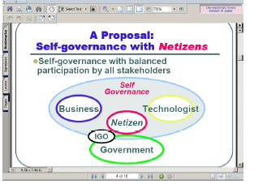

Online, there is a forum involved with the WSIS process. But few people who are involved with WSIS seem to pay attention to it. However, a comment on the forum seemed quite relevant to the problems being raised. The contributor to the forum, Safaa Moussa was from Egypt. Moussa, too, echoed Licklider’s concerns, writing that the crucial issues of Internet governance involve the issue of public access and the issue of how to widen the scope of public engagement in the decision making process.

In September 2004, a meeting was held in Geneva. Many contributions to that meeting seemed in line with the vision of Licklider expressed to guide computer network development. But there was contention, also. Summarizing the conflict that has developed in the WSIS process, a representative of Egypt, H. E. Dr. Tarek Kamal, explains that there are two conflicting view points. One view is that Internet governance involves primarily technical and operative issues which can be best coordinated by technical groups and business organizations (this is the view of those in favor of ICANN). The other view pointed to by Dr. Kamal is that technical resource management and other policy matters concerning the Internet are social and public questions needing international and government participation.

At the Sept 2004 meeting, supporting this second viewpoint, a member of the Brazil delegation, Jose Marcos Nogueira Viana, proposed the need to create an inter-governmental forum - a meeting place for governments to discuss Internet related issues. Also putting public interest into the debate, was Hans Falk Hoffman, a representative from the international scientific institution CERN. He described how the scientific community would continue to try to connect universities and therefore major cities to the global network with sufficient bandwidth at affordable prices. A representative from the Chinese delegation Madam Hu Quiheng, explained how

The Internet is a resplendent achievement of human civilization
in the 20th century. And that government has to play the essential
role in Internet governance...creating a favorable environment
boosting Internet growth while protecting the public interests.

I want to propose that this activity as part of the WSIS process demonstrates the importance of understanding the fact that the Internet is international and that there is a demand for an international management process and structure.

Similarly, and perhaps even more important is the need to understand how to determine the public interest. In connection with this goal, I want to propose the need to seriously consider whether the goal of netizen empowerment is one of the important policy issues to be injected into the WSIS process. This would imply the need to provide means for the online community to be able to be active participants in the WSIS process. In the online forum on 09 September 2004, Safaa Moussa wrote:

This online forum constitutes an important part of mobilizing efforts for the
pursued effective outcome. But, in view of the wide-ranging aspects that Internet
Governance covers, I believe it is duly important to make it clearer the
inclusion of online contributions into the decision-making process.

Online interaction and feedback need to be seen all along the decision-making and
implementation processes.

Another point I would like to underline is the creation of online working groups
to help integrate and coordinate initiatives and efforts undertaken at national
regional and international levels.

(Safaa Moussa’s post can be seen at
http://www.wsis-online.net/igov-forum/forums/message-view?message_id=416031 )

The Tunis Summit will take place in November 2005. Will it be able to meet the challenges of the continuing development and spread of the Internet? There are promising signs that the public and international essence of the Internet as envisioned by JCR Licklider which were so important in the origin and development of the Internet are being taken up. But will there be a means of welcoming the online community, the community of netizens into the WSIS process? Will there be a convergence of netizen participation and defense of the public essence of the Internet strong enough for the results of the Tunis summit to be significant?

