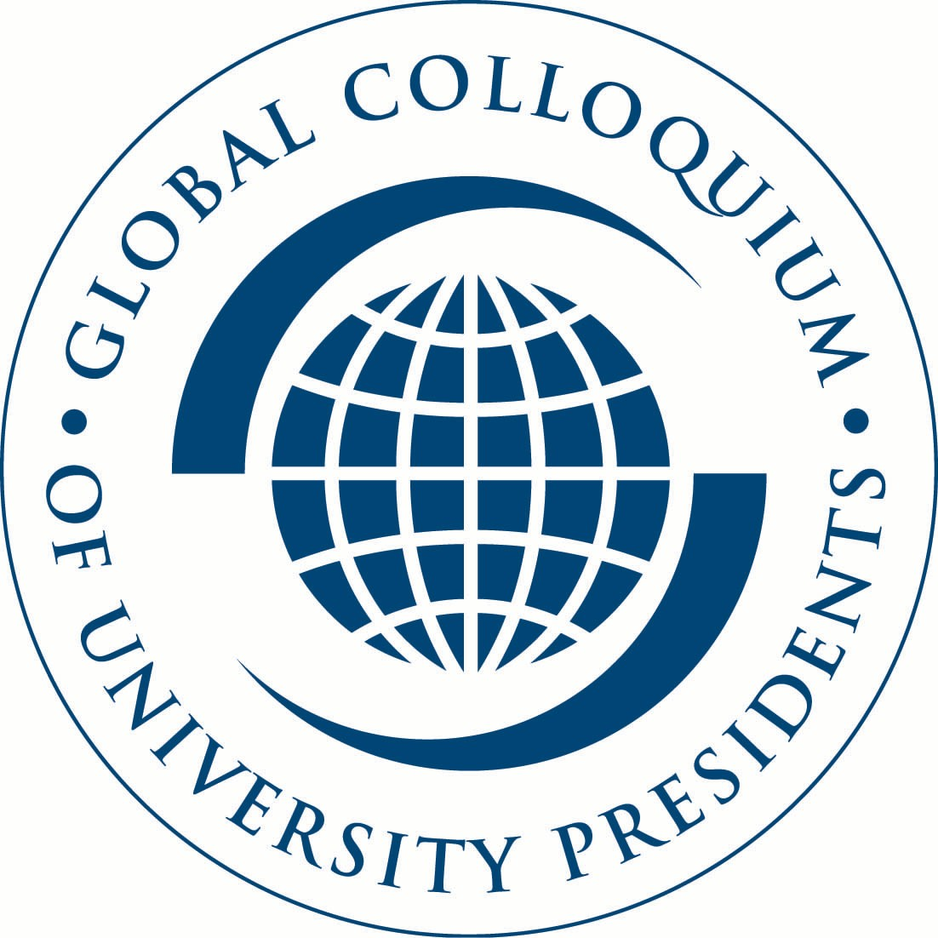

ACADEMIC FREEDOM STATEMENT OF THE FIRST GLOBAL COLLOQUIUM
OF UNIVERSITY PRESIDENTS

Columbia University
January 18-19, 2005

The first annual Global Colloquium of University Presidents met at Columbia University on January 18 and 19, 2005. Envisioned as a series of annual events growing into an international network of research universities, the inaugural meeting gathered more than 40 university leaders and professors. In response to the United Nations Secretary-General’s request for greater involvement of the global academic community in exploring international public policy concerns, five New York-area universities launched the Colloquium. This year, the presidents of 15 universities discussed academic freedom in higher education while their expert representatives met to consider the pressing issue of international cooperation on migration.

In the introduction to this year’s opening session, Columbia University President, Lee C. Bollinger, welcomed his counterparts from major research universities throughout Europe, Asia, Africa, South America, and Australia, and emphasized the critical importance of increased collaboration among universities. “In these days of rapid globalization and a more interconnected world,” remarked Bollinger, “we have a tremendous responsibility to lend our collective scholarship and expertise toward the resolution of challenges worldwide.” The Global Colloquium of University Presidents will facilitate a collaborative network of university leaders and academics that will regularly gather to consider some of the most significant issues facing the global community. Each year, university presidents will meet to focus on issues of direct importance to the academic community, while their expert faculty members discuss key global policy challenges — chosen for their importance to the Secretary-General. Hosting responsibilities for the Colloquium will rotate among the five sponsoring universities: Columbia University, New York University, Princeton University, University of Pennsylvania, and Yale University. The inaugural Colloquium was made possible through the generous support of the William and Flora Hewlett Foundation.

The Secretary-General, Kofi Annan, chaired the plenary discussion of both topics, and also addressed the attendees at an opening dinner. Mr. Annan’s remarks focused on his hopes for the Colloquium and on the results of two of his recent reform reports (described below).

Secretary-General Annan began by noting that, “One of the first speeches I gave on taking office as Secretary-General was to a distinguished group of university presidents from around the world. From the outset, I was convinced that universities would be tremendously important partners of the United Nations. And so it has been. As educators, as repositories and creators of knowledge, as people deeply involved in helping the world address the issues of our times, your role has been vital. This colloquium is yet another example of the productive ties we have developed over the years, and I hope it will become a tradition.”

The Secretary-General then remarked that we are “at the start of a year that has the potential to bring fundamental change not only to the United Nations, but also to the way the world handles the challenges and threats we face. Member States have decided to hold a summit in September to review the progress we have made in implementing the Millennium Declaration which, as you know was adopted five years ago at the Millennium Summit. It is my hope that leaders will use the months between now and then for serious discussions, and arrive in September ready for bold decisions about our common future.”

In his own recommendations to the forthcoming summit, Mr. Annan will draw on two landmark reports, the High Level Panel Report on Threats, Challenges and Change, entitled “A More Secure World,” and the Millennium Project Report. Mr. Annan embraced the work of the High Level Panel in achieving a definition of terrorism. He was particularly hopeful that this definition would ultimately be accepted by the global community because it was articulated by a consensus of experts from all regions of the world.

Noting the interconnectedness of threats in today’s world, Mr. Annan stressed that governments can no longer afford to ignore the plight of citizens of other nations. He expressed his hope that the Security Council would continue to embrace the role of protecting citizens when their governments were unable or unwilling to do so, and referenced the Evans-Sahnoun Commission’s finding of an emerging international norm of a “duty to protect.” He also discussed other changes that he hoped would move the international community toward a stronger collective security regime, mentioning the possibility of reforming the Security Council to better reflect the global situation of the world today.

Turning to the Millennium Project Report, Mr. Annan emphasized the link between security and development and welcomed the Report’s inclusion of “ideas to help those who have fallen behind.” Responding to a question regarding the breadth of the agenda expressed by the reports, the Secretary-General stressed his belief that the goals of the reports are achievable. He stated that he would issue a report in March that outlines priorities for working towards the Millennium Development Goals, noting in particular the pressing need to double the current level of development assistance, from $50 billion to $100 billion.

Mr. Annan particularly welcomed the participation of the academic community in assisting the United Nations in its work, stressing that, “There is ample scope in the year ahead for university leaders such as you to contribute to this process. I hope you will do what you do best: challenge your students, your faculty, and the wider communities in which you operate, to engage and work together for the greater good of humankind.”

The Secretary-General concluded his remarks with a brief discussion of his trip to Asia in the aftermath of the tsunami. He shared his deep admiration for the way the victims of the disaster, at both local and governmental levels, have come together to rebuild their communities, specifically citing the summit of Asian governments in Jakarta and subsequent fundraising efforts. Emphasizing the fact that “it is the poorest who are hardest hit,” Mr. Annan also emphasized the need for the global community’s assistance.

The Colloquium focused on two topics: international migration, a key element of globalization, and academic freedom, a crucial foundation of university research and teaching. The participants met in parallel sessions to discuss the two issues before reconvening in plenary, with the Secretary-General as chair.

The full record of the symposium, including this report and the background papers prepared by each of the participants, is available at: http://www.columbia.edu/~md2221/global_colloquium.htm

The two sessions prepared the following two statements designed to highlight the conclusions of their deliberations. They have invited other university presidents and other experts in migration to join them in endorsing the statements.

Statement on Academic Freedom
May 26th, 2005

I.

The Context of Academic Freedom

The Purposes of Universities
The international community recognizes the important role played in society by universities and other institutions of higher learning and research. Indeed, all states are expected to provide higher education in fulfillment of Article 26 of the Universal Declaration of Human Rights (1948) and Article 13, paragraph 2(c), of the International Covenant on Economic, Social and Cultural Rights (1966).

Modern societies now entrust universities with greater responsibilities than ever before. Universities are charged with preserving the knowledge of the past and transmitting it to the next generation; educating tomorrow’s citizens, professionals, and leaders; and fostering the discovery of new knowledge that may either strengthen or challenge established ideas and norms -- all with the aim of deepening human understanding and bettering the human condition. They also function as engines of economic development, foster technological and scientific innovation, stimulate creativity in the arts and literature, and address urgent global problems such as poverty, disease, ethno-political conflict, and environmental degradation.

The Principles of Universities
At the International Conference convened by UNESCO in 1950, in Nice, the Universities of the World articulated three interdependent principles for which every university should stand:

- The right to pursue knowledge for its own sake and to follow wherever the search for truth may lead.
- The tolerance of divergent opinion and freedom from political interference.
- The obligation as social institutions to promote, through teaching and research, the principles of freedom and justice, of human dignity and solidarity, and to develop mutually material and moral aid on an international level.

These principles reflect the central role that university-based research and education play in the cultural, social, political and economic development of societies. They apply regardless of whether universities are state-funded, state-regulated, or private institutions.

II.

The Meaning of Academic Freedom

The Foundations of Academic Freedom
The principles upon which universities, and the academic activities they embody, stand are widely recognized. These principles are morally, legally, and politically grounded in the values that define the role of scholars in all academic disciplines (including the humanities, the natural, biological, and social sciences, the arts, engineering, law, medicine, etc.) as professionals and the universities in which they work, study, and teach as important social institutions that enable, support, and protect scholars’ professional activities.

The activities of preserving, pursuing, disseminating, and creating knowledge and understanding require societies to respect the autonomy of universities, of the scholars who research and teach in them, and of the students who come to them to prepare for lives as knowledgeable citizens and capable leaders. The autonomy of universities is the guarantor of academic freedom in the performance of scholars’ professional duties.

Academic freedom is therefore distinct from -- and not a mere extension of -- the freedoms of thought, conscience, opinion, expression, assembly, and association promised to all human beings under Articles 18, 19, and 20 of the Universal Declaration of Human Rights and other international covenants.

The Definition of Academic Freedom
At its simplest, academic freedom may be defined as the freedom to conduct research, teach, speak, and publish, subject to the norms and standards of scholarly inquiry, without interference or penalty, wherever the search for truth and understanding may lead.

The Importance of Academic Freedom
The value of academic freedom is closely linked to the fundamental purposes and mission of the modern university. The expanding role that universities are playing in the Information Age only increases its significance. The emergence of a world-wide knowledge economy, the unparalleled transnational flow of information and ideas, and the growing number of young democracies, all make necessary the continued re-examination and articulation of the nature and importance of academic freedom. Indeed, across the globe, the defense of academic freedom remains at the heart of ongoing political and economic battles over the role and autonomy of universities.

Academic freedom benefits society in two fundamental ways. It benefits society directly, and usually immediately, through the impacts and benefits of applied knowledge, the training of skilled professionals, and the education of future leaders and citizens. It benefits society indirectly and usually over longer periods of time, through the creation, preservation, and transmission of knowledge and understanding for its own sake, irrespective of immediate applications.

Thus, academic freedom has both intrinsic and practical value. Above all, by facilitating critical thinking and open discourse, academic freedom provides the foundation for the continued intellectual and social value of the university as a place of unfettered debate and the free exchange of ideas. It thereby enables universities to produce citizens equipped to thrive in and sustain free and open societies.

III.

The Practice of Academic Freedom

Academic freedom applies to the activities of faculty and students that are closely related to or impact upon the educational, scholarly, and research purposes of universities. Academic freedom is not applicable to every activity, and without accountability it can be barren and unproductive. The “freedom” in “academic freedom” is qualified or bounded by what can reasonably be counted as “academic.” In practice, this means that universities are best able to gauge the parameters of academic freedom and therefore must be responsible for a considerable degree of self-regulation. All of the relevant individual actors, governance bodies, and constituencies within the university must use their freedom not only to advance the university’s goals of education, research, and service, but also to contribute positively to an environment of academic freedom, defending its privileges and fulfilling its obligations.

Like other professional privileges, academic freedom confers both rights and responsibilities on universities, individual scholars, and students:

- The Rights of Scholars and Students
Academic freedom is fundamental to the central values and purposes of universities, which must in turn protect freedom of inquiry and speech, without which neither faculty nor students can flourish or achieve the ends that academic freedom is designed to serve. Scholars and students must be able to study, learn, speak, teach, research, and publish, without fear of intimidation or reprisal, free from political interference, in an environment of tolerance for and engagement with divergent opinions. The teacher is entitled to freedom in the classroom in discussing his or her subject, and when speaking or writing outside the classroom as an individual, the teacher must be free from institutional censorship or discipline.

- The Responsibilities of Scholars
Academic freedom carries with it a concomitant responsibility of scholars to resist corrupting influences on their research and teaching, to transcend partisanship and prejudice, and to foster intellectually vigorous and open discussion within the classroom, adhering to the highest norms and standards of scholarly inquiry and teaching. In their academic duties, faculty are responsible to further the learning of students and should avoid statements and actions that may inhibit students’ freedom of inquiry and expression, thereby compromising the university’s most fundamental values.

- The Rights of Universities
Academic freedom requires the institutional autonomy of universities, which enables them to preserve the human record of knowledge and ideas, to advance the discovery and interpretation of new knowledge, to educate students, and to serve the larger society. This autonomy includes the right of the university to determine for itself, on academic grounds, who may teach, what may be taught, how it shall be taught, and who may be admitted to study. Likewise, this institutional autonomy should determine the framework for statutory provisions that govern or impact universities.

- The Responsibilities of Universities
Academic institutions bear a heavy responsibility to protect the scholars and students who work within them from improper pressures, whether political, cultural, economic, or ideological. Universities must maintain and encourage freedom of inquiry, discourse, teaching, research, and publication, and they must protect all members of the academic staff and student body against external and internal influences that might restrict the exercise of these freedoms.

The Operational Meaning of Academic Freedom
Though national realities inevitably shape perspectives on the meaning and practice of academic freedom, at minimum, the performance and expressions of faculty in the classroom and other educational settings must be subject solely to the professional judgment of scholarly colleagues. Freedom of expression inside and outside the classroom must be strongly defended by the university, regardless of the popularity or content of the views expressed. It is essential that each university have established guidelines and procedures that address and safeguard academic freedom. The structure of relationships, responsibilities, and accountabilities among the constituents of the institution (students, faculty, administrators, and trustees or governing council) should be of a nature that facilitates the full implementation of and respect for such guidelines and procedures.

Although academic freedom can be threatened from a variety of sources, both internal and external to the academic community, historically the most fundamental threats to academic freedom have come from the state, whose political power and disposition to regulate often stands in opposition to the university’s need for institutional autonomy.

Common practices and institutions of civil society may also threaten the integrity of academic freedom. For example, the pressures and lures of commercial initiatives and alliances, or attacks by outside groups on the freedom of the academy (particularly, but not only, in periods of national crisis), can seriously threaten the autonomy of universities and the academic freedom of their faculty and students. Universities must be free of obligation to external groups, alumni, community leaders, the media, or other elements of civil society who may object to or seek the suppression of viewpoints expressed by faculty members, students, public speakers, and others who participate in the academic and educational activities of universities.

University authorities themselves, by bending to political pressures or popular will, can also weaken the environment of academic freedom within the university, stifling student dissent or the unpopular views of controversial professors. In addition, disciplinary orthodoxy in some academic fields may pose a threat to the university’s environment of free dialogue by compelling scholars or students to conform to established lines of thought. Among the most important mechanisms for maintaining scholarly standards and protecting academic freedom are peer-review systems that determine how research is funded, conducted, and results published, but peer review systems must never be allowed to become vehicles to enforce blind adherence to dominant viewpoints or silence those perspectives that deviate from established, orthodox ideas.

It is our hope that the principles set forth in this document will help to clarify the nature of academic freedom, reaffirm its value, strengthen its practice, and resist threats to the academic freedom of scholars, students and universities around the world.

Kwadwo ASENSO-OKYERE Lee BOLLINGER
University of Ghana Columbia University

Gavin BROWN G.K. CHADHA
University of Sydney Jawaharlal Nehru University

Bernard COULIE Richard DESCOINGS
Université catholique de Louvain Institut d’Etudes Politiques de Paris

Ali DOĞRAMACI Amy GUTMANN
Bilkent Üniversitesi University of Pennsylvania

John HOOD Guillermo JAIM-ETECHEVERRY
University of Oxford University of Buenos Aires

Richard LEVIN Njabulo NDEBELE
Yale University University of Cape Town

Neil RUDENSTINE John SEXTON
President Emeritus Harvard New York University
University

Shirley TILGHMAN
Princeton University

June 27, 2005
Matthew GOLDSTEIN Tunçalp ÖZGEN
The City University of New York Hacettepe University

Naoto YOSHIKAWA Dieter LENZEN
Hawaii Tokai International College Freie Universitat Berlin

Itamar RABINOVICH Renato GUARINI
Tel Aviv University Universita degli Studi di Roma

Nabeel KASSIS Alison RICHARD
Birzeit University University of Cambridge

September 14, 2006

Endorsed by all 191 UN Member States, the Declaration sets international goals across a wide spectrum of global issues, ranging from peace and security through development and poverty eradication to UN reform

