March 30, 2006 Draft

Credit Cards, Consumer Debt, and Bankruptcy

*

Table of Contents
1. The Existing Literature 2
2. Research Questions and Hypotheses 4

3. Data 7
3.1. Credit Card Use 7
3.1.1. Problems with Different Types of Data 7
3.1.2. Data Sources 12
3.2. Consumer Credit 13
3.3. Consumer Bankruptcy 13
3.4. Macroeconomic Data 14

4 Results 14
4.1. Credit Cards and Consumer Credit 14
4.2. Credit Cards and Bankruptcy 22
5. Discussion and Conclusion 29
Bibliography 1
Tables
Table 1 – Summary Data (Consumer Debt and Credit Card Debt) 15
Table 2 – Credit Card Debt and Consumer Debt 17
Table 3 – Credit Card Spending and Consumer Debt 18
Table 4 – Credit Card Spending, Credit Card Debt, and Consumer Debt 19
Table 5 – Credit Card Spending, Credit Card Debt, Macroeconomic Variables,
and Consumer Debt 21
Table 6 – Summary Data (Bankruptcy Filings) 23
Table 7 – Credit Card Debt and Bankruptcy 25
Table 8 – Consumer Debt and Bankruptcy 25
Table 9 – Credit Card Use, Consumer Debt, Macroeconomic Variables,
and Bankruptcy 26
Table 10 – Credit Card Use, Consumer Debt, and Bankruptcy 27
Table 11 – Final Model (with Dummies) 28

Figures

Figure 1 – Credit Card Debt, Credit Card Spending, and Consumer Debt 15
Figure 2 – Scatterplot of Consumer Credit on Credit Card Debt 16
Figure 3 – 2002 Consumer Bankruptcy Rates (Per Million) 23
Figure 4 – Scatterplot of Bankruptcy on Credit Card Debt 24

Abstract
This paper analyzes the effects of credit card use on broader economic indicators, specifically consumer credit, and consumer bankruptcy filings. Using aggregate nation-level data from Australia, Canada, Japan, the United Kingdom, and the United States, I find that credit card spending, lagged by 1-2 years, has a strong positive effect on consumer credit. Finally, I find a strong relation between credit card debt, lagged by 1-2 years, and bankruptcy, and a weaker relation between consumer credit, lagged by 1-2 years, and bankruptcy. The relations are robust across a variety of different lags and models that account for problems of multicollinearity and auto-correlation in the time series and include variables to control for the effects of economic cycles on bankruptcy and dummy variables to isolate nation-specific effects.

Credit Cards, Consumer Credit, and Bankruptcy
In the last half century, the credit card has evolved from a novelty item used by business diners in Manhattan to the dominant noncash payment system in the developed economies of the world. During that time, the credit card has experienced a series of transformations. The original card was for the most part a charge card for business travelers, on which customers were expected to pay their charges on a monthly basis. Later, when banks began issuing cards to their depositors en masse, the cards began to be used as a vehicle for providing revolving credit. Finally, in the modern market, most of the debt on credit cards is on cards issued not by the cardholder’s bank of deposit, but by one of a small number of specialized lending institutions. See Mann 2006 for detailed discussion.
A major reason for the worldwide success of the credit card is that it is a great technological idea, from almost any perspective. First, as a payment device it is (at least in its modern form) cheaper to process, easier to use, and easier to accept than the cash, checks, and similar paper instruments that it replaces. Similarly, as a device to facilitate borrowing, it provides a markedly cheaper way for the typical consumer to borrow money. Where the card qua payment device competes against cash and checks, the card qua loan agreement competes against the closed-end loan from a bank or a consumer-finance company. The closed-end loan from a bank typically has been preceded by one or more visits to a banker’s office, an interview, and completion of forms in the banker’s presence. For decades, however, the process of obtaining a line of credit on a card has been streamlined: completing and mailing a short application that typically is received in the mail or picked up at a merchant that the borrower patronizes.
Of course, during the same time that the credit card has been spreading throughout the developed world, other aspects of the United States economy have spread as well, including consumer credit and insolvency. The spread of credit cards obviously is intertwined with the general trend toward the globalization of financial products and services. The actual patterns of usage, however, reflect shifts as the product spreads from this country, caused both by cultural norms and by fortuitous historical circumstances at the time the product first became important. See Mann 2006 for detailed discussion. The natural question, then, is whether those phenomena are spreading independently, or whether they have a causal relationship to each other. In particular, there is a persistent concern – not to date backed by any rigorous quantitative analysis – that the ready availability of credit cards causes excessive levels of consumer spending, consumer credit, and consumer bankruptcy.
This paper examines that question from a comparative perspective, using time series data from Australia, Canada, Japan, the United Kingdom, and the United States to assess the causal connections among credit cards, consumer credit, and bankruptcy. Section 1 addresses the existing literature. Section 2 discusses the research questions and hypotheses that I set out to examine. Section 3 discusses the data available to examine those questions. Section 4 presents the results. Section 5 briefly discusses the results and concludes.

1. The Existing Literature
The principal focus of the existing literature has been to establish that both credit card debt and consumer credit in the United States correlate with consumer bankruptcy filings. For example, the most prominent early work on this topic, Ellis 1998, discusses a general correlation between consumer bankruptcy rates and levels of credit card debt in the United States. Similarly, both Bhandari & Weiss 1993 and Warren 1998 note a positive correlation between total consumer debt and bankruptcy filings. Using a slightly different metric, Ausubel 1997 and Mester 2002 both note a positive correlation between household debt burden and bankruptcy filings. Of those papers, however, only Bhandari & Weiss used regressions or similar statistical techniques to isolate the effect of particular variables. Thus, among other things, the other papers did not include regressions or attempt to control for autocorrelation in the time series.
More importantly from my perspective, none of those papers tried to untangle the separate effects of credit card activity and consumer debt more broadly. Thus, Bhandari & Weiss analyze only aggregate levels of debt; they did not analyze any data specifically related to credit cards. Although it is reasonable to expect that the level of credit card debt would correlate with the level of aggregate debt, any analysis that aims to study the general effect of credit cards must look both at data about borrowing on credit cards and at data about borrowing more generally.
The first paper to consider the question of whether particular kinds of debt might contribute more to rising bankruptcy filings was Lawless 2002. Generally, he provides a correlation matrix showing that the correlation with consumer bankruptcy filings is higher for revolving consumer credit than it is for total consumer credit. Even Lawless, however, does not include any formal statistical analysis to separate out the potential effects that the disparate credit variables might have on bankruptcy.
The only paper that has attempted to analyze the separate effects of credit card borrowing and consumer credit more broadly is Stavins 2000. She shows that total credit card debt correlates more closely with bankruptcy rates in a particular region of the United States than total consumer credit. Even Stavins, however, does not control for the obvious multicollinearity of the independent variables (credit card debt and total consumer credit) or investigate whether time lags can clarify the direction of causation.
Finally, with respect to the comparative aspects of the problem on which my research focuses, none of the literature has compared data across borders. The closest thing in the existing literature is a brief discussion about Canada in Ellis 1998 that is not amplified by quantitative analysis. If, as I believe, credit card use is at least in part an aspect of globalization, a broader lens seems necessary to any thoughtful evaluation of the phenomenon.
In response to those papers, Zywicki (writing both by himself (Zywicki 2005) and with Judge Edith Jones (Jones & Zywicki 1999)) has argued that those papers do not establish any causative relation between the use of credit cards and bankruptcy. He generally argues that the casual nature of the quantitative analysis in the existing literature makes it inappropriate to argue that borrowing on credit cards can be said to “cause” bankruptcy filings. Those papers raise the policy debate to a more pointed level, arguing not only that credit card use cannot be shown to cause bankruptcy, but that the data indicate that the rise in consumer bankruptcy is so clearly attributable to consumer abuse as to justify a substantial tightening of the system for consumer bankruptcy. Jones & Zywicki 1999; Zywicki 2005.

2. Research Questions and Hypotheses
My project starts from the premise that the credit function of credit cards makes it possible for credit cards to have effects on consumers and the economy as a whole beyond their role as a payment device. Credit card lending is beneficial to the economy if it substitutes for lending that is less effective or more expensive. Credit card lending also potentially benefits the economy if lower costs facilitate the use of credit for value-increasing transactions. Because the transaction costs for credit card lending are so much lower than they are for competing forms of lending to small businesses and individuals, those effects are important. Mann 1997. Similarly, by making it simpler for smaller businesses to extend credit, credit cards can facilitate competition in retail markets. Evans & Schmalensee 2005. To put the point more generally, a robust consumer credit market can substantially increase consumer welfare and contribute to overall economic growth. Therefore, it was not entirely irrational for the South Korean government to conclude several years ago that it could increase the growth of its economy by fostering the increased consumer spending that would come from more ready availability of consumer credit. Mann 2006.
On the other hand, credit card lending might adversely affect the economy in several ways. The most problematic is that it might cause excessively prodigal spending patterns that ultimately lead to financial distress. The other side of the same problem is that excessive credit card spending (or debt) might lower the savings rate. Specifically, the concern is that the credit card might be too convenient: by making borrowing so convenient that borrowers do not give adequate concern to the risks of a borrowing transaction, a credit card might have a unique ability to foster prodigal behavior. Evans & Schmalensee 2005; Mann 2006. Thus, for example, it is noteworthy that a country like Germany – with a high savings rate and low card use – also seems to have one of the lowest rates of consumer borrowing among highly developed countries.
Prodigal spending, in turn, plausibly might lead to an increase in financial distress. The intuition is that credit cards might increase the size of the group of people who have put themselves in a position where the family unit is unable to withstand some material adverse change of circumstances – a loss of employment, medical crisis, or the like. Warren & Tyagi 2003. This could be attributable to several features of credit card borrowing that make it categorically more convenient and less reflective than conventional borrowing. Most importantly, the extension of the line of credit is separated from the occasion for borrowing. Thus, the credit card is issued at one time, based on a statistical assessment of the cardholder’s ability to repay that provides adequate protection to the lender’s interest in repayment of future loans. The borrowing, however, takes place later, when even the minimal formalities of signing the original credit card application are long in the past. Sullivan, Warren & Westbrook 2000; Mann 2006.
The product’s tendency to minimize present-day awareness of the borrowing is underscored by low minimum payment amounts. Because the monthly payment amounts associated with initial purchases are so low, some consumers might fail to appreciate the future significance of the aggregate amount of credit that has been extended. Human nature suggests that undue use of credit might arise when we couple the elimination of a focusing event like a loan closing with the tendency to underestimate the true costs of adverse future events of low probability. Thaler 1991; Dellavigna & Malmendier 2004; Bar-Gill 2004. The experience of Japan is illustrative, where credit card borrowing appears to be stifled in significant part by a practice requiring the borrower to state an oral intention to borrow to use a revolving credit feature of a credit card. Mann 2002. Similarly, if Calder and Olney are right in thinking that beneficial effects of installment credit arise from the constraining effect of fixed installment payments, the credit card model’s departure from that practice arguably undermines its normative attractiveness. Calder 1999; Olney 1991.
If that concern is justified, credit card borrowing is not just a convenient part of consumer credit. Its convenience makes it a uniquely troublesome piece of the consumer credit puzzle, a type of borrowing that is uniquely likely to contribute to an increase in the risk of financial distress. The policy implications of that link are unclear, because of the different perspectives from which the problem can be seen. For example, a straightforward normative perspective might condemn any increase of financial distress attendant on credit cards solely because of the human pain and suffering that comes with financial distress. My goal here is to take a more narrowly economic perspective. From the perspective I examine here, the problem is that financial distress generates substantial external costs for the economy, costs that are not borne entirely by the lenders whose debts are not repaid or by the borrowers that fail to repay them. Hynes 2004; Medoff & Harless 1996.
Collectively, those concerns suggest a series of hypotheses about the relation between credit card use and consumer credit and bankruptcy:
- Credit card use is positively related to total consumer borrowing
- Credit card use is positively related to consumer bankruptcy
I turn now to the difficulties of collecting data with which to analyze those questions.

3. Data
Analysis of the hypotheses discussed in Part 2 requires data of four different kinds: credit card use, consumer credit, bankruptcy, and macroeconomic data on population and the like. The first of those is challenging; the others are routine. I discuss each of the four data collections separately.
3.1 Credit Card Use
3.1.1 Problems with Different Types of Data
The biggest problem in analyzing credit cards is the difficulty in obtaining data that captures the key concern – the possibility that credit cards foster a prodigal impulse that leads to financial distress. For example, it is easy to obtain data about delinquency rates on credit card accounts and to show that those rates correlate with consumer bankruptcy filings. Ausubel 1997; Stavins 2000. That is hardly surprising. I expect that careful analysis would confirm that delinquency rates on automobile loans and home mortgages also correlate highly with consumer bankruptcy filings. But the causal link evidenced by that data is not at all clear, because it is at least as likely that the same economic conditions that lead to consumer bankruptcies also lead to credit card delinquencies as it is that delinquencies on credit cards cause consumer bankruptcies. Even if the data show that the delinquencies precede the bankruptcies, it would remain quite likely that the sequential rise in the two variables reflects a single pattern caused by larger economic conditions.
We also know that people in bankruptcy are likely to have more credit card debt than people not in bankruptcy. Sullivan, Warren & Westbrook 2000. Even that data, however, is consistent with Zywicki’s hypothesis that people borrow in anticipation of bankruptcy based on the expectation that they can discharge the debt in bankruptcy. Jones & Zywicki 1999; Zywicki 2005.
My aim is to examine the effects of economic activity that is arguably benign: credit card spending and borrowing are attributes of many households that are not experiencing economic distress of any kind. The available data that is most useful for that inquiry is nation-level aggregate data about credit card spending and credit card debt. To be sure, that evidence cannot provide direct evidence about the dimensions of that problem. Different economies could have the same aggregate amount of credit card spending and debt. If it were distributed in a less responsible (more regressive) way, it would put more people at risk, and thus have a larger effect on bankruptcy rates. Conversely, if the spending and debt appears in a more responsible (more progressive) pattern, the same amount of spending and debt might have no significant effect on bankruptcy rates. To look at it from the familial perspective, the problem is worse when the aggregate amount of credit card debt is concentrated on a smaller number of families that have borrowed to the brink than it is when it is spread more uniformly across a large number of families in more manageable amounts.
Another difficulty with relying on aggregate data to assess the conditions of individual family units is the large variation in the circumstances and behaviors of individual family units. For example, we know that a large number of families have both substantial amounts of liquid assets and substantial amounts of credit card debts. Gross & Souleles 2000; Bertaut & Haliassos 2002; Haliassos & Reiter 2003. Thus, it is not fair to assume that substantial credit card debt always indicates exposure to financial distress. It also is clear that the rate of adverse impact from credit card spending and debt might shift over time if (as seems to be true in the United States) the pool of credit card users becomes more risky as the market matures. Black & Morgan 1999; Furletti 2003.
The basic difficulty is that it is not easy to use aggregate data on credit card debt to separate out the specific reasons that people might have large amounts of that debt. Because the different ways in which people might have incurred the debt reflect differing roles for the credit card, and different degrees of prodigality, the difficulty of disentangling them renders it difficult to resolve the problem through analysis of data. The problem is exacerbated by the normative subjectivity of the concept of prodigality: without some objective baseline as to what constitutes “prodigal” borrowing it is difficult to be sure which family situations reflect a use of credit cards that a well-ordered society should foster and which reflect uses that a well-ordered society would regret.
At one end of the continuum, there surely is some subset of people that irresponsibly spend themselves directly into bankruptcy, with credit cards being the vehicle. Those cases might involve conduct that is morally blameworthy, but most would think it inappropriate to “blame” the credit cards rather than the borrower. To put it another way, those cases might reflect excessive borrowing, but they are not caused in any significant degree by the borrower’s failure to appreciate consequences of borrowing; the behavior suggests a calculated indifference to consequences. As it happens, however, the available data suggests that those cases are not a major part of consumer bankruptcies, at least in this country. Sullivan, Warren & Westbrook 1989; Sullivan, Warren & Westbrook 2000; Warren & Tyagi 2003; Sullivan, Warren & Westbrook 2003.
At the other end of the continuum is a group of bankruptcy cases associated with a catastrophic family crisis such as a divorce, loss of job, or medical event. Data from the Consumer Bankruptcy Project, for example, indicates that one of those three events is present in 87% of bankruptcies involving families with children. Warren & Tyagi 2003; Jacoby, Sullivan & Warren 2001. More recent study of a related data set provides further details about the pervasiveness of medical problems in consumer bankruptcies. Himmelstein, Warren, Thorne & Woolhandler 2005. At the same time, efforts to find a statistical relation between those kinds of problems and bankruptcy filings have been more mixed. Fay et al. 2002, for example, does conclude that divorce increases the probability of bankruptcy filing, but at the same time finds no significant effect related to job loss or health problems.
The use of credit cards in those cases is ambiguous. First, high credit card borrowing might reflect rational post-crisis borrowing as a response to the tragedy. For example, available data suggests that many families use credit cards to meet crisis-level medical expenses. Himmelstein, Warren, Thorne & Woolhandler 2005. For those families, the special features of credit card borrowing might have eased the difficulty. After all, a rational lender faced with a loan application after the crisis has come might have declined to extend the credit that the family can obtain so easily from the existing credit cards. Moreover, there doubtless is a large group of families similar to those, who engage in heavy crisis-related credit card borrowing but manage to turn things around and avoid bankruptcy. Evans & Schmalensee 2005:102. For those families, the credit card can be the lifeline by which they pull themselves out of distress. That borrowing is not profligate in its failure to consider the future. It is a reasoned reaction to an adverse situation. To be sure, particularly for those families that fail, and perhaps for the group as a whole, the availability of credit card borrowing might delay refuge in bankruptcy beyond the point where the family’s financial affairs would be restructured optimally. The key point for this paper, however, is that those are not cases in which a credit card unambiguously is used for prodigal spending.
Another group of cases, the cases at the heart of Elizabeth Warren’s recent book with Amelia Tyagi (Warren & Tyagi 2003), involves people that use credit cards to borrow enough to put themselves in an unstable position, which left them unable to withstand a catastrophic event that they otherwise could have weathered. The cases they discuss provide one specific example of the problem that is relevant to my thesis. When a family borrows to the hilt, it does not have any discretionary cash flow available to apply to respond to the adverse event. Moreover, because by hypothesis the family already has used the credit that a prudent lender would have extended to it while times were good, it will be difficult to obtain additional credit to respond to adversity.
This paper does not attempt, however, to assign any relative level of normative responsibility to different types of credit card use. Rather, my point is that the aggregate nation-level data will conceal a wide variety of usage patterns, some of which will reflect calculated abuse, some prudence, and some prodigality. The collection of those various patterns into nation-level data might obscure the effects that I wish to examine. However, it should not undermine the reliability of any findings that come from analysis of the data.
I should mention two Federal Reserve datasets that I have chosen not to use for this project: the Survey of Consumer Finances (SCF) and Federal Reserve data on household debt burdens. At first glance, the SCF data seem to provide an intriguingly valuable dataset for my research. Previous scholars have used it to make a variety of points about credit card use. For example, Domowitz & Sartain 1999 finds that families with high credit card and medical debts are overrepresented in bankruptcy. A particularly interesting paper is Lupton & Stafford 2000, which suggests that a specific set of individuals become increasingly mired in credit card debt as they grow older.
Because the SCF involves consumer responses to questionnaires about the financial position of their family, it has the potential to permit disentanglement of the various scenarios I discuss above. Unfortunately, it is likely to be particularly inaccurate for the families in which I am most interested – those that are on the borders of financial distress because of an inadequate ability to understand the significance of the amounts that they are spending and borrowing. Indeed, what little we do know about that data makes it clear that those families do understate their prodigality. For example, Warren & Tyagi 2003 reports that a sample from the Survey of Consumer Finances understates the expected rates of personal bankruptcy by about 50%. Similarly, a careful analysis by Demos of growth in American credit card usage during the 1990’s notes that data from the Survey of Consumer Finances appear to understate credit card receivables by about 25%. Demos 2003. It seems to me imprudent to ignore the likelihood of selection bias in data collected by survey that understates the “true” amount of borrowing by such substantial amounts.
The other possible dataset is the Federal Reserve’s data on household debt burden, the basis of Ausubel 1997 and Mester 2002. Lawless 2002, however, documents serious problems with that data, which make me doubt the reliability of the method of data collection. Moreover, I cannot obtain such data from any of the other countries that I have been examining. Finally, debt-service burden for my purposes would really be a proxy for consumer credit, because it should correlate quite closely with total consumer credit. Because my purpose is to inquire whether some specific component of consumer behavior can explain prodigality better than total indebtedness, substituting debt-service burden (which seems to be measured inaccurately) for total consumer credit (which can be observed directly) does not seem useful.
3.1.2 Data Sources
Because I am not aware of any source of official information about credit card debt or spending on an international level, I have collected information from different sources in each country. My analysis is limited to five countries (Australia, Canada, Japan, the United Kingdom, and the United States) because I have not been able – despite a protracted effort assisted by the intense labors of two of the best law libraries in the country to find even five years of data on credit card spending and credit card debt for any other country.
The data for the United States comes from the Nilson Report, a proprietary periodical that reports detailed information about all aspects of credit and debit card transactions in the United States and a variety of information about other countries. Because the Nilson Report is proprietary, it is not clear exactly how the data is collected. In the absence of any substantial public source, it is, however, plainly the best source for the United States. Data for Australia comes from the Royal Bank’s Web site at www.rba.gov.au. For Canada, I have accepted the advice of the Bank of Canada and rely on data about Visa and MasterCard transactions, which the Bank has provided to me. The most general source of information for the UK is APACS (the Association for Payment Clearing Services), www.apacs.org.uk. I have relied on APACS’s Plastic Card Review 2004 for information about the number and amount of credit and debit card transactions. For credit card debt, I rely on information provided to me by the Bank of England. Japanese data is from the yearbooks of the Japanese Consumer Credit Industry Association.
Even for the five countries that I examine, I cannot use extended periods of data, because the data is meaningful only for periods during which credit card use has existed at a level of sufficient magnitude for it to have any plausible relation to the economy as a whole. In any event, even in the United States I have not been able to obtain reliable data on credit card use for periods before 1990. Accordingly, I necessarily am working with quite a small dataset. My analysis thus should be examined with great caution outside of the countries that I examine here.
3.2 Consumer Credit
For all of the countries except Japan, information on the aggregate amount of consumer credit is publicly available from the central bank. In the case of Japan, that information is available from the yearbooks of the Japanese Consumer Credit Industry Association. In each case, I have excluded mortgage debt, reasoning that markedly differential rates of home ownership would make the data less comparable.
3.3 Bankruptcy
The main problem with bankruptcy data is that it means something quite different in the five countries for which I have been able to collect data. Among other things, the United States consumer bankruptcy system surely is more generous than the systems in the other countries. Those differences introduce considerable “noise” into the data, which should make it difficult to discern any effects that credit card use might have on bankruptcy filings. As with the problems in relying on credit card data, I expect that those problems would make it harder for me to find results; they do not seem likely to exaggerate the significance of my statistical findings.
Australian bankruptcy data is from the Australian Insolvency Barometer, compiled by Hall, Chadwick and Australian Business Research. Canadian bankruptcy data is from the Canadian government site at http://strategis.ic.gc.ca. U.K. bankruptcy data is from the Statistics Directorate of the Department of Trade and Industry (www.dti.gov.uk) and from Lord Chancellor’s Department, Judicial Statistics: England and Wales. U.S. bankruptcy data is from the American Bankruptcy Institute. For Japan, I use data from Japanese judicial records collected and translated for me by Mark West and Kent Anderson.
3.4 Macroeconomic Data
I collected miscellaneous data on population, gross domestic product, unemployment and exchange rates from the World Bank’s proprietary database of World Development Indicators (WDI).

4. Results
4.1 Credit Cards and Consumer Credit
The first question I examined is the most basic: the relation between credit cards and consumer credit. The level of those variables differs considerably among the countries. The level of those variables differs considerably among the countries. Figure 1 displays the data, in 2002 U.S. dollars per capita, for 2001 (the latest year for which I have data for all five countries). Table 1 displays the mean values and standard deviations for each country for consumer debt and credit card debt.
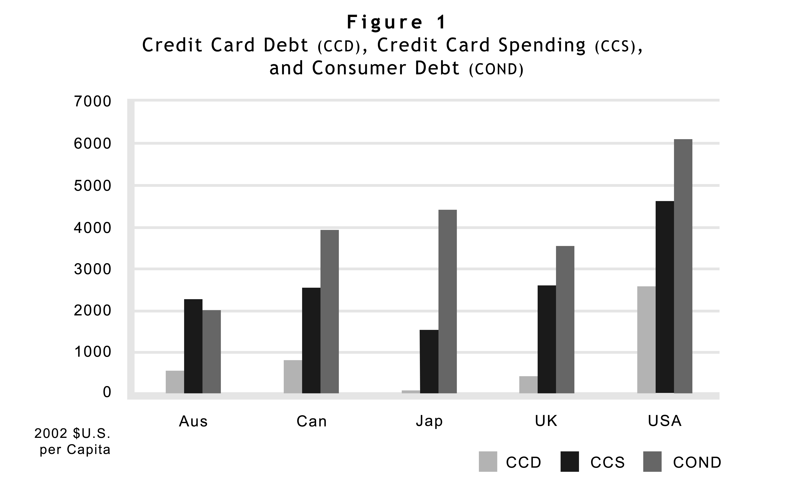
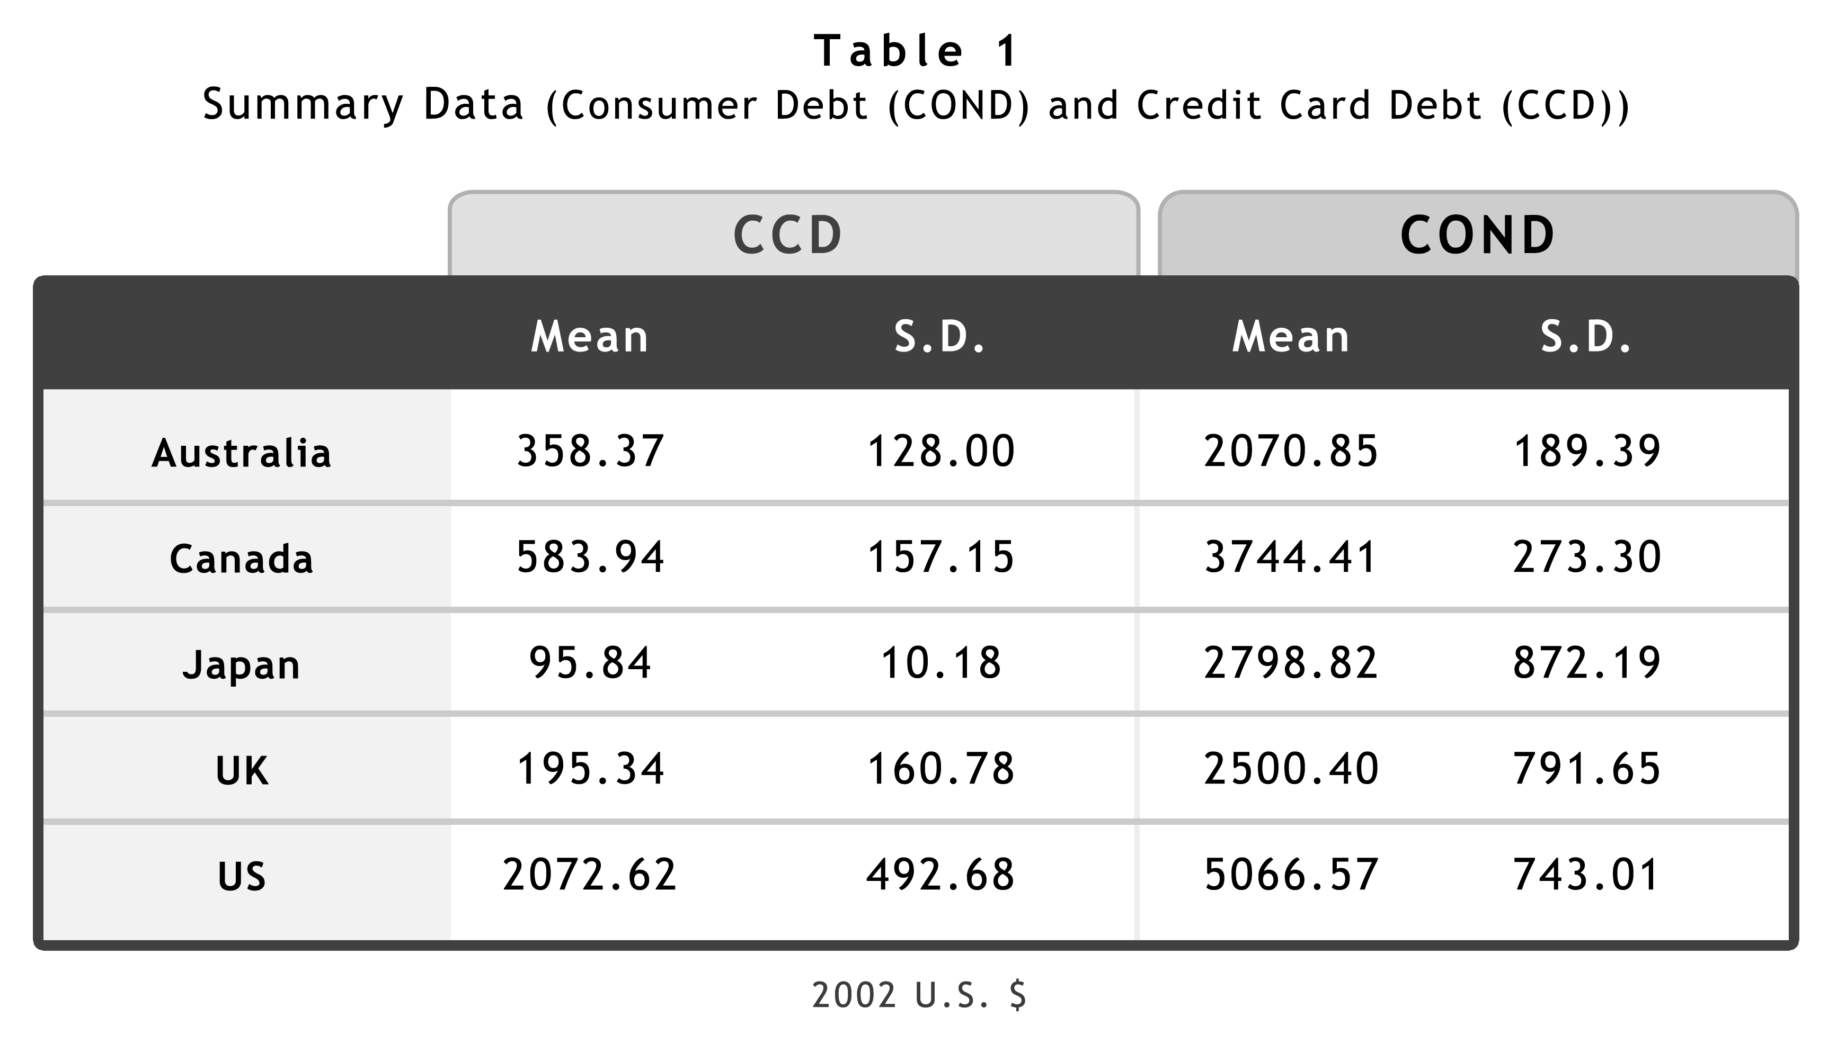
I start with a scatterplot of consumer credit per capita against credit card debt per capita (lagged by one year). Because the trend is roughly linear, and there is no obvious skewing or outliers, it seems appropriate to analyze these variables with OLS regressions, without log forms.
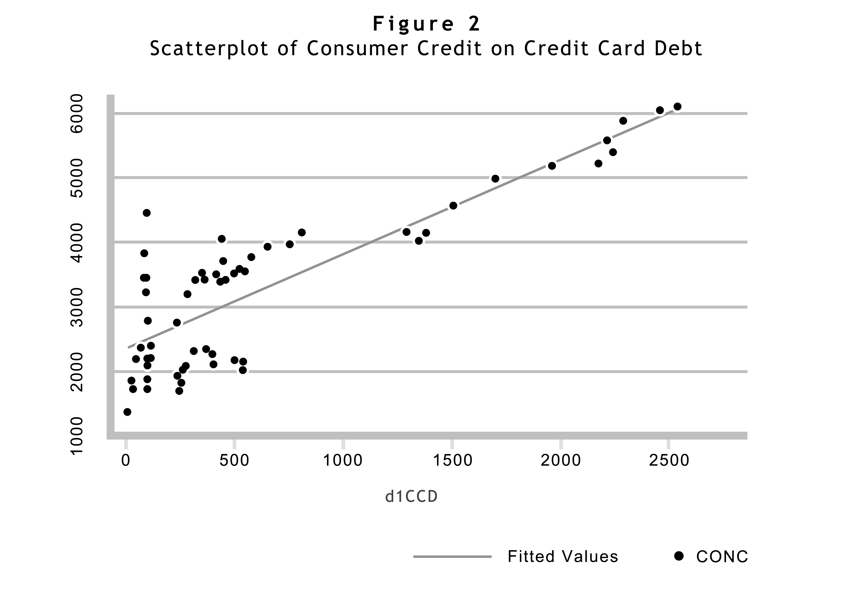
There obviously is a substantial correlation between total consumer debt and credit card debt: the correlation coefficient is .8354. To examine the relation more carefully I performed a series of OLS regressions (on Stata SE8) using total consumer debt as the dependent variable and credit card debt as the independent variable, with robust clusters to respond to the problem of autocorrelation in the time series. In the first runs, I lagged the independent variable one year to ensure that I was tracking a relation that ran from credit card debt to consumer credit rather than the reverse. The relation was significant at a 0.001 level. Moreover, the R-squared (the extent to which changes in credit card borrowing explained variations in consumer credit the next year) was .71. Generally, the coefficient suggests, a $100 increase in credit card debt per capita is associated with an increase in consumer credit a year later of about $147 dollars per capita. {All of the currencies are normalized to 2002 United States dollars.}
My selection of the one-year lag was arbitrary: I used the lag solely to test whether the causation arrow ran from credit cards to total borrowing or in the reverse direction. Interestingly, the results were about the same with a lag of two years or three years: in each case significant at the 0.001 level, an R-squared of slightly more than .70, with the coefficient increasing steadily with the increased lag. The steadily increasing coefficient strongly supports the causation arrow as it suggests that the effect of an increase at one point in time has a persistent compounding effect far into the future. Table 2 reports summary results for those regressions.
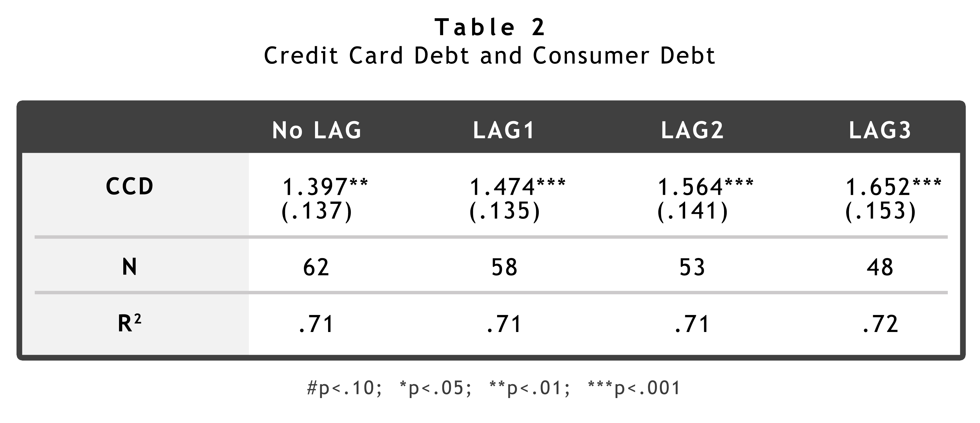
The finding of a relation between credit card debt and consumer credit is interesting, but not particularly provocative. If the convenience of a credit card lowers the transaction cost of borrowing, you would expect that it would result in an increase in the total amount of borrowing, just as a decrease in the cost of gasoline might result in an increase in driving. The more provocative question would be whether there is a connection between credit card spending alone (apart from borrowing) and consumer credit.
To examine that question, I again calculated correlation coefficient (.8626) and then ran OLS regressions with robust clusters, just as I had for the credit card debt analysis. Interestingly, the results here (summarized in Table 3) were even stronger than they were for credit card debt. As that table indicates, the relationship was even more significant, with T-statistics above 20 for all of the various lags and R-squareds ranging from .75-.83. As with the credit card debt analysis, the coefficients steadily rise as the lag increases.
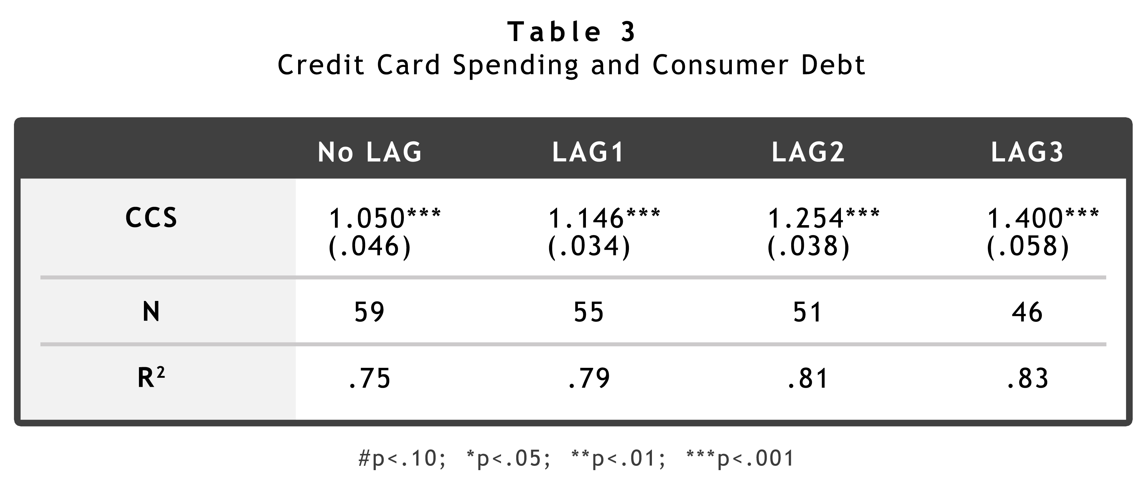
Those relations suggest a more central question, whether credit card spending and credit card debt have independent effects on overall consumer debt levels. After all, given the obvious correlation between credit card spending and credit card debt, it is not surprising that both variables show similar relations to consumer debt. Accordingly, I next ran several models including both credit card spending and credit card debt as explanatory variables. As a diagnostic for the possibility of undue multicollinearity (the correlation coefficient for those variables is about 92%), I calculated the variance inflation factor (VIF) for a model that included both credit card debt and credit card spending. As Table 4 illustrates, the mean VIFs were between 5 and 6, where 1.0 would indicate that the variables were wholly unrelated and 10 would indicate an unacceptable degree of multicollinearity. This model was successful, with adjusted R-squareds over .75, and a consistent relation, significant at least at the .05 level for credit card spending. Again, as with the previous tables, the coefficient on credit card spending increases steadily as the lag increases, supporting the idea that the causation runs from spending to debt rather than the converse.
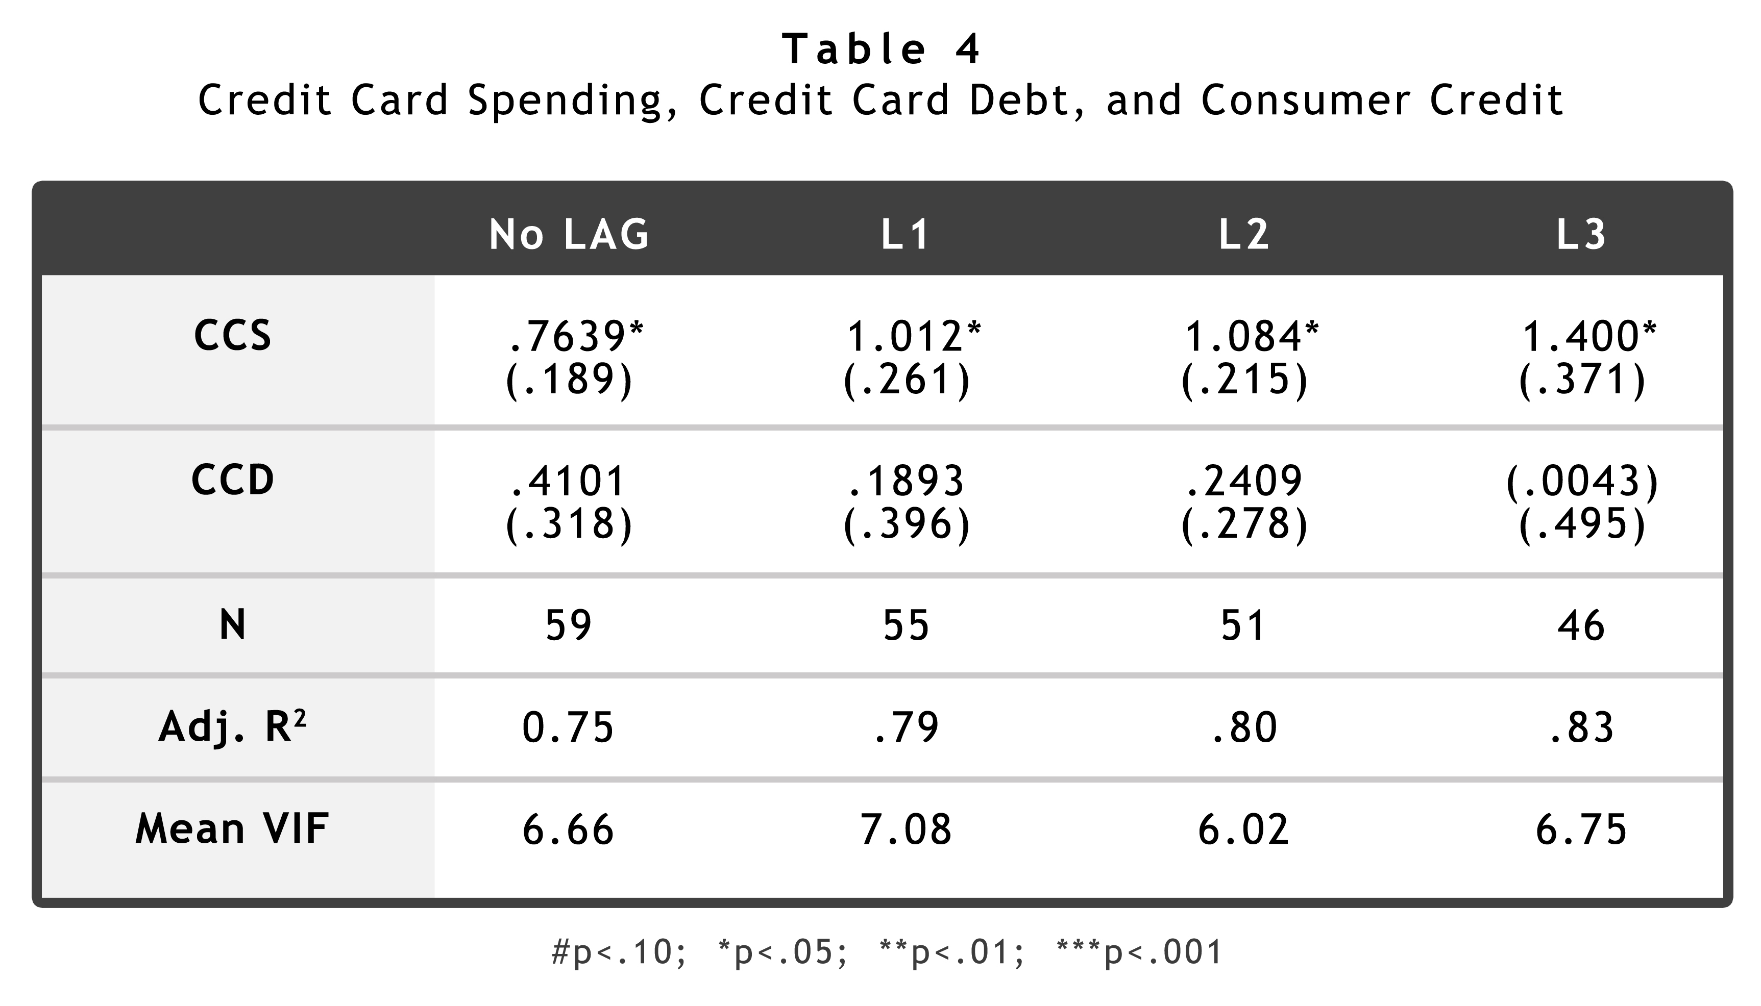
The most salient thing about Table 4 is that when both credit card spending and credit card debt are combined in a single model, only credit card spending continues to be significant. That result surprised me at first. I expected that credit card debt would have a more direct effect on consumer debt levels than credit card spending and ran the analysis wondering whether credit card spending would have a smaller secondary effect. It seemed odd that credit card debt does not have an effect separate from the effect of credit card spending.
On reflection, however, there is a good explanation for the results. To put it in a narrative form, at least in recent years, in the set of countries that I have studied, the best indicator of consumer debt levels is whether credit card use has been growing rapidly. That is true because once credit card use grows, the growth of consumer debt is inevitable. It is just easier – psychologically and physically – to spend.
We can imagine circumstances in which credit card spending might remain constant, but an increase in credit card debt would lead to an increase in consumer debt. Similarly, we can imagine circumstances in which credit card spending rises, but overall borrowing remains constant. The data suggest, however, that such scenarios are implausible, at least within the confines of this data set. Total debt does not generally rise without a preceding increase in credit card use, and credit card use does not generally rise without a subsequent increase in total debt.
Yet could there be another, more general, explanation – perhaps one explained by macroeconomic conditions? To investigate the possibility that the effects I identified might be caused by general conditions in the economy, I added data on two macroeconomic variables (unemployment and GDP) and ran tests with consumer debt as the dependent variable and with the macroeconomic variables and the credit card variables as independent variables (all lagged one year). As Table 5 reports, neither test diminished the significance of the analysis reported above. Because this is the model with the most variables, and the highest explanatory value, it is the one whose coefficients are most useful in understanding the relations. It suggests, holding all else equal, that an increase of $100 in per capita credit card spending is associated with an increase, one year later, in total consumer borrowing of $105. Although I do not report them here, I ran similar models with country dummies (much like the analysis I report below), but VIFs in the range of 25 indicated an unacceptable degree of multicollinearity.
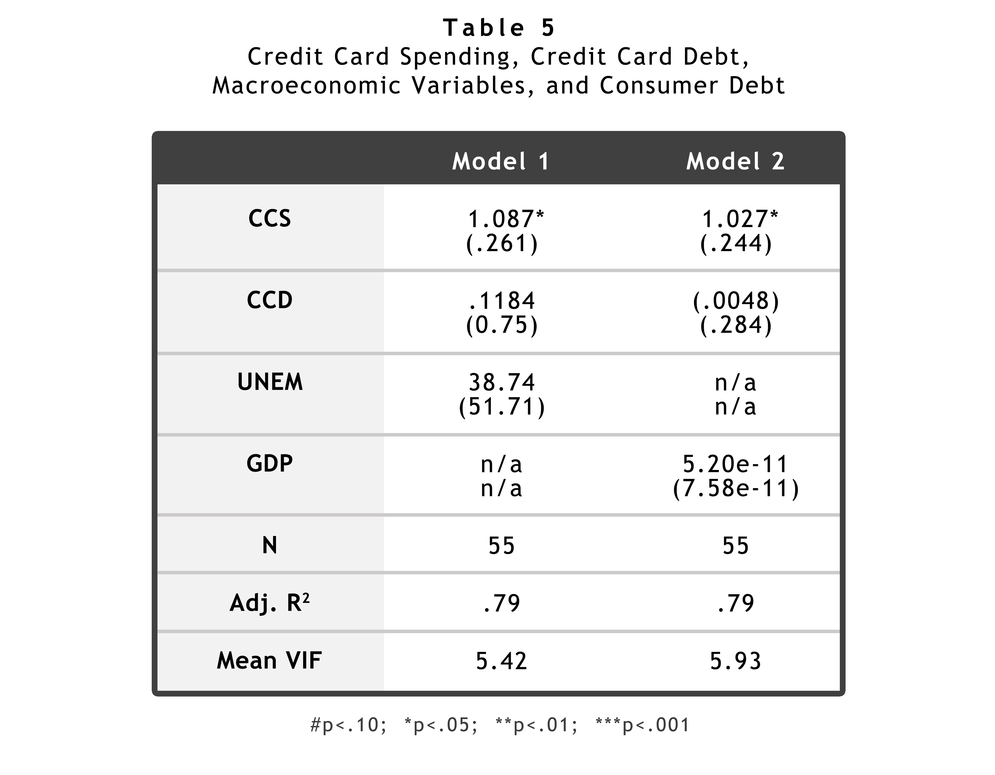
Finally, it would be interesting to know whether the effects arise solely from credit card spending or from plastic card spending in general. In other words, are the effects more closely associated with the convenience of carrying a card? Or, are they best explained by the separation of payment and borrowing functions that the credit card, in particular, offers? Trying to isolate the effect of the credit card – as distinguished from the payment card in general, I also ran analyses with a separate variable for total cards spending (in addition to the data for credit card spending and credit card debt discussed above). That analysis is particularly challenging for a data set so small, because for the analysis to work, the separate effects of three closely related variables must be untangled: credit card spending, credit card debt, and total card spending. My concern was borne out because the diagnostic indicators I used suggested that the variables are so highly correlated that I was unable to come to any conclusion on that point.
4.2 Credit Cards and Bankruptcy
I come at last to the focal point of my inquiry, the relation between credit card use and consumer bankruptcy. A relation between credit card use and borrowing is one thing – because it is difficult to tell when borrowing has crossed the line to excess. Bankruptcy filings, however, are a considerably less ambiguous indicator of financial distress. To be sure, the desire to encourage entrepreneurial risk-taking suggests that there might be some “optimal” floor of consumer bankruptcy in a well-ordered economy, but it seems plausible given the externalities of the financial distress caused by consumer bankruptcy to regard increases in consumer bankruptcy as unambiguously bad. Thus, analysis of the relation between credit card use and bankruptcy is more pointed than the analysis reported above.
Using nation-level aggregate data from five countries, I examined the relation between credit card debt and consumer bankruptcy. There is a wide variation in the level of bankruptcy. At least in part, of course, this is caused by differences in the procedures from country to country, but it also surely reflects differing cultural attitudes towards borrowing and failure. Figure 3 shows 2002 bankruptcy rates (per million of population) in each of the five countries. Table 6 displays the mean values and standard deviations for each country for bankruptcy filings. The most obvious data point is that the United States bankruptcy rate is more than twice the next highest rate (Canada’s). Given the discussion in the preceding chapters, perhaps that is not surprising. What is more intriguing is the gap between Canada’s filing rate of 2000/million and the UK’s filing rate of about 500/million. To some degree, those differences doubtless depend on differences in the bankruptcy systems that make them more or less hospitable to insolvent consumers, but the broad range of filing rates remains provocative.
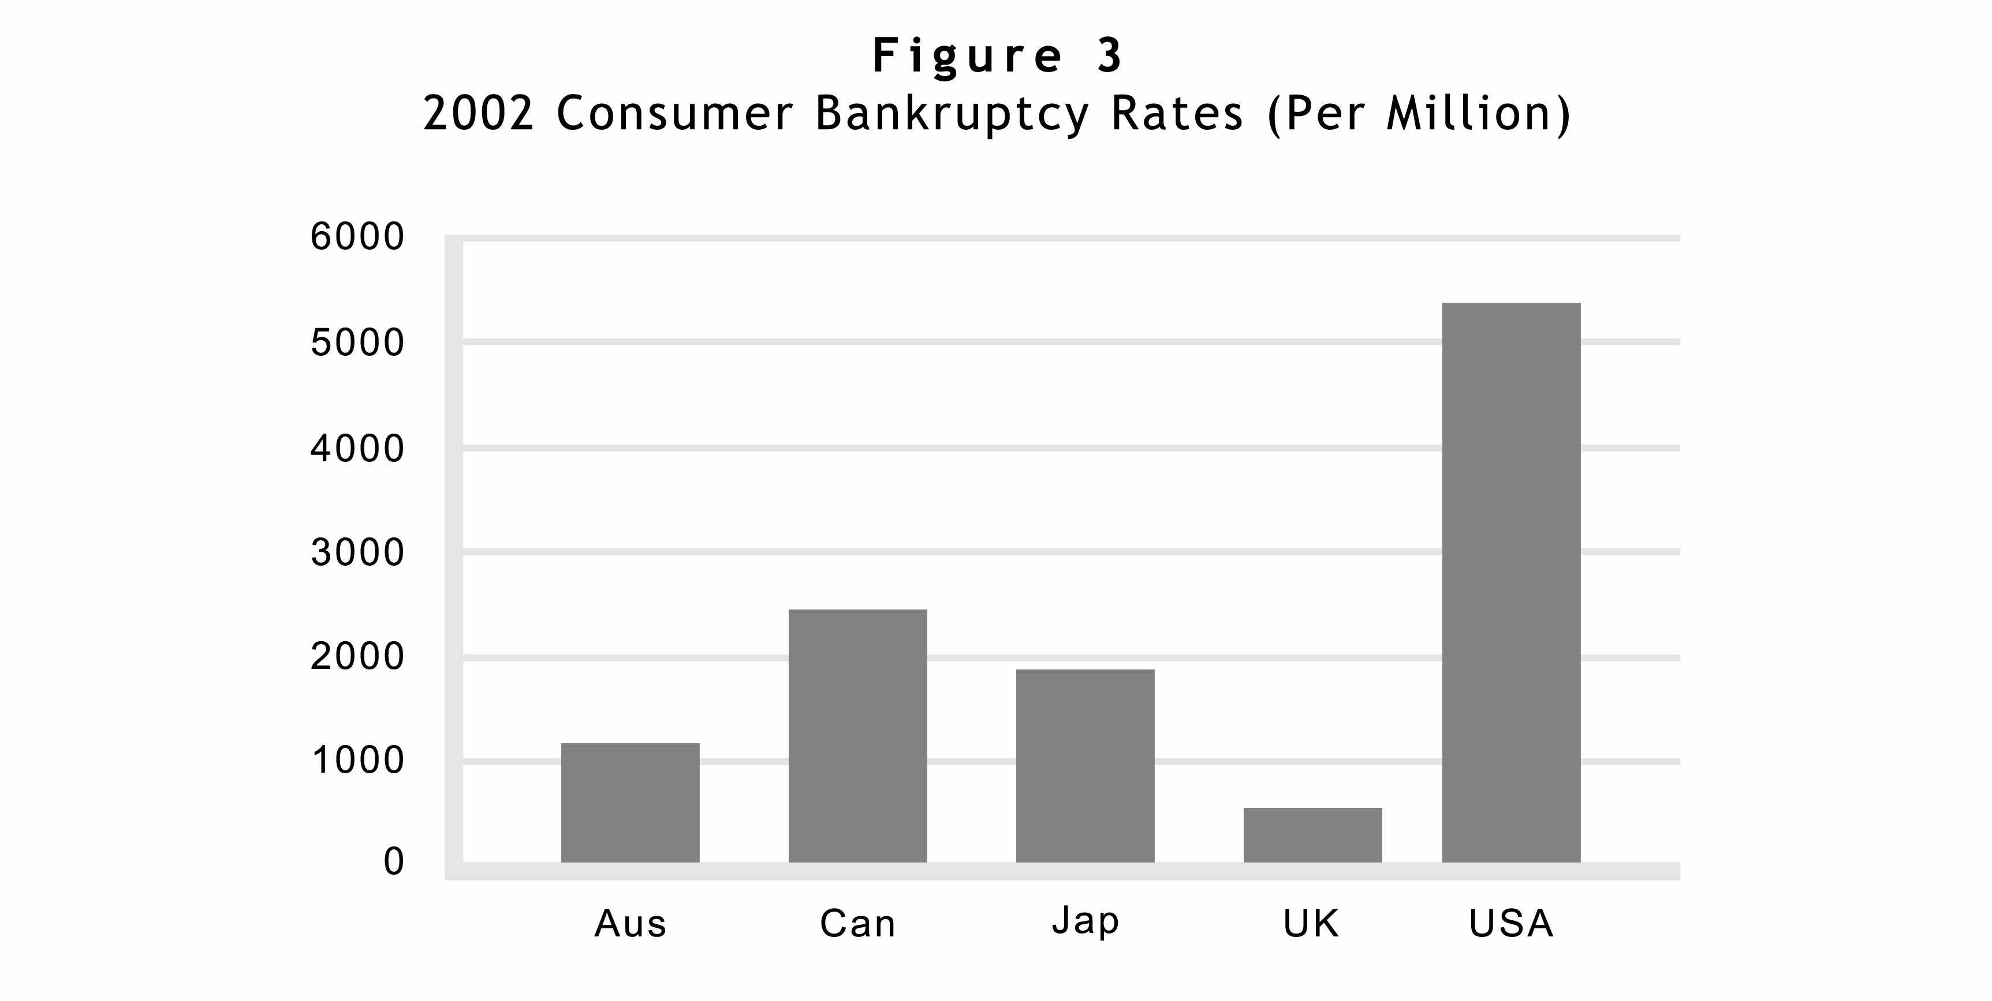
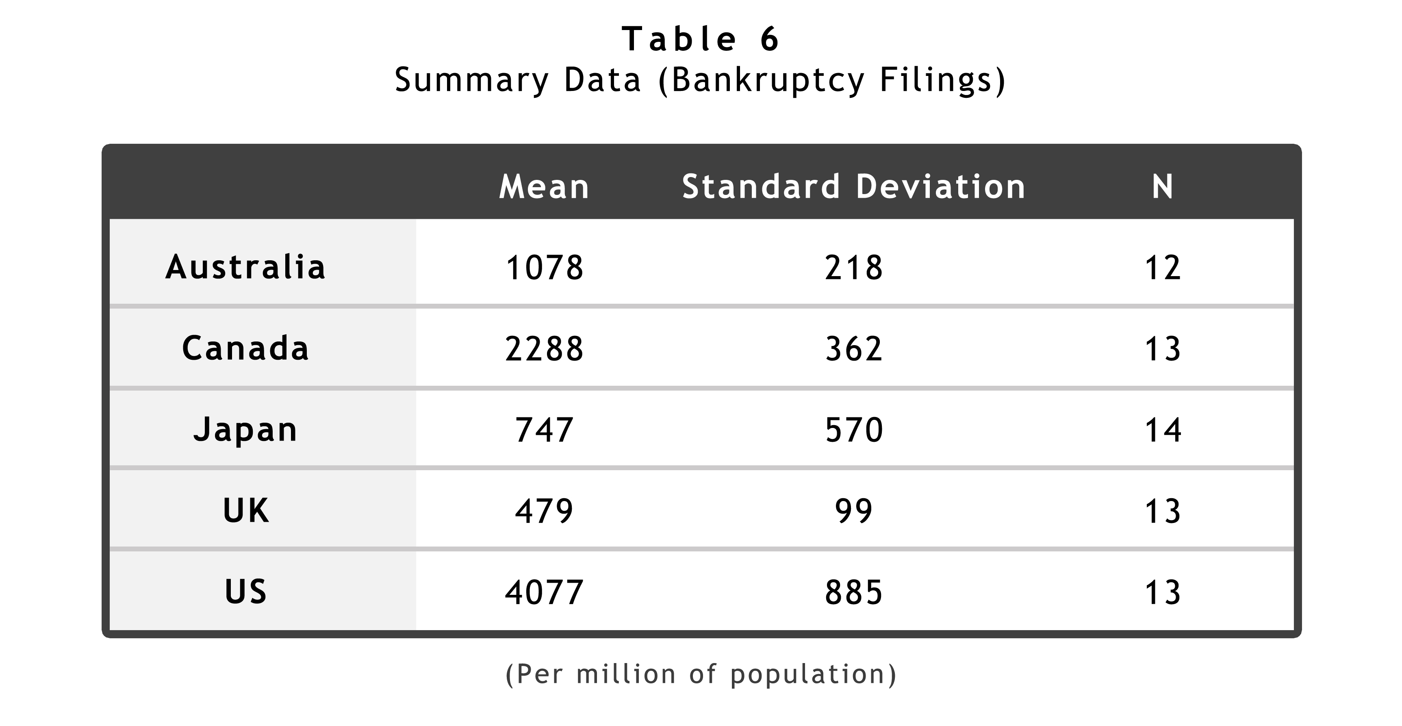
Again, I start with a scatterplot of bankruptcy filings (per million of population) against credit card debt per capita (lagged by one year). Because the trend is roughly linear, and there is no obvious skewing or outliers, it seems appropriate to analyze these variables with OLS regressions, without log forms.
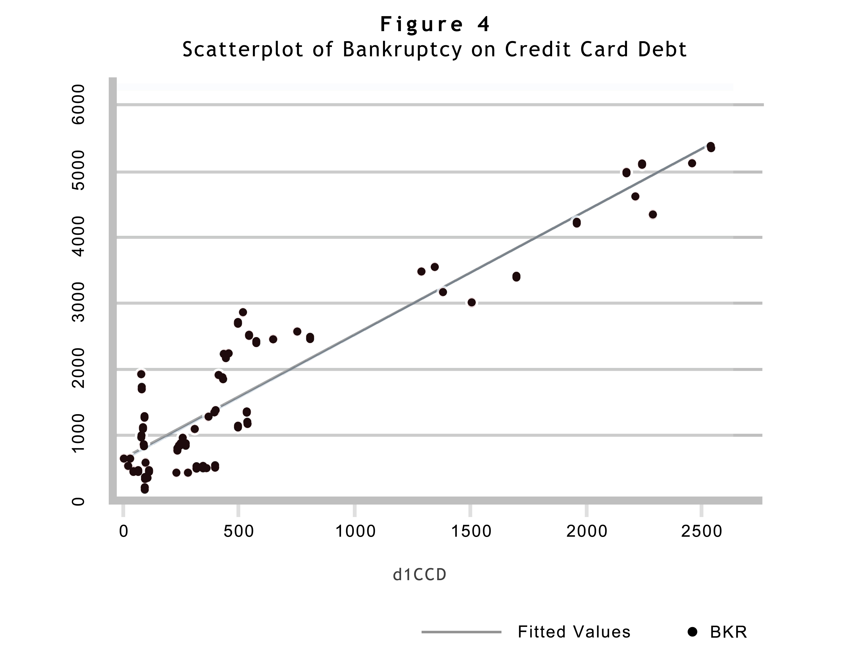To test the possible relation between credit card use and bankruptcy filings, I again used an OLS regression, this time with consumer bankruptcies per million of total population as the dependent variable, and robust clusters to respond to the problem of autocorrelation in the time series. My first runs used credit card debt as the lone independent variable, lagged by one year to ensure that I was tracking a relation that ran from credit card debt to bankruptcy filings rather than the reverse. A simple correlation coefficient between those variables is .9301. As summarized in Table 7, the relation was significant at a 0.001 level, with an R-squared of .85. Table 8 summarizes a parallel analysis, showing a similar relation between consumer debt and bankruptcy. The correlation coefficient between those variables is .8746.
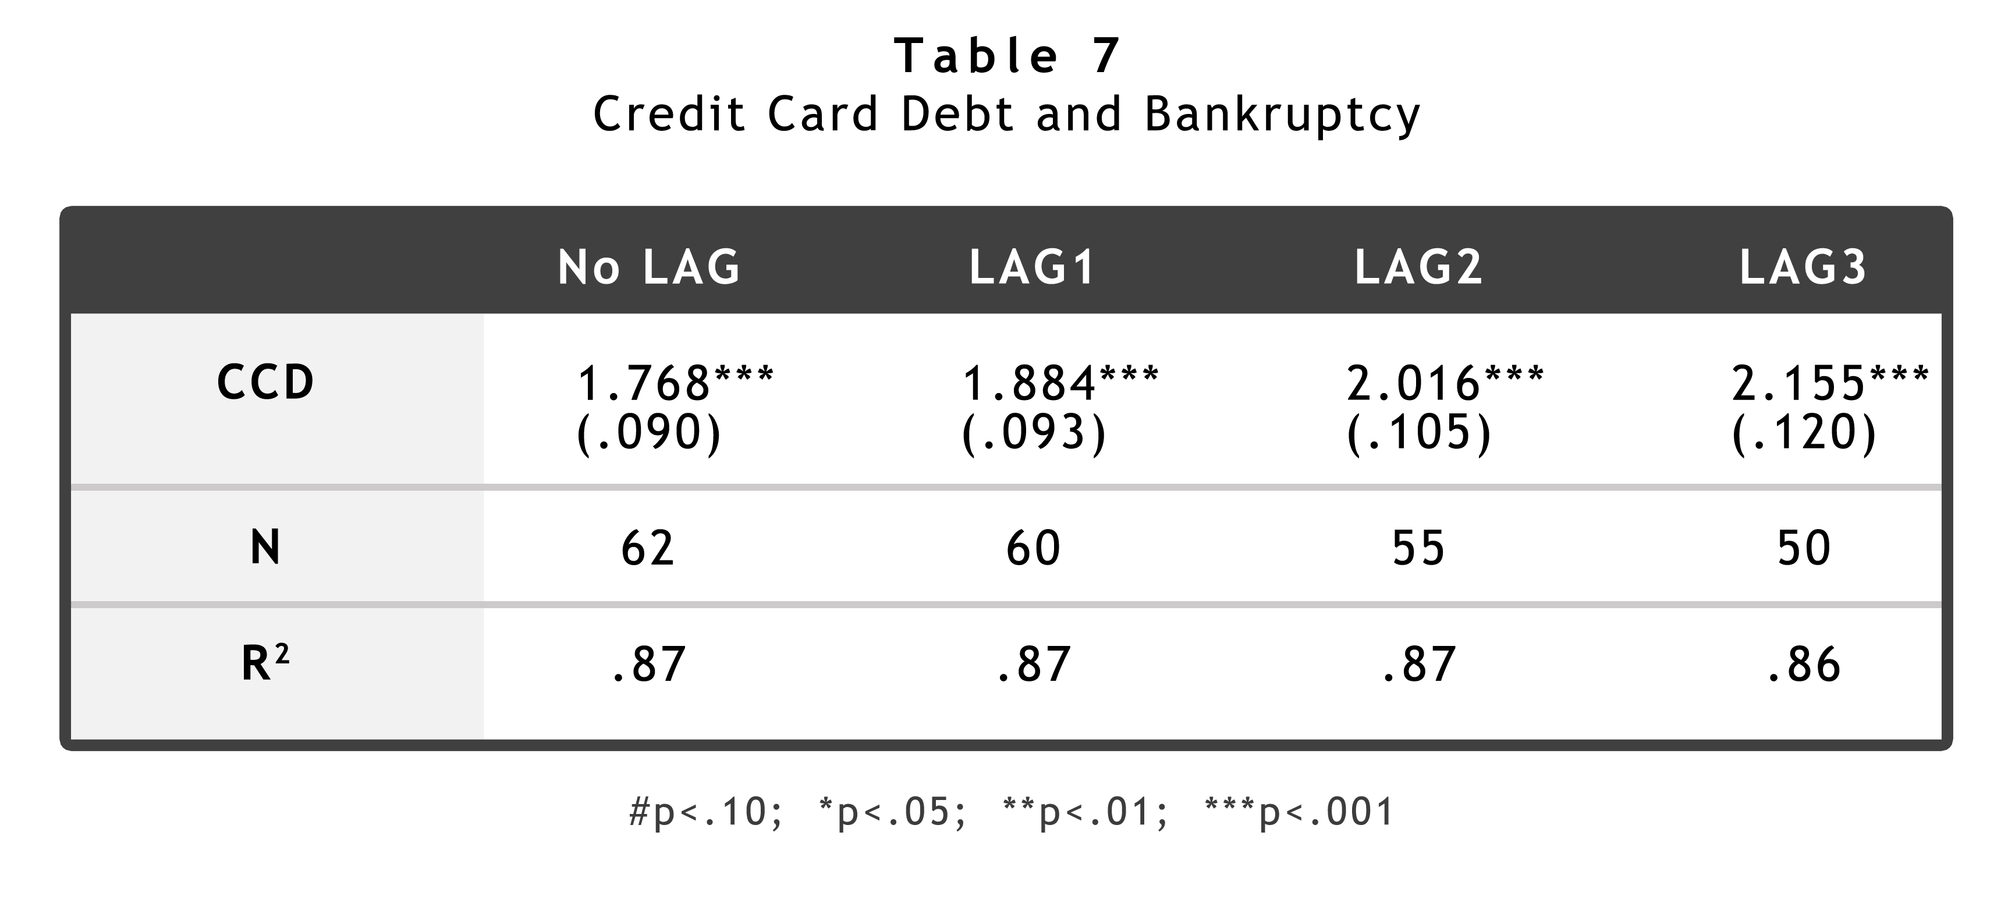

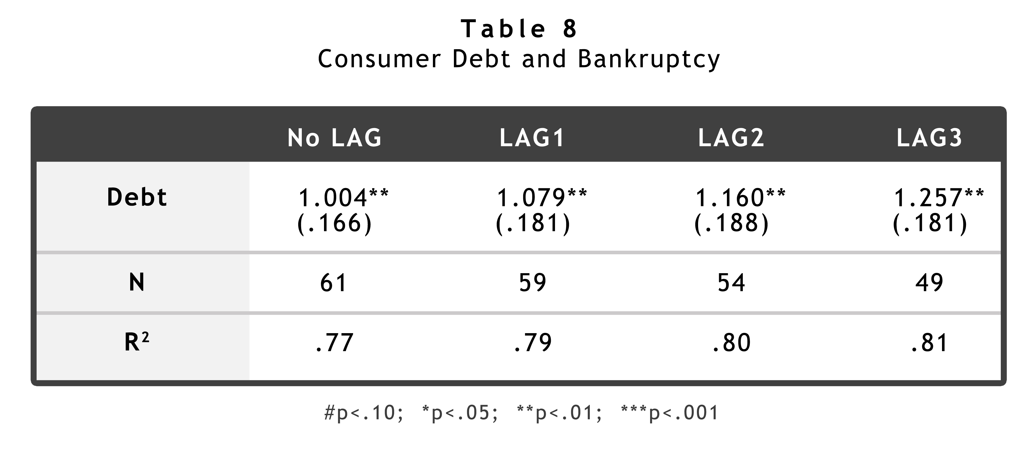
As I explain at the beginning of the chapter, my goal was to untangle the effects of credit card debt and consumer debt. I hoped to understand not only whether there is a relation between credit card debt and bankruptcy, but also whether the credit card simply facilitates borrowing or instead has a different relation to bankruptcy than other forms of borrowing. The crucial question, of course, is what separate effects credit card use and consumer debt might have on bankruptcy filings. As before, that question is a difficult one, because the strong correlations between credit card spending, credit card debt and consumer debt make it challenging to isolate the effects of the three closely related activities.
To analyze the relationship, I used a multivariate model, including credit card debt, consumer debt, and credit card spending as explanatory variables in a model with bankruptcy filings as the dependent variable. As summarized in Table 9, the basic model with the one-year lag was highly significant, and the variables explained 93% of the variation in consumer bankruptcy filings. Most interestingly, all of the variables retained independent significance (at least at the 0.1 level in a two-tailed test). The results are relatively robust: the signs on the coefficients are stable, and the sizes of the coefficients steadily increase over time.
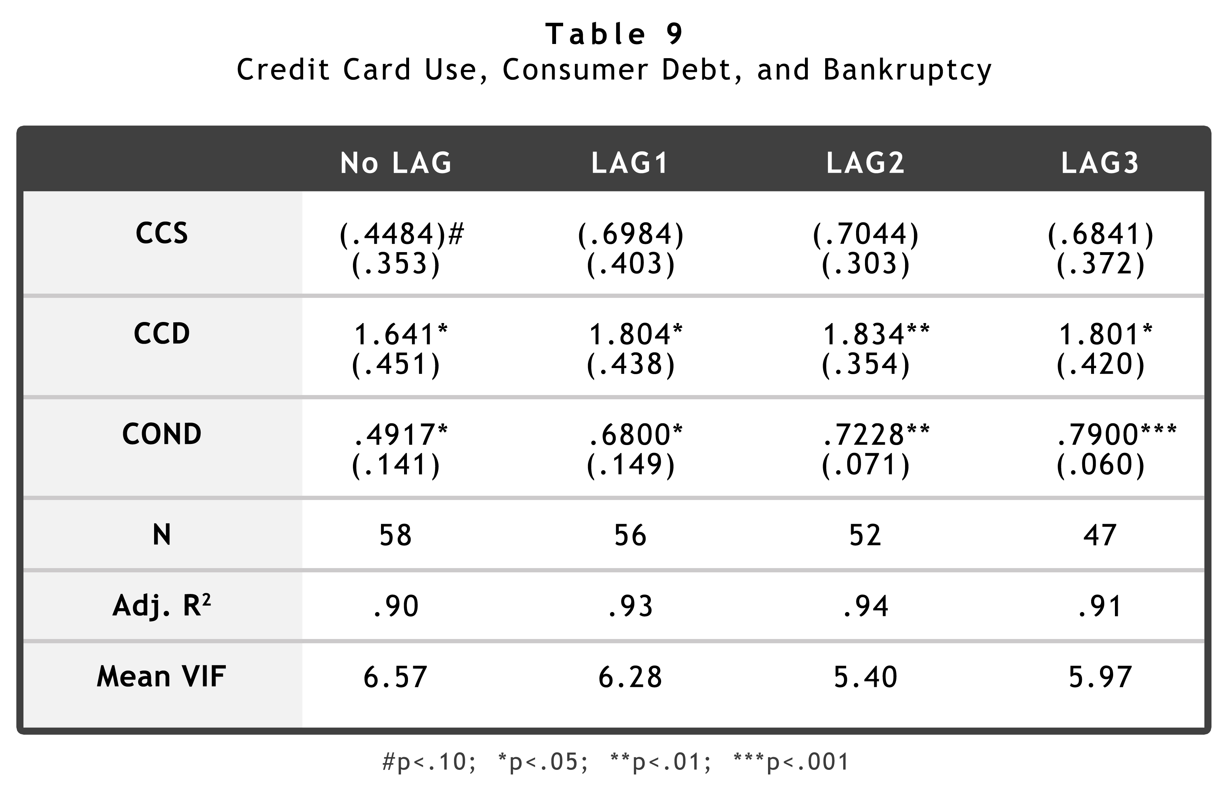
As with the consumer debt analysis reported above, I ran an additional model incorporating unemployment and GDP as alternative macroeconomic independent variables. The addition of the macroeconomic variables (unlike the addition of unemployment data to the model in Table 5) improved the significance of the variables. That is not surprising, because it suggests that macroeconomic variables have an important effect on bankruptcy. Including them in the model helps to reveal more precisely the effects of the financial variables studied here. As Table 10 summarizes (for a lag of one year), credit card debt and consumer debt are both significant at the .01 level in models with the macroeconomic variables. With an R-squared of .94, the model is highly instructive.
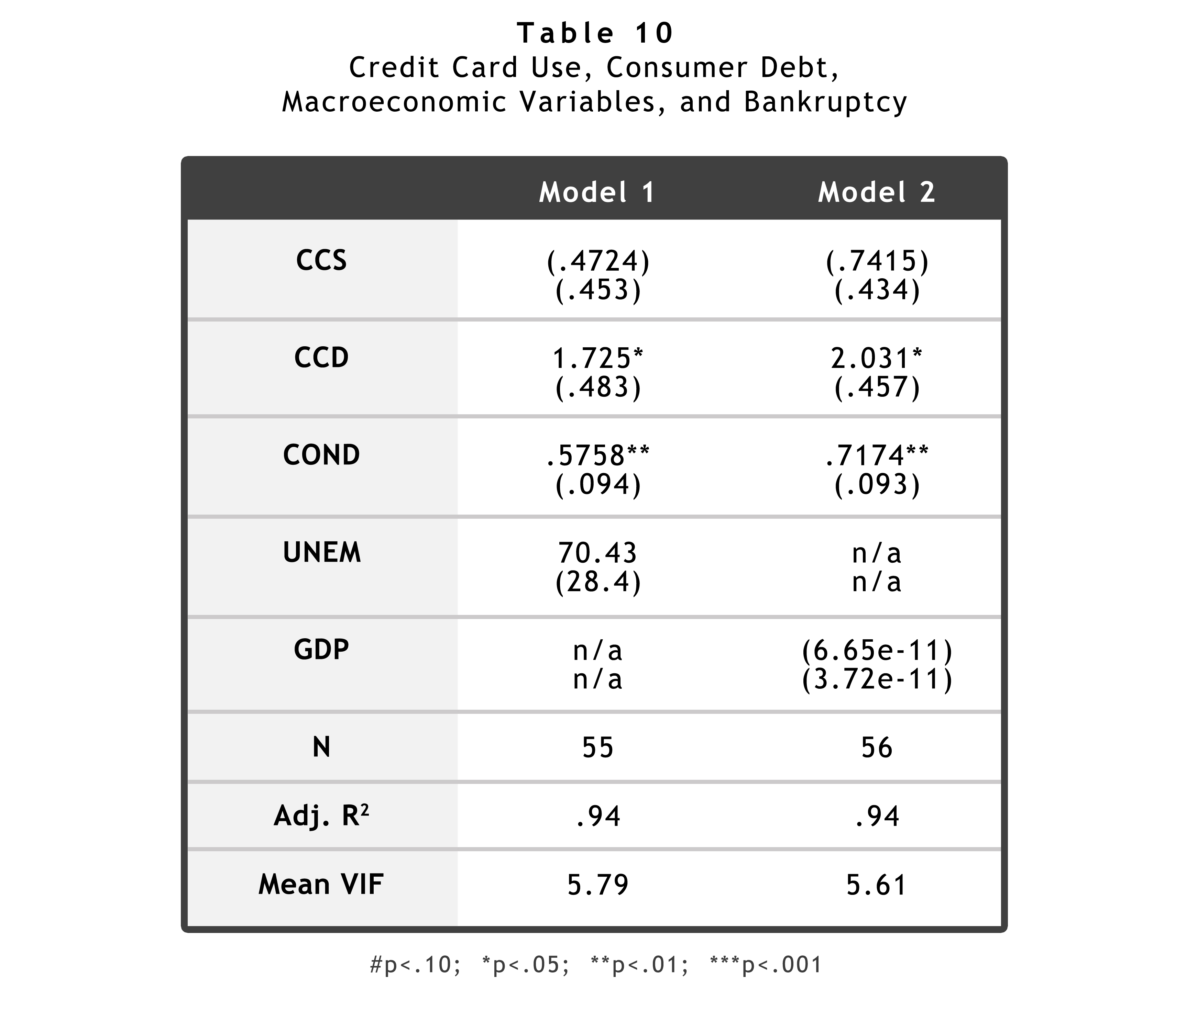
To respond to the possibility that country-specific differences might be causing spurious correlations, in a final set of runs summarized in Table 11 I incorporated both the macroeconomic variables and “dummy” variables for all of the countries other than the United States. Even with the inclusion of dummy variables, and in a dataset so small, the credit card debt variables retained significance (albeit only at the 0.1 level for the GDP run). Given the small number of data points available, the results are striking. With only a few variables – data related to card use, overall borrowing, and the state of the economy, my models explain about 97% of the variation in bankruptcy filings.
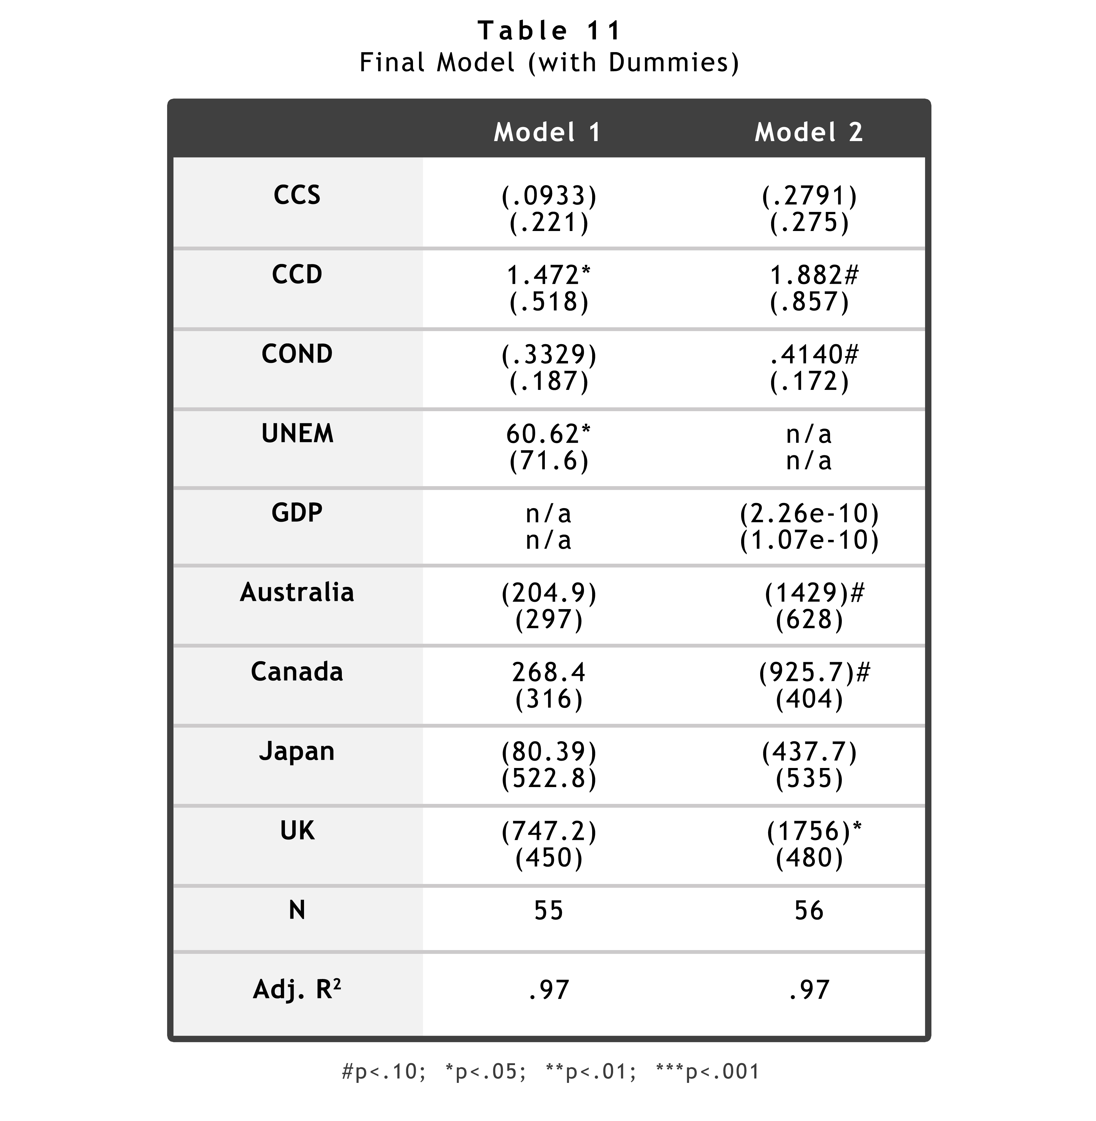
The most important aspect of the results is the finding on credit card debt. Even if credit card spending and consumer debt are held constant, an increase in credit card debt – a shift of consumer borrowing from noncard borrowing to card borrowing – is associated with an increase in bankruptcy filings. The size of the effect is in the range of an increase of 165 bankruptcy filings per million for each $100 increase in per capita credit card debt. As Figure 3 shows, that effect amounts to about 40% of all filings in the UK and about 4% of all filings in the United States – a startlingly large effect for a debt increase of only $100 per capita. To be sure, the overall debt level also appears to be significant. Thus, the results in Table 11 suggest that even if credit card use remains constant, an increase in total borrowing of $100 per capita (new borrowing not on credit cards), will be associated, after a lag of one year, with an increase in bankruptcy filings of about 35 per million. That does not undermine the separate effect of credit card debt. Rather, it suggests that if other forms of borrowing are held constant, an increase of $100 per capita in credit card debt would increase bankruptcy filings by about 200 filings per million (the sum of the effects of increased credit card debt and increased overall borrowing). It is not surprising that the coefficient on credit card spending in Table 11 is negative. If total borrowing and credit card borrowing remain constant in the face of increased spending, we would expect bankruptcy rates to fall – this would suggest a generally positive economic climate.
For several reasons, the data are not definitive. The number of data points is small, and the number of years over which the time series run is short. Moreover, particularly with respect to the bankruptcy data, there is the possibility that the apparent relationships might be caused not by profligacy in the borrowing, but rather by practical features of credit card debt (such as its general lack of collateral, as compared to home mortgages, car loans, and other common types of consumer debt).

5. Discussion and Conclusion
Still, if the relations that the data suggest are not spurious, the policy implications are intriguing. To understand why, consider first the relation between credit card use and consumer credit. Before conducting this analysis, I would have thought that the relation between credit card use and total consumer borrowing depended on the distinction between convenience users and borrowers: that the borrowers use credit cards to increase borrowing in the economy, while the convenience users use the cards only as a payment device. That view would have implied that policy responses to any concern about excessive borrowing should focus on the features of cards that facilitate borrowing.
The data suggest, however, that credit card spending alone is related to an increase in consumer credit – and, quite surprisingly, that credit card borrowing by itself has no separate significant effect on overall borrowing. Of course, given the small number of data points that I have (only about 50), it is entirely possible that there is a significant relation between credit card debt and total consumer debt that my data does not reveal, but it seems unlikely that the “true” relation is more significant than the relation between spending and consumer credit that I report above. Thus, policymakers concerned with excessive borrowing justifiably might take steps to limit credit card use directly.
For another thing, because the data are drawn from five different countries, they strongly undermine the idea that problems that credit cards might cause are limited to their use by Americans, infected by the “consumerist” values that so many decry here and abroad. If the relation between credit cards and borrowing was markedly different among the countries in my dataset (admittedly mostly countries that are culturally tied to the United States by their membership in the Commonwealth), the data would not disclose the powerful relationships that they do. If, as I argue in Mann 2006, the differential patterns of credit card use are temporary artifacts related to the youth of the product, then the results I report here suggests that – absent thoughtful policy intervention – the adverse effects of credit card use will follow rapidly upon the globalization of the product.
Finally, with respect to the data on bankruptcy filings, the use of a time lag in my model – the model suggests that bankruptcy rates rise one or more years after the increase in credit card borrowing – is particularly instructive with respect to my inclination to infer something about causation from the results. Thus, I think it is quite plausible to think that an increase in credit card debt causes an increase in bankruptcy filings one year later. It is not plausible, however, to think that the causation arrow runs in the reverse direction, that an increase in bankruptcy filings causes an increase in consumer debt or credit card activity one year earlier.
That point is particularly salient because of the prominent argument in Zywicki 2005 that the rise in bankruptcy filings since 1978 is caused by changes in the bankruptcy system in 1978 and by institutional responses to those changes. See also Jones & Zywicki 1999:210-15. There certainly is some truth to the claim that legal changes in 1978 caused a rise in bankruptcy filings. For example, it surely is the case that the bankruptcy system is both more efficient and more generous than it was before 1978, and it would be surprising if that had not had some effect on bankruptcy filing rates. I have a similar view that some of the ten-fold difference in the level of bankruptcy filings between the United States and the United Kingdom is attributable to the relatively generous system for such filings in the United States. But those points seem to me logically unrelated to the analysis that I present here, which suggests that card use and borrowing have an effect on the filings made each year while the nature of the system is held more or less constant, as it is in each of the jurisdictions during the time periods that I examine.
The most persistent counterargument – again presented by Todd Zywicki – is that credit card borrowing actually rises in anticipation of bankruptcy. From that perspective, families borrow excessively – they “load up” their credit card as he puts it – because they expect that bankruptcy will come and they know that they will not have to repay it. Zywicki 2005. Again, my data undercuts that hypothesis, because the time lag that produced the best correlations was a lag of a year – the bankruptcies lagged the increase in credit card debt and consumer credit by a year. Zywicki’s thesis would be more plausible with a lag of a few months at most. Moreover, the fact that the lag increases over time is much more consistent with my theory than with Zywicki’s. Specifically, his theory suggests that the effect should decrease as the lag increases (because the ability to predict bankruptcy should decrease over time), while mine suggests that it should increase (as the borrowing has a longer opportunity to affect the financial stability of the borrower).
* * * * *
In recent years, policymakers around the world have focused their attention on the possible adverse effects that credit cards might have on a modern economy. Central banks in Australia and the EU have challenged interchange rates that might have the effect of subsidizing card use at the retail counter. Trade regulators in the UK have worried about the risks unfairly high interest rates pose to consumers. South Korea teeters on the brink of financial chaos plainly attributable to excessive extensions of credit to cardholders. Thailand and Singapore have adopted stringent regulations to limit borrowing on cards. Even in the United States, where the cards are a central part of daily life, Presidential candidates (at least in the Democratic Party) worry about inadequate disclosures to card users. At the same time, Congress continues to ponder a bankruptcy reform project founded in large part on the supposition that the existing bankruptcy system is insufficiently hospitable to credit card lenders.
For the most part, however, the policymakers have proceeded without a firm basis in data for understanding the relation between credit card use and broader economic indicators of concern. Although I must wait for another paper to analyze those policy questions in detail, the data I present here provide a foundation for analysis of those questions. If we know what kinds of problems credit cards plausibly might cause, we are in a position to respond to those problems without abandoning the acknowledged economic benefits that cards provide as an effective low-transaction-cost mechanism for payment and borrowing. The data analyzed in this paper suggests that the use of credit cards leads ineluctably to financial distress, which brings with it social costs that credit card lenders would not bear completely even in a world with a freely available bankruptcy discharge. Further work will help to elucidate the kinds of policies that can limit that distress and the external costs it brings with it. It is enough for this paper to present the data that suggest the existence of that effect.

Bibliography
Lawrence M. Ausubel, Credit Card Defaults, Credit Card Profits, and Bankruptcy, 71 Am. Bankr. L.J. (1997)
Oren Bar-Gill, Seduction by Plastic, 98 Nw. U. L. Rev. 1373 (2004)
Michael S. Barr, Banking the Poor, 21 Yale J. on Reg. 121 (2004)
Carol C. Bertaut & Michael Haliassos, Debt Revolvers for Self Control (June 2002 draft)
Jagdeep S. Bhandari & Lawrence A. Weiss, The Increasing Bankruptcy Filing Rate: An Historical Analysis, 67 Am. Bank. L.J. 1 (1993).
Sandra E. Black & Donald P. Morgan, Meet the New Borrowers, Current Issues in Econ. & Fin. (Fed. Res. Bank of New York), Feb. 1999
Lendol Calder, Financing the American Dream: A Cultural History of Secured Credit (1999)
Stefano Dellavigna & Ulrike Malmendier, Contract Design and Self Control: Theory and Evidence 199 Quarterly Journal of Economics 353 (2004)
Demos, Borrowing to Make Ends Meet: The Growth of Credit Card Debt in the 90’s, available at http://www.demos-usa.org/demos/debt_assets/borrowing.pdf
Ian Domowitz & Robert L. Sartain, Determinants of the Consumer Bankruptcy Decision, 54 J. Fin. 403 (1999)
Rafael Efrat, Global Trends in Personal Bankruptcy, 76 Am. Bankr. L.J. 81 (2002)
Diane Ellis, The Effect of Consumer Interest Rate Deregulation on Credit Card Volumes, Charge-offs, and the Personal Bankruptcy Rate, Bank Trends 98-05 (FDIC, Div. of Ins., Mar. 1998)
David S. Evans, The Antitrust Economics of Multi-Sided Platform Markets, 20 Yale J. on Reg. 325 (2003)
David Evans & Richard Schmalensee, Paying with Plastic: The Digital Revolution in Buying and Borrowing (2nd ed. 2005)
Scott Fay, Erik Hurst & Michelle J. White, The Household Bankruptcy Decision, 92 Am. Econ. Rev. 706 (1992)
Federal Reserve, Board of Governors, The Profitability of Credit Card Operations of Depository Institutions (June 2002 report submitted to the Congress).
Mark Furletti, Credit Card Pricing Developments and Their Disclosure (Fed. Res. Bank of Philadelphia, Payment Cards Center, Discussion Paper) (January 2003)
William H. Greene, Econometric Analysis (4th ed. 1999).
David B. Gross & Nicholas S. Souleles, Do Liquidity Constraints and Interest Rates Matter for Consumer Behavior? Evidence from Credit Card Data, 117 Qu. J. Econ. 149 (2002)
Michael Haliassos and Michael Reiter, Credit Card Debt Puzzles (May 2003 draft)
David U. Himmelstein, Elizabeth Warren, Deborah Thorne & Steffie Woolhandler, MarketWatch: Illness and Injury as Contributors to Bankruptcy, Health Affairs, February 2005
Richard M. Hynes, Non-Procrustean Bankruptcy, 2004 Ill. L. Rev. (forthcoming).
Melissa B. Jacoby, The Bankruptcy Code at Twenty-Five and the Next Generation of Lawmaking, 78 Am. Bankr. L.J. 221 (2004)
Melissa B. Jacoby, Teresa A. Sullivan & Elizabeth Warren, Rethinking the Debates over Health-Care Financing: Evidence from the Bankruptcy Courts, 76 NYU L. Rev. 375 (2001)
Edith H. Jones & Todd J. Zywicki, It’s Time for Means-Testing, 1999 BYU L. Rev. 177
Robert M. Lawless, The Relationship Between Nonbusiness Bankruptcy Finlings and Various Basic Measures of Consumer Debt (2002 e-article)
Joseph Lupton & Frank Stafford, Five Years Older: Much Richer or Deeper in Debt? (Jan. 2000)
Ronald J. Mann, The Role of Secured Credit in Small-Business Lending, 86 Georgetown L.J. 1 (1997)
Ronald J. Mann, Credit Cards and Debit Cards in the United States and Japan, 55 Vand. L. Rev. 1055 (2002)
Ronald J. Mann, Charging Ahead: The Growth and Regulation of Payment Card Markets Around the World (forthcoming Cambridge U. Press 2006)
James Medoff & Andrew Harless, The Indebted Society: Anatomy of an Ongoing Disaster (1996)
Loretta J. Mester, Is the Personal Bankruptcy System Bankrupt?, Bus. Rev., 1st Qu. 2002, at 31 (Phil. Fed. Res.)
Consumer Payment Systems, Nilson Rep., Dec. 2004 (Issue 823), at 1, 6.
Martha A. Olney, Buy Now Pay Later (1991)
Joanna Stavins, Credit Card Borrowing, Delinquency, and Personal Bankruptcy, New England Econ. Rev., July/Aug. 2000, at 15
Teresa Sullivan, Elizabeth Warren & Jay Westbrook, As We Forgive Our Debtors (1989)
Teresa Sullivan, Elizabeth Warren & Jay Westbrook, The Fragile Middle Class (2000)
Teresa A. Sullivan, Elizabeth Warren & Jay Lawrence Westbrook, Who Uses Chapter 13?, in Consumer Bankruptcy in Global Perspective 269 (J. Niemi-Kiesiläinen, I. Ramsay & W. Whitford eds. 2003)
Richard H. Thaler, Quasi Rational Economics (1991)
Elizabeth Warren, The Bankruptcy Crisis, 73 Ind. L.J. 1079 (1998)
Elizabeth Warren and Amelia Warren Tyagi, The Two-Income Trap: Why Middle-Class Mothers and Fathers Are Broke (2003)
Michelle J. White, Bankruptcy and Small Business – Lessons from the U.S. and Recent Reforms, CESifo DICE Report (January 2006)
Martin Wolf, Why Globalization Works (2004)
Jacob S. Ziegel, Comparative Consumer Insolvency Regimes—A Canadian Perspective (2003)
Todd J. Zywicki, The Economics of Credit Cards, 3 Chapman L. Rev. 79 (2000)
Todd J. Zywicki, An Economic Analysis of the Consumer Bankruptcy Crisis, 99 Nw. U. L. Rev. 1463 (2005).

*[To be added]
A recent unpublished ABI study apparently updates the analysis from Bhandari & Weiss, concluding that there is a positive correlation between household debt burden and consumer bankruptcy, even taking account of credit-card default and charge-off rates. See American Bankruptcy Institute, Consumer Bankruptcy Filing Trends: The Year Ahead (Jan. 6, 2005 press release) http://www.abiworld.org/Template.cfm?Section=Press_Releases1&CONTENTID=12944&TEMPLATE=/ContentManagement/ContentDisplay.cfm. That study uses information about failed credit card borrowers, rather than general credit card use. Thus, it does not examine the effects of non-distressed credit card use. As I explain below, it is important to examine non-distressed credit card use empirically because that type of economic activity has positive effects on the economy against which the costs of distress must be balanced.
Even when they are not used for long-term borrowing, credit cards are important solely as a mechanism for making payments. For example, in 2003 credit cards were used in almost a quarter of all retail transactions in the United States. Nilson Report 2004.
Bar-Gill 2004 argues that credit card lending succeeds where other forms of lending have not because of behavioral features about the product that make it more attractive. His argument is most impressive when he describes the market forces that make it difficult for competing credit card issuers to refrain from designing products that take advantage of behavioral inadequacies of their potential customers. I do not think, however, that the behavioral effects readily explain the absence of low-cost closed-end lending products. The basic problem with closed-end lending products for the consumer is that the consumer even in the simplest system would have to identify to the lender each transaction for which the borrower needs funding. If the costs per transaction are to approach zero (as they do now), that can only occur if the lender in practice decides in advance to fund all transactions up to a preset credit limit, which means as a practical matter that the lender is making an open-ended loan like the ones that credit card lenders traditionally make. Another difficulty that closed-end loans would face is the problem of transmitting the funds from the lender to the merchant from whom the consumer is to make the purchase. In the credit card context, that problem is solved by an existing network in which the overwhelming majority of retail points have the infrastructure to accept payments at almost no marginal cost. A system of closed-end loans would have to develop an analogous infrastructure to compete against credit card products.
I do not use Germany or any other continental European countries in this study because of my inability to collect data about credit card debt in those countries. It would be difficult in any event to compare data from countries like Germany, where a particularly effective and widely used checking overdraft product provides easy access to consumer credit that in some ways parallels traditional credit card use. I analyzed savings data obtained from the World Bank, but the results were inconclusive and I do not report them here.
Israel has a similar practice.
Thus, I am less sure that models that accounted for macroeconomic conditions (like the models I use below) would show a significant relation between distressed borrowers and consumer bankruptcy.
Wolf 2004:152-157 reports pervasive problems with similar household survey data for countries other than the United States.
It is not at all clear to me why the Federal Reserve has had so much difficulty in developing a reliable method of data collection on this point. Information on the Federal Reserve Web site suggests that it recently has altered its method of collecting this data, but that does nothing to improve the reliability of older data. Jones & Zywicki 1999:223 also criticizes research on the correlation between debt and bankruptcy, arguing that the correlation is likely to be spurious because it does not show a decreased effect of debt burdens related to the interest-rate drops in the late 1990’s. I am not persuaded by that criticism. The most likely explanation for that phenomenon is that the interest rates charged to credit card borrowers that actually are paying substantial sums of interest probably have not fallen so far, both because those rates are relatively “sticky,” Zywicki 2000, and because of the substantial shift of credit card portfolios to riskier borrowers during the 1990’s, Black and Morgan 1999. For evidence of the rapidly increasing differentiation between the rates paid by borrowers of differing risk profiles, see Furletti 2003.
Academics frequently rely on the Nilson Report as authoritative, generally without noting the difficulty of verifying its reliability. E.g., Barr 2004; Evans 2003; Jacoby 2004. Indeed, even the Federal Reserve relies on the Nilson Report from time to time. Federal Reserve 2002.
The exclusion of transactions that use cards other than Visa and MasterCard products doubtless weakens the reliability of the data in some respects, but I have been unable to obtain more inclusive data, and thus have accepted the advice of the Bank of Canada that the data they have provided to me is adequate for my purposes.
The most obvious problem is the significant difference in the nature of the discharge in different countries. For discussion, see Efrat 2002; Ziegel 2003.
I used a box-cox estimator to determine if a log or semilog form would be better than the linear form. The estimator did not reject the linear form.
Specifically, the robust clusters account for the autocorrelation in the estimates of standard errors.
It may seem odd that the coefficients are greater than one – suggesting that one dollar of credit card debt is related to more than one dollar of total debt. I think, however that this is an artifact of using nation-level aggregates, rather than individual family data. Thus, it generally suggests that an increase in my credit card related variables is related, some time later, to a somewhat larger increase in overall borrowing. The reliability of the analysis is suggested by the robustness of the results, which include coefficients of the same order of magnitude, across a variety of different independent variables, steadily increasing as the lags increase.
To be sure, it does contradict the argument of Zywicki 2005 that increased use of credit cards has not led to an increase in consumer credit, but that is clear even from the figures in Zywicki 2005, which plainly show a major increase in total consumer credit between 1993 and 2003.
For discussion of the use of VIF’s, see Greene 1999.
I also inspected a log-log scatterplot, which did not indicate a better form than the linear form I have analyzed.
Although I do not report the results here, I also estimated a fixed effects autoregressive model with interactive variables for credit card debt in each country. I do not report those results in detail here, but they suggest that the net effect of credit card debt on bankruptcy is positive in the USA, Canada, Australia, and Japan, and essentially zero in the UK.

