Figure 3.1 is presented in different formats to illustrate the pros and cons of different file formats. Other figures on the Payment Systems Web site have similar characteristics. Please consider these features when using the images.

Figure 3.1 – BMP Format

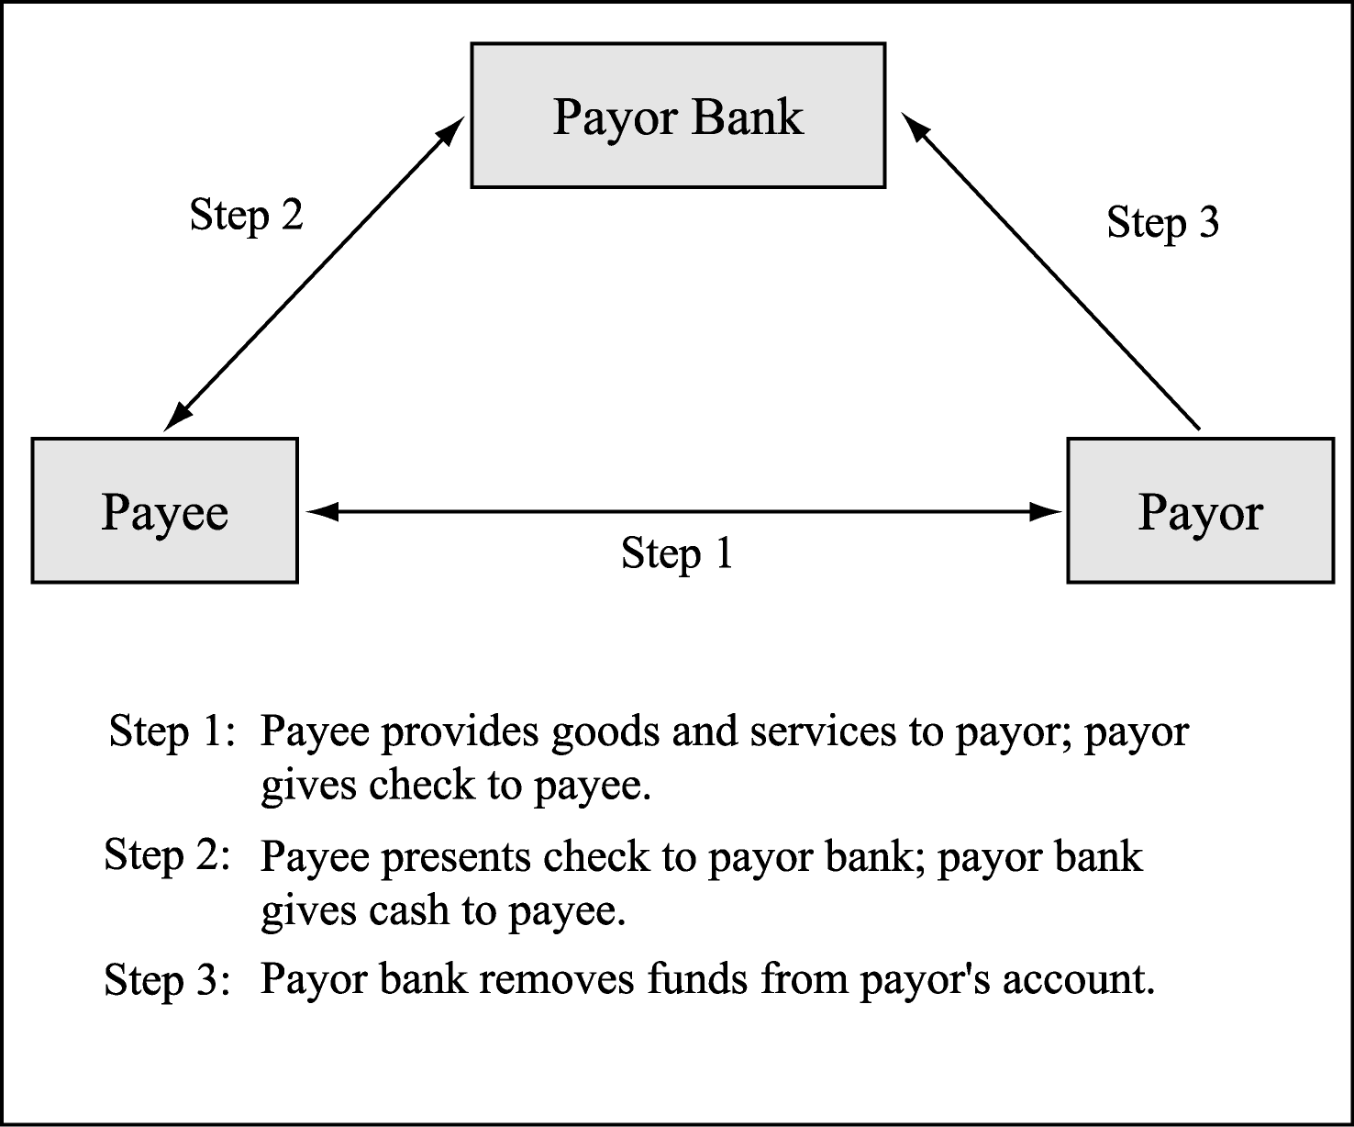

Figure 3.1 – GIF Format

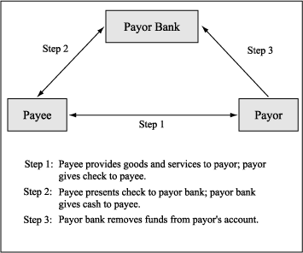

Figure 3.1 – EPS Format

Figure 3.1 – WMF Format – from Adobe Illustrator

Figure 3.1 – WMF Format – From PowerPoint

Figure 3.1 – EMF Format – From PowerPoint

