Human Digestive System Review

Label the following diagram.

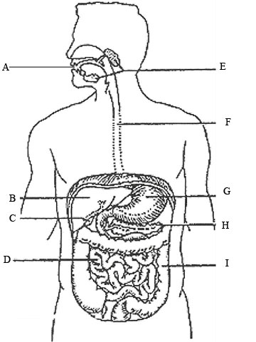

Write the correct letter from the diagram above in the space provided to answer the following questions.
- This organ produces gastric juice in humans. ____
- This is where bile is temporarily stored in many humans. ____
- This organ produces an emulsifying fluid. ____
- This is where peristalsis begins in the human alimentary canal. ____
- Amylase begins its function in this organ in most humans. ____
- Most chemical digestion and absorption occur in this organ in humans. ____
- This structure reabsorbs excess water and forms the feces. ____
- This organ produces and secretes enzymes into the small intestines. ____
- These structures produce substances that begin the chemical breakdown of our food. ____
Complete the following table.

Enzyme | Produced in | Acts on | Produces

