The 1987 Birth of the China-CSnet Email Link and How Its History Got Corrected∗
by Jay Hauben

In September 1987 an email link was established between the People’s Republic of China and the Federal Republic of Germany. That link allowed China to participate in the CSNET, an international email network. It was the first link of China into an international email system based on a mail server in China and a major step toward China’s joining the internet.

The following article tells some of the details of how that link was developed and how the story of that development was corrected in China. It documents some of the international collaboration that characterizes the science and technology on which the internet is based.

I. Finding Werner Zorn

In the early 1990s, Ronda Hauben and Michael Hauben sought to find and document where the internet came from, how it was developed and how it was spreading. They found substantial evidence that the internet developed as an open, scientific and engineering collaboration. All the evidence was that the process was international from the very beginning and was guided by a vision of a major advance to human society from a new universal inexpensive communication system.

In 2004, Ronda Hauben and I were in Germany. Ronda had heard that the first permanent email link between China and the rest of the world was connected to the University of Karlsruhe, a major institute for education and research in western Germany. While in Germany, we were told if you want to know about the Germany-China link see Werner Zorn.

We located and interviewed Professor Werner Zorn in Berlin. He shared his memories and some documents from 1983 to 1987. During those four years, a Chinese-German international collaboration prepared the link so that China would be part of a worldwide email system called CSNET. Professor Zorn particularly gave credit on the Chinese side to Professor Wang Yunfeng who was the Senior Advisor of the Institute for Computer Applications (ICA) in Beijing. The Institute of Computer Applications was located at the Beijing Institute of Technology (BIT). It was under the Chinese Ministry of Machinery and Electronics Industry. The ICA was created to provide data processing and computer services to small and medium organizations that were not large enough to have their own computer installations. It became a foremost computer networking center. From 1987 to 1994, ICA was the mailserver and hub on the Chinese side for the CSNET email exchange between China and the rest of the world.

II. A Chinese-German Collaboration Builds China’s First International Email Link

Many factors contributed to make that link possible. In the early 1980s, the World Bank supported the import of computers for use in universities in China. At that time, export of computers from the US to China was forbidden by the US government. The German government also subscribed to the COCOM export rules but some computers made by the German company Siemens met the criteria to be allowed export to China. In 1982, the World Bank Chinese University Development Project I was allotted $200 million. It used some of that money for the import into China of 19 Siemens BS2000 mainframe computers manufactured in Germany. One of these Siemens computers was delivered to the ICA.

As part of the project, Professors Zorn and Wang collaborated to organize the first Chinese Siemens Computer Users Conference (CASCO – Symposium ‘83) which took place in September 1983. At the conference, Professor Zorn led a seminar on the German Research Network project. One of the Chinese interpreters challenged Professor Zorn, remarking that lecturing was not enough. Would Professor Zorn do something more for China? That planted the seed that grew into the Chinese-German computer networking collaboration which developed the email link based on the Siemens BS2000 computers installed at the ICA in China and in the Karlsruhe University in West Germany.

In 1983-4, Professor Zorn was part of the effort that connected Germany to the CSNET, a network begun in the US in 1980 to provide email connections among university computer science departments. To connect to CSNET, a computer would need particular communication functionality as part of its operating system. The specifications or protocols providing that functionality for CSNET had not yet been implemented in the Siemens BS2000 operating system. In late 1984, Professor Zorn decided to undertake this task together with his students but only as a background job. It took two years to complete. The work was financially supported in part by the government of the West German state of Baden-Wuerttemberg. Its Prime Minister Lothar Spaeth was friendly to China.

The CSNET international email network was based on ordinary telephone lines and switches using a communication protocol with the name X.25. In 1985, both China and West Germany were developing internal X.25 email traffic systems. But there was no physical path to carry such email traffic between them. With the help of the PKTELCOM data network administered by the Beijing Telecommunications Administration, the Karlsruhe team made contact with the Italian cable company Italcable. Italcable had some leased lines via satellite between China and Italy. The Italian company agreed to open its switches to route X.25 email traffic between China and Germany. Italcable was able to open its switches on Aug. 26 1986. From that day on, reliable remote computer-to-computer dialogue was available between Karlsruhe University and ICA through PKTELCOM. But a CSNET email link was not yet possible because the Siemens computers at the ICA and in Karlsruhe did not have the necessary functionality to handle CSNET email messages.

In late summer 1987, Professor Zorn was in Beijing for the third CASCO conference but also to work with the staff of the ICA to set up the email link between China and Germany. His team at Karlsruhe University had succeeded in getting the CSNET protocols to work on their Siemens BS2000 computer.

In a little over two weeks, September 4 to 20, 1987 the Chinese and the German teams implemented within the operating system of the ICA Siemens computer the necessary protocols, installed the necessary communications equipment and overcame the many technical problems to make possible email connectivity with Karlsruhe.

III. The First Email Message from China to the CSNET

On September 14, 1987, the joint German and Chinese team composed an email message with the subject line, "First Electronic Mail from China to Germany". The message began in German and English "Across the Great Wall we can reach every corner in the world." Not only was the message addressed to Karlsruhe in Germany, it was also addressed to CSNET computer scientists, Lawrence Landweber and David Farber in the US and Dennis Jennings in Ireland. It was signed by Professor Werner Zorn for the University of Karlsruhe Computer Science Department and Professor Wang Yunfeng for the ICA.
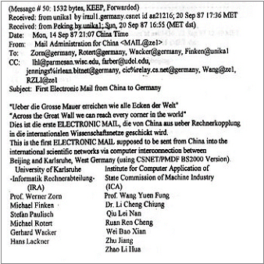
Eleven coworkers are also listed as signatories, Michael Finken, Stefan Paulisch, Michael Rotert, Gerhard Wacker and Hans Lackner on the Karlsruhe side and Dr. Li Cheng Chiung, Qiu Lei Nan, Ruan Ren Cheng, Wei Bao Xian, Zhu Jiang and Zhao Li Hua on the ICA side, suggesting the complexity of the task. But they could not send the message they composed. to their great disappointment, the message failed to leave China. There was a last technical problem to solve. Successful connectivity was achieved in a few more days. On September 20, 1987, the first CSNET email message, the one composed on September 14, could The First Email Message for CSNET to Leave China actually be sent to Karlsruhe
.
The transmission of this first email message went over an X.25 connection. At ICA, the sender dialed using a 300 baud modem to one of the X.25 ports of the PKTELCOM Beijing. PKTELCOM Beijing was connected over a satellite link to ITAPAC, which was the X.25 packet network of Italy. From there the message was sent via a gateway to the German X.25 network DATEX-P, to be delivered to the Karlsruhe Siemens host. This route was very expensive because it included international telephone charges for each separate link.

The Siemens host in Karlsruhe was connected via the Karlsruhe local area network with a VAX 11/750. That computer acted as the central CSNET node for Germany. It polled the CSNET relay in Boston several times a day. Thus the CSNET node in Beijing was, with that first email message, fully integrated into CSNET and via CSNET to the rest of the email world. With this first email node in China, a step was taken for the people of China to begin online communication with people around the world. But this was not an internet connection but a very expensive email link.

IV. China Welcomed into the International Email Community

Email connectivity between China and Germany was only the necessary technical precondition for an email service. What was missing was the official approval of the US authorities that funded CSNET. The US National Science Foundation (NSF) was the umbrella institution for all CSNET networking within the US and also abroad at that time. Immediately after the technical connectivity was achieved, Professor Zorn worked with Professor Wang to win acceptance from the NSF for worldwide email traffic to and from China. With the help of Lawrence Landweber, the Chairman of the CSNET project, and other US computer scientists, acceptance by the NSF was achieved less than two months later. On November 8, 1987, in a letter to the executive committees of CSNET and BITNET, Stephen Wolff, Director of the NSF Division of Networking and Communications Research and Infrastructure welcomed the CSNET email connectivity with China.
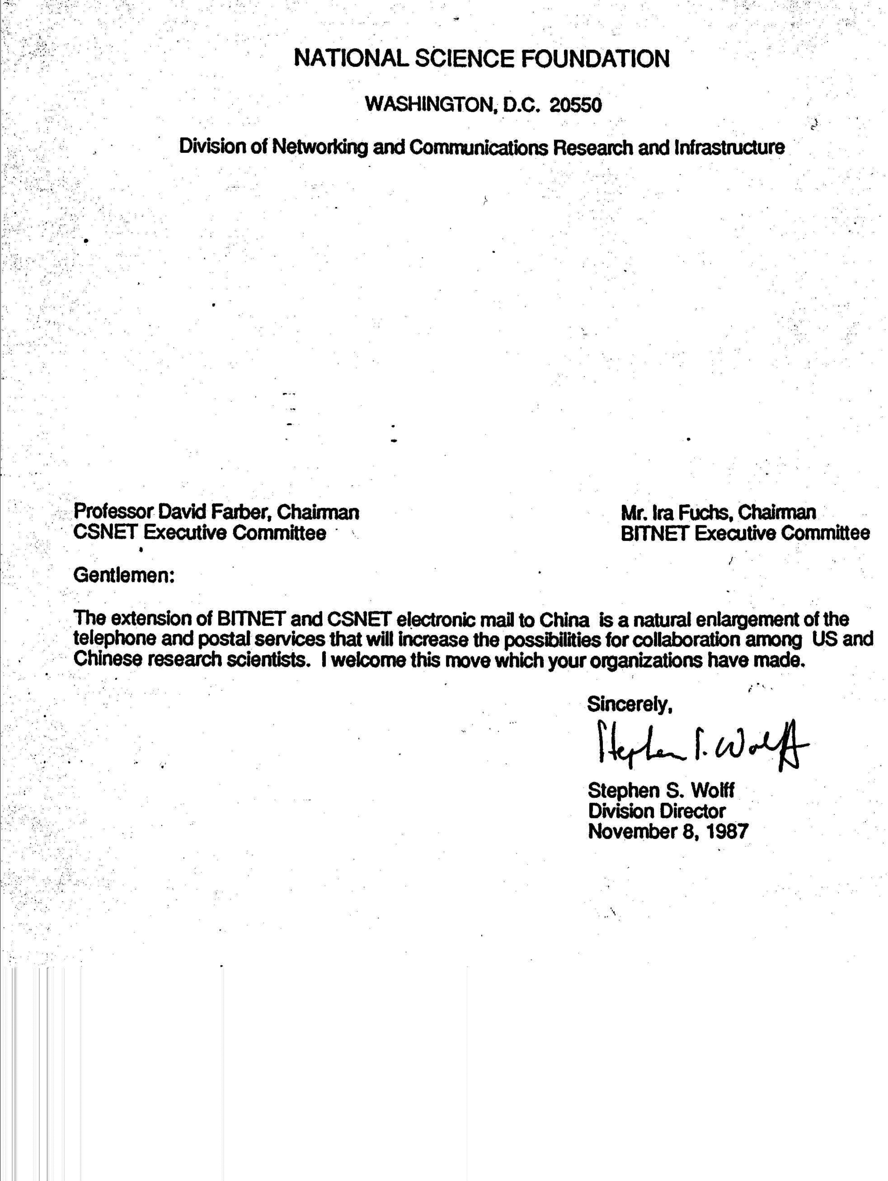
This letter was the official political approval, of what technically was already implemented. As far as I can tell there was no government to government activity, no treaty or signed agreement. The story is told that Stephen Wolff did get a command from the US White House to rescind permission after he had already given it, but as he says, “you don’t ask permission in advance. You ask forgiveness afterwards.”

Without Wolff's letter, the China-Germany email connection would have been vulnerable to a cutoff. The NSF could decide to deny forwarding of email messages to and from ICA in Beijing. Professor Zorn considers November 8, 1987 as the time China became officially connected with the rest of the world via the
CSNET email system. Email received from Letter from Stephen Wolff, Nov. 8, 1987
China at Karlsruhe would be relayed from there to whichever CSNET host worldwide it was addressed. And the reverse, any CSNET host worldwide could send email to ICA in Beijing and it would be relayed from there to users of the China Academic Net (CANET) throughout China as well as to users in other Chinese institutions outside CANET. The international computer science community and Chinese students abroad who learned of this connectivity answered with their warm congratulations.

Still these were small steps. Even with the support of the Chinese State Science and Technology Commission, hardly any Chinese institution and no individual scientist could afford to send or receive email messages to or from abroad. That was because X.25 for international traffic increased in cost as the size of the email message increased. The cost on the Chinese side included charges for every message received as well as sent. Longer email messages could cost 150 RMB, for a professor the equivalent of a whole month's salary. The monthly charges for the link, between $2000 and $5000 paid by each side, were more of a burden for the Chinese side than the German side. Email usage was thus severely restricted.

But for the five years during which expensive email connectivity was the only network connectivity that could reach the rest of the world, China prepared itself to truly join the Internet.

With encouragement from the Chinese government, knowledge and understanding of international computer networking was spreading in China, especially in the scientific and computer communities. The Institute for High Energy Physics (IHEP) belonging to the Chinese Academy of Sciences opened an email connection in 1989 with its partner in the US, the Stanford Linear Accelerator Center (SLAC) in California. Message Handling Systems (MHS) were set up in 1990 between the German Research Network (DFN) and the Chinese Research Network (CRN) and between the Beijing Tsinghua University Network (TUNET) and its partner in Canada at the University of British Columbia (UBC).

The email and remote logon only phase of connectivity between China and the rest of the world came to an end in 1994. That is when IHEP worked together with SLAC to take the next big step in connectivity between the people of China and the people of the world. On May 17, 1994, IHEP and SLAC established a full TCP/IP connection between China and the US. The use of the TCP/IP protocols allows data packets to take independent paths which meant the cost for email could come down and file transfer (FTP) and remote logon (Telnet) would now be available. That connectivity opened the Internet to China and China to the Internet.

V. Getting the Accurate Story

After Ronda and I interviewed Professor Zorn in 2004, I took up to write an article for the Amateur Computerist, an online news journal, about this history. My online journalism research for the article took me mostly to web sites in China. The story told there gave most credit for the China-CSNET connection to a Chinese engineer, Qian Tianbai whom Professor Zorn had hardly mentioned. Mostly missing from the history on the websites in China I found was any credit to Professor Wang or to the international component which Professor Zorn had stressed.

I sent email to Professor Zorn asking him about the discrepancy. I also sent email to Liu Zhijiang at the China Internet Network Information Center (CNNIC) asking if there was any evidence for citing on the CNNIC website that Qian Tianbai was responsible for the first email message. Professor Zorn sent me via email more documents and the email addresses for two Chinese scientists, Dr. Li Chengjiong and Ruan Ren Cheng, who had signed the first email message. Dr. Li Chengjiong was the Director of the ICA from 1980 to 1990. A copy of the first email message was online. I saw that Qian Tianbai’s name was not among the 13 signatures.

The two Chinese scientists answered with more information about the September 1987 email message and about Qian Tianbai. Particularly they both answered that Qian Tianbai was not in China at the time of the opening of the link in 1987 and that Qian Tianbai had not participated in this project. I found no evidence otherwise.

Through further digging and via email correspondence with Dr. Li Chengjiong and Ruan Ren Cheng, I was able to confirm to my satisfaction Professor Zorn’s story of the events.

VI. Spreading the Accurate Story

I wrote my article and it was published in the Amateur Computerist giving justified credit to Professors Wang and Zorn and their teams and to Lawrence Landweber of the CSNET and Stephen Wolff. My article appeared online and I sent copies to CNNIC and other contacts I had made in China. Encouraged by my journalism, Professor Zorn intensified his efforts to get the story corrected in China.

A bit later Professor Zorn was invited by Ronda to tell the story at a panel planned in conjunction with the World Summit on Information Society (WSIS) for Nov 2005 in Tunis in North Africa. In Tunis, Professor Zorn presented his story of the international effort and collaboration especially between himself and his team in Germany and Professor Wang and Dr. Li and the team in Beijing. Professor Zorn put up many slides showing the Chinese and German teams during the period and he put up one slide which said:

“The official time lines contain some seriously mistaken information and are also omitting important facts. They cause hereby fatal misinformation meanwhile spread all over the world.”

In the audience in Tunis was Madame Hu Qiheng, Vice President, China Association for Science & Technology, and Chair of Internet Society of China. Mdm Hu rose and spoke of her friendship with Qian Tianbai but said she would investigate why the story told in China differed from the one Professor Zorn told. I gave her a copy of my article and Professor Zorn gave her copies of some of the documents he had given me.

VII.The CNNIC Internet Time Line Gets Corrected

Just before the Tunis event, Professor Zorn had sent documents to CNNIC supporting the roles of Professor Wang and the ICA team and of the Karlsruhe team. Also, Nanjun Li one of Professor Zorn’s PhD students made contact with Wang Enhai Director of the Information Service Department at CNNIC to help it investigate the discrepancy between the CNNIC Internet Time Line and Professor Zorn’s documents. When Mdm Hu returned to China from Tunis she asked CNNIC to investigate the 1987 email message. As the editor of the CNNIC Internet Time Line, Wang Enhai took the task. He was assisted by Chen Jiangong. During the investigation different experts and participants in the events gave different stories. Min Dahong of the Chinese Academy of Social Sciences helped explain publicly the controversies that CNNIC had to investigate.

The Internet Time Line Committee of CNNIC met in March 2007 and decided, based on all the evidence, that entries on the official CNNIC website Internet Time Line should be changed to give proper credit to the work of Professors Zorn and Wang, their teams and the international effort that made the first email link between China and the world via CSNET possible. It had taken 18 months. The first entry of the CNNIC Internet Time Line was changed in May 2007 to read:

In September 1987, with the support from a scientific research group led by Professor Werner Zorn of Karlsruhe University in Germany, a working group led by Professor Wang Yunfeng and Doctor Li Chengjiong built up an Email node in ICA, and successfully sent out an Email to Germany on Sep 20th. The Email title was ‘Across the Great Wall we can reach every corner in the world.’

VIII. Celebrating the International Collaboration

In spring 2007, Professor Zorn was organizing a celebration of the 20th anniversary of the success of the opening of the China-CSNET link for September 2007 in Potsdam Germany. He was overjoyed by the news he was receiving that Professor Wang and Dr Li and himself and the ICA and Karlsruhe teams were being recognized in China for their hard work in setting up the China-Germany CSNET link. He invited to Potsdam many of the international pioneers who helped spread the internet. And he invited Mdm Hu because the accurate story about that link was now spreading in China. For me, the celebration was for both the success of the email link and the success of helping correct how the history was being told. At the celebration, Mdm Hu representing the internet community in China presented a souvenir from China to Werner Zorn, Lawrence Landweber and Stephen Wolff as representatives of the international internet pioneers. In her presentation she emphasized what Professor Zorn had always stressed:

“The international collaboration in science and technology is the driving force for computer networking across the country borders and facilitating the early Internet development in China.”

But this is not the end of the story.

In late 2008, the Internet Society of China asked online users in China what date would they chose for a National Net Citizens (Netizens) Cultural Festival? It is reported that about 500,000 users voted. The largest number of those voting chose September 14. That is the day in 1987 when the first message to be sent on the China-CSNET link was composed. When the Internet Society of China organized the first-in-the-world Net Citizens (Netizens) Cultural Festival Day, it invited Professor Zorn. It also invited Ronda Hauben and me for our work about netizenship and about the international collaboration that made the internet possible.

The first Netizens Cultural Festival Day was held September 14, 2009 in Beijing at the CCTV Tower. It was a lively event with speeches and awards for some bloggers. An oral history panel was held discussing some of the problems of opening an internet link to China in 1994 so the Chinese people could have full internet connectivity. This first net citizens’ day was not yet well known among the public or even among the then 350,000,000 net users. It was like a baby being born, small but of a big potential.

Instead of seeing that potential, a Wall Street Journal blog post framed the event as an “official day” that “didn’t seem to muster much enthusiasm.” But the Wall Street Journal was not the only media covering the events. About 40 online media journalists attended and reported on the celebration. They did live online blogging of the event and put up text, photo and video reports so that online users could see and judge the event for themselves.

On the oral history panel at the CCTV Tower, Qian Hualin, Chief Scientist and Vice President of the Internet Society of China informed the audience that:

"Just as Germany was helpful with China establishing an email link with the CSNET in 1987, today China is offering its experience to Vietnam in network construction and to the DPRK in setting up and managing the domain name system of dot KP."

With this statement, Qian Hualin showed that the international collaboration that characterizes the internet continues.

XI. Summary

From 1983-1987, despite the Cold War, computer scientists in China and West Germany were able to collaborate to build up a link between China and the international CSNET email network. They had support from the international computer networking community to transcend national borders, ideological differences, and political restrictions. After a false start, the history of this international collaboration is known and respected in China. With such collaborations and efforts to spread accurate stories, the internet will continue to develop and bring the people of the world closer together.

----
Notes:

 This article is a slightly revised version of a presentation made for the Institute of History of Natural Sciences, Chinese Academy of Sciences, in Beijing, July 10, 2012. The presentation was accompanied by a slideshow which is online at: http://www.columbia.edu/~hauben/beijing2012/j-china2012-email-link-slides.ppt. Part of this presentation was given at the International Conference on Media Education and Global Agendas, Southwest University of Political Science and Law, Chongqing, China, January 12-13, 2010.
See for example, “Part II The Past: Where it has Come From” in Michael Hauben and Ronda Hauben, Netizens: On the History and Impact of Usenet and the Internet, IEEE Computer Society Press, Los Alamitos, CA., 1997. There is an online version of the book at http://www.columbia.edu/~hauben/netbook/
See Cindy Zheng, “Current Computing/Networking Status in China,” China News Digest, Special Issue on Networking in China, July 11, 1993, http://www.sdsc.edu/~zhengc/93trip.html.
COCOM, the Coordinating Committee for Multilateral Export Controls, was established during the Cold War to put an embargo on Western exports to East Bloc countries. It established multilateral export controls for strategic and military goods/materiel and technologies to proscribed destinations.
CASCO- Chinesische Anwender von Siemens Computern.
The CSNET was the result of a proposal in 1979 submitted to the US NSF by Lawrence Landweber to make computer network connections among US and other university computer science departments. It started as a simple telephone-based email relay network which became known as PhoneNet. By 1984, computer science departments outside of the US began to connect. Canada, Israel, Germany and France had early connections, soon followed by South Korea, Australia and Japan.
http://en.wikipedia.org/wiki/X.25
Wang Enhai tells this story at http://tech.sina.com.cn/i/2008-11-06/09452560594.shtml (in Chinese)
See, “Panel Discussion: The Road to the First Email”, The Amateur Computerist, Vol. 16 No. 2, Summer 2008, page 5. Available on line at: http://www.ais.org/~jrh/acn/ACn16-2.pdf.
For computer networking activity, ICA was financially better off than were the Chinese universities. ICA was funded by the Ministry of Machinery and Electronics Industry. The universities were funded by the Ministry of Education which could not distribute as much money to each university as ICA received.
http://www.nsrc.org/db/lookup/operation=lookup-report/ID=890202373777:497422478/fromPage=CN.
“‘Across the Great Wall’: The China-Germany Email Connection 1987-1994.” See http://www.columbia.edu/~hauben/china-email.doc.
Email message from Wang Enhai to the author, August 27, 2008. Wang Enhai gave an interview in 2008 to SINA which details the method and results of this investigation. It is online at: http://tech.sina.com.cn/i/2008-11-06/09452560594.shtml and http://tech.sina.com.cn/i/2008-11-06/09452560595.shtml (both in Chinese).
See for example, 董平, “突破美国政府的封锁 中国接入互联网的早期历史” in Economy of China April 2010. Available online in Chinese at: http://www.economyofchina.com/cms/html/zazhi/wangqi/2010nian4yuekan/fengmian/2010/0501/661.html and 闵大洪, “究竟何人何时发出的中国第1封电子邮件”, xinhuanet, Nov 22, 2006. Available online at: http://news.xinhuanet.com/newmedia/2006-11/22/content_5358191.htm (in Chinese).
The Committee had been established in 2002. Its members were experts from governments, research institutes, newspaper agencies, Internet companies, universities, and retired Internet contributors. In 2007 Min Dahong was on the Committee.
See “Cordial Thanks to Our Friends”, The Amateur Computerist, Vol. 16 No. 2, Summer 2008, pages 13-14. Online at: http://www.ais.org/~jrh/acn/ACn16-2.pdf.
“China’s Netizens Day Gets Scant Attention” by Juliet Ye. See http://blogs.wsj.com/digits/2009/09/15/chinas-netizens-day-gets-scant-attention/tab/article/
See for example the video at: http://my.tv.sohu.com/u/vw/21977107.

